No | PDB ID | Macromolecule | Native Ligand | Active site
1. | 6LU7 | 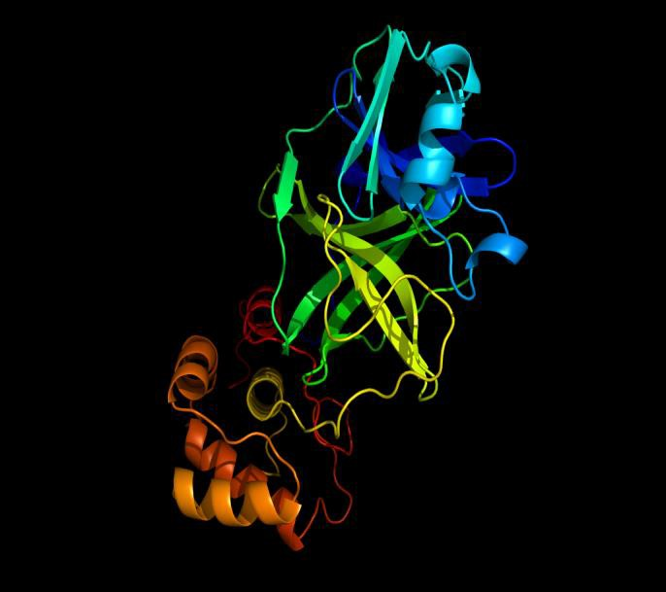 | 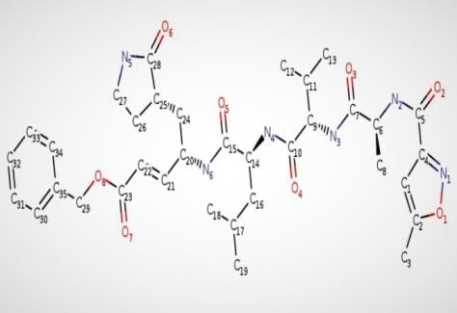 | Thr 24,Thr 26, Phe140,Asn142, Gly143, Cys145, His163, His164,  Glu166, His172 Asp 187,Arg188 Gln 189,Thr190  Gln192
Table 1. Protein target structures and active site amino acids and the native ligand structure

S.N. | Compound | Sourc e | Molecular formula | Molecular structure | Lipinski’s rule of five
 |  |  |  |  | Properties | Value
1. | Herbacetin | [23] | C15H10O7 | 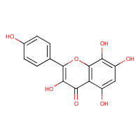 | Mol. Wt. (<500Da) | 302.24  g/mol
 |  |  |  |  | Log P (<5) | 1.50
 |  |  |  |  | H-Bond donors (5) | 5
 |  |  |  |  | H-bond acceptors  (<10) | 7
 |  |  |  |  | Violations | 0
2. | Rhoifolin | [24] | C27H30O14 | 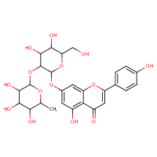 | Mol. Wt. (<500Da) | 578.52  g/mol
 |  |  |  |  | Log P (<5) | 2.07
 |  |  |  |  | H-Bond donors (5) | 8
 |  |  |  |  | H-bond acceptors  (<10) | 14
 |  |  |  |  | Violations | 3
3. | Pectolinarin | [25] | C29H34O15 | 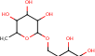 | Mol. Wt. (<500Da) | 622.57  g/mol
 |  |  |  |  | Log P (<5) | 1.73

 |  |  |  |  | H-Bond donors (5) | 7
 |  |  |  |  | H-bond acceptors  (<10) | 15
 |  |  |  |  | Violations | 3
4. | Apigenin | [26] | C15H10O5 | 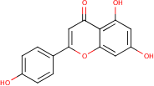 | Mol. Wt. (<500Da) | 270.24  g/mol
 |  |  |  |  | Log P (<5) | 1.89
 |  |  |  |  | H-Bond donors (5) | 3
 |  |  |  |  | H-bond acceptors  (<10) | 5
 |  |  |  |  | Violations | 0
5. | Luteolin | [27] | C15H10O6 | 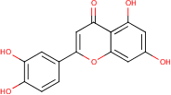 | Mol. Wt. (<500Da) | 286.24  g/mol
 |  |  |  |  | Log P (<5) | 1.86
 |  |  |  |  | H-Bond donors (5) | 4
 |  |  |  |  | H-bond acceptors  (<10) | 6
 |  |  |  |  | Violations | 0
6. | Amentoflavone | [28] | C30H18O10 | 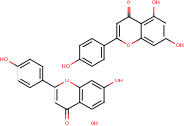 | Mol. Wt. (<500Da) | 538.46  g/mol
 |  |  |  |  | Log P (<5) | 3.06
 |  |  |  |  | H-Bond donors (5) | 6
 |  |  |  |  | H-bond acceptors  (<10) | 10
 |  |  |  |  | Violations | 2
7. | Daidzein | [29] | C15H10O4 | 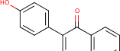 | Mol. Wt. (<500Da) | 254.24  g/mol
 |  |  |  |  | Log P (<5) | 1.77
 |  |  |  |  | H-Bond donors (5) | 2

 |  |  |  |  | H-bond acceptors  (<10) | 4
 |  |  |  |  | Violations | 0
8. | Puerarin | [30] | C21H20O9 | 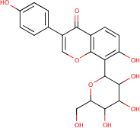 | Mol. Wt. (<500Da) | 416.38  g/mol
 |  |  |  |  | Log P (<5) | 1.96
 |  |  |  |  | H-Bond donors (5) | 6
 |  |  |  |  | H-bond acceptors  (<10) | 9
 |  |  |  |  | Violations | 1
9. | Epigallocatechin | [31] | C15H14O7 | 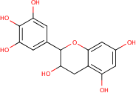 | Mol. Wt. (<500Da) | 306.27  g/mol
 |  |  |  |  | Log P (<5) | 0.98
 |  |  |  |  | H-Bond donors (5) | 6
 |  |  |  |  | H-bond acceptors  (<10) | 7
 |  |  |  |  | Violations | 1
10. | Gallocatechin gallate | [32] | C22H18O11 | 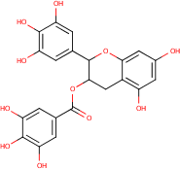 | Mol. Wt. (<500Da) | 458.37  g/mol
 |  |  |  |  | Log P (<5) | 1.83
 |  |  |  |  | H-Bond donors (5) | 8
 |  |  |  |  | H-bond acceptors  (<10) | 11
 |  |  |  |  | Violations | 2
11. | Resveratrol | [33] | C14H12O3 | 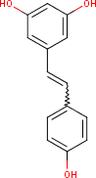 | Mol. Wt. (<500Da) | 228.24  g/mo
 |  |  |  |  | Log P (<5) | 1.71
 |  |  |  |  | H-Bond donors (5) | 3
 |  |  |  |  | H-bond acceptors  (<10) | 3

 |  |  |  |  | Violations | 0
12. | Maslinic acid | [34] | C30H48O4 | 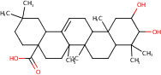 | Mol. Wt. (<500Da) | 472.70  g/mol
 |  |  |  |  | Log P (<5) | 3.55
 |  |  |  |  | H-Bond donors (5) | 3
 |  |  |  |  | H-bond acceptors  (<10) | 4
 |  |  |  |  | Violations | 1
13. | Piperine | [35] | C17H19NO3 | 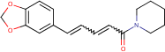 | Mol. Wt. (<500Da) | 285.34  g/mol
 |  |  |  |  | Log P (<5) | 3.42
 |  |  |  |  | H-Bond donors (5) | 0
 |  |  |  |  | H-bond acceptors  (<10) | 3
 |  |  |  |  | Violations | 0
14. | Ganomycin B | [36] | C21H28O4 | 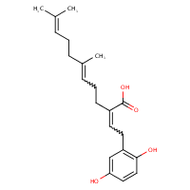 | Mol. Wt. (<500Da) | 344.44  g/mol
 |  |  |  |  | Log P (<5) | 3.16
 |  |  |  |  | H-Bond donors (5) | 3
 |  |  |  |  | H-bond acceptors  (<10) | 4
 |  |  |  |  | Violations | 0
Table 2: List of compounds with suitable ADME properties

S.N. | Protein | Ligand | Binding Energy (ΔG) | Chain
1. | COVID-19 (6LU7) | Ritonavir | -8.52 | A
2. | COVID-19 (6LU7) | Lopinavir | -8.5 | A
3. | COVID-19 (6LU7) | Herbacetin | -7.4 | A
4. | COVID-19 (6LU7) | Rhoifolin | -6.71 | A
5. | COVID-19 (6LU7) | Pectolinarin | -5.88 | A
6. | COVID-19 (6LU7) | Apigenin | -7.42 | A
7. | COVID-19 (6LU7) | Luteolin | -7.58 | A
8. | COVID-19 (6LU7) | Amentoflavone | -9.13 | A
9. | COVID-19 (6LU7) | Daidzein | -7.32 | A
10. | COVID-19 (6LU7) | Puerarin | -7.97 | A
11. | COVID-19 (6LU7) | Epigallocatechin | -6.13 | A
12. | COVID-19 (6LU7) | Gallocatechin gallate | -7.59 | A
13. | COVID-19 (6LU7) | Resveratrol | -7.41 | A
14. | COVID-19 (6LU7) | Maslinic acid | -7.97 | A
15. | COVID-19 (6LU7) | Piperine | -7.65 | A
16. | COVID-19 (6LU7) | Ganomycin B | -6.46 | A
Table 3. Shows the molecular docking analysis results for selected natural compounds against COVID-19 main protease M^{pro} (PDB-6LU7).

S.No. | Compounds | Toxicity  class | LD50  (mg/kg) | Hepatotoxicity | Cytotoxicity
1. | Herbacetin | 5 | 3919 | Inactive | Inactive
2. | Rhoifolin | 5 | 5000 | Inactive | Inactive
3. | Pectolinarin | 5 | 5000 | Inactive | Active
4. | Apigenin | 5 | 2500 | Inactive | Inactive
5. | Luteolin | 5 | 3919 | Inactive | Inactive
6. | Amentoflavone | 5 | 3919 | Inactive | Inactive
7. | Daidzein | 5 | 2430 | Inactive | Inactive
8. | Puerarin | 4 | 832 | Inactive | Inactive
9. | Epigallocatechin | 6 | 10000 | Inactive | Inactive
10. | Gallocatechin  gallate | 4 | 1000 | Inactive | Inactive
11. | Resveratrol | 4 | 1560 | Inactive | Inactive
12. | Maslinic acid | 4 | 2000 | Inactive | Inactive
13. | Piperine | 4 | 330 | Inactive | Inactive
14. | Ganomycin B | 4 | 370 | Inactive | Inactive

Table: Toxicity predictions for selected natural compounds

