Supplementary Information for:
Ambient pressure storage of high-density methane in carbon nanopores having thermally switchable graphene-locks
Shuwen Wang¹, Fernando Vallejos-Burgos², Ayumi Furuse¹, Juan P. Marco-Lozar³, Miu Nagae¹, Hideki Tanaka¹, Hirofumi Kanoh⁴, Joaquín Silvestre-Albero⁵, Takuya Hayashi⁶, Katsumi Kaneko^{1✉}
1. Research Initiative for Supra-Materials, Shinshu University, Nagano 380-8553, Japan
2. Morgan Advanced Materials, Carbon Science Centre of Excellence, State College, PA, USA
3. G2MTech, Plaza de Calvo Sotelo, 16-2ºC, Alicante, 03001, Spain
4. Department of Chemistry, Graduate School of Science, Chiba University, Chiba 263-8522, Japan
5. Laboratorio de Materiales Avanzados, Departamento de Química Inorgánica-Instituto Universitario de Materiales, Universidad de Alicante, E-03690 San Vicente del Raspeig, Spain
6. Department of Water Environment and Civil Engineering, Shinshu University, Nagano 380-8553, Japan
✉email: kkaneko@shinshu-u.ac.jp

Contents
Supplementary Note 1 to 3
Supplementary Figures 1 to 18
Supplementary Tables 1 to 9
Supplementary References

Supplementary Note 1: Temperature elevation-induced pressure changes of ANG and CNG
The temperature dependence of methane adsorption was studied with 1.26-nm carbon pores (A20). Methane adsorption in the carbon pores decreased with increasing temperature (Supplementary Fig. 1a). Assuming methane was stored at 3.5 MPa and 298 K in containers filled by porous carbon without packing voids, with a temperature rise from 298 K to 313 K, the amount of methane adsorbed in the nanopores decreases, and a new equilibrium is achieved under the higher pressure of 6.0 MPa. Similarly, if methane is stored at 3.5 MPa and 273 K in containers filled by porous carbon, the pressure of the newly established equilibrium at 298 K is 6.5 MPa. The reported methane adsorption on MOFs is also widely affected by temperature elevation^{1,2}. On the other hand, the pressure of a CNG vessel with an initial pressure of 25 MPa increases to 27.7 MPa (or 31.2 MPa) with an increase in temperature from 298 to 313 K (or from 273 to 298 K) (Supplementary Fig. 1b and Supplementary Table 1), i.e., the CNG method is much less affected by temperature elevation than the ANG method. The temperature-elevation induced pressure changes of ANG using porous carbon with 1.00 nm (A15), 1.26 nm (A20) and 1.62 nm (PG973) pores are shown together with those of CNG in Supplementary Figure 1c.

Supplementary Note 2: Porosity variations of carbon during graphene grafting at pore entrances and pore reopening by air oxidation
The porosities of carbons were evaluated with nitrogen adsorption at 77 K. The surface areas were determined by using subtracting pore effect (SPE) method^{3,4} as well as with the Brunauer‒Emmett‒Teller (BET) method (P/P₀ range of 0.05-0.20). The pore size distribution was determined by using quenched solid density functional theory (QSDFT)⁵ with the slit-pore model. The total pore volume was determined from the amount of nitrogen adsorbed at P/P₀ = 0.98 according to Gurvitch’s rule.
Pore entrance wrapping of a-ACF was carried out by using the CVD method with methane as the carbon source (Supplementary Fig. 8). The nitrogen adsorption isotherms (77 K) of CVD-treated a-ACF showed a decrease in nitrogen uptake with increasing CVD temperature (Supplementary Fig. 8a,b). Moreover, distinct hysteresis at low relative pressures was observed for a-ACF treated by CVD at 1093 and 1113 K (Supplementary Fig. 8b), suggesting that the partially wrapped entrances of a-ACF had narrow pores whose sizes were close to that of the nitrogen molecule. The comparison plots of a-ACF treated by CVD at 1053 and 1073 K against the original a-ACF were generally straight with a slight downwards bend at large adsorption amounts (Supplementary Fig. 8c). The porosity variation of CVD-treated a-ACF is shown in Supplementary Figure 8d,e.
The entrance-wrapped nanopores can be reopened by using air oxidation to form nanoscale windows in the pore walls (Supplementary Fig. 9). Nitrogen adsorption isotherms (77 K) for entrance-wrapped carbon prepared at 1123 K showed an increase in nitrogen uptake with increasing oxidation temperature up to 693 K and become almost constant at higher oxidation temperatures (Supplementary Fig. 9a), suggesting that 693 K was sufficient to open all inaccessible nanopores of this entrance-wrapped carbon. The comparison plots for entrance-wrapped carbon after air oxidation against the original a-ACF were straight in general with slight downwards bending at large adsorption amounts (Supplementary Fig. 9b), suggesting that the reopened pores gave a porous structure similar to that of the carbon precursor. The weight loss of entrance-wrapped carbon induced by air oxidation at 693 K was 2.7%, which is quite small. Intensive oxidation at 713 K gave rise to a weight loss of 5.2% without further development of porosity. The porosity parameters for the entrance-wrapped carbon treated by air oxidation under different temperatures are shown in Supplementary Figure 9c,d. Similarly, entrance-wrapped carbon prepared at 1113 and 1133 K was fully reopened by air oxidation at 673 and 713 K (Supplementary Fig. 10), respectively, i.e., a higher CVD temperature gave rise to more stable entrance wrapping. The porosities of entrance-wrapped carbons after full pore opening are shown in Supplementary Figure 10c,d. The pore volume of entrance-wrapped carbon decreased with increasing CVD temperature due to increased carbon deposition.
A variety of slit-shaped porous carbons with different pore widths were used as precursors to prepare pore entrance-wrapped carbons (Supplementary Fig. 11). The nitrogen adsorption isotherms (77 K) and pore size distributions of these carbons before grafting the entrance wrapping are shown in Supplementary Figure 11a,b. The required CVD temperature and the amount of carbon deposited increased rapidly with the pore widths of the carbon (Supplementary Fig. 11c) because full wrapping of wider pores was more difficult due to ineffective carbon deposition. Therefore, a porous carbon precursor with small pore widths and a large pore volume is favoured for preparation of entrance-wrapped pores with a large blocked pore volume.

Supplementary Note 3: Wall thickness and space utilization ratio of the pressure vessel⁶
The formulas used for calculating the wall thickness (t_{r}) of the pressure vessel are

t_{r} = R_{i} (Z₁^{1/2} - 1),
where Z₁ = (S + P)/(S - P),
S = 0.667 E* F_{y}

Nomenclatures:
E: Joint efficiency factor
F_{y}: Minimum specified yield strength
P: maximum working pressure
R_{i}: inner diameter of vessel
t_{r}: wall thickness of vessel

The joint efficiency factor (E) used in this calculation was 1.0 (seamless vessel). The minimum specified yield strength (F_{y}) was set as 1000 MPa (14504 psi)⁷. The density of stainless steel is 7800 kg m⁻³. The calculated m/V ratio at 25 MPa was 1.274, which was within those for commercial CNG vessels (1.0~1.5)^{8,9}. The wall thickness and mass/volume (m/V) ratio of the pressure vessel for different working pressures are shown in Supplementary Figure 3. The space utilization ratio of a cylindrical pressure vessel was determined to be 0.74 by taking a cuboid structure as a standard (Supplementary Fig. 4). Ambient-condition methane storage using entrance-wrapped carbon does not require a heavy pressure vessel with a specific cylindrical or spherical shape; therefore, the weight of the container is negligible, and the space utilization ratio is close to unity.

Supplementary Figures
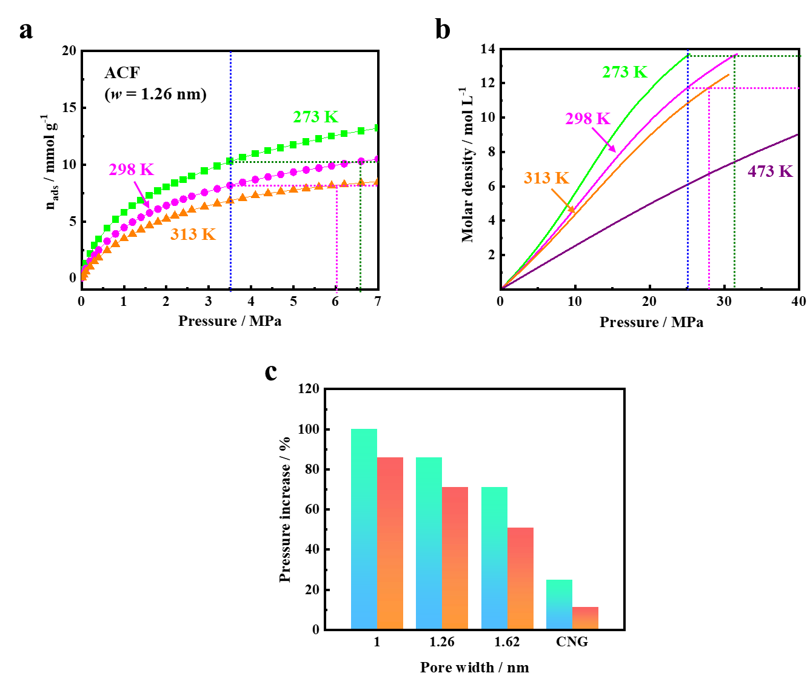
Supplementary Figure 1. Effect of temperature elevation on methane storage with ANG and CNG. a, High-pressure methane adsorption on 1.26-nm carbon pores at 273, 298 and 313 K. b, Molar density of methane at different pressures and temperatures (Supplementary Table 1). c, Temperature-elevation induced pressure increase for the ANG method using porous carbon with different pore widths and the CNG method. Temperature increase from 273 K to 298 K: Light blue; temperature increase from 298 K to 313 K: Orange.

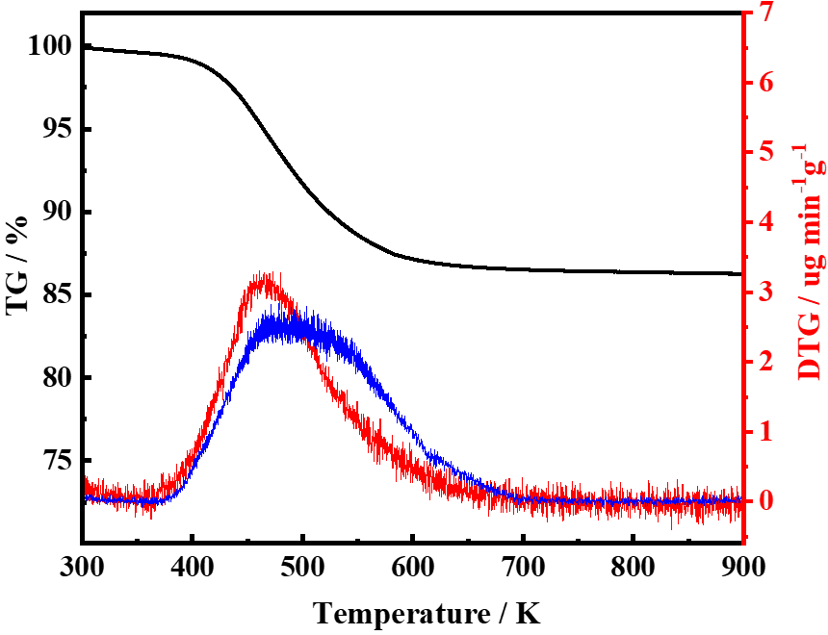
Supplementary Figure 2. TG-mass measurements of entrance-wrapped carbon entrapped with methane. TG curve: black, DTG curve: red, mass curve (z = 15, corresponding to CH₃⁺): blue. Here, the mass curve signal was normalized to fit the magnitude of the DTG curve.

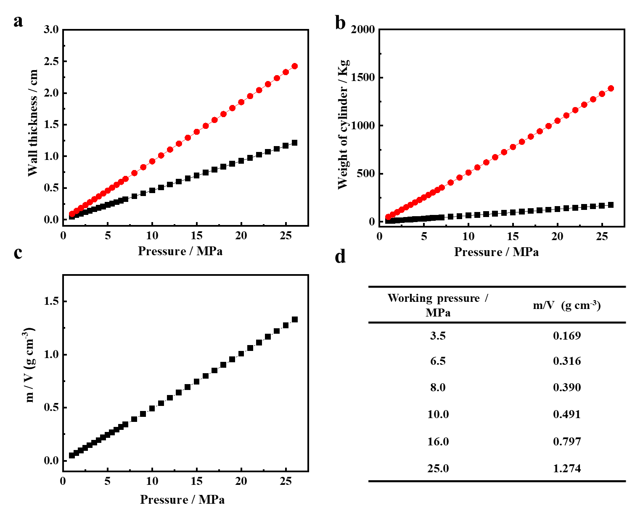
Supplementary Figure 3. Design of a pressure vessel for different working pressures. a-c, Required wall thickness (a), weight (b) and mass/volume (m/V) ratio (c) of the pressure vessel as a function of its working pressure. The length/diameter (L/D) = 5 was used here for working pressures > 3.5 MPa⁶. Pressure vessels with inner diameters of 1 foot (30.48 cm, black square) and 2 feet (60.96 cm, red sphere) were calculated independently, and the obtained m/V values of the two different pressure vessels were identical. d, m/V values for the pressure vessel with several typical working pressures.
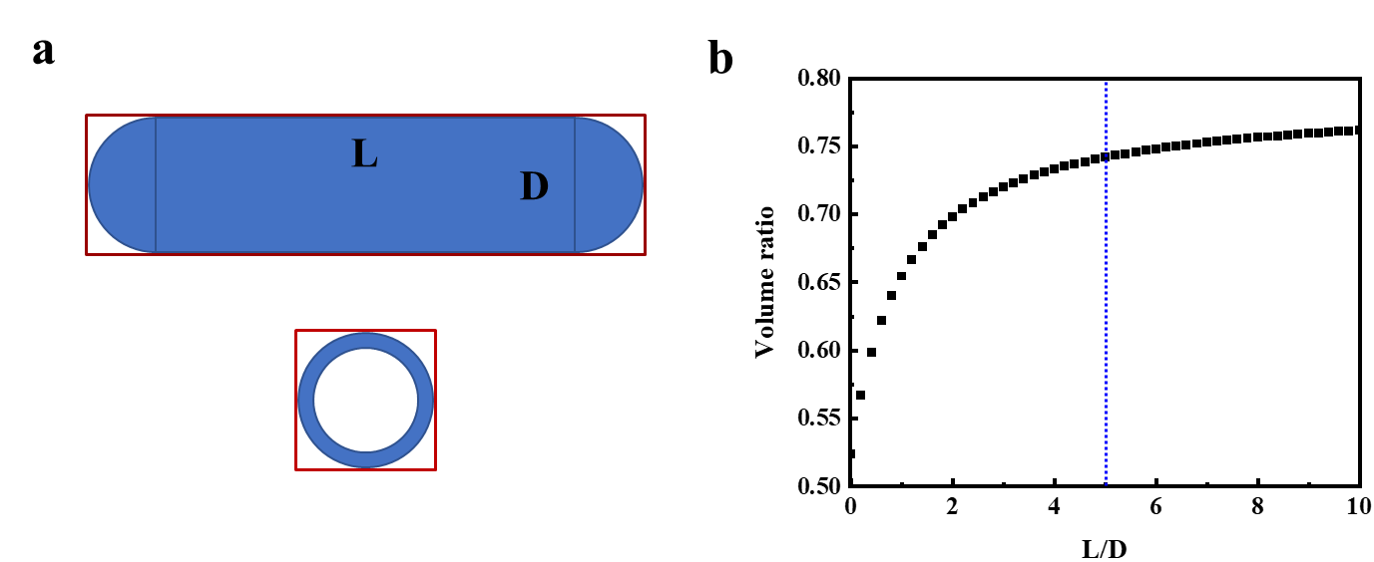
Supplementary Figure 4. Space utilization ratio for the pressure vessel. a, Sketch of a pressure vessel and the space occupied (red box). b, Space utilization ratio of the pressure vessel at different L/D values. The dotted blue line in (b) indicates a space utilization ratio of 0.74 at L/D = 5. The space utilization ratio of a cylindrical pressure vessel was determined to be 0.74 by taking a cuboid structure as a standard.

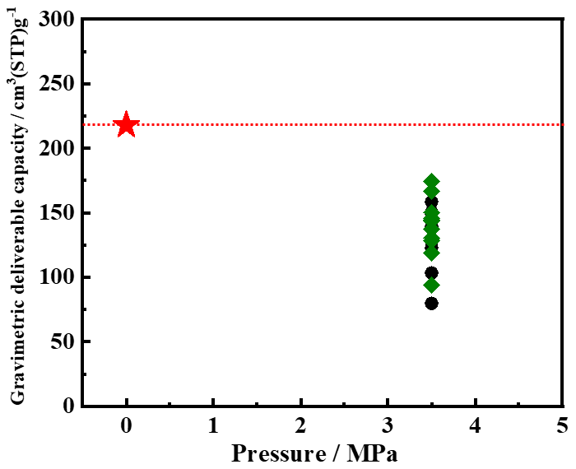
Supplementary Figure 5. Gravimetric methane deliverable capacities of the entrance-wrapped carbon in this study (red star), ANG with porous carbons (black spheres) and MOFs (green diamonds) at 3.5 MPa using a pressure vessel with a design pressure of 6.0 MPa. The red dotted line indicates the methane storage amount for entrance-wrapped carbon under ambient pressure.
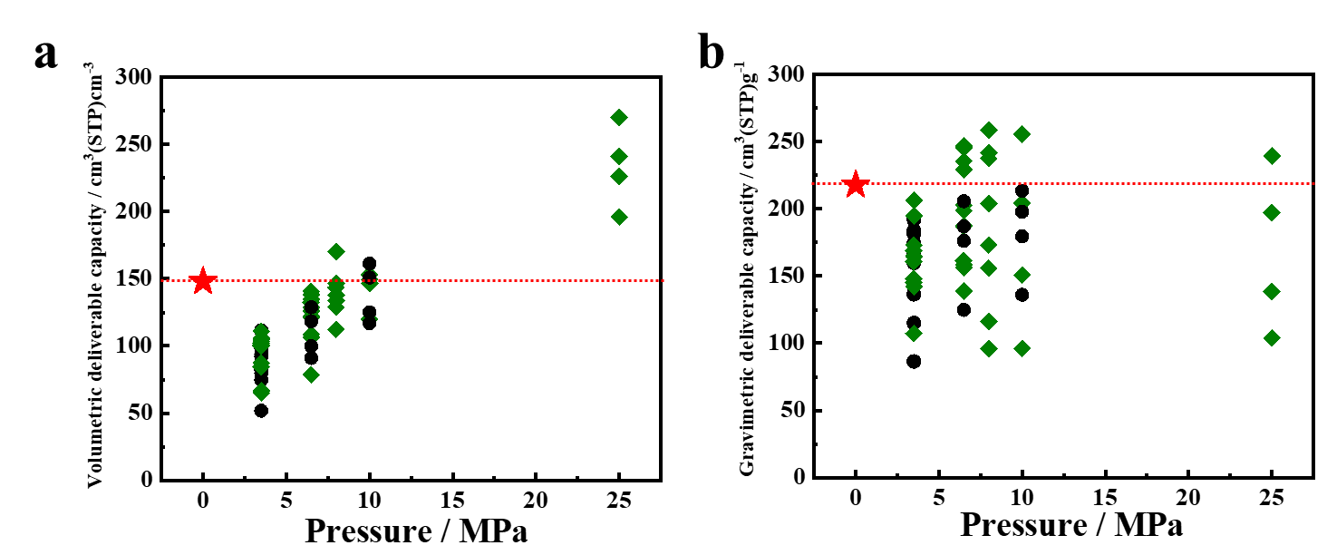
Supplementary Figure 6. a, b, Volumetric (a) and gravimetric (b) methane deliverable capacities of the porous carbon with graphene locks in this study (red star), ANG with porous carbons (black spheres) and MOFs (green diamonds) under different pressures. The methane deliverable capacities of different adsorbents at 298 K are shown in detail in Supplementary Table 2-5.

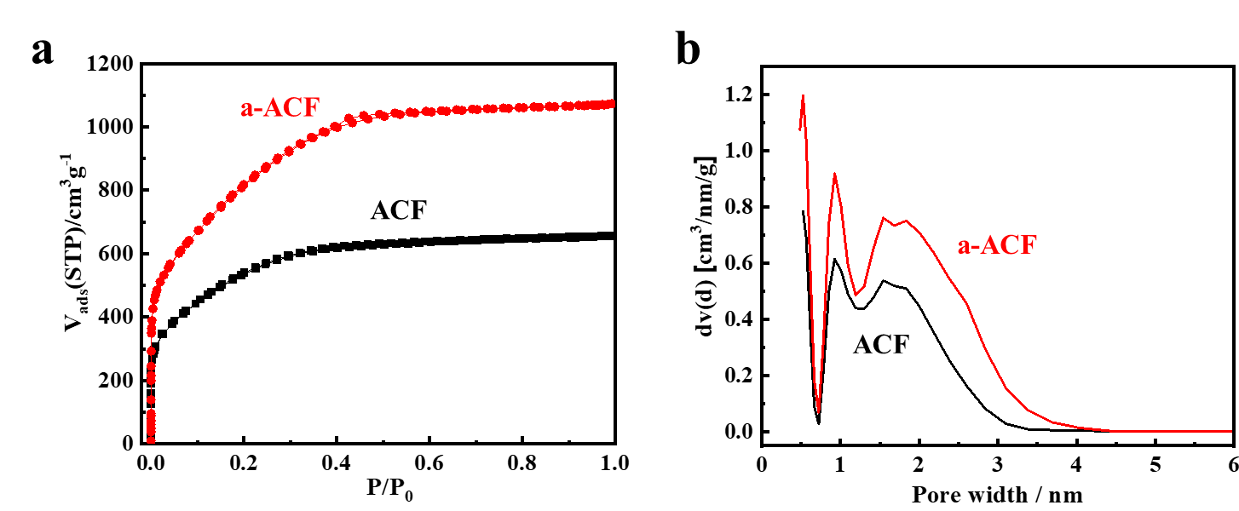
Supplementary Figure 7. Porosities of ACF before and after CO₂ activation. Nitrogen adsorption isotherms at 77 K (a) and pore size distributions (b) of ACF and a-ACF.

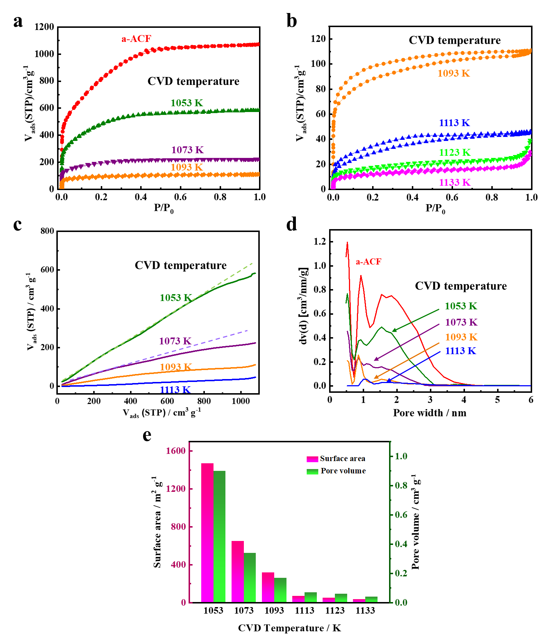
Supplementary Figure 8. Porosity of a-ACF after CVD at different temperatures. Nitrogen adsorption isotherms at 77 K (a, b), comparison plots (against the adsorption isotherm of a-ACF) (c), pore size distributions (d) and porosities (e) of a-ACF treated by CVD at different temperatures.

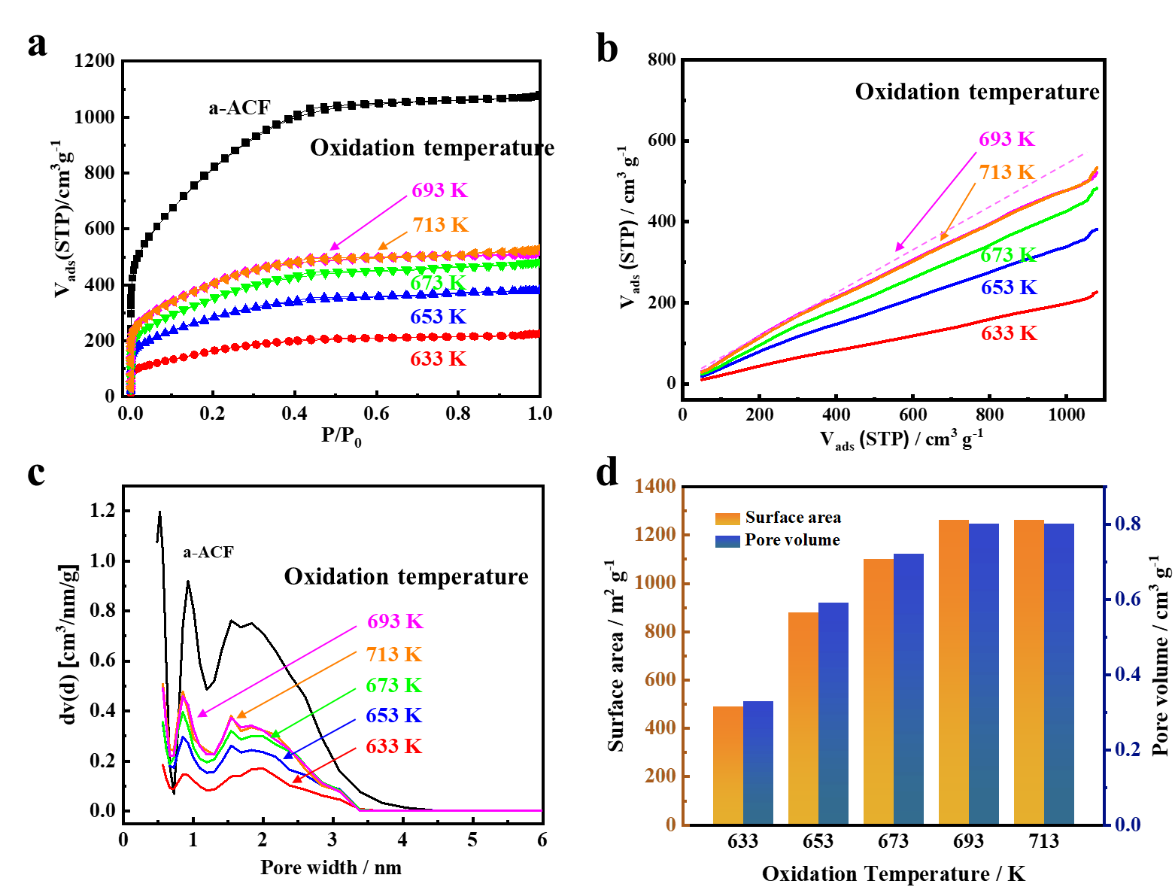
Supplementary Figure 9. Porosity of entrance-wrapped pores after generation of nanoscale windows by air oxidation. Nitrogen adsorption isotherms at 77 K (a), comparison plots (against the adsorption isotherm of a-ACF) (b), pore size distributions (c) and porosities (d) of entrance-wrapped carbons (prepared at a CVD temperature of 1123 K) treated by air oxidation at different temperatures.
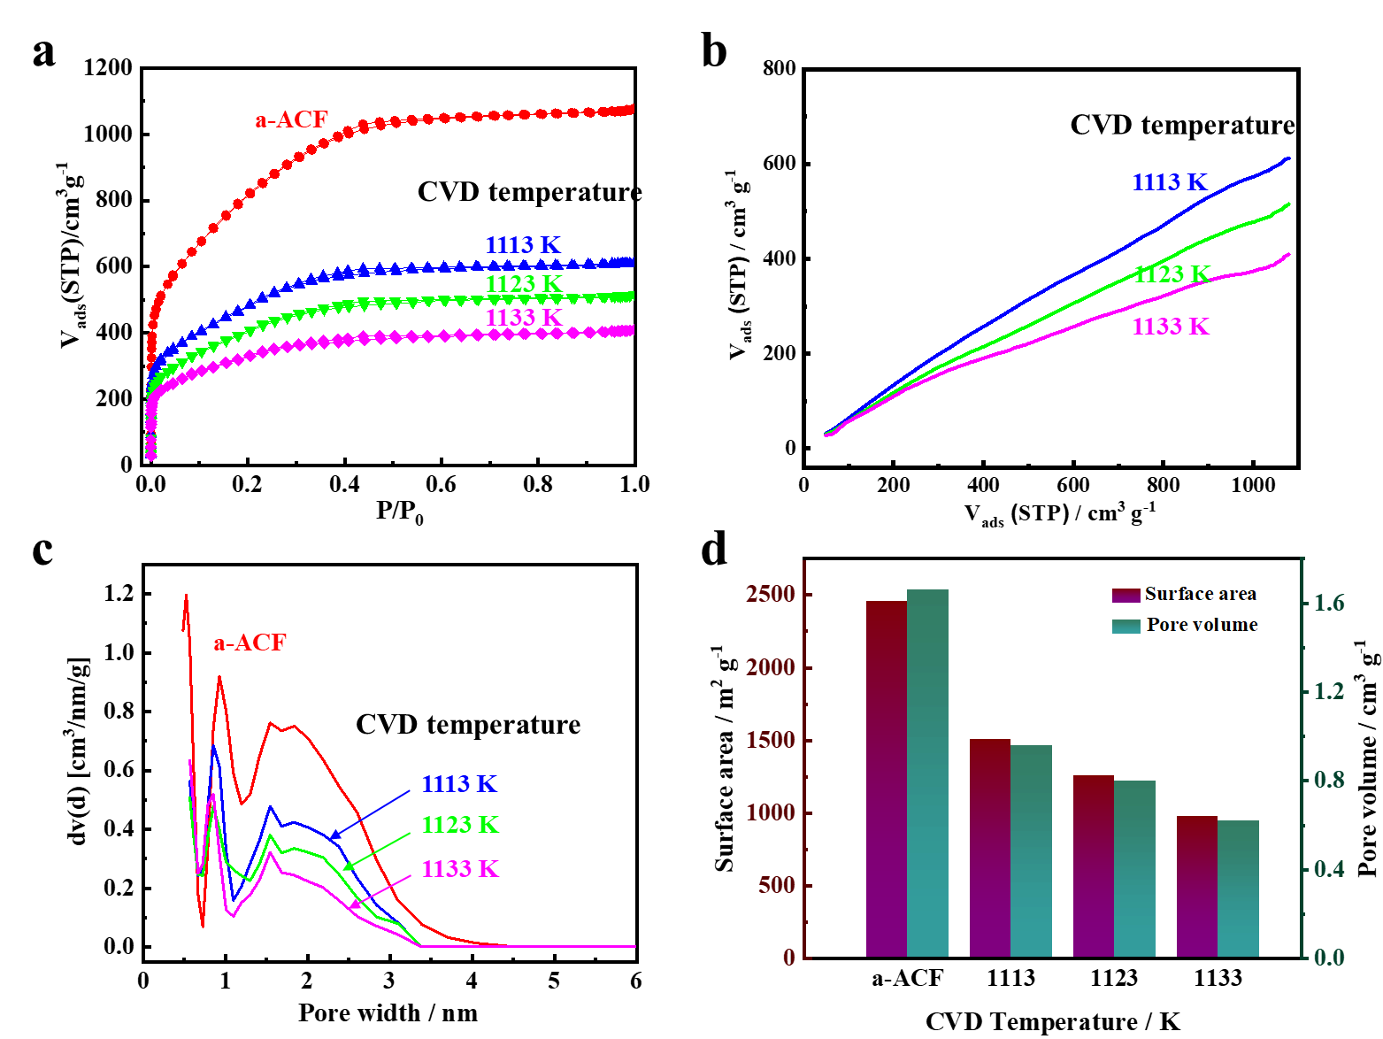
Supplementary Figure 10. Porosity of entrance-wrapped carbon after full opening. Nitrogen adsorption isotherms at 77 K (a), comparison plots (against the adsorption isotherm of a-ACF) (b), pore size distributions (c) and porosities (d) after full pore opening for three entrance-wrapped carbons prepared at different CVD temperatures. The optimum oxidation temperature for pore opening is 673 K for the sample prepared via CVD at 1113 K, 693 K for the sample prepared via CVD at 1123 K, and 713 K for the sample prepared via CVD at 1133 K.
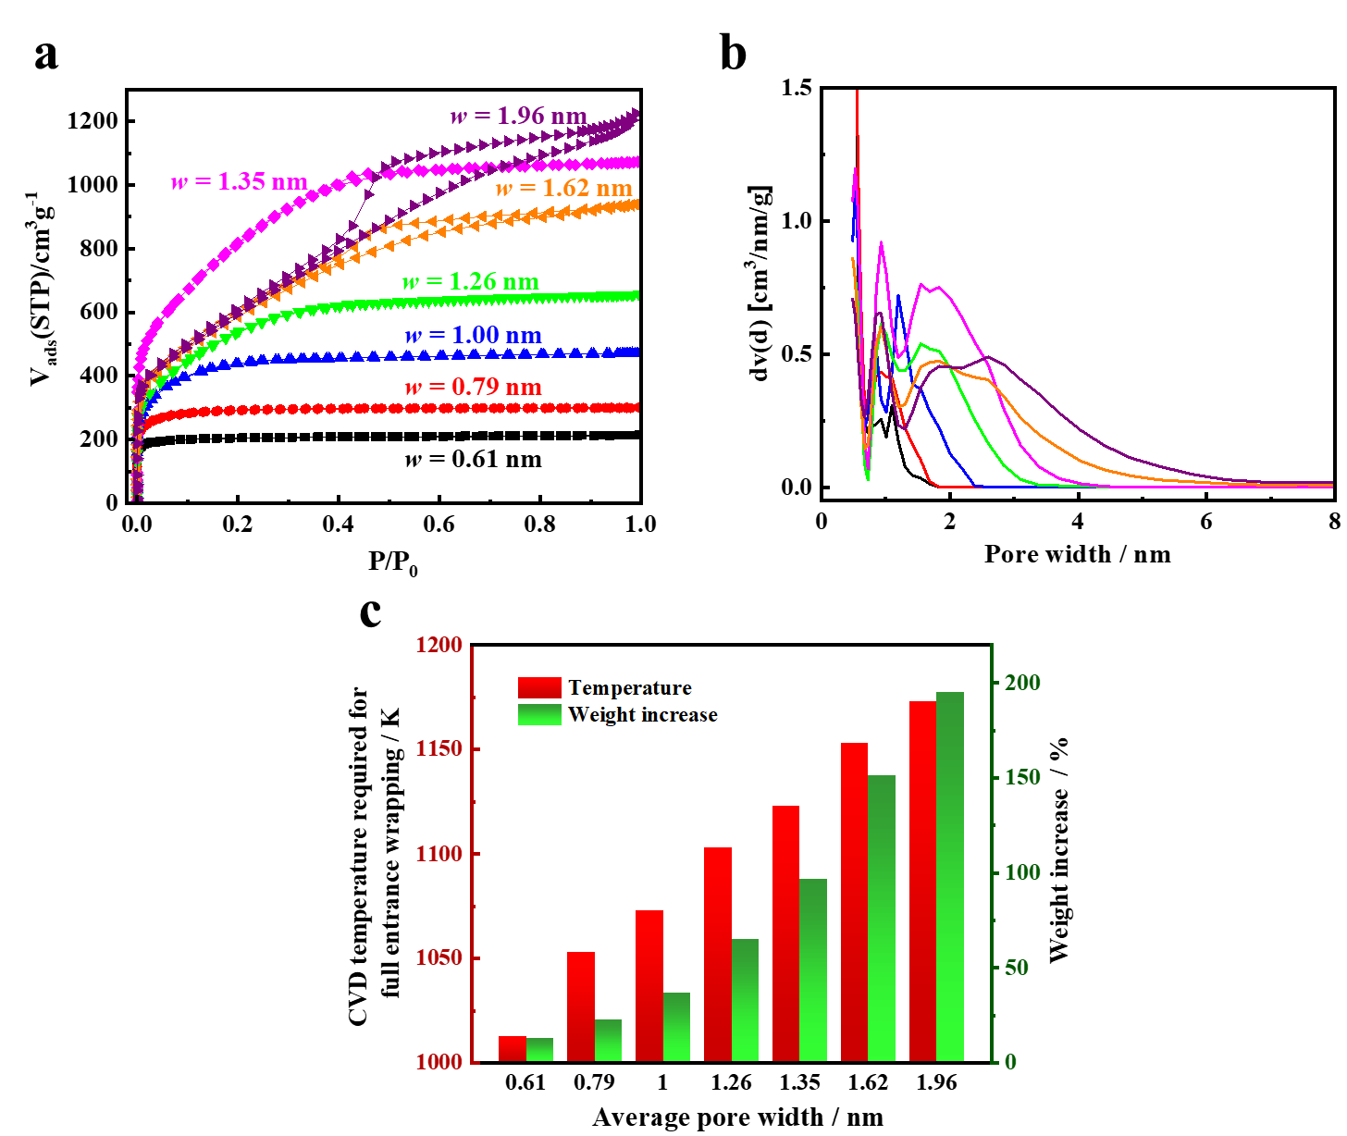
Supplementary Figure 11. Entrance-wrapped carbon prepared from carbons with different pore widths. a, b, Nitrogen adsorption isotherms at 77 K (a) and pore size distributions (b) of porous carbons with different pore widths. c, CVD temperatures required for grafting the entrance wrapping onto different carbon pores (under a two-hour reaction) and the weight increase of the carbon precursor after grafting the entrance wrapping.
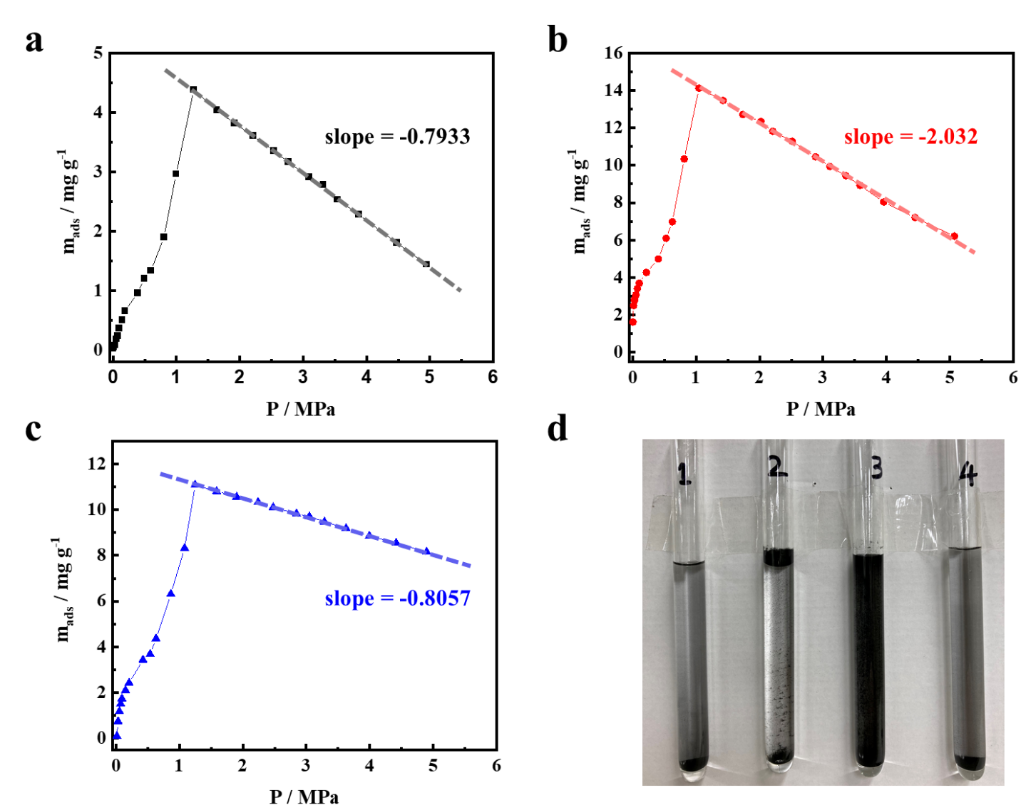
Supplementary Figure 12. True density measurement using the buoyancy (a-c) and dispersion of carbon in water and ethanol (d). a-c, Helium excess adsorption isotherms (298 K) for a-ACF (a), entrance-wrapped carbon before (b) and after (c) pore opening. The true densities of carbons were determined using the slope from a plot of weight against pressure^{10,11}. d, Photo showing the dispersion of a-ACF (1) and entrance-wrapped carbon (2) in water, entrance-wrapped carbon in ethanol (3) and entrance-wrapped carbon after pore opening in water (4).
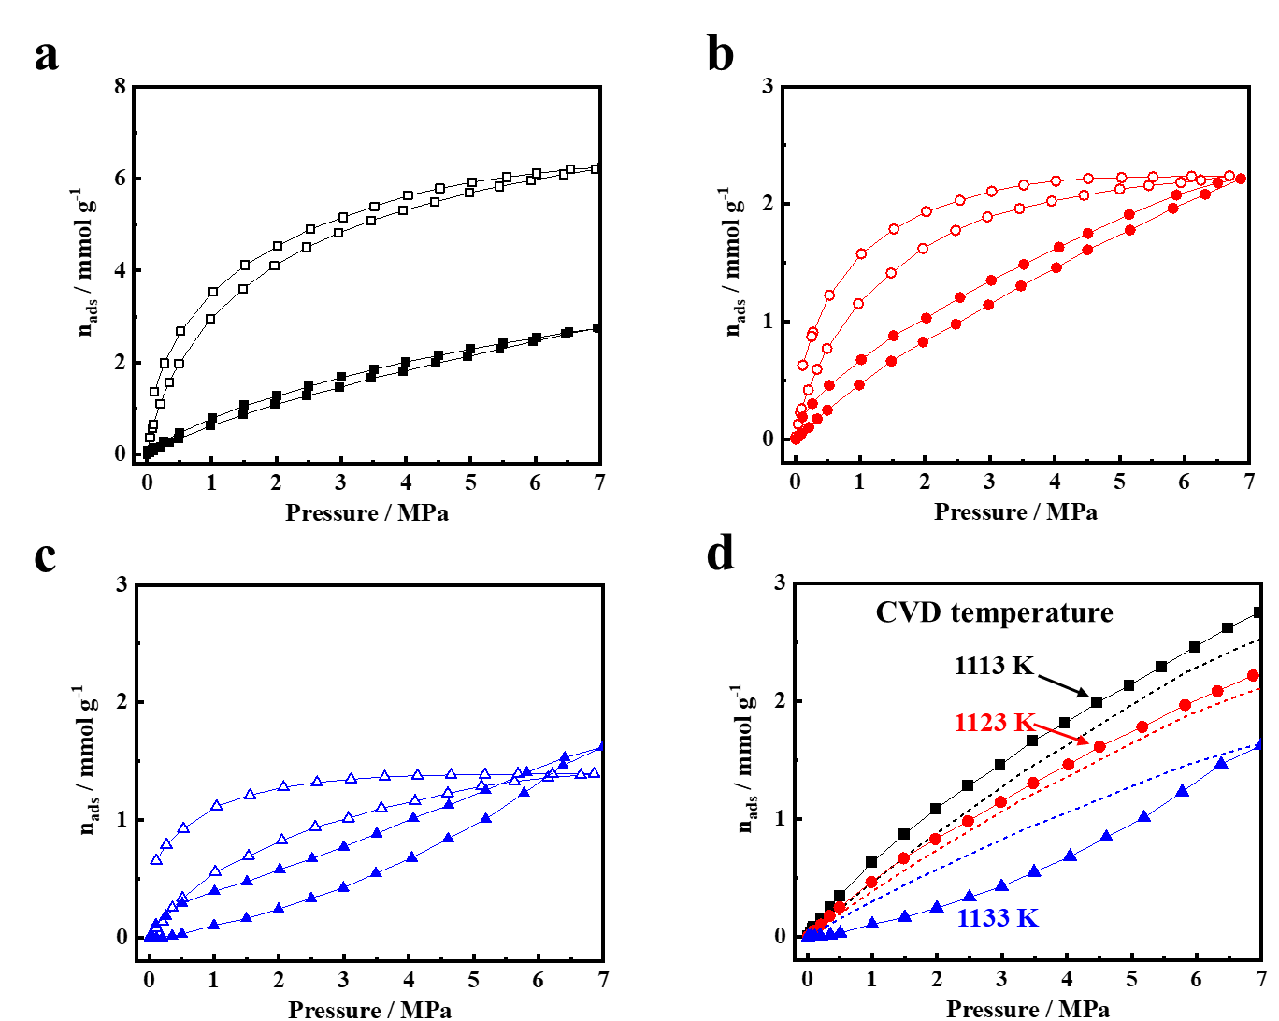
Supplementary Figure 13. Methane adsorption on entrance-wrapped carbons without pore opening. a-c, Isotherms for adsorption of methane at 298 K (hollow) and 473 K (solid) on entrance-wrapped carbons prepared at 1113 K (a), 1123 K (b), and 1133 K (c). d, Comparison of experimental (solid symbols) and calculated (dotted lines) methane adsorption on entrance-wrapped carbon at 473 K. The calculated methane adsorption isotherms shown in (d) were obtained from the computational results (Supplementary Fig. 14) and transformed in proportion to the surface area of the entrance-wrapped carbons after pore opening and ideal monolayer graphene (2630 m²g⁻¹). The experimental amounts of methane adsorbed at 473 K were slightly higher than those from GCMC simulations based on the porosity parameters from nitrogen adsorption at 77 K, which underestimated the real accessible porosity for methane at 473 K.
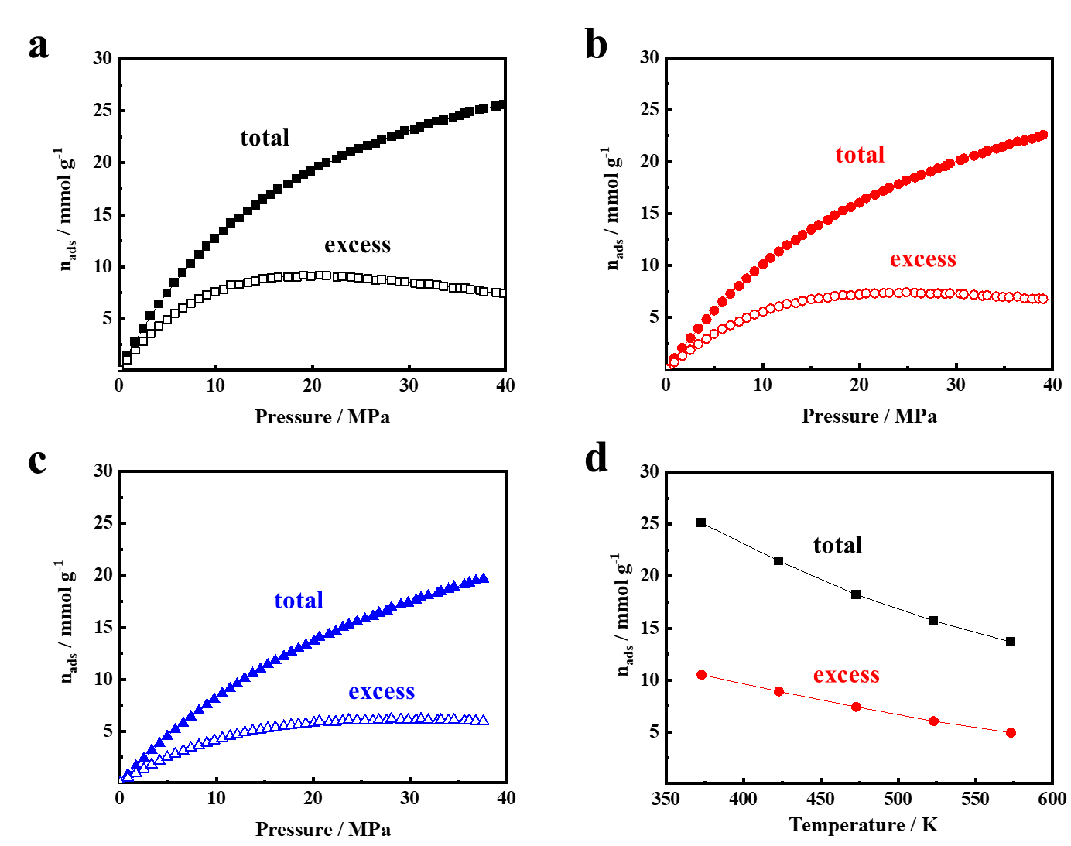
Supplementary Figure 14. Computational total and excess isotherms for adsorption of methane on slit-shaped carbon pores of 1.35 nm. a-c, Methane adsorption isotherms at 423 K (a), 473 K (b) and 523 K (c). Here, total adsorption was identical to absolute adsorption. d, Amount of methane adsorbed as a function of temperature with a pressure of 25 MPa.

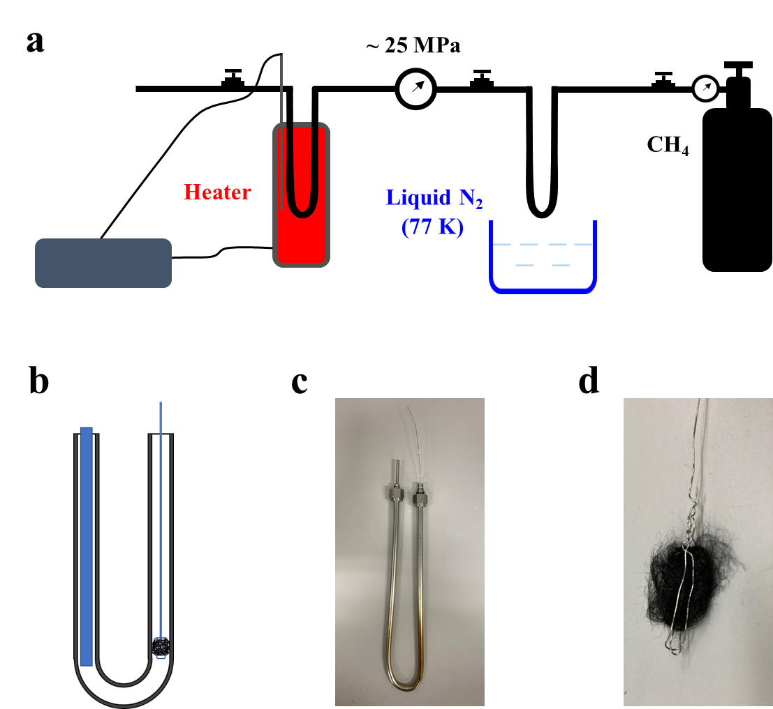
Supplementary Figure 15. a, Schematic for methane encapsulation into entrance-wrapped carbon under high pressure (25 MPa) and moderate temperatures (373~523 K). b, c, Sketch (b) and photograph (c) of the sample cell. d, Photograph of the sample fixed with stainless-steel wire.

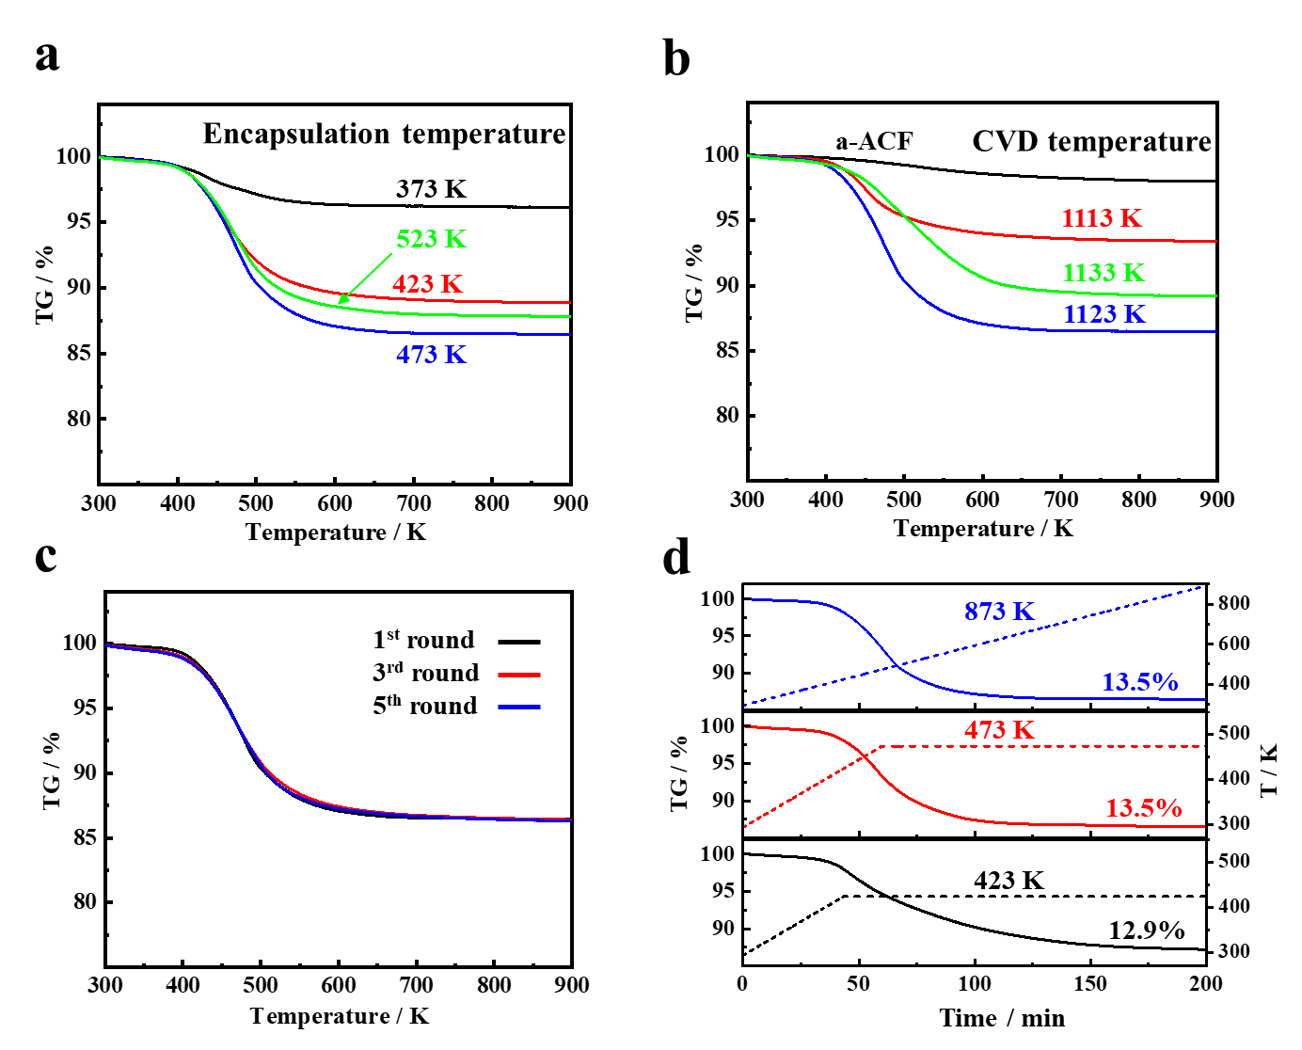
Supplementary Figure 16. Assessment of methane storage in entrance-wrapped carbon through TG studies. a, Encapsulation of methane was conducted at 373, 423, 473 and 523 K on entrance-wrapped carbon prepared at 1123 K. b, Encapsulation of methane was conducted at 423 K on entrance-wrapped carbons prepared at 1113, 1123 and 1133 K. c, Cycling performance of entrance-wrapped carbon for methane storage. d, Release of methane under different heating processes. Heating method 1 (blue dotted line): Continuous heating up to 873 K. Heating method 2 (red dotted line): Heating up to 473 K followed by maintaining the temperature at 473 K. Heating method 3 (black dotted line): Heating up to 423 K followed by maintaining the temperature at 423 K.

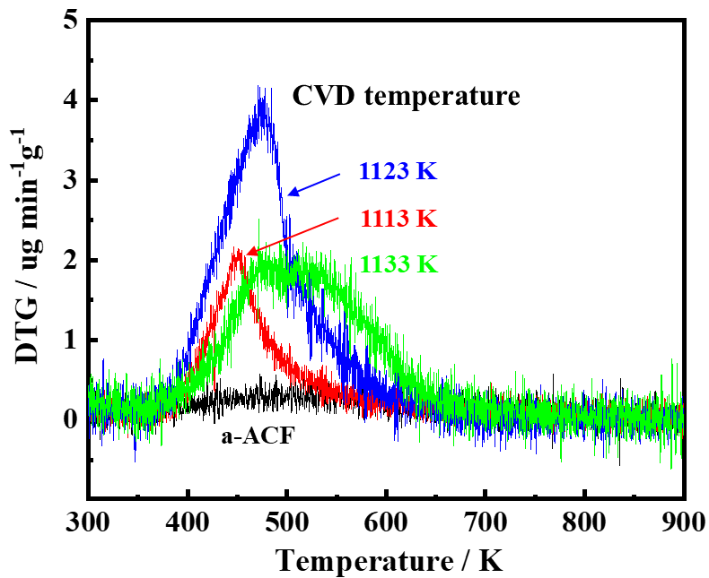
Supplementary Figure 17. DTG curves for methane stored in entrance-wrapped carbons prepared under CVD temperatures of 1113, 1123 and 1133 K in comparison with a-ACF.
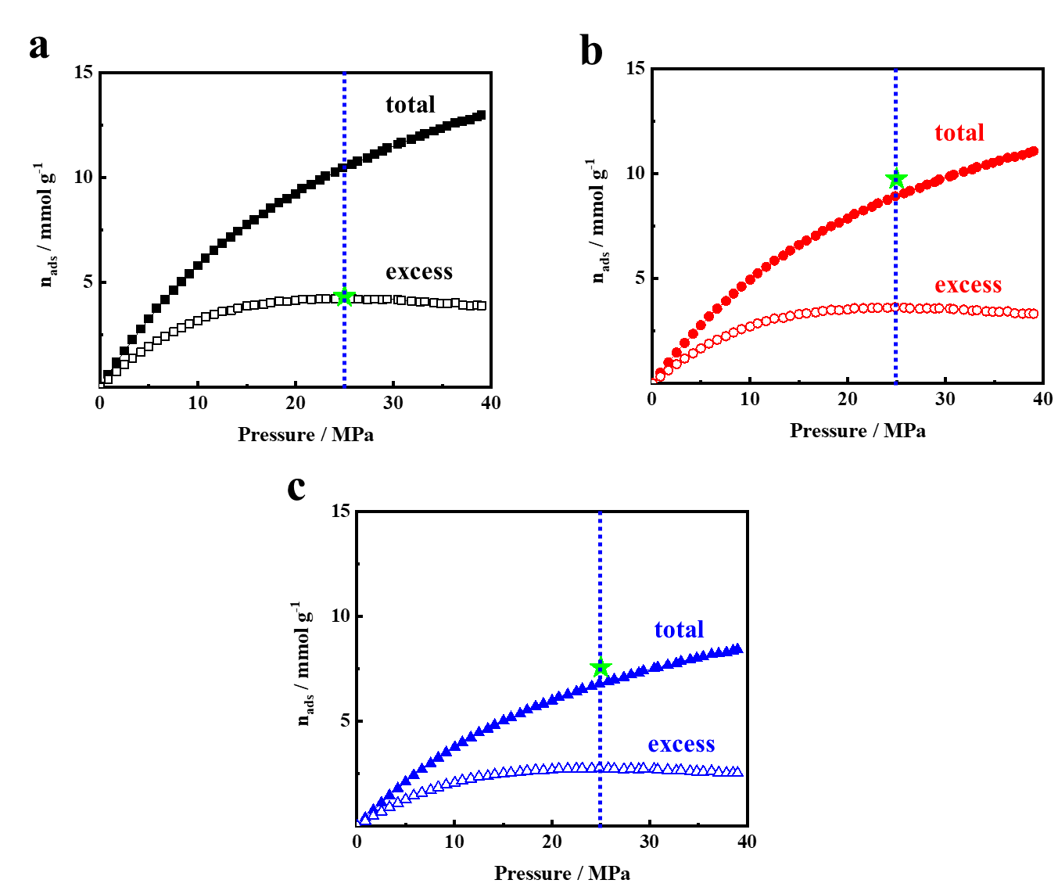
Supplementary Figure 18. Assessment of methane storage in entrance-wrapped carbons through methane adsorption isotherms. a-c, methane adsorption isotherms determined at 473 K for entrance-wrapped carbons prepared at CVD temperatures of 1113 K (a), 1123 K (b) and 1133 K (c). The methane adsorption isotherms were obtained from computational results (Supplementary Fig. 14b) and transformed in proportion to the surface area of the entrance-wrapped carbons after pore opening and ideal monolayer graphene (2630 m²g⁻¹). The blue dotted line indicates the amount of methane stored at 25 MPa. The green star indicates the amount of methane stored as determined by TG.

Supplementary Tables
Supplementary Table 1. The pressures of methane at different molar densities and temperatures¹².
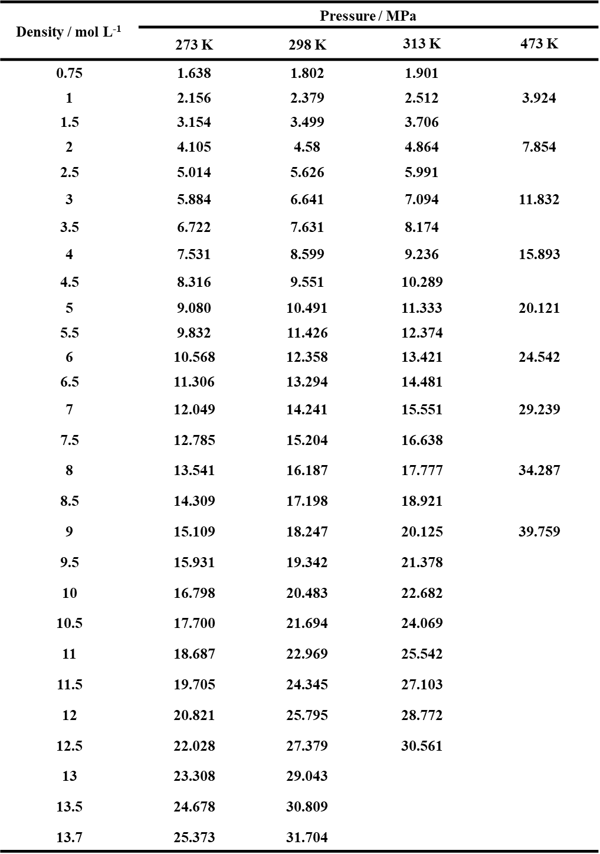

Supplementary Table 2. Volumetric methane deliverable capacities of MOFs under different pressures at 298 K^{2,13,14}. The deliverable capacities shown in Figure 1d are amended by multiplying the space utilization ratio of 0.74.
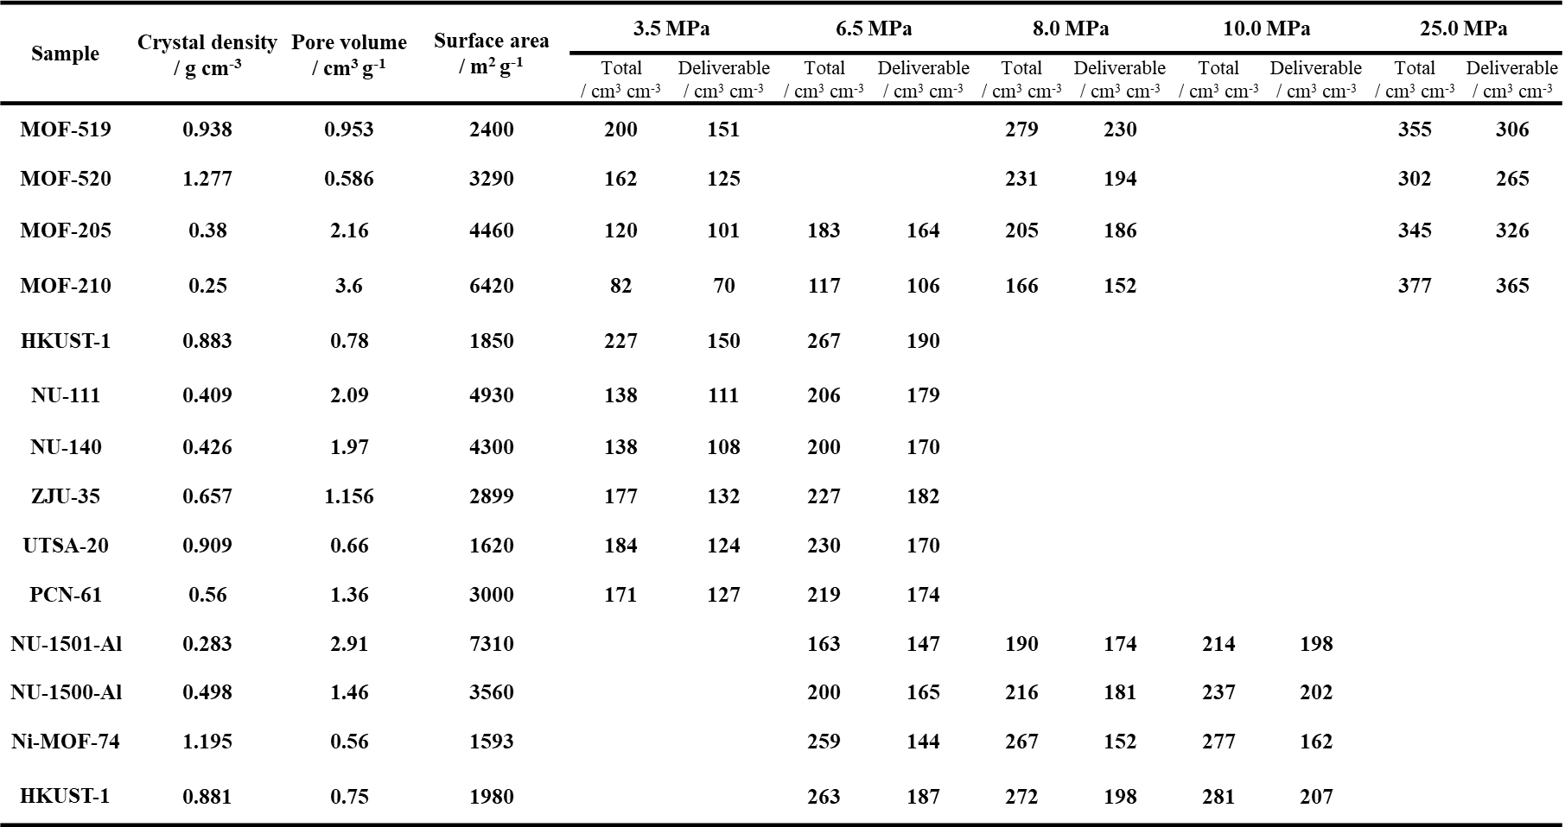

Supplementary Table 3. Gravimetric methane deliverable capacities of MOFs under different pressures at 298 K by taking into account the weight of pressure vessel.
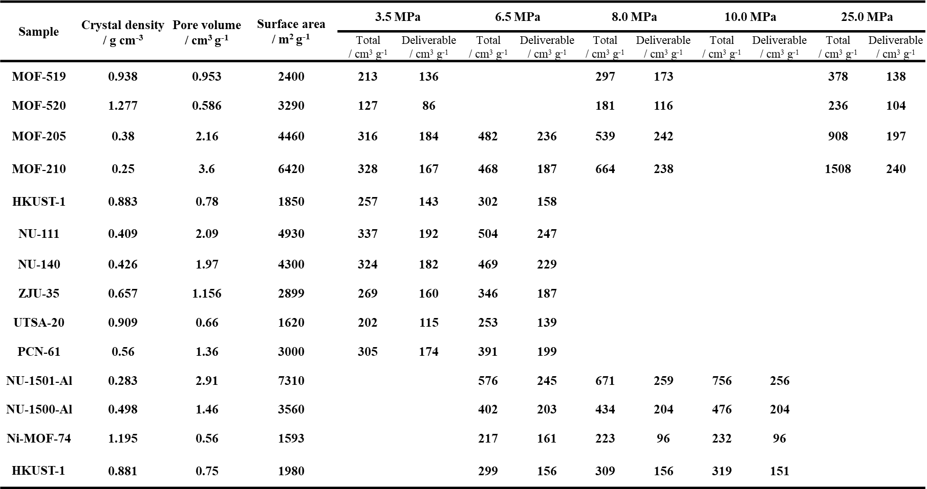

Supplementary Table 4. Volumetric methane deliverable capacities of porous carbons under different pressures at 298 K^{15,16}. The deliverable capacities shown in Figure 1d are amended by multiplying the space utilization ratio of 0.74.
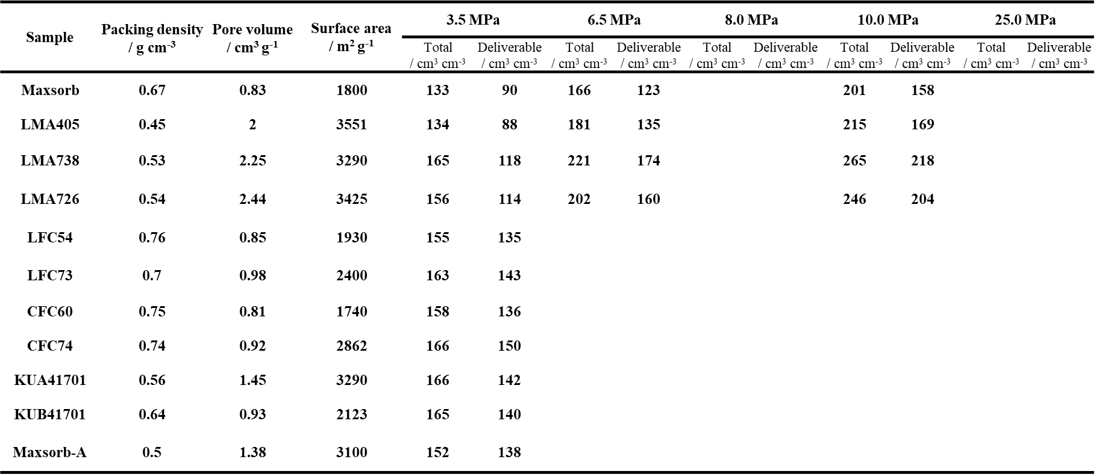

Supplementary Table 5. Gravimetric methane deliverable capacities of porous carbons under different pressures at 298 K by taking into account the weight of pressure vessel.
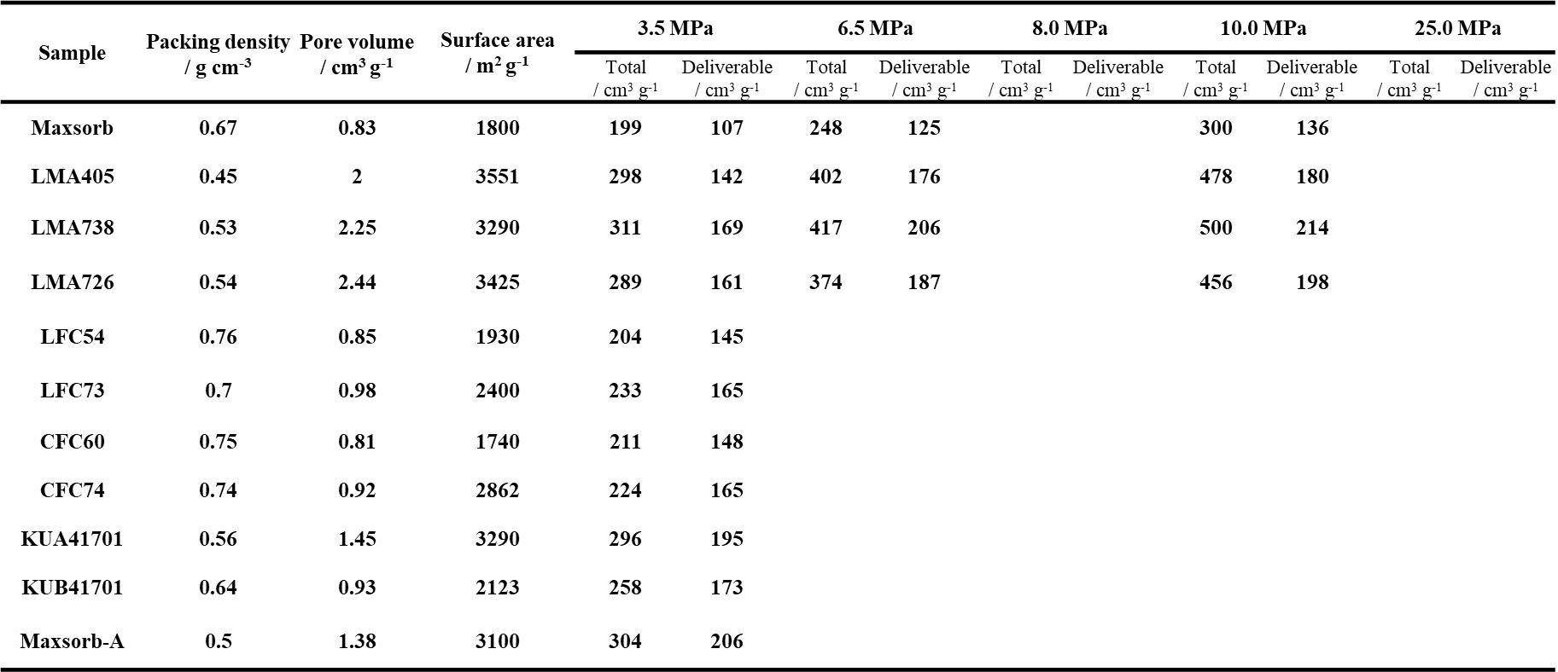

Supplementary Table 6. Apparent porosity parameters of entrance-wrapped carbons prepared at different CVD temperatures.
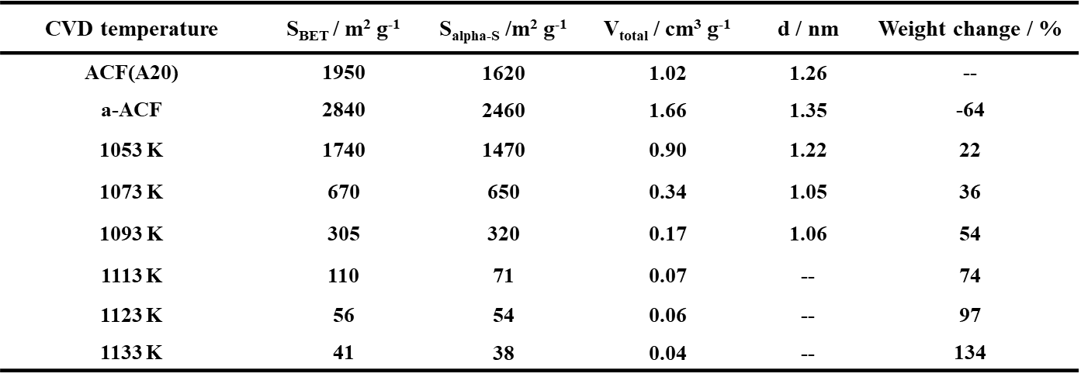

Supplementary Table 7. Apparent porosity parameters of entrance-wrapped carbon prepared at 1123 K reopened by air oxidation at different temperatures.
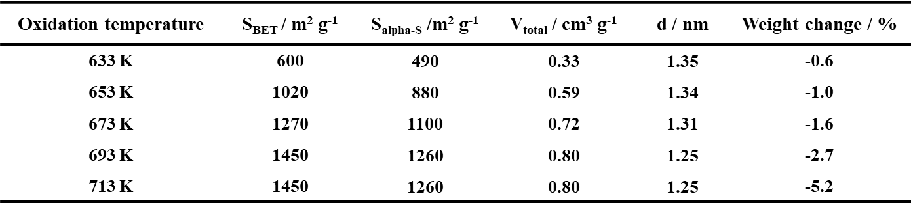

Supplementary Table 8. CVD temperatures required for grafting the entrance wrapping onto different carbon pores (under a two-hour reaction) and the weight increases of the carbon precursors after grafting the entrance wrapping.
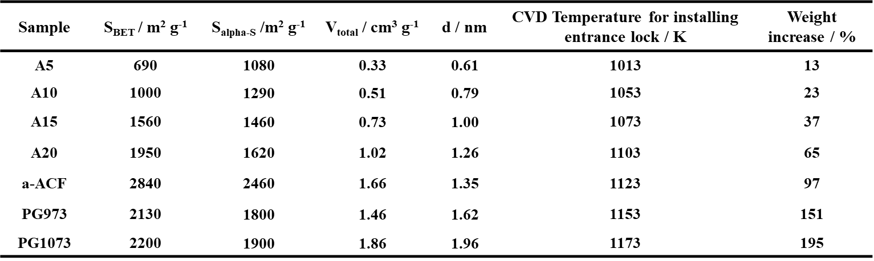

Supplementary Table 9. Structural parameters of pristine ACF, a-ACF and entrance-wrapped carbon prepared at CVD temperature of 1123 K.
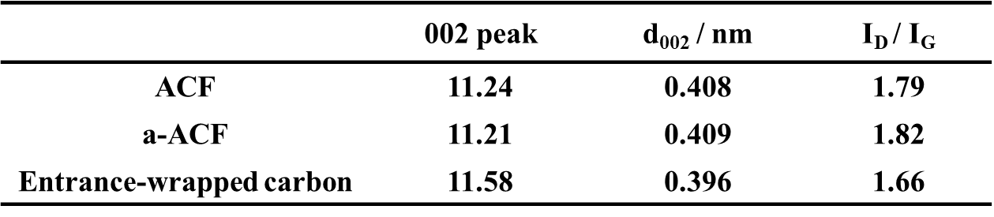

Supplementary References
1. Peng, Y. et al. Methane Storage in Metal–Organic Frameworks: Current Records, Surprise Findings, and Challenges. J. Am. Chem. Soc. 135, 11887–11894 (2013).
2. Chen, Z. et al. Balancing volumetric and gravimetric uptake in highly porous materials for clean energy. Science 368, 297–303 (2020).
3. Setoyama, Norihiko; Suzuki, Takaomi; Kaneko, K. Simulation Study on The Relationship Between A High Resolution α-Plot and The Pore Size. Carbon 36, 1459–1467 (1998).
4. Wang, S. et al. The subtracting pore effect method for an accurate and reliable surface area determination of porous carbons. Carbon 175, 77–86 (2021).
5. Neimark, A. V., Lin, Y., Ravikovitch, P. I. & Thommes, M. Quenched solid density functional theory and pore size analysis of micro-mesoporous carbons. Carbon 47, 1617-1628 (2009)
6. Moss, D. R. & Basic, M. Pressure Vessel Design Manual. (Elsevier, 2013).
7. Oilfield Casing data sheet. https://www.drillingformulas.com/oilfield-casing-data-sheet-free-download
8. Rama Cylinder. https://ramacylinders.in/service/on-board-cng
9. Sahuwala Cylinders. http://www.sahuwalacylinders.com/cngtanks.html
10. Kaneko, K., Shimizu, K. & Suzuki, T. Intrapore field‐dependent micropore filling of supercritical N 2 in slit‐shaped micropores. J. Chem. Phys. 97, 8705–8711 (1992).
11. Murata, K. et al. Pore structure of single-wall carbon nanohorn aggregates. Chem. Phys. Lett. 331, 14–20 (2000).
12. Friend, D. G., Ely, J. F. & Ingham, H. Tables for the Thermophysical Properties of Methane. (NIST Publications, 1989).
13. Gándara, F., Furukawa, H., Lee, S. & Yaghi, O. M. High methane storage capacity in aluminum metal-organic frameworks. J. Am. Chem. Soc. 136, 5271–5274 (2014).
14. He, Y., Zhou, W., Qian, G. & Chen, B. Methane storage in metal-organic frameworks. Chem. Soc. Rev. 43, 5657–5678 (2014).
15. Lozano-Castelló, D., Alcañiz-Monge, J., De La Casa-Lillo, M. A., Cazorla-Amorós, D. & Linares-Solano, A. Advances in the study of methane storage in porous carbonaceous materials. Fuel 81, 1777–1803 (2002).
16. Casco, M. E. et al. High-pressure methane storage in porous materials: Are carbon materials in the pole position? Chem. Mater. 27, 959–964 (2015).

