Supplement 2

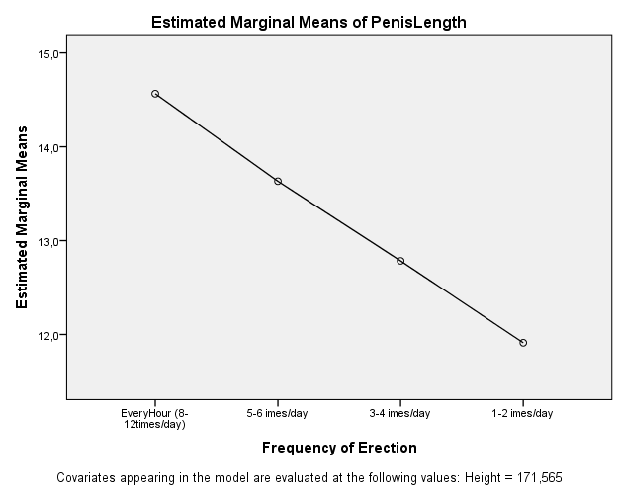

Figure 1a. Dependency of penis erect length from frequency of erection during their body growth (n=225).

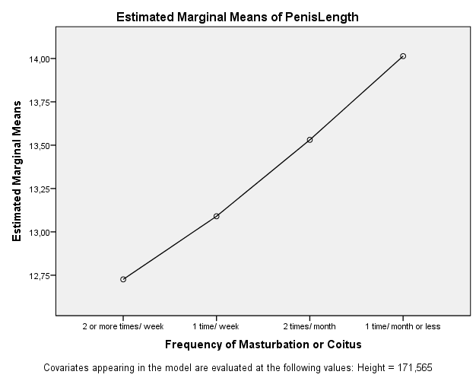
Figure 1b. Dependency of penis erect length from frequency of masturbation/ coitus (ended in ejaculation) during their body growth (n=225).

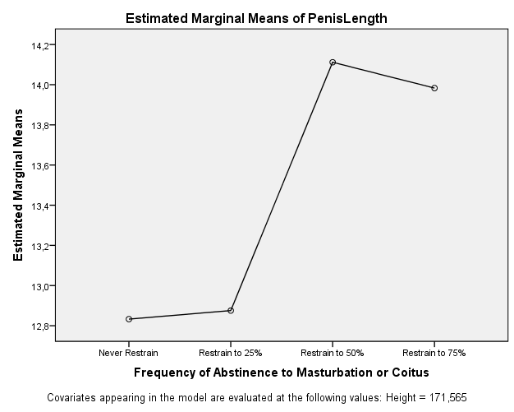

Figure 1c. Dependency of penis erect length from frequency of abstinence to masturbation/ coitus (ended in ejaculation) during body growth (n=225).

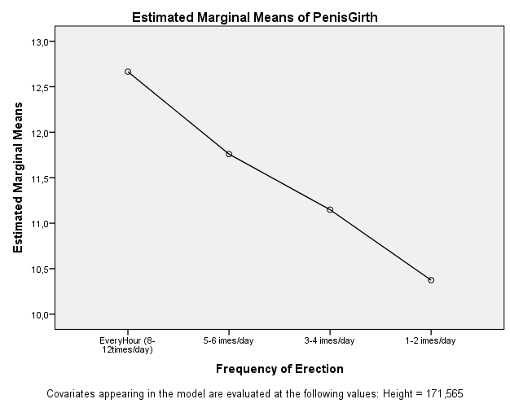

Figure 2a. Dependency of penis erect girth from frequency of erection during their body growth (n=225).

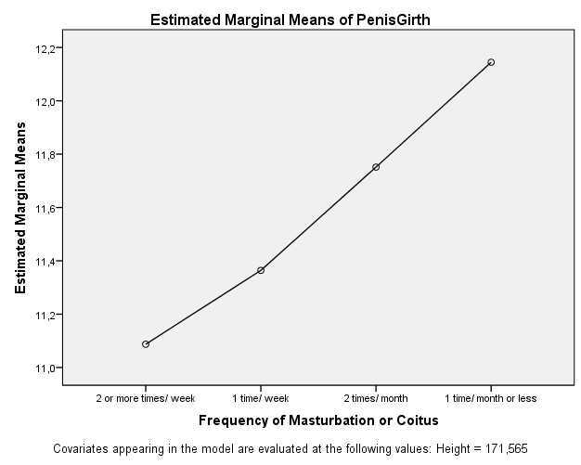
Figure 2b. Dependency of penis erect girth from frequency of masturbation/ coitus (ended in ejaculation) during their body growth (n=225).

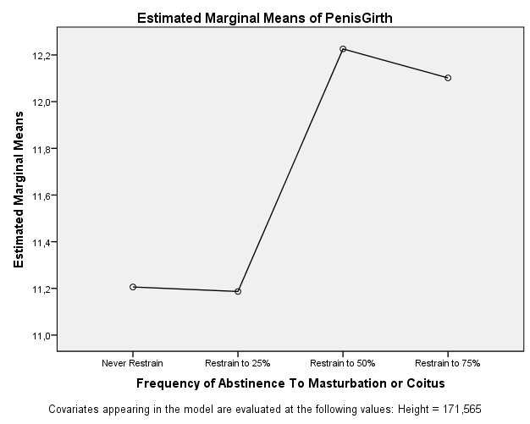
Figure 2c. Dependency of penis erect girth from frequency of abstinence to masturbation/ coitus (ended in ejaculation) during body growth (n=225).

