Effectiveness of local exercise therapy versus spinal manual therapy in patients with patellofemoral pain syndrome: medium term follow-up results of a randomized controlled trial
Aldo Scafoglieri^{1,2}, Jona Van den Broeck¹, Stijn Willems³, Rob Tamminga⁴, Henk van der Hoeven⁵, Yde Engelsma⁵, Stijn Haverkamp⁵

- Department of Physiotherapy, Human Physiology and Anatomy (KIMA), Experimental Anatomy Research Group, Vrije Universiteit Brussel, Laarbeeklaan 103, 1090 Brussel, Belgium
- SOMT University of Physiotherapy, Softwareweg 5, 3821 BN, Amersfoort, The Netherlands
- Department of Neuroscience, Vrije Universiteit Amsterdam, The Netherlands
- Fysioholland, Medicort, Rijksweg 69, 1411 GE, Naarden, The Netherlands
- Bergman Clinics BV, Rijksweg 69, 1411 GE, Naarden, The Netherlands

Corresponding author: Prof. dr. Aldo Scafoglieri, PT, MT, PhD, Department of
Physiotherapy, Human Physiology and Anatomy (KIMA), Experimental Anatomy Research Group, Vrije Universiteit Brussel, Laarbeeklaan 103, 1090 Brussel, Belgium, aldo.scafoglieri@vub.be, +3224774450

Appendix 1: Description of interventions

Technique 1: Oscillation Techniques and connective tissue massage
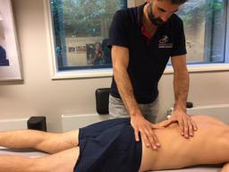
The oscillation techniques are performed with both hands / arms in the joint play of two vertebrae in the TLO region alternately in ventral, ipsi- and contralateral rotation. The patient is in prone position. The thumb and pink mouse are placed on the arc of the underlying vertebra of the level to be treated on the ipsilateral side. Before performing the following manipulation(s), a connective tissue massage is performed to relax the tissues around the T12-L3 region.

Technique 2 Traction-rotation manipulation of the Th12-L3 region
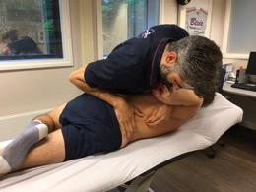
For the manipulation, the patient is in side position. Hip and knee of the lower leg are extended while the knee and hip in the upper leg are flexed in a 45 degrees angle. The spinal column is in ventral position with ipsilateral rotation. The hand of the underlying arm holds the wrist of the upper arm. The therapist is in front of the patient. The fixing hand / arm is placed under the patient's upper arm. The thumb is placed on the ipsilateral side against the spinous process of the upper vertebra of the level to be treated. The forearm rests against the ventral side of the patient's thorax. The wrist and middle fingers of the working hand / arm are placed on the contralateral side against the underlying vertebra's spinous process of the level to be treated. The forearm of the therapist rests against the dorsolateral side of the ilium. The fixing hand / arm maintains the position of the upper vertebra. The working hand / arm performs the traction / rotation manipulation. If no cavitation is observed, the manipulation is carried out in supine position (Appendix 1, technique 3)
Technique 3: Bilateral flexion gap manipulation of the Th12-L3 region
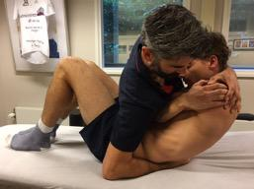
The patient is supine position with bent knees. Both arms are crossed over the chest and are they hold the outside of the other shoulder. With the contralateral arm, the therapist holds the patient underneath the neck and the patient is raised so far that the therapist can fixate the underlying vertebrae of the Th12-L3 region with the ipsilateral arm while keeping the chest pressured on the elbows of the patient. Subsequently, a trust is given from the upper body in dorsocranial direction to the upper vertebra to create a cavitation of the contralateral and ipsilateral side of the facet joints.
Technique 4: Manipulation of the SIJ
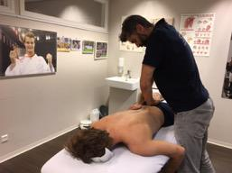
The patient is in prone position with the face to the side that is to be treated. The therapist is on the contralateral side with the homogeneous hand on the ilium and the heterogeneous hand on the contralateral and distal side of the sacrum. Through a body drop, the pulse is given in contranutation direction of the sacrum.

Technique 5: Extension manipulation of the hip joint
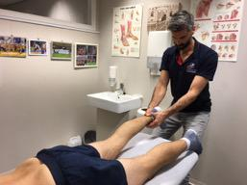
The patient is in prone position with the ankles over the treatment bench and with his head in a homonymous rotation. The therapist stands caudal from the patient with the fingers around the ankle. The hip is manipulated in the longitudinal direction of the leg.

Technique 6: Mobilization exercise for the Th12-L3 region
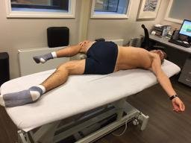
The patient is in supine position. The patient actively moves the left leg over the right leg so that the left shoulder rises. The head turns to the left side. The centre of rotation will thus be in the Th12-L3 region. This is also repeated for the other side. A total of 10 times is performed.

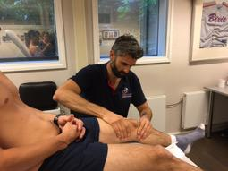
Technique 7: Mobilization of the patella
The patient is in supine position. The patella is mobilized in caudal and cranial direction at 0 degrees, 30 degrees and 60 degrees.

Appendix 2: Maximum voluntary isometric contraction test for the quadriceps muscle
After a 15-minute warming-up at an ergometer subjects were seated in the chair with the seat angle adjusted to give a maximum of 95° hip flexion. The position of the seat and other components of the dynamometer were standardized for each test. The trunk, lower back, and the leg were strapped to minimize compensation. The knee was resting in a 90 degrees angle. The lateral femoral condyle was used as a bony landmark for the axis of rotation. The subject is encouraged during the test (Callaghan et al. 2000). Each subject had a practice of 6 sub maximal repetitions at 90 degrees/second with the non-affected side followed by 1 min rest as part of the warm up prior to the test. After 3 maximal repetitions at 60 degrees/second for data collection the attachment of the dynamometer was changed to test the affected side.
Appendix 3: Description of the physiotherapy intervention
Exercise | Frequency
Knee extensions 90-45 degrees | 3x10
Leg press 45 degrees | 3x10
Squat 0-45 degrees | 3x10
Single leg calf raises | 3x10
Prone knee flexion with a resistance band | 3x10
Hip abduction - sideways | 3x10
Hip abductions with a restistance band - standing | 3x10
Hip external rotations with a resistance band - seated | 3x10

Appendix 4: Anatomical Map
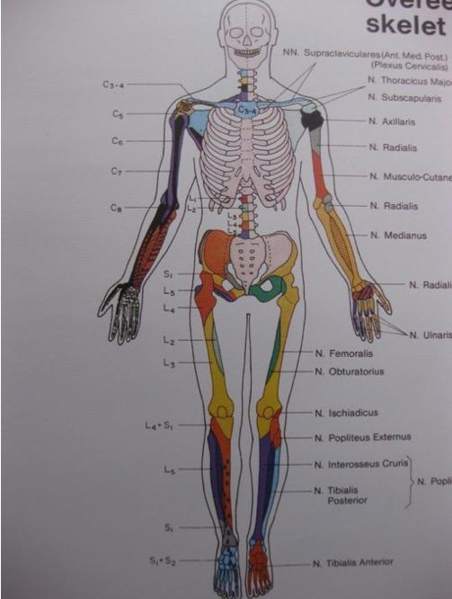
Appendix 5: Exercise journal
Week | Treatment received / exercise program at the clinic performed | Home exercises performed day 1 | Home exercises performed day 2
1
2
3
4
5
6

