SUPPORTING INFORMATION
Investigation of surface quality degradation of polyimide containing steroidal structure as a function of storage time using second-order nonlinear optical spectroscopy
Trinh Thi Nguyen,¹ Wentao Du,¹ Hien Thi Thu Khuat,¹ Goro Mizutani,^{1,*} Yoshitaka Murakami,² and Takashi Okada²
¹School of Materials Science, Japan Advanced Institute of Science and Technology, Ishikawa 923-1292, Japan.
²LCD Materials 2nd Laboratory, Display Materials Research Laboratories, JSR Corporation, Mie 510-8552, Japan.
* Corresponding author: mizutani@jaist.ac.jp

1. The amplitude ratios of the $r_{2}^{+}$ peak and the $r_{2}^{-}$ peak
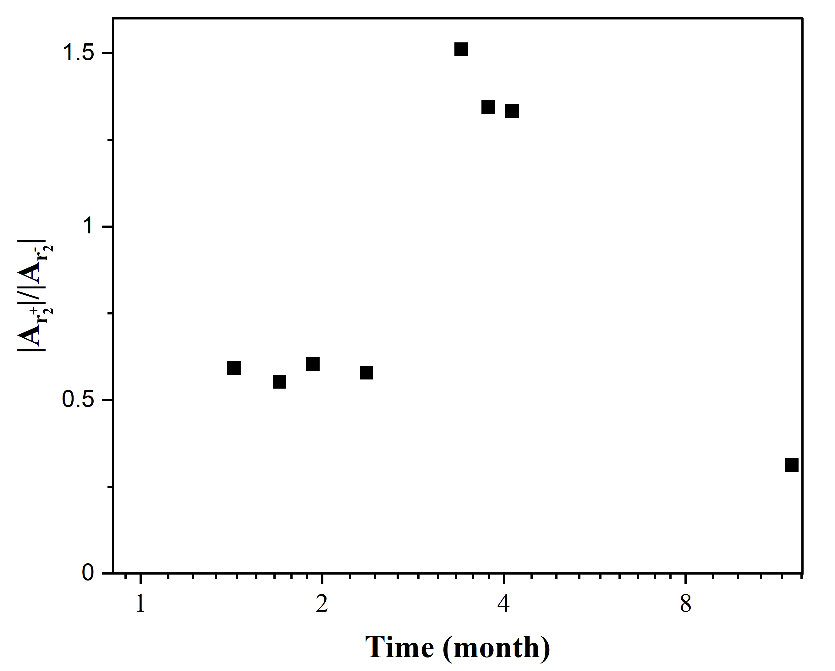
Figure S1. The amplitude ratios of the amplitude of the $r_{2}^{+}$ peak and the $r_{2}^{-}$ peak as a function of storage time.

Figure S1 shows the amplitude ratios of the $r_{2}^{+}$ peak (CH₃ symmetric stretching mode of the isopropyl group) and the $r_{2}^{-}$ peak (CH₃ anti-symmetric stretching mode of the isopropyl group) as a function of storage time. There is no significant variation between the amplitude ratios of the $r_{2}^{+}$ peak and the $r_{2}^{-}$ peak within 2.5 months storage time while those of the $r_{2}^{+}$ peak and the $r_{2}^{-}$ peak are obviously changed after longer storage time.
2. SFG spectra of unrubbed polyimide films
Figure S2. SFG spectra of unrubbed polyimide films for the PPP polarization combination as a function of storage time. The solid lines are the fitting curves obtained using Eq. (1) in the main text.
Figure S2 shows the SFG spectra of unrubbed polyimide films after different storage times. The spectral line shapes of the sample after 8 and 9 months storage times are quite different from that of the sample after 17 days storage time, especially in the 2830-2890 cm⁻¹ range. For example, one sees $r_{2}^{+}$peak at ∼2875 cm⁻¹ in the spectrum of the sample after 17 days storage time but does not see any at the same wavenumber after 8 and 9 months storage times. The results indicate that the degradation of surface quality occurs in the unrubbed polyimide film as well as in the rubbed polyimide film.
3. SFG spectra of a rubbed polyimide film kept in dry N₂ gas
We also collected the SFG response of a rubbed polyimide film (25x8 mm²) kept in a quartz cell filled with dry N₂ gas for comparison. The quartz cell is an infrared spectrophotometer cell with 45 mm height, 5 mm path length, 10 mm path width, and two polished windows (S10-IR-5, GL Sciences). The cap of this cell was sealed by ultraviolet curing resin. The rubbing direction is the direction from the cap to the bottom of the quartz cell. As shown in Fig.S3, the relative peak shapes and positions are not similar in the SFG spectra of the sample at 7 days and 10 months storage time. The results indicate that the polyimide surface in dry N₂ gas also might be modified after 10 months storage time.
Figure S3. SFG spectra of a rubbed polyimide film kept in dry N₂ gas for the PPP polarization combination measured at 7 days and 10 months storage time. The solid lines are the fitting curves obtained using Eq. (1) in the main text.

4. Indices of refraction of the fresh rubbed polyimide films and the one after 10 months storage time
Table S1 shows the refractive indices of the fresh rubbed polyimide film and the one at 10 months storage time (old sample), used to compare the Fresnel factors for the polyimide/air surface. These refractive indices were measured using spectroscopic ellipsometry.
Table S1. Refractive indices of the fresh rubbed PI-30 film and the one after 10 months storage time (the old sample).
Beam | Refractive index
Beam | Fresh sample | Old sample
IR (969 nm) | 1.5142 ± 0.0035 | 1.5155 ± 0.0100
Visible (532 nm) | 1.5259 ± 0.0040 | 1.5273 ± 0.0104
SFG (461 nm) | 1.5349 ± 0.0107 | - .0083

5. The fitting parameters used in the theoretical curves drawn in Figure 2 in the main text
Table S2. Fitting parameters of the SFG spectra of the rubbed polyimide films for the PPP polarization combination as a function of the storage time.
Parameter | 1m13d | 1m21d | 1m28d | 2m11d | 3m12d | 3m23d | 4m4d | 12m
$A_{NR}$(a. u.) | 2.207 | 2.308 | 2.011 | 2.145 | 2.553 | 3.055 | 2.294 | 2.58
$ϕ$ (rad) | -1.305 | -1.762 | -1.069 | -2.105 | -1.348 | -1.908 | -1.829 | -1.589
$A_{1}$ (a. u.) | 0.413 | 0.32 | 0.40 | 0.36 | 0.26 | 0.57 | 0.45 | 0.30
$A_{2}$ (a. u.) | 0.32 | 0.67 | 0.56 | 0.43 | 0.50 | 0.68 | 0.54 | 0.27
$A_{3}$ (a. u.) | 0.98 | 1.16 | 0.70 | 1.18 | 0.68 | 0.82 | 0.48 | 0.25
$A_{4}$ (a. u.) | 0.38 | 0.85 | 0.60 | 0.67 | 0.40 | 0.64 | 0.39 | 0.43
$A_{5}$ (a. u.) | 0.36 | 0.56 | 0.22 | 0.71 | 0.18 | 0.25 | 0.04 | 0.08
$A_{6}$ (a. u.) | 1.65 | 2.1 | 1.160 | 2.05 | 0.45 | 0.61 | 0.36 | 0.8
$A_{7}$ (a. u.) | -1.16 | -0.95 | -1.25 | -0.3 | -0.56 | -0.45 | -0.15 | -0.5
$Γ_{1}$ (cm⁻¹) | 5 | 4 | 7 | 6 | 4 | 6 | 5 | 4
$Γ_{2}$ (cm⁻¹) | 4 | 4 | 5 | 6 | 5 | 5 | 5 | 4
$Γ_{3}$ (cm⁻¹) | 5 | 6 | 6 | 6 | 5 | 5 | 6 | 4
$Γ_{4}$ (cm⁻¹) | 6 | 10 | 7 | 6 | 6 | 6 | 6 | 6
$Γ_{5}$ (cm⁻¹) | 5 | 5 | 5 | 5 | 4 | 5 | 3 | 4
$Γ_{6}$ (cm⁻¹) | 5 | 6 | 6 | 7 | 5 | 5 | 5 | 5
$Γ_{7}$ (cm⁻¹) | 6 | 6 | 6 | 6 | 6 | 10 | 4 | 6
$ω_{1}$ (cm⁻¹) | 2846 | 2842 | 2841 | 2842 | 2839 | 2854 | 2846 | 2840
$ω_{2}$ (cm⁻¹) | 2861 | 2855 | 2858 | 2860 | 2850 | 2864 | 2859 | 2855
$ω_{3}$ (cm⁻¹) | 2875 | 2876 | 2873 | 2876 | 2865 | 2876 | 2872 | 2867
$ω_{4}$ (cm⁻¹) | 2903 | 2904 | 2899 | 2903 | 2901 | 2906 | 2906 | 2891
$ω_{5}$ (cm⁻¹) | 2937 | 2936 | 2937 | 2937 | 2930 | 2931 | 2939 | 2937
$ω_{6}$ (cm⁻¹) | 2964 | 2964 | 2962 | 2966 | 2961 | 2960 | 2961 | 2960
$ω_{7}$ (cm⁻¹) | 2977 | 2976 | 2975 | 2979 | 2974 | 2978 | 2975 | 2965

