Supplementary Information for
Generating Direct Current Electricity from Dripping or Flowing Ionic Water
Haoze Kuang^{1,2}, Shuyi Huang³, Kaihang Zhang^{1,2}, Xinyu Cai^{1,2}, Haobin Wang^{1,2}, Chi Zhang^{1,2}, Jinkai Chen⁴, Yubo Li^{1,2*}, Xiaozhi Wang^{1,2*}, Jin Hao^{1,2}, Shurong Dong^{1,2}, Zongying Yang^{1,2}, Tawfique Hasan^{5*}, Zhonglin Wang^{6*} and Jikui Luo^{1,2*}
¹ College of Information Science & Electronic Engineering, Zhejiang University, Hangzhou 310027, China
² International Joint Innovation Center, Zhejiang University, Haining 314400, China.
³ Shanghai Precision Metrology & Test Research Institute, Shanghai 201109, China.
⁴ College of Electronics & Information, Hangzhou Dianzi University, Hangzhou, 310018, China.
⁵ Cambridge Graphene Centre, University of Cambridge, Cambridge, CB3 0FA, UK.
⁶ Beijing Institute of Nanoenergy and Nanosystems, Chinese Academy of Sciences, Beijing 100083, China

Fig. S1. Characterization of ferroelectric properties of the PZT film. (a) The ferroelectric hysteresis loop (P-E loop) and (b) I-V loop of a 500 nm PZT film on Silicon substrate. (c) The ferroelectric hysteresis loop (P-E loop) and (d) I-V loop of a 1 μm PZT film on Silicon substrate. The remnant polarization of the PZT film reaches ~ 50 μC cm⁻² (500 mC cm⁻²).

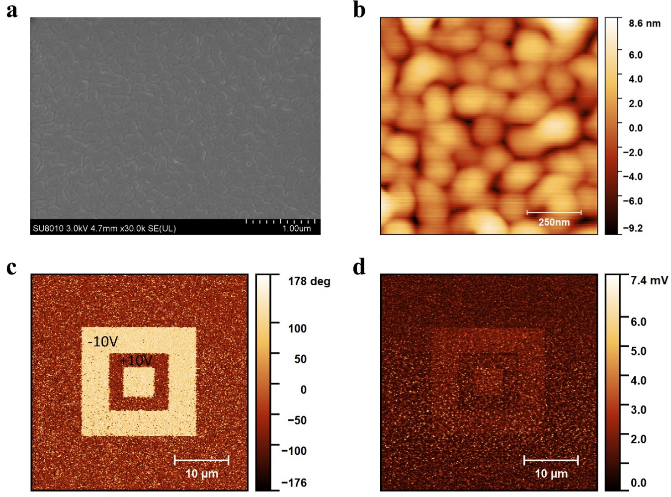
Fig. S2. Characterization of surface properties of the PZT film. (a) The SEM image and (b) AFM image of the PZT surface. (c) The phase image and (d) corresponding amplitude image of the PFM test. The light-colored area in (c) is polarized using a probe with a -10 V bias before testing, while the dark area is polarized using a probe with a +10 V bias.

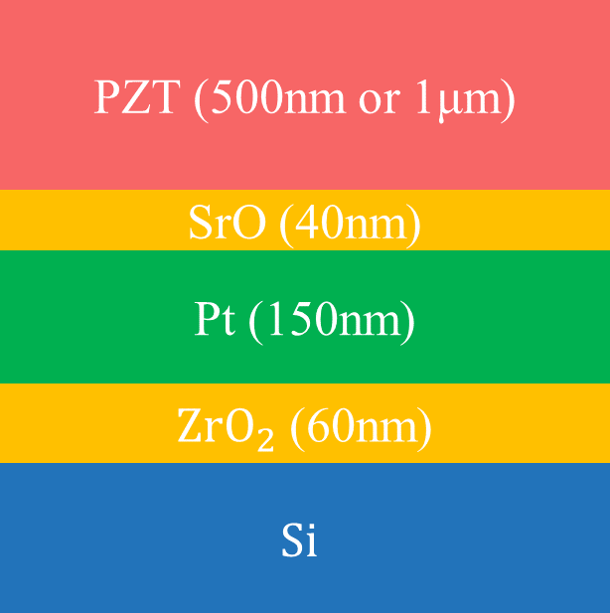
Fig. S3. The structure of the PZT film. The PZT film is grown by physical vapour deposition (PVD) with a polycrystalline structure and ~250 nm mean grain size.

Fig. S4. Contact angle test. The surface of the PZT films is treated with heptadecafluoro-1,1,2,2-tetrahydrodecyltrichlorosilane to obtain a hydrophobic surface to ensure easy movement of the droplets. Comparison of contact angles between the PZT surfaces (a) before and (b) after the hydrophobic treatment. The contact angle of the (c) PTFE film used in the control sample is 100.3°. Compared with the untreated PZT surface (a, 85.2°), the water contact angle of the PZT surface after hydrophobic treatment (b) is 125.4°, an increment of 40.2°. The increased hydrophobicity of the PZT surface allows the droplets to remain within confined areas and slide on the surface. This ensures the stability of the FEG output. It is noted that the hydrophobic surface treatment is not necessary for the flow-based FEG.

Fig. S5. Charging performance of the FEG with droplets. (a) Experimental setup for testing FEG with droplets. (b) Capacitors can be readily charged without any external rectifier circuit with a 2 Hz dripping frequency, a 12 cm falling height, a 55 μL droplet volume, a 0.1 M NaCl concentration, and a 60° inclination. In particular, a capacitor of 10 μF can be charged to ~ 3.2 V by 65 droplets.

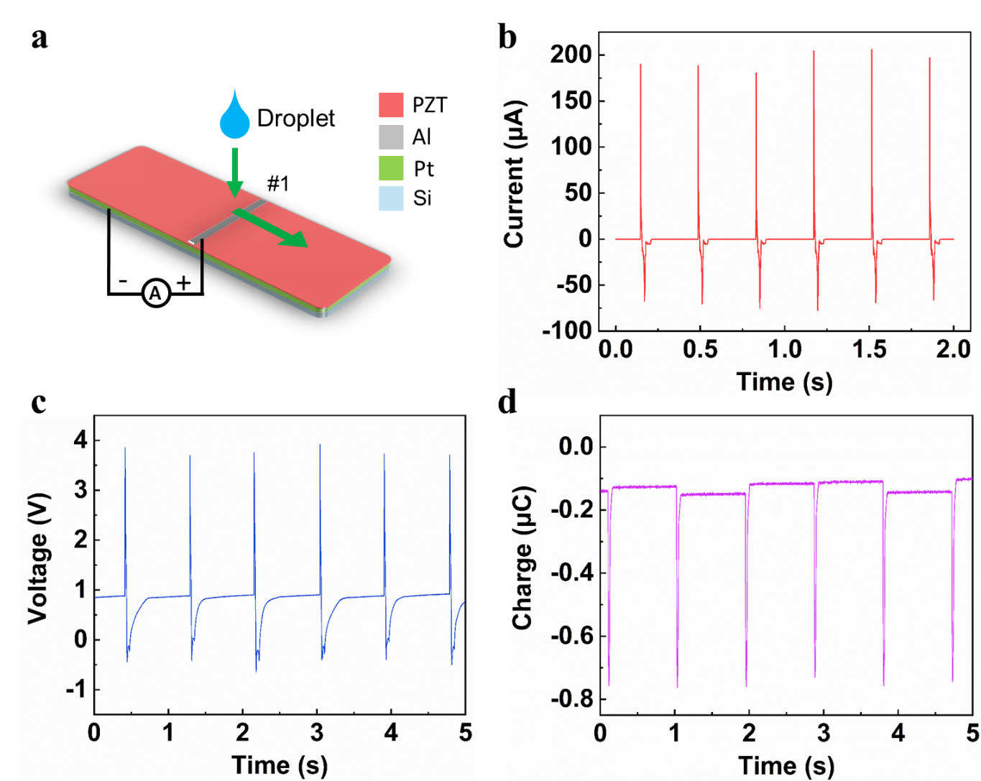
Fig. S6. Characterization of the control device without Electrode #2. (a) Schematic diagram of the control device without Electrode #2. (b) The short circuit current, (c) open-circuit output voltage, and (d) transferred charge of the control FEG.
Fig. S7. The FEG output voltage offset test. (a) Schematic of the bias test. (b) The result of the remnant bias test U_{offset} of between Electrode #1 and Electrode #2 after several impinges of droplets. Step 1 means the positive probe of Keithley 6514 is connected to Electrode #2, while the negative probe is connected to Electrode #1. Step 2 means the probes of Keithley 6514 are reverse-connected. The U_{offset} is about 0.7~1.7 V, depending on test conditions. (c) The open-circuit voltage of the FEG at the first several impinges.

Fig. S8. Relationship between the transferred charge and ion concentration of the solutions. The transferred charge per one cycle and the proportion of charge in Peak III to the total as a function of the NaCl concentration of droplets (0 ~ 1 M), d = 1 cm. The maximum charge density is ~ 2.53 μC cm⁻² for a droplet area of 1.2 cm². The proportion of the transferred charge in Peak III to the total charge increases from 0 % to 77.8 %. This reveals that at high concentrations, the device's output is dominated by ion movement, presenting a unique and particularly beneficial characteristic that no other DEGs possess.

Fig. S9. The effects of test conditions on current output. The peak short-circuit current and the net transferred charge of the FEG as a function of (a) droplet falling height, (b) droplet volume, and (c) the width of Electrode #1.

Fig. S10. The effect of PZT film thickness on transferred charge and output voltage. The net transferred charge and the open-circuit voltage of the FEG with the thickness of PZT film as a variable.

Fig. S11. The effect of different ionic solutions on output current. (a) The short circuit current and transferred charges of the FEG using droplets with different water solutions: DI water, tap water and NaCl solution. The short circuit current of the FEG with (b) 0.1 M LiCl droplets and (c) 0.1 M Na₂SO₄ droplets. The FEG impinged with other kinds of solution droplets exhibits similar DC output characteristics as by the NaCl solution.

Fig. S12. Voltage output vs. dripping or flow of a solution. The open-circuit voltage of the FEG, as the droplet frequency increases the dripping gradually become a solution flow (1 M NaCl). The periodic voltage waveform becomes a constant with a value of 0.94 V.

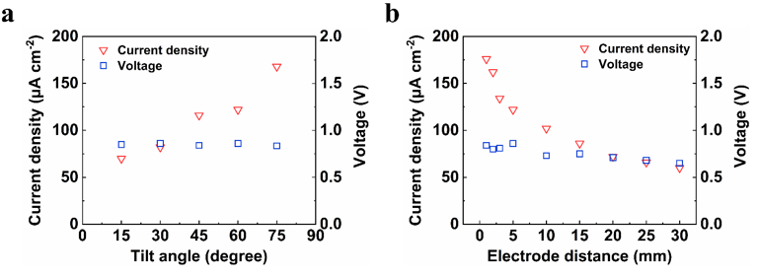
Fig. S13. The effects of test conditions on outputs of the FEG with solution flow. The short-circuit current and open-circuit voltage of the FEG affected by (a) the tilt angle of the FEG and (b) the electrode distance between Electrode #1 and #2, with a 1 M NaCl solution flow at a 1.96 mL/s flow rate.

Fig. S14. The durability test of the FEG with 1 M NaCl solution flow. The output current of FEG with (a) multiple droplets and (b) continuous flow measured intermittently for 120 days. The test conditions: For droplets, 55 μL droplet volume, 12 cm falling height, 1M NaCl concentration, and 60° inclination; For continuous flow, a 1.96 mL/s flow rate, 60° inclination, and 1M NaCl concentration.

Fig. S15. The effect of the width of flow on the FEG. (a) The photograph of the fabricated FEG with a tube above the device. (b) The short-circuit current of the device with 1M NaCl solution flow for 1 hour. (c) The open-circuit voltage of the FEG with different width of flows. The value of the output voltage remains constant when the flow width changes.

Fig. S16. Outputs of the two FEGs in parallel connection. (a) The circuit and (b) schematic of the fabricated device with two sub FEGs connected in parallel. (c) The total current output is the add-up current of the sub FEGs; (d) while the output voltage of the FEG is determined by the sub-unit with a lower output voltage.

Fig. S17. Application of the multiple FEGs in series with solution flow. (a) The photograph of three FEGs in series connection to increase output voltage of the device. (b) 3 commercial LEDs in parallel are powered continuously by the three sub-unit FEG in series connection. (c) Charging performance of the multiple FEGs in series for different capacitors with a 1 M NaCl solution flow.

Fig. S18. Output of the PTFE-FEG with ionic solution flow. (a) The short-circuit current and (b) open-circuit voltage of the PTFE-FEG with 1M NaCl solution flow.

Video S1. The Movement of droplets on FEG.

Video S2. 32 commercial LEDs connected in parallel are light up directly by the FEG with a NaCl solution droplet.

Video S3. 3 commercial LEDs connected in parallel are light up directly and continuously by the FEG with a NaCl solution stream.
Supplementary Discussion 1 | Discussion and calculation of the working mechanism of the FEG with droplets
A four-step process can explain the working mechanism of the FEG with falling droplets; see schematic in Fig. 2a, the equivalent circuit in Fig. 2b and short circuit current in Fig. 2c for d = 3 cm. We denote R_{I1} and R_{I2} as the charge injection resistances at the droplet/Electrode #1 and droplet/Electrode #2 interface, respectively. R_{d1} and R_{d2} are the equivalent resistances inside the droplet. We also define C₁ as the capacitor formed by Electrode #1, PZT film and Pt bottom layer; C₂ as the capacitor formed by the droplet, PZT and Pt bottom layer; C₃ as the capacitor formed at the droplet/PZT interface (electric double layer (EDL) capacitor), respectively. The expressions for these capacitors are:
$C_{1}=\frac{ε_{pzt}}{d_{pzt}}S_{e}$ (1)
$C_{2}\left(t\right)=S_{d}(t){(\frac{d_{pzt}}{ε_{pzt}}+\frac{d_{h}}{ε_{h}})}^{-1}$ (2)
$C_{3}\left(t\right)=\frac{ε_{d}}{d_{EDL}}S_{d}(t)$ (3)
where d_{pzt} and d_{h} are the thickness of the PZT film and the hydrophobic layer, respectively; d_{EDL} is the thickness of the EDLs in the droplet interfaces; ε_{pzt}, ε_{h} and ε_{d} are the dielectric constants of the PZT, the hydrophobic layer and the droplet respectively; S_{e} and S_{d} are the areas of the PZT covered by Electrode #1 and the droplet, respectively. Due to the remnant polarization of PZT, the Pt bottom layer (represented as node n2) has a potential difference, U_{p1}, in series with C₁. Likewise, there is also a potential difference U_{p2}, in series with C₂.
$U_{p2}=\frac{Q}{C}=\frac{σ_{pzt}d_{pzt}S_{d}(t)}{ε_{pzt}S_{d}(t)}=\frac{σ_{pzt}d_{pzt}}{ε_{pzt}}=\frac{σ_{pzt}d_{pzt}S_{e}(t)}{ε_{pzt}S_{e}(t)}= U_{p1}$ (4)
After polarization, the PZT film has a high density of fixed surface charges, σ_{PZT}, providing an electrostatic field to redistribute ions and hydrated charges¹. Once the ionic droplet comes in contact with the PZT surface, the negative charges at the surface attract the positive ions and charges (e.g. Na⁺ and H₃O⁺) to form an EDL^{2,3}, C₃. Before the droplet touches Electrode #1, the switch SW1 (in Fig. 2b) is open, keeping the circuit in open state (Step I).
Next, when Electrode #1 is contacted and subsequently covered by the spreading droplet, SW1 is turned on, closing the circuit (Step II). Since the thickness of PZT (1 μm) is much larger than that of the EDL (several nanometers) formed at the droplet/PZT interface, and the area of PZT covered by Electrode #1 is an order of magnitude smaller than the maximum spread area of the droplet, the capacitors satisfy the following relationship:
$C_{1}<C_{2}≪C_{3}$. (5)
The open-circuit output voltage U_{o} of the FEG can be approximated as:
$U_{o}= U_{n2}-U_{n1}=U_{p1}+U_{C1}$ (6)
where U_{n1} and U_{n2} represent the electrical potentials at nodes n1 and n2, respectively. U_{C1} represents the voltage across C₁. Initially, U_{o} = 0 since the electrodes (Electrode #1 and Pt bottom layer) have electrostatically attracted charges from the environment to neutralize U_{p1}, i.e., U_{c1} = - U_{p1}.
Once SW1 is turned on, U_{p2} starts to charge C₁ to C₃. We can infer from Equation (5) that the voltage drop is mainly distributed at C₁. And at this time, U_{o} can be approximately calculated as:
$U_{o}=U_{p1}+U_{C1}=U_{p2}-U_{C2}-U_{C3}≅U_{p2}-U_{C2}=U_{p2}\frac{C_{2}}{C_{1}+C_{2}}=\frac{σ_{pzt}d_{pzt}C_{2}}{ε_{pzt}(C_{1}+C_{2})}$ (7)
${\frac{{C_{1}C}_{2}}{C_{1}+C_{2}}U}_{p2}=Q=C_{2}U_{C2}$ (8)
Given σ_{pzt} =50 μC cm⁻², d_{pzt} =1 μm, ε_{pzt} =500ε_{o}, S_{e} =0.12 cm² and the maximum S_{d} = 1.2 cm², we find the maximum U_{o}≈113 V. This value is much larger than the measured maximum value of U_{o} (~ 5.9 V). This is because, after poling, the surface of PZT attracts a large number of charged particles from the environment, which neutralizes most of the polarized surface charges, leaving only a small portion of the fixed charges on the PZT surface that can be utilized. If the measured maximum transferred charge density of 25.3 mC m⁻² is used as the effective charge density of the PZT to replace σ_{pzt} in Equation (7), we calculate U_{o}≈5.7 V. This is in excellent agreement with the experimentally obtained ~5.9 V. This highlights the accuracy of our proposed model. Although the effective charge density is a fraction of the remnant charge density, it is much larger than 1.8 mC m⁻² in previously reported DEG obtained via charge injection⁴, and ~25 times larger than those highest charge densities reported for solid-solid TENGs ⁵. We suggest that the performance of our FEGs could be further enhanced if the neutralizing of surface charges can be minimized. When the short-circuit current is measured from nodes n1 and n2, C₁ and U_{p1} are shorted. Once SW1 turns on, U_{p2} starts to charge the capacitors (C₂ and C₃), and a forward current moves from n1 to n2. This corresponds to Peak I (Fig. 2c). With the spreading of the droplet, the areas of EDL (S_{d1}) increase rapidly, and the capacitance (C₂ to C₃) increases. The capacitors (C₂ to C₃) keep charging through the external circuit, driving more negative ions and electrons, such as Cl⁻ and OH⁻, towards Electrode #1⁶.
After the droplet spreads and reaches its maximum value (Step II), it tends to shrink (Step III). During the rapid (~10 ms) shrinking process, the capacitances of C₂ and C₃ suddenly decrease; see Equation (2, 3). The voltage across the capacitors (C₂ and C₃) rises dramatically (U = Q/C), which results in a valley in U₀, according to Equation (7). As for the current, due to the discharge of C₂ and C₃, there will be a negative value in the output current (Peak II).
Next, if the distance d between Electrode #1 and #2 is small, the droplet will contact Electrode #2 before detaching Electrode #1 (Step IV). When the droplet contacts Electrode #2, the switch SW2 turns on. Due to the downward ionic flow inside the droplet, positive charges near the droplet/PZT interface are carried to Electrode #2. The neutrality of the droplet part on Electrode #2 is broken as there is no fixed negative charge of PZT, electrons from Electrode #2 are injected into the droplet to neutralize the droplet, forming another positive value in the output current (Peak III). From the circuit point of view, it is a closed circuit with electron flow via droplet, Electrode #1, bottom Pt layer and Electrode #2. And the current caused by the ionic flow can be expressed as an equivalent current source, If. As electron transportation is much faster than ionic flow, the value of If is largely determined by the ionic flow rate, and affected by the electron injection efficiency and solution resistance.
As d further decreases, the droplet contacts Electrode #2 before it shrinks. Hence, there is no capacitance (C₂ and C₃) decrease associated with negative Peak II and Peak III moves close to Peak I (Fig. 3a) to overlap it. As for the open circuit output voltage, since there exists a net transferred charge in one cycle from n1 to n2, at the end of the cycle, U_{c1} > -U_{p1} and there will be a voltage offset, U_{offset} is the open circuit voltage and is positive (U_{o} = U_{p1} + U_{c1} = U_{offset} > 0). Typically, U_{offset} is stabilized after a few droplets (see supplementary Fig. S7). Finally, when the droplet detaches from Electrode #1, SW1 turns off, and the output stops.

Supplementary Discussion 2 | Calculation of the energy conversion efficiency of the FEG with droplets
The conversion efficiency of one single impinging droplet, $η,$ can be calculated as follows:
$η=\frac{E_{out}}{E_{grav}}=\frac{\int{I^{2}R_{L}}}{mgh}$ (9)
For a typical 55 μL droplet (with 0.1 M NaCl), the mass m is ~55 mg. Therefore, the kinetic energy of the droplet falling from a height of 12 cm is ~64.7 μJ. For the FEG working with the optimal load of R_{L} = 20 kΩ (Fig. 3f), the generated electrical energy can be calculated to be 1.18 μJ by integrating the square of the current waveform. This corresponds to an energy conversion efficiency $η$ of ~1.82%, which is less than that of the reported DEGs^{4,7}. In practice, by increasing the thickness or reducing dielectric constant of the PZT film, the output voltage of the FEG can be further improved, thus further improving the energy conversion efficiency.

Supplementary Discussion 3| Expression for C_{h}
In Fig. 4c, C_{h} represents the hybrid capacitor at the solution/PZT interface and mainly consists of C₂ and C₃. the C_{h} represents the hybrid capacitor at the solution/PZT interface and mainly consists of C₂ and C₃ as follows:
$C_{h}\left(t\right)=S_{d}(t){(\frac{d_{pzt}}{ε_{pzt}}+\frac{d_{h}}{ε_{h}}+\frac{d_{EDL}}{ε_{d}})}^{-1}$ (10)
U_{p} is the internal potential difference of the PZT film, U_{p} = U_{p1} = U_{p2} as discussed in Supplementary Discussion 1.

Supplementary Discussion 4| Calculation for the output current and flow velocity at the solution/PZT interface
The output current for the solution flow can be approximated as:
$I_{f}=\frac{Q}{t}=\frac{1}{{rR}_{f}}σ_{pzt}WV$ (11)
where r is a constant, which is related to the type of the solution and ionic concentration, and rR_{f} is a dimensionless quantity; W and V represent the width of the solution flow and the flow velocity, respectively. For example, for a 1 M NaCl solution flow, since the effect of ion concentration on the device output is saturated at this concentration (Fig. 3d), the value of σ_{pzt}/rR_{f} can be roughly replaced by the value of measured effective charge density (2.53 μC cm⁻²). From the equation, we note that the output current could be increased proportionally by increasing the width of the continuous flow on the device.
Fig. S19. Schematic of the solution flow. h represents the thickness of the flow, and W represents the width of the solution flow.

The average of the velocity, V, of the flow at the solution/PZT interface can be roughly expressed as:
$V=\frac{V_{f}}{wh}$ (12)
Where V_{f} is the flow rate.
Given that V_{f} is 1.96 mL s⁻¹, h is 0.9 mm and W is 4 mm, V can be calculated as ~ 0.54 m s⁻¹.

Supplementary Discussion 5 | Calculation of energy harvesting from current
Assume FEG devices have a width of 1 m, and they are fabricated on a substrate in series connection. Consider the subunit FEG devices with the following dimensions: 1 mm for Electrode #1, separation distance of 10 mm between Electrode #1 and Electrode #2, and Electrode #2 has a length of 16 mm. Thus, each subunit has a total length of about 30 mm. With some spacer between the subunits, then 30 subunits could be arranged in series. Based on the result of Fig. 4g obtained and the conditions used, then the maximum current could be 68.5 mA (685 μA cm⁻¹ * 100 cm) and the output voltage reaches 24 V (0.8V * 30 units). The maximum possible power, without considering the optimal load condition, is P= IV=68.5 mA * 24V = 1.6 W.
Since the FEG devices are thin, if multiple FEG devices can be stacked on each other, then the power output could be proportionally increased. The potential for energy harvesting efficiency is quite high. With the further understanding of the FEG device and development of the technology, the device structures could be further optimized with higher output, we expect that the FEG’s efficiency for energy harvesting could be largely improved. Thus, it has great application prospects.

Supplementary References
1. Wang, Y. et al. Facile strategy to generate charged droplets with desired polarities. ACS Omega 5, 26908–26913 (2020).
2. Huang, Y., Cheng, H. & Qu, L. Emerging Materials for Water-Enabled Electricity Generation. ACS Mater. Lett. 3, 193–209 (2021).
3. Loh, Z. H. et al. Observation of the fastest chemical processes in the radiolysis of water. Science (80-. ). 367, 179–182 (2020).
4. Wu, H. et al. Charge Trapping-Based Electricity Generator (CTEG): An Ultrarobust and High Efficiency Nanogenerator for Energy Harvesting from Water Droplets. Adv. Mater. 32, (2020).
5. Xu, L., Bu, T. Z., Yang, X. D., Zhang, C. & Wang, Z. L. Ultrahigh charge density realized by charge pumping at ambient conditions for triboelectric nanogenerators. Nano Energy 49, 625–633 (2018).
6. Wu, H., Mendel, N., Van Den Ende, D., Zhou, G. & Mugele, F. Energy Harvesting from Drops Impacting onto Charged Surfaces. Phys. Rev. Lett. 125, 78301 (2020).
7. Xu, W. et al. A droplet-based electricity generator with high instantaneous power density. Nature 578, 392–396 (2020).

