Preoperative detection of the TERT promoter mutations in papillary thyroid carcinomas

Tomoe Nakao,^{1,2} *Michiko Matsuse,² Vladimir Saenko,³ Tatiana Rogounovitch,³
Aya Tanaka,⁴ Keiji Suzuki,² Miyoko Higuchi,⁵ Hisanori Sasai,⁶ Tutomu Sano,⁶ Mitsuyoshi Hirokawa,⁷ Akira Miyauchi,⁸ Atsushi Kawakami,² and Norisato Mitsutake¹

Supplementary file 1

Determination of the cutoff limits for detection of the TERT promoter mutation by ddPCR

1. Minimum TERTmut% significantly exceeding the false-positive background
The ddPCR technique used to detect the TERT promoter (TERT-p) mutation displays false-positive droplet calls in a DNA copy-dependent manner. We used the Kruskal-Wallis test with the Dunnet posttest to determine the minimum TERTmut% which ensures statistically significant difference from the background value (corresponding to 0% mutant allele) at a given total DNA copy number in a reaction (see Supplementary Figure 2). These results are summarized in Supplementary file 1 Table 1.

Supplementary file 1 Table 1. Minimum TERTmut% in a ddPCR reaction resulting in the statistically significant difference from the background at a given total DNA copy number.
Expected (nominal) total DNA copies | Observed total DNA copies (average)ª | Expected (nominal) minimum TERTmut%^{b} | Observed TERTmut% (average)
250 | 241 | 1.0 | 1.49
500 | 509 | 1.0 | 1.41
1000 | 832 | 1.0 | 1.40
3000 | 3045 | 0.5 | 0.66
6000 | 6223 | 0.5 | 0.62
12000 | 13305 | 0.5 | 0.62
ª rounded to the nearest greater integer
^{b} expected (nominal) minimum TERTmut% resulting in the statistically significant difference from the background
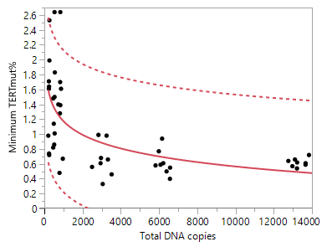
The distribution of the minimum TERTmut% values significantly exceeding those in the background by the total number of DNA copies in a ddPCR reaction is shown in Supplementary file 1 Figure 1.

Supplementary file 1 Figure 1. Minimum TERTmut% values statistically significantly exceeding those from the false-positive background in relation to the total number of DNA copies in a ddPCR reaction. Solid line represents logarithmic fit of data points, dotted lines indicate the 95% prediction interval for an individual minimum TERTmut% value.
Data points were fitted using a logarithmic function in JMP 15 Pro software:

$Minimum TERTmut\%=a-b ln\left(Total DNA copies\right)$,

where $Total DNA copies=TERTmut copies +TERTwt copies$,

and the 95% prediction interval for an individual value was calculated and saved as a formula. The formula for the upper prediction interval limit was as follows (as appears in JMP Formula Window):

PI Upper( "Add",
"Expression",
Formula(
3.00064490487188 + -0.264372243557457 * Log( :Total DNA copies )
+2.01289559891943 * Sqrt(
Vec Quadratic(
[0.595175750917144 -0.0771243978949013, -0.0771243978949013
0.0103564921700791],
[1] || Log( :Total DNA copies )
) * 0.218757569569557 + 0.218757569569557
)
)
); [1]

Thus, formula [1] determines the cutoff of the minimum TERTmut% in a ddPCR reaction required to obtain the TERTmut% value statistically significantly exceeding that from the false positive background at a given number of total DNA copies. The formula was used to calculate the TERTmut% cutoff over the range of total DNA copies in JMP 15 Pro software as presented in Figure 2 of the main manuscript and in Supplementary file 1 Figure 3.
Any data point above the cutoff is interpreted as positive for the TERT-p mutation.

2. Definition of the limits of inadequate samples
Since the purpose of our study was to evaluate the performance of ddPCR in detecting the TERT-p mutation in FNA samples, one should bear in mind that some FNA specimens may contain insufficient number of the material sampled from a thyroid nodule, which may result in a “nondiagnostic/unsatisfactory” cytopathology. Applicably to the ddPCR, insufficient material may result in the absence (or in too few) of wild-type TERT-p calls, which in the absence of the TERT-p mutant calls do not allow to define the sample as wild-type.
This subsection describes our calculations of the minimum number of the TERT-p wild-type calls (n_{neg}), and corresponding TERTmut% and total DNA copy number values that define the nondiagnostic limit.

2.1. Recall that the percentage of TERTmut copies (TERTmut%) is defined as follows:

$TERTmut\% =\frac{TERTmut copies}{TERTmut copies+ TERTwt copies }100\%$ [2]

2.2. Relationship between the TERT-p wild-type or mutant copy number with the number of corresponding calls
The number of the TERT-p DNA copies in a ddPCR reaction, either mutant or wild-type, is automatically calculated by QuantaSoft software based on the number of positive ($n_{pos}$) or negative ($n_{neg}$) calls, respectively, accounting for the number of valid (accepted) droplets; all these data are included in the ddPCR run report. We used linear regression forced through the origin to approximate TERTmut or TERTwt copies by the number of positive or negative calls, respectively, i.e.:
TERTmut copies $=b_{mut}n_{pos}$ , and
TERTwt copies $=b_{wt}n_{neg}$.
The results of these calculations are presented in Supplementary file 1 Figure 2.
A B
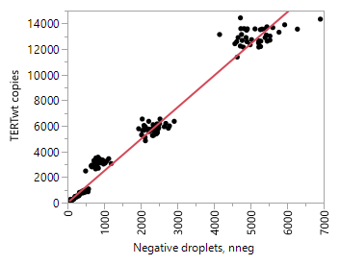
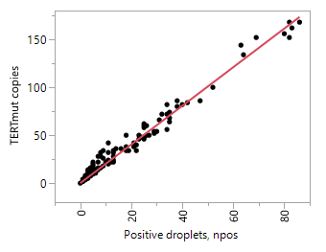

Supplementary file 1 Figure 2. Linear regression-based determination of the TERT promoter (A) mutant (TERTmut) or (B) wild-type (TERTwt) copy number through the number of positive or negative calls (droplets), respectively. The obtained estimates were as follows: b_{mut} = 2.017 (1.990–2.044) (95%CI), r² = 0.989, p = 4.836E-235; b_{wt} = 2.479 (2.445–2.512) (95%CI), r² = 0.989, p = 1.680E-234.

Thus, the number of either TERTmut or TERTwt copies is determined by the number of corresponding calls (droplets) as follows:

$TERTmut copies$= 2.017⋅$n_{pos}$ [3]
$TERTwt copies$ = 2.479⋅$n_{neg}$ [4],

2.3. Inputting formulas [3] and [4] into [2] yields the following definition of $TERTmut\%$:

$TERTmut\%=\frac{2.017n_{pos}}{2.017n_{pos}+ 2.479n_{neg}}100\%$ [5]

Since the natural limit for the minimal number of calls (registered droplets) in a ddPCR reaction is 1, formula [5] is converted to the following when $n_{pos}=1$ :

$TERTmut\%=\frac{2.017}{2.017+ 2.479n_{neg}}100$% [6]

2.4. The minimal number of TERTwt calls (i.e. negative droplets, $n_{neg}$) at which 1 positive call becomes interpretable is determined by the condition:

$TERTmut\%=\frac{2.017}{2.017+ 2.479n_{neg}}100\%$ > minimum TERTmut% ;

the minimum TERTmut% (i.e., the cutoff value) was determined above in formula [1], and therefore solving the equation
[6] = [1]

for n_{neg} would yield the minimum number of wild-type TERT-p calls below which the results of a ddPCR reaction in the absence of mutant calls could not be interpreted. One may see here some parallelism to the “nondiagnostic/unsatisfactory” cytopathology, which applicably to ddPCR means insufficient template DNA in a reaction to deem the absence of mutant TERT-p calls an evidence of the wild-type status of the TERT promoter. The minimum TERTmut% and the minimum Total DNA copies corresponding to the determined n_{neg} (n_{neg}=25) were calculated and are presented in Supplementary file 1 Table 2.

Supplementary file 1 Table 2. Calculated values of the minimum TERTmut% and the minimum Total DNA copies defining the nondiagnostic limit.
Minimum n_{neg} | Minimum TERTmut% | Minimum Total DNA copies
25* | 3.15 | 64*
* rounded to the nearest greater integer

The obtained estimates were used to interpret mutational status of the TERT promoter in FNA and FFPE samples based on the values of Total DNA copies (the abscissa) and TERTmut% (the ordinate) for each data point as schematically shown in Supplementary file 1 Figure 2.

Supplementary file 1 Figure 3. Schematic presentation of the areas defining mutational status of the TERT promoter based on a ddPCR result.

