Fig S1 Original image of BCL-2 in FIGURE 4B
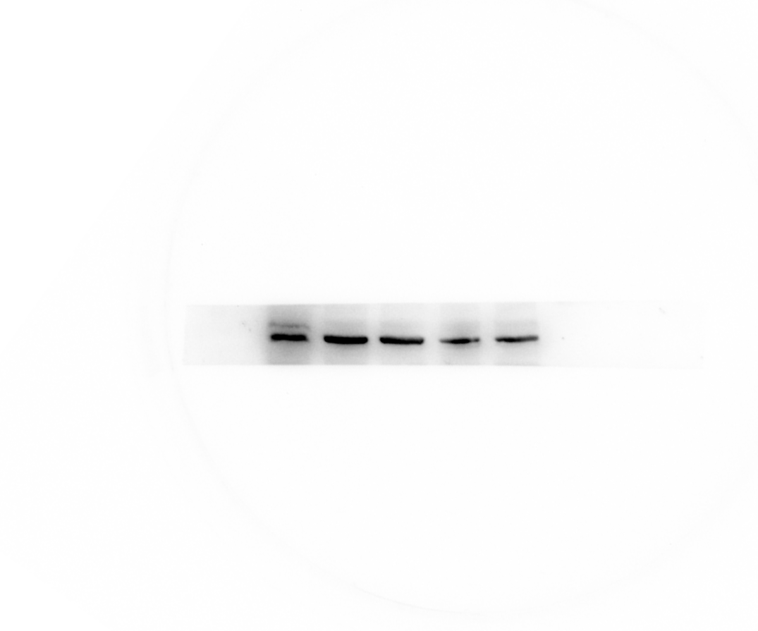
Fig S2 Original image of BCL-2 in FIGURE 4B

Fig S3 Original image of GAPDH in FIGURE 4B
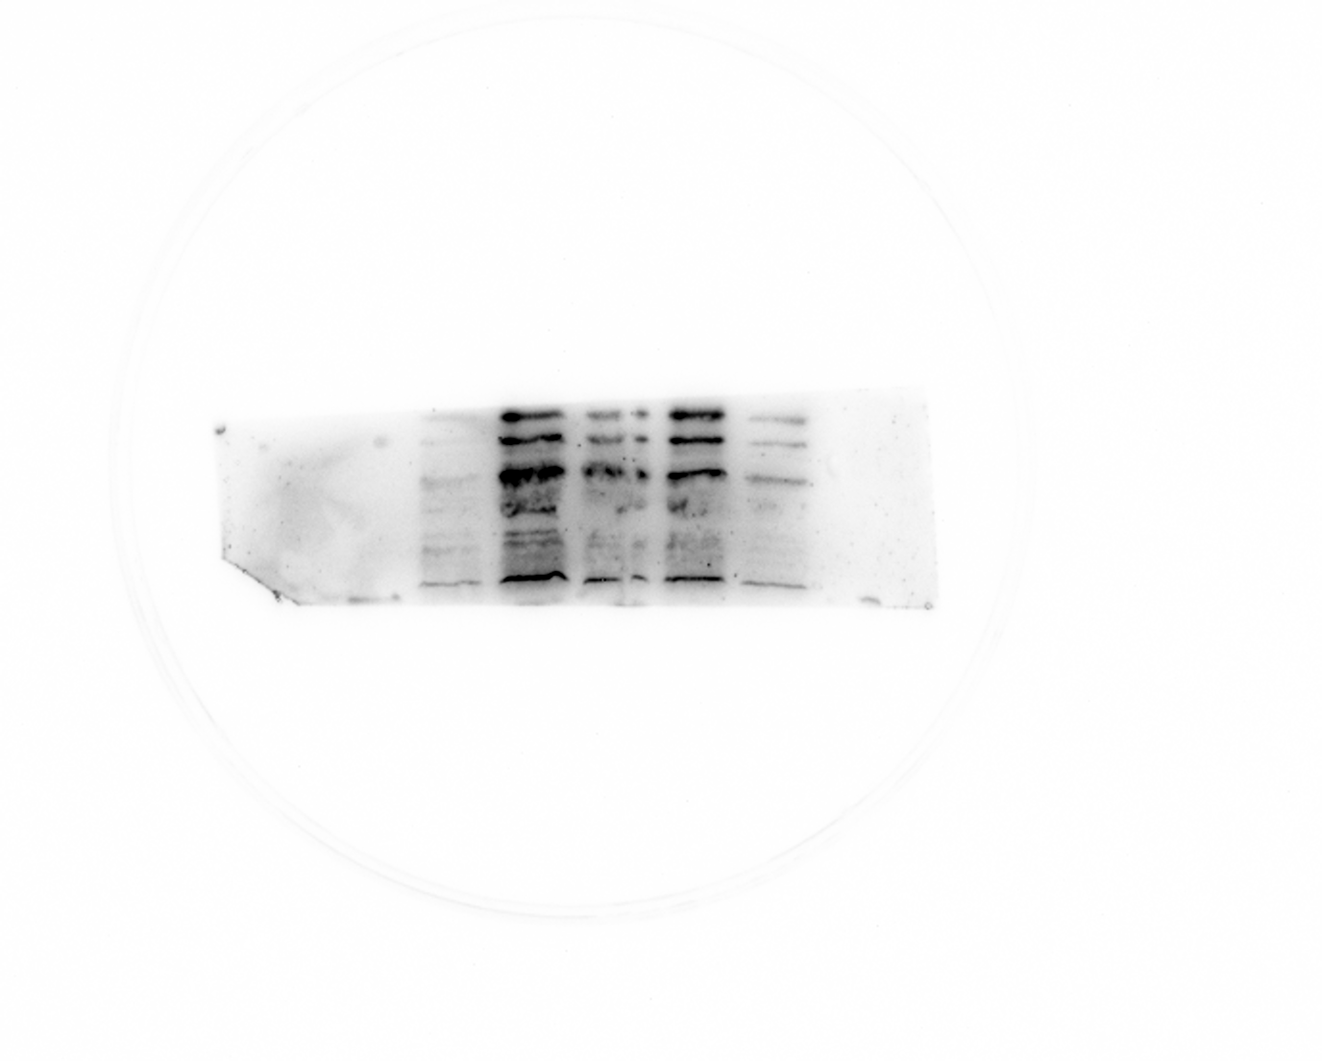
Fig S4 Original image of P38 in FIGURE 5A
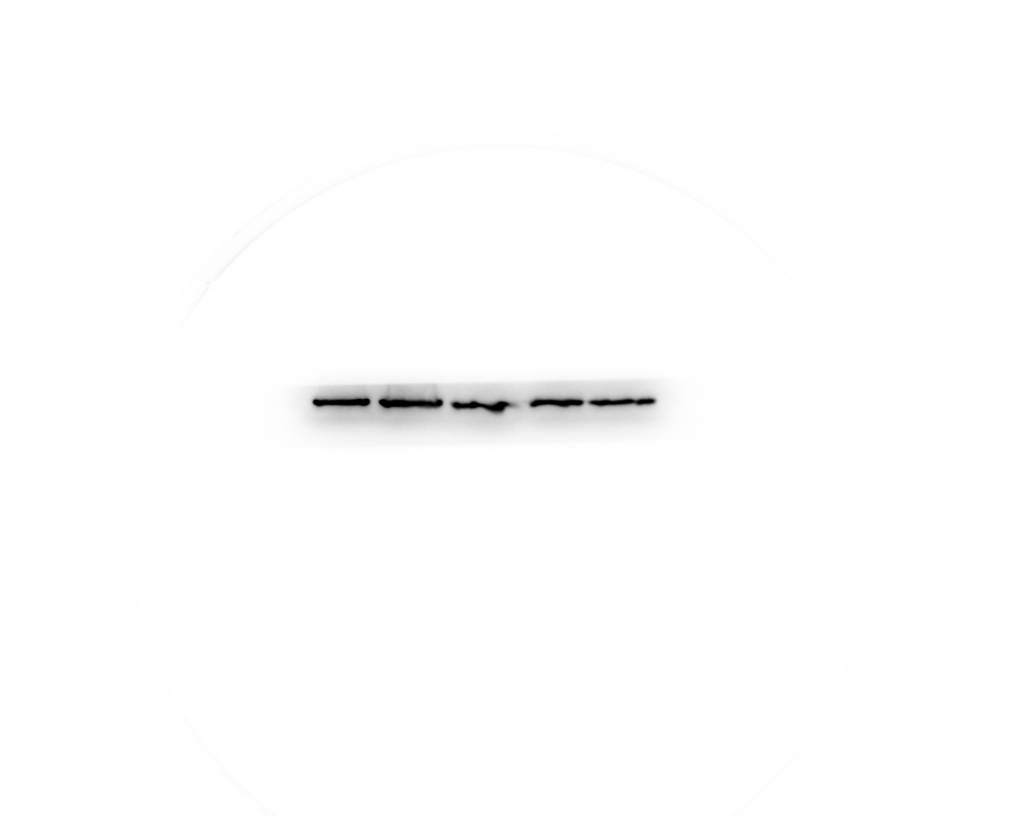
Fig S5 Original image of GAPDH in FIGURE 5A

Fig S6 Original image of BCL-2 in FIGURE 5G
Fig S7 Original image of Bax in FIGURE 5G
Fig S8 Original image of GAPDH in FIGURE 5G

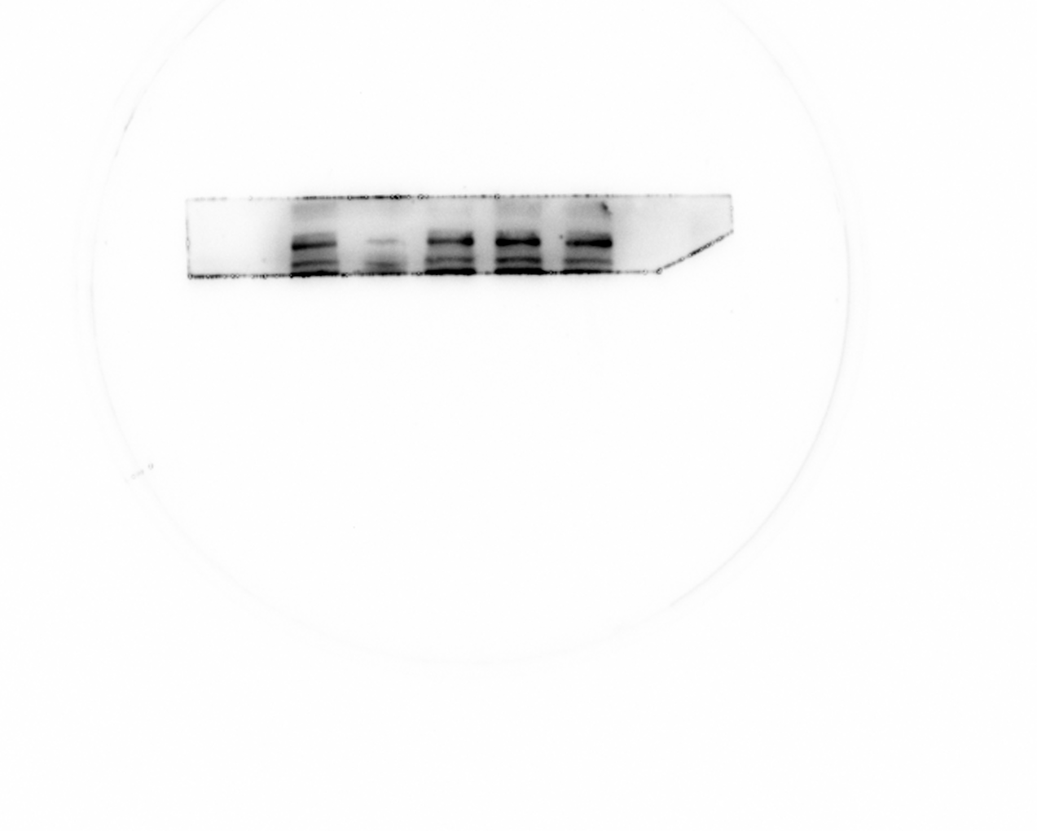
Fig S9 Original image of BCL-2 in FIGURE 6C
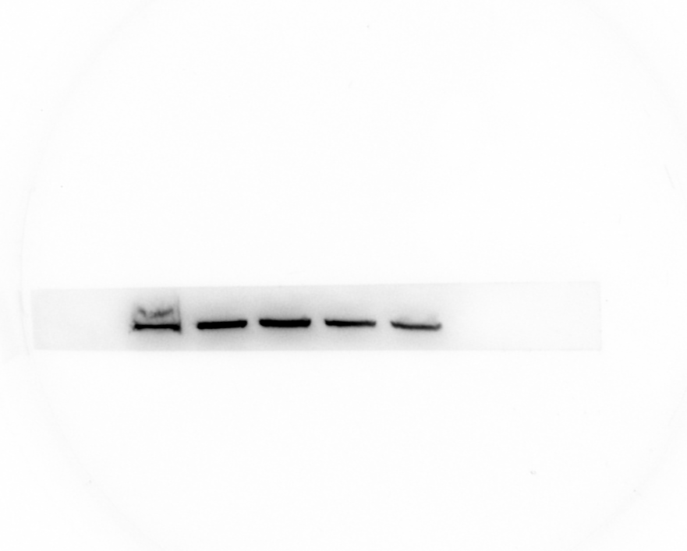
Fig S10 Original image of Bax in FIGURE 6C
GAPDH
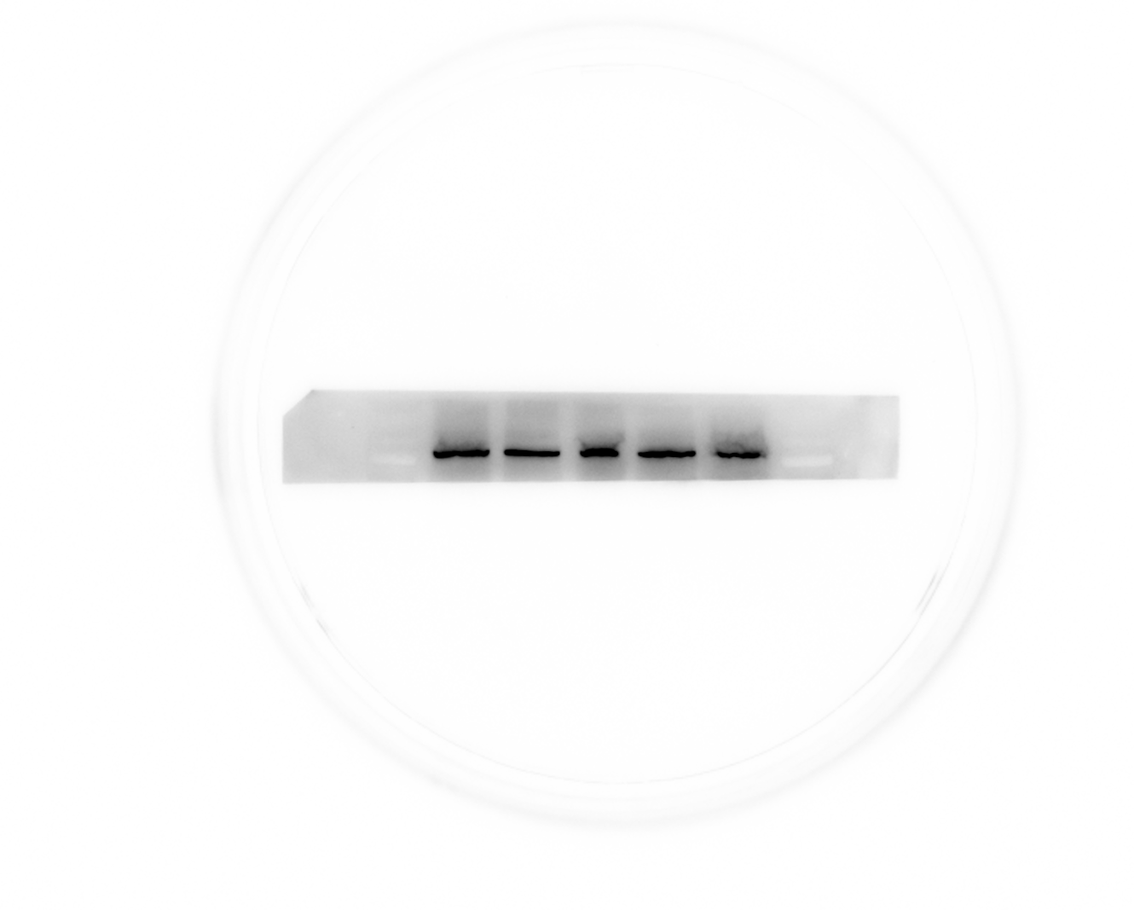
Fig S11 Original image of GAPDH in FIGURE 6C
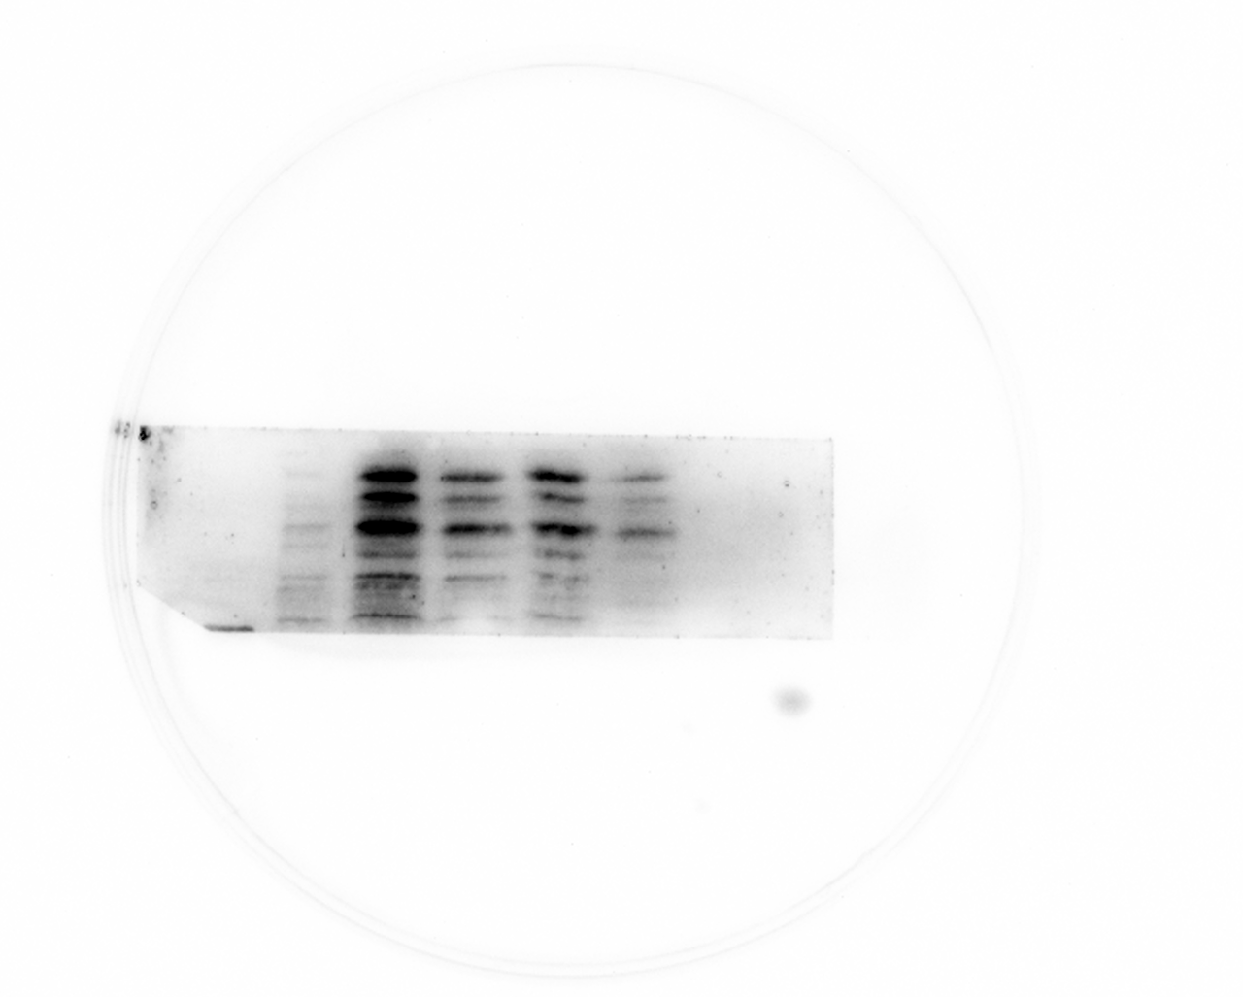
Fig S12 Original image of P38 in FIGURE 7A

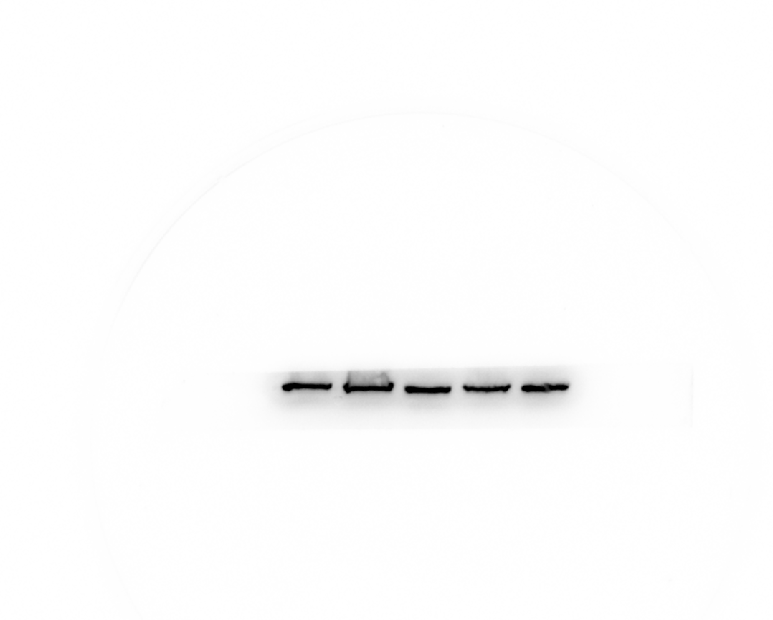
Fig S13 Original image of GAPDH in FIGURE 7A

Fig S14 Original image of P38 in FIGURE 7B
Fig S15 Original image of GAPDH in FIGURE 7B

Fig S16 Original image of Bcl-2 in FIGURE 7E
Fig S17 Original image of Bax in FIGURE 7E
Fig S18 Original image of GAPDH in FIGURE 7E

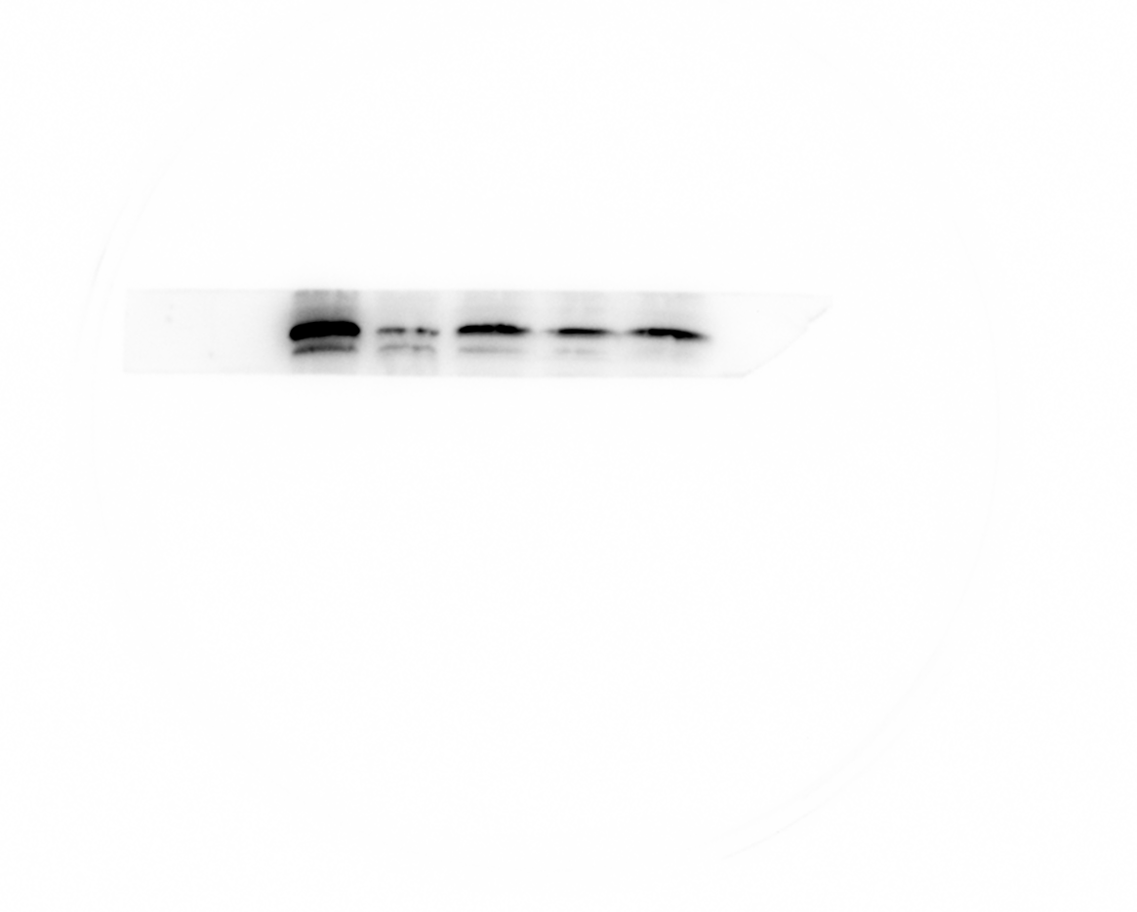
Fig S19 Original image of Bcl-2 in FIGURE 8E
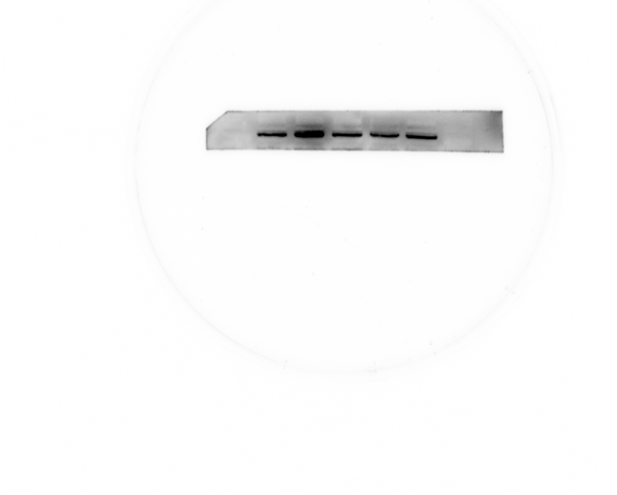
Fig S20 Original image of Bax in FIGURE 8E
GAPDH
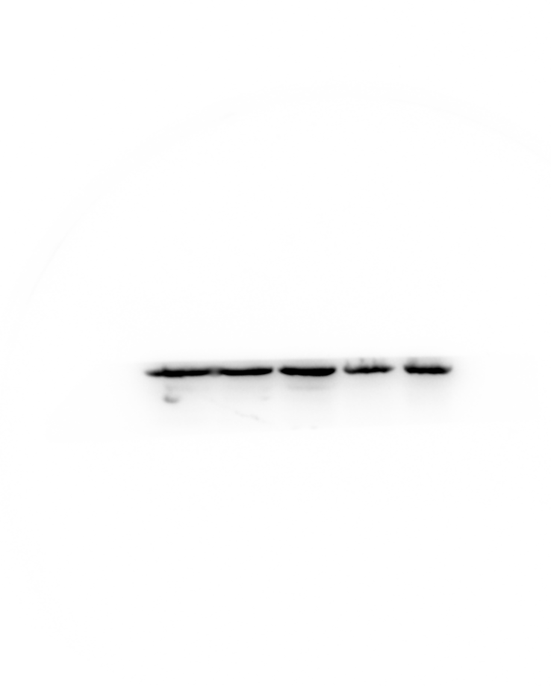
Fig S21 Original image of GAPDH in FIGURE 8E

Fig S22 Original image of P38 in FIGURE 8G

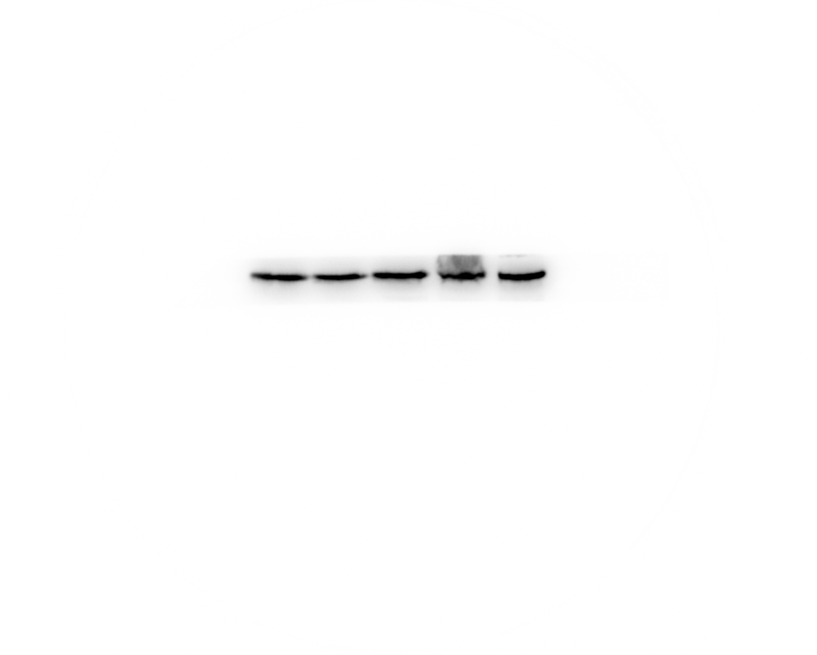
Fig S23 Original image of GAPDH in FIGURE 8G

