·Supplementary Material

The common fatty acids act as pheromones universal in mammals to relieve anxiety
Yuan-Hua Li^{a,b,c} , Yao-Hua Zhangª*, Wei-Chao Wang^{a,c}, Zhen-Shan Wang^{b}*, Jian-Xu Zhang^{a,c}*

*Address correspondence to Yao-Hua Zhang, E-mail: zhangyh@ioz.ac.cn; Jian-Xu Zhang, E-mail: zhangjx@ioz.ac.cn

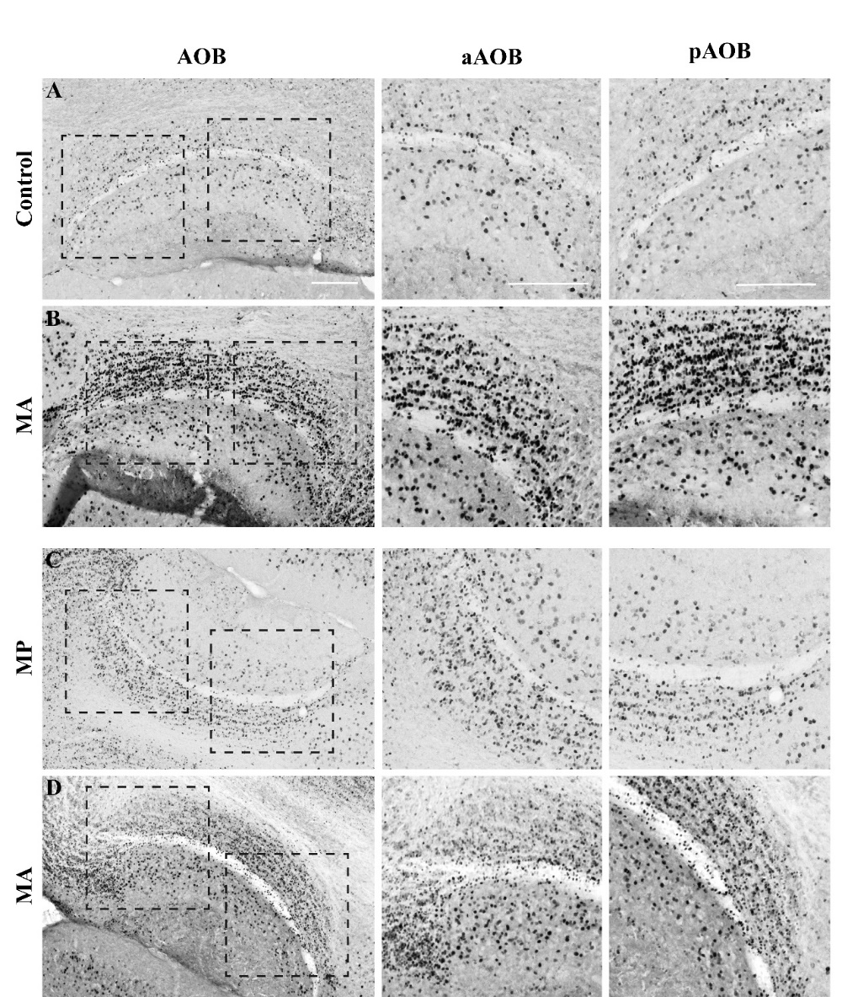

Supplemental Figure 1 Micrographs of representative slices of the female mouse AOB after exposure to MA, MP and DMSO (control) through the nuclei of the VNO neural pathway. (A-B) C-Fos-immunostaining images of female AOB sections stimulated by MA as well as control. The regions of the aAOB and pAOB at a higher magnification, respectively. (C-D) C-Fos-immunostaining images of female AOB sections stimulated by MA as well as MP. The regions of the aAOB and pAOB at a higher magnification, respectively. Scale bar, 200 μm.

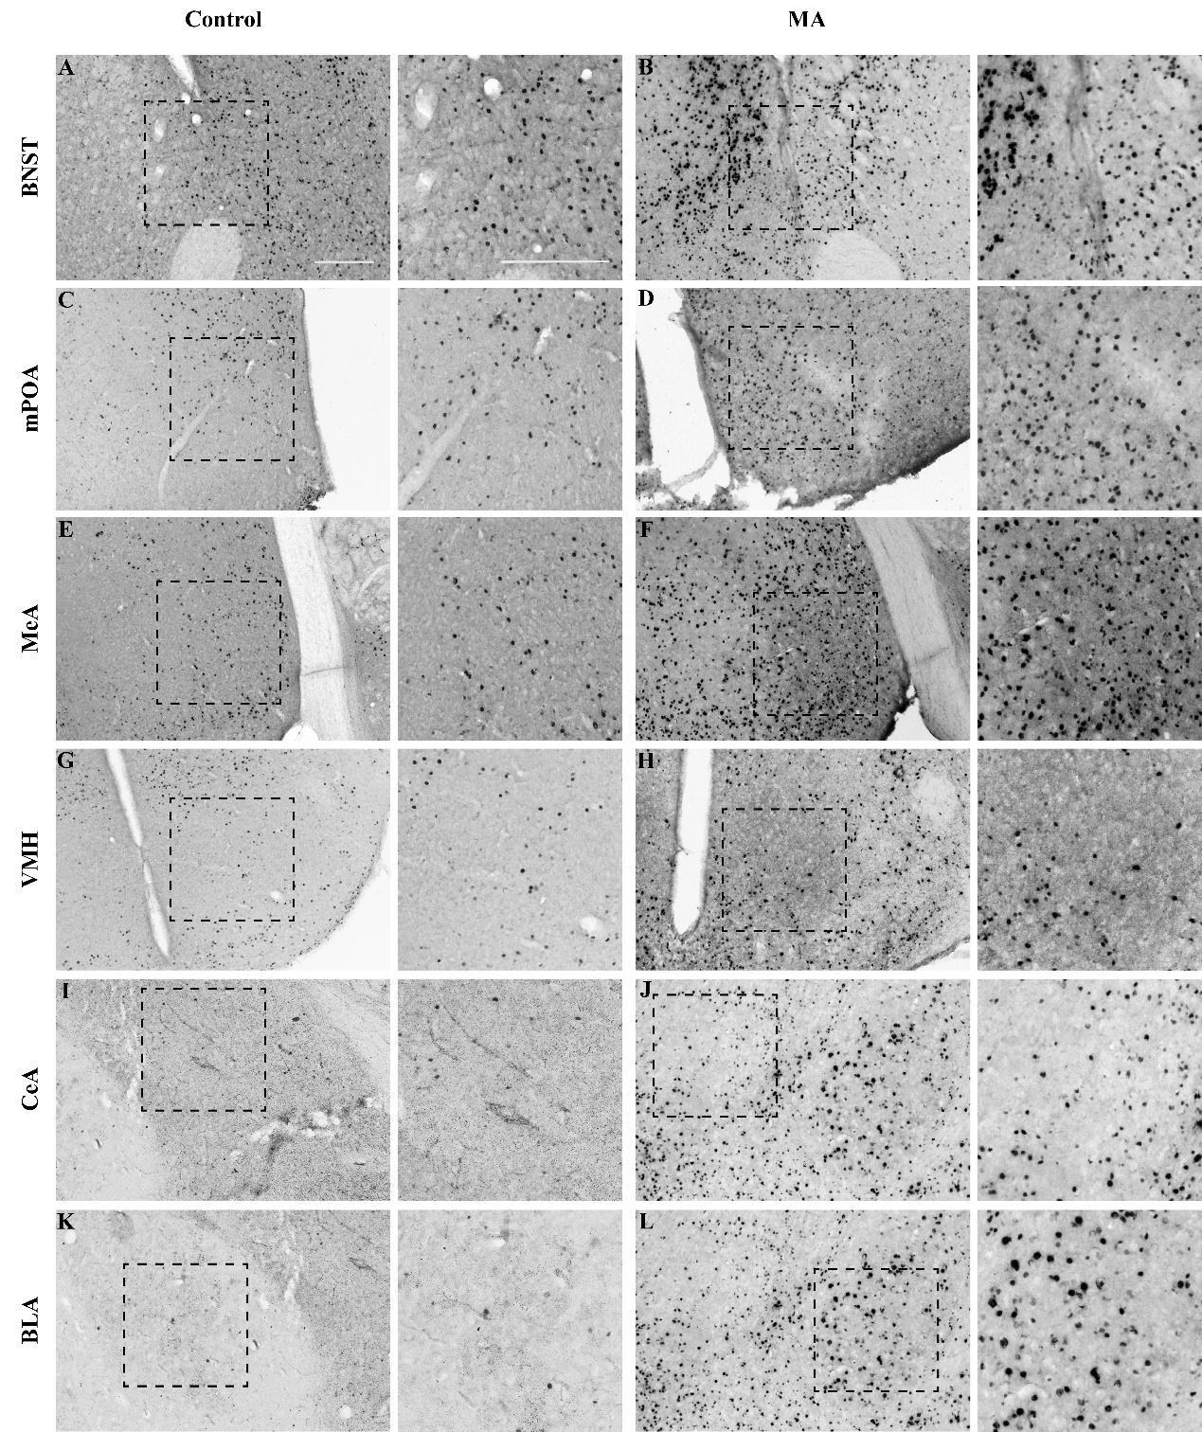

Supplemental Figure 2 Micrographs of representative slices of the female mouse brain tissues after exposure to MA and DMSO (control) through the nuclei of the VNO neural pathway. (A-L) Representative images and their insets of c-Fos+ cells in the BNST, MeA, mPOA, VMH, CeA and BLA of female mice after exposure control and MA and DMSO (control), respectively. Scale bar, 200 μm.

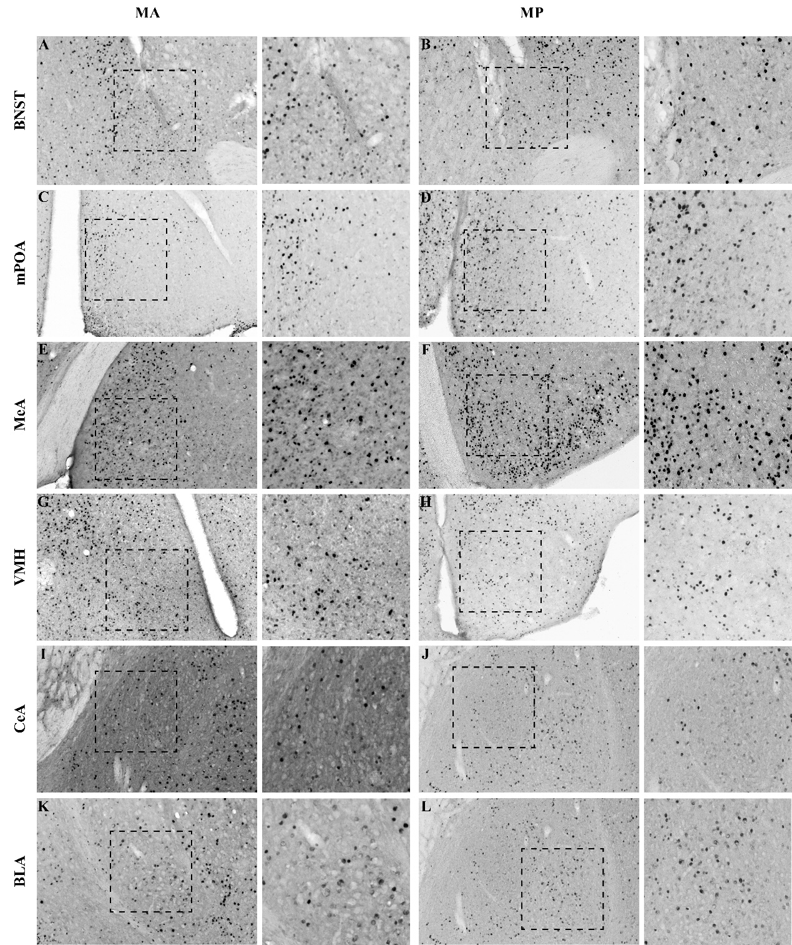

Supplemental Figure 3 Micrographs of representative slices of the female mouse brain tissues after exposure to MA and MP through the nuclei of the VNO neural pathway. (A-L) Representative images and their insets of c-Fos+ cells in the BNST, MeA, mPOA, VMH, CeA and BLA of female mice after exposure MA and MP, respectively. Scale bar, 200 μm.

Supplemental Figure 4 The body weight of female mice pre-exposed to MA, MP and Control solution.

Supplemental Table 1
Listing of primers used in real-time PCR

Gene | 5’→3’ Primer sequences
BDNF | AATGCCGAACTACCCAATCGT  CTTCCCCTTTTAATGGTCAGTGT
DRD2 | AGAGCCAACCTGAAGACACCA  CATCCATTCTCCGCCTGT
ERβ | CAACTCCAGTATGTACCCCTT  TCACTGCGTTCAATAGGTGT
GluN2B | TTCCGAACAAAGGAGAACTCG  TCGCTTGAAGTCATCACTACGTT
5HT1A | CTCCAACTCCCTGCTCAACCC  TCAGCGGCAGAACTTGCACT
5HT2A | TTCCTGAAAATCATTGCGGTGT  GAATCATCCTGTAGCCCGAAG
β-actin | TCCATCATGAAGTGTGACGT  GAGCAATGATCTTGATCTTCAT

Supplemental Table 2
Effect of MA and MP on neuronal c-Fos immunoreaction in accessory olfactory bulb and brain nuclei of mice.

Brain region | MA vs Control |  | MP vs MA
Brain region | Control  (n = 4) | MA  (n = 4) | MP  (n = 4) | MA  (n = 4)
AOB | 427.8 ± 26.76 | 803.2 ± 22.4 | 617.1 ± 25.3 | 716.1 ± 21.9
aAOB | 252.7 ± 17.1 | 438.2 ± 10.6 | 357.0 ± 15.9 | 387.6 ± 11.9
pAOB | 175.1 ± 12.6 | 365 ± 16.0 | 260.6 ± 12.3 | 328.5 ± 14.0
BNST | 66.6 ± 8.4 | 142.9 ± 6.8 | 83.0 ± 7.6 | 129.0 ± 11.6
MeA | 61.0 ± 4.7 | 94.0 ± 6.0 | 73.5 ± 5.3 | 86.3 ± 4.8
mPOA | 52.4 ± 5.7 | 119.0 ± 5.5 | 127.4 ± 12.6 | 91.9 ± 7.5
VMH | 31.6 ± 4.0 | 52.6 ± 4.4 | 63.9 ± 6.7 | 46.6 ± 3.7
CeA | 30.7 ± 3.4 | 40.1 ± 9.0 | 48.8 ± 4.5 | 56.2 ± 9.8
BLA | 68.2 ± 3.2 | 102.5 ± 6.6 | 77.6 ± 3.9 | 61.0 ± 4.2

