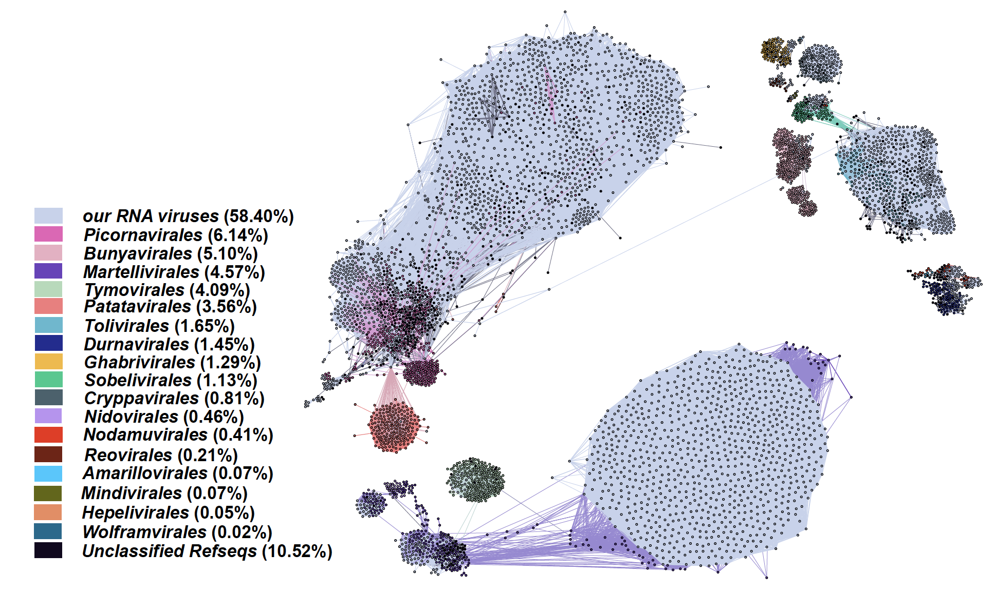
Fig. S1 Similarity network of RNA viruses.
RNA viruses network showing all RNA viruses discovered here related to those known references. The RNA viruses we identified here are colored grey, and different order of references with different color, part of unclassified references were colored black.

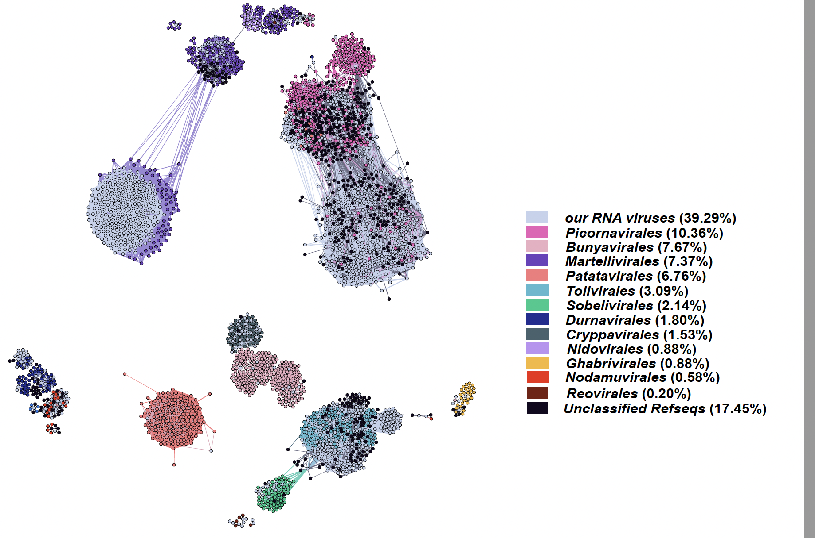
Fig. S2 Similarity network of RNA viruses in 2019 year.
RNA viruses network showing all RNA viruses discovered here related to those known references. The RNA viruses we identified here are colored grey, and different order of references with different color, part of unclassified references were colored black.

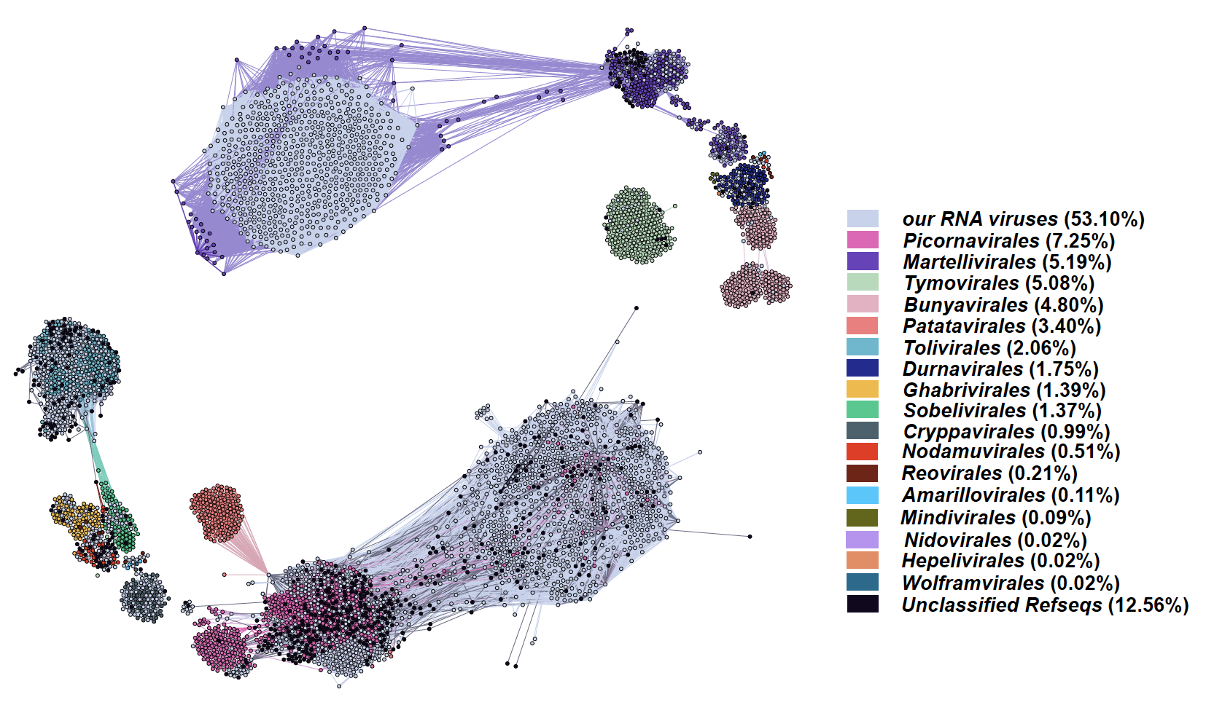
Fig. S3 Similarity network of RNA viruses in 2020 year.
RNA viruses network showing all RNA viruses discovered here related to those known references. The RNA viruses we identified here are colored grey, and different order of references with different color, part of unclassified references were colored black.

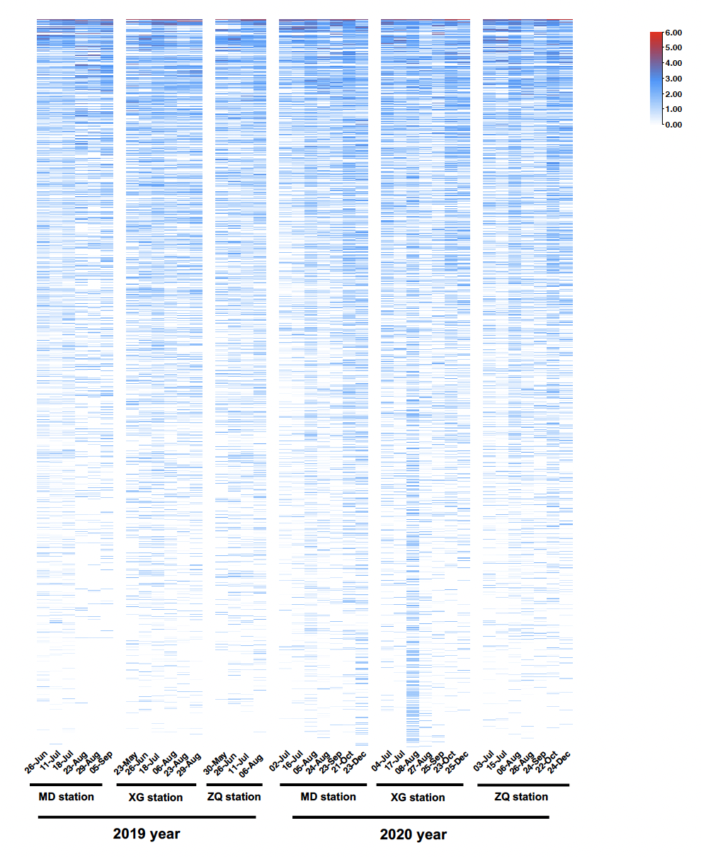
Fig. S4 Abundant vOTUs in all 37 samples of three stations in 2019 year and 2020 year.
2351 abundant vOTUs with 90% average nucleotide identity over 80% coverage in all samples of two years.

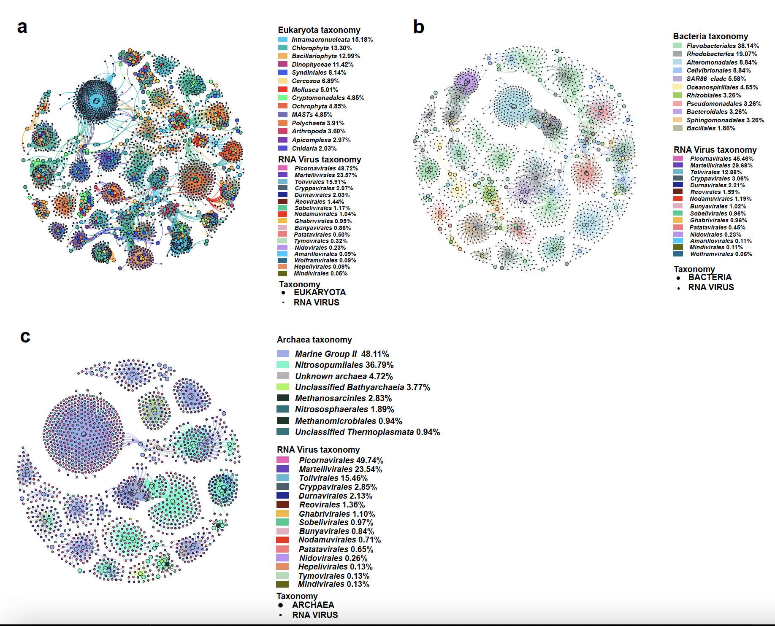
Fig. S5 Correlation network of RNA viruses with bacteria and archaea.
a Correlation of RNA viruses and eukaryote. The big point means eukaryote and small point means RNA viruses. The taxonomy of eukaryote at the order level with different color, RNA viruses color is RNA viral order. b Correlation of RNA viruses and bacteria. The big point means bacteria and small point means RNA viruses. The taxonomy of bacteria at the order level with different color, RNA viruses color is RNA viral order. c Correlation of RNA viruses and archaea. The big point means archaea and small point means RNA viruses. The taxonomy of archaea at the order level with different color, RNA viruses color is RNA viral order.

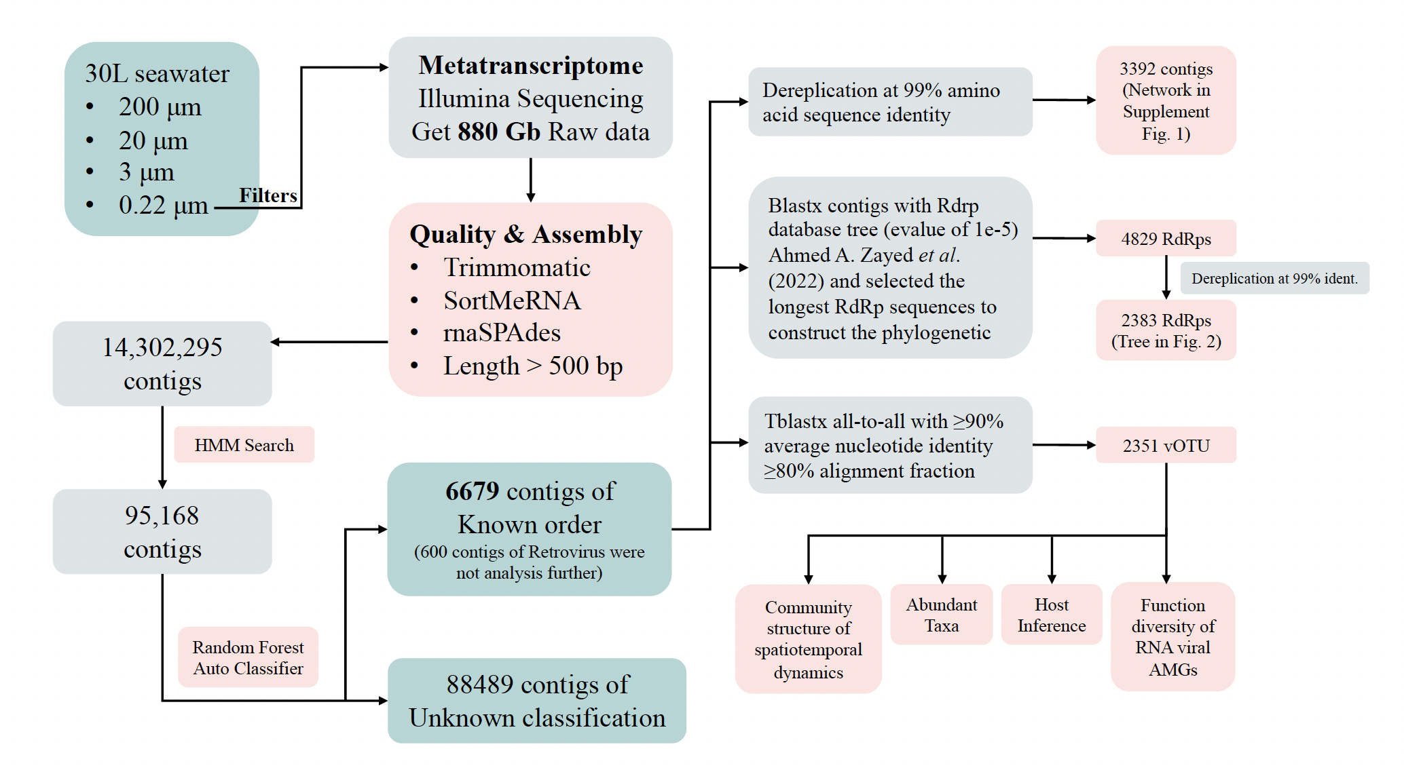
Fig. S6 Sampling, RNA virus discovery and analysis pipeline.

