Supplementary Materials for

Controlled On-chip Fabrication of Large-scale Perovskite Single Crystal Arrays for High-performance Laser and Photodetector Integration

Zhangsheng Xu, Xun Han*, Wenqiang Wu, Fangtao Li, Junlu Sun, Ru Wang, Hui Lu, Qiuchun Lu, Binghui Ge, Ningyan Cheng, Xiaoyi Li, Guangjie Yao, Hao Hong, Kaihui Liu and Caofeng Pan*

Supplementary Text
Discussion about the influence of the gap on the thickness of perovskite.
The gap can be tuned by changing the pressure of the clamp. After placing the hydrophobic glass substrate on the target substrate, we use a clamp to hold the two pieces of substrate. By changing the pressure of the clamp, the gap could be tuned from 9 μm to 45 μm.
As shown in figure S2A, the thickness of the MPs decreases with reducing the gap between two substrates while the thickness of MPs remains smaller than the gap. However, the crystals fabricated with the gap of 9 μm demonstrate irregular shapes, which is because the perovskite tends to nucleate at the corner of the hydrophilic squares and grow along the edges (Fig. S2b). Under the large gap conditions, the edges of crystals become smooth due to the uncontrolled evaporation rate of the solvent of the precursor solution (Fig. S2c). Considering the control of the crystallization process and pixel positions, we adopted the gap of 20 μm in this work for the fabrication of perovskite crystal arrays.

Calculation of the trap density and carrier mobility.
For easy measurement, a large hydrophilic window is utilized for the crystal array growth. We firstly measured the I-V curve of the MAPbBr₃ crystals in the dark condition (Fig. S9). It shows three different regimes: the ohmic regime at low bias, the trap-filled regime with a starting point of V_{TFL}, and the child regime at high bias. The trap density (n_{trap}) and carrier mobility (μ) could be calculated by the following equations ^{1, 2}:
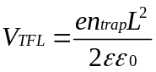 (1)
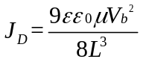 (2)
where ε is the relative dielectric constant, ε₀ is the vacuum permittivity, L is the distance between two electrodes, J_{D} is the current density at the applied voltage of V_{b}. As a consequence, the trap density and carrier mobility were calculated to be 1.05 ×10¹² cm⁻³ and 111.4 cm²V⁻¹s⁻¹, respectively.

Discussion of the perovskite microplate cavity. In order to confirm that the main contribution to the laser is the whispering gallery mode (WGM) cavity rather than Fabry-Pérot (F-P) cavity (Fig. S9), the quality factor (Q factor) of the FP cavity is calculated by the equation:
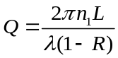 (3)
where n₁ is the refractive of the perovskite microplate, L is the cavity length and λ is the emission wavelength and R is the reflectivity of the boundary. R can be calculated according to the equation:
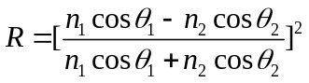 (4)
where n₂ is the refractive index of air, θ₁ and θ₂ the angle of incidence and refraction which can be considered as 0° in the F-P cavity. In addition, the stimulated radiation wavelength and the thickness of the perovskite microplate was measured in the experiment. According to the above formula, we can calculate Q factor of the F-P cavity is 92.6, which is much smaller than the test results (Q factor = 2915). Hence, the F-P cavity hardly contributes to the stimulated emissions ^{2, 3, 4, 5}.

The preparation process of the perovskite photodetector array.
- ITO electrodes were deposited on the glass by RF Magnetron sputtering (80 W, 30 min).
- The patterned substrate was obtained by the preparation process (Fig. S1).
- Perovskite microplates array was fabricated according to the method as shown in Fig. 1a.
- PMMA as insulating and protective layers was spin-coated on the perovskite microplates array (500 rpm/s, 1 min) and cured at 80 ℃ for 5 min.
- After finishing PMMA coverage, PMMA thin film was etched by RIE (~ 160 W, 1 min) for removal of redundant PMMA on the perovskite microplate array.
- Patterned Ag as top electrodes was deposited with PET mask (prepared by laser cutting machine) by RF magnetron sputtering (60 W, 3 min).

Analysis of noise spectral density.
The noise in the dark current of the photodetector array was analyzed by a reported method ⁵ using a power source, a low noise current preamplifier (Stanford Research System SR 570) and an oscilloscope (Keysight, InfiniiVision MSOX4154A). The dark current was measured with a sampling rate of ~ 645 Hz, as shown in Fig. S17a. Through a Fourier transform (FFT) of the measured dark current ⁶, the noise spectral density was obtained, as shown in Fig. S17b. Then, the noise-equivalent-power (NEP) can be calculated by dividing the noise spectral density by the responsivity. The NEP of the MAPbBr₃ photodetector is calculated to be 1.43×10⁻¹⁴ W/Hz^{1/2} at a modulation frequency of 1 Hz. Thus, the specific detectivity (D*) could be calculated by
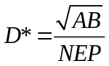 (7)
where A is the device area. The D* of the MAPbBr₃ photodetector is calculated to be 4.2×10¹¹ Jones.

Fig. S1. a Schematic illustration of the substrate preparation process. b The image of contact angle in different areas. The optical image of the patterned substrate c before and d after smearing perovskite solutions

Fig S2. a The dependence of thickness of MPs on the gap between target and confinement substrate. The optical images of the MPs synthesized under b small and c large gap conditions.

Fig. S3. a Schematic illustration of the growth process about a perovskite microplate. b The top-view microscopical optical image of samples.

Fig. S4. SEM images of MAPbBr₃ microplate with different perspectives.

Fig. S5. Fluorescence image of the large-scale perovskite array excited by 365 nm illumination. The inset is an enlarged image.

Fig. S6. Distribution of a width and b thickness of 100 perovskite microplates.

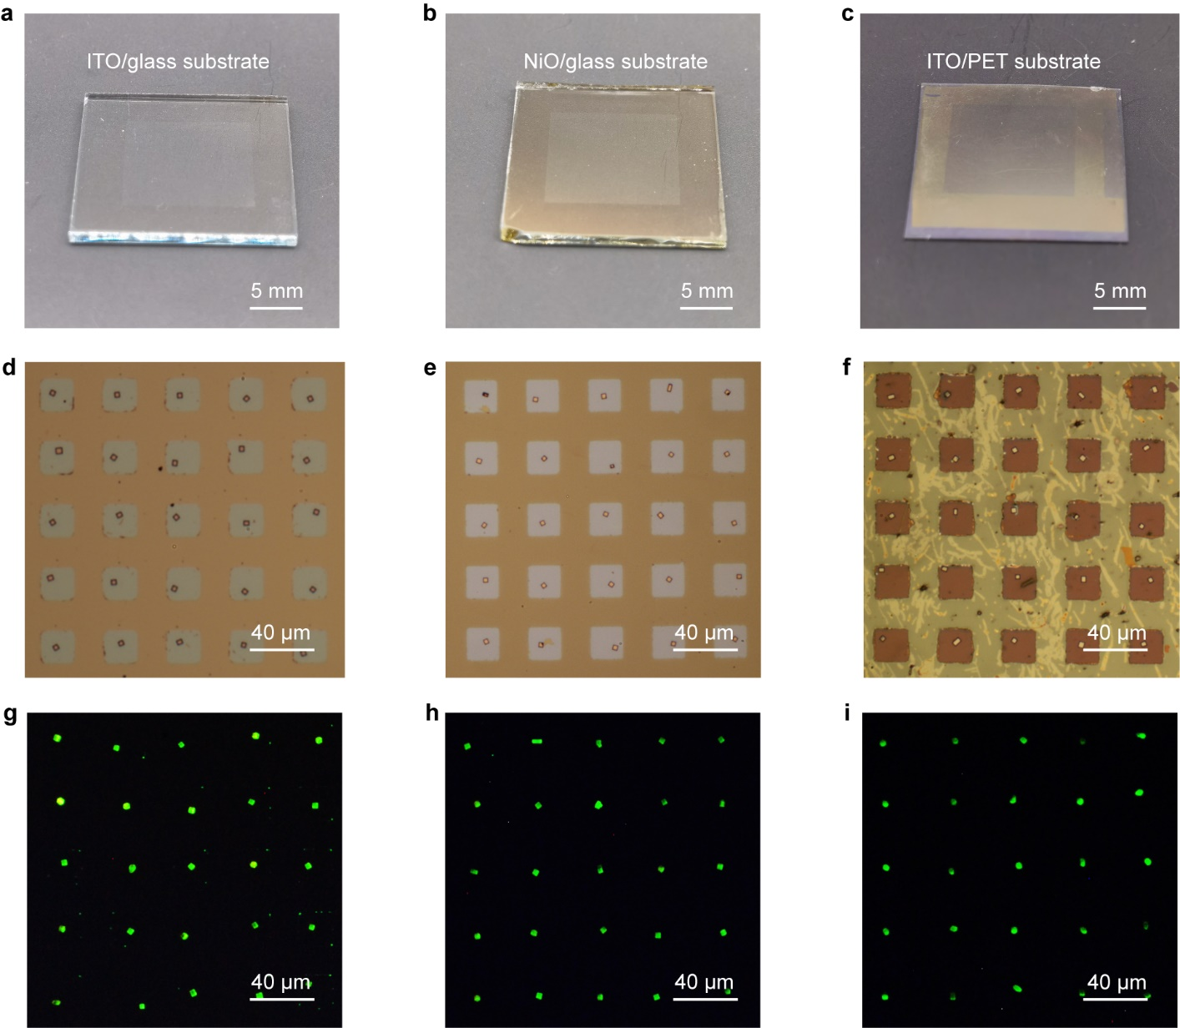

Fig. S7. Optical images of the as-fabricated perovskite microplates array on a ITO, b NiO and c PET substrate. d-f The corresponding microscope photograph of perovskite microplate arrays. g-i Fluorescence image of the perovskite microplates array fabricated on different substrates.

Fig. S8. Schematic illustration of lattice about CsPbBr₃ on SrTiO₃ (100) substrate.

Fig. S9. a SEM image of MAPbBr₃ MP array synthesized on KTO (100) substrate. b Statistics of the in-plane rotation of 100 perovskite MPs array synthesized on KTO (100) substrate.

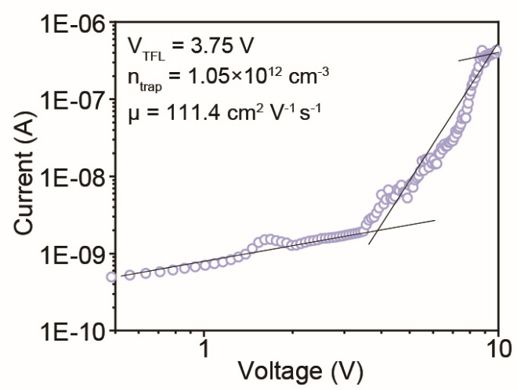
Fig. S10. I-V characterization of the MAPbBr₃ MPs devices in the dark condition.

Fig. S11. Schematic illustration of the entire optical path and test system for laser measurement.

Fig. S12. PL decay trace of the MAPbBr₃ MPs.

Fig. S13. a FDTD stimulations of WGM mode. Schematic diagram of the lightwave path in b whispering gallery mode cavity and c Fabry–Pérot cavity in the perovskite microplate.

Fig. S14. Schematic illustration of the preparation process of the perovskite photodetector array.

Fig. S15. Response time and decay time of the a MAPbBr₃ crystal photodetector.

Fig. S16. The dependence of current on power density at a bias voltage of 1V.

Fig. S17. a The dark current waveform of the MAPbBr₃ photodetector arrays. b Analysis of noise spectral density of photodetector based on the dark current waveform measured in a.

Fig. S18. Schematic illustration of measurement circuit about a 5×5 pixels photodetector array.

Table S1. Comparison of threshold and Q factor between the previous reports and our work.
Materials | Method | Threshold (μJ/cm²) | Q factor | Array configuration | Ref.
MAPbBr₃ microplates | Liquid knife | 3.5 | 1090 | Y | 7
MAPbBr₃ microplates | One-step solution | 9.1 | 2605 | N | 8
MAPbBr₃ microrods | Liquid-phase self-assembly | 62 | 657 | N | 9
MAPbBr₃ nanowires | PDMS rectangular groove-templates | 12.3 | 500 | Y | 10
MAPbBr₃ nanowires | Solution-processed | 9.8 | 1260 | N | 11
MAPbBr₃ thin film | Spin-coating | 16.2 | 1570 | Y | 12
MAPbBr₃ thin film | Spin-coating | 2.75 | 1025 | Y | 13
CsPbBr_{x}I_{3-x} nanowires | Vapor phase epitaxial growth | 28 | 1390 | N | 14
CsPbBr₃ microplates | Vapor phase growth | 4.0 | 6806 | Y | 15
CsPbBr₃ microwires | Template-confined antisolvent crystallization | 2.2 | 1555 | Y | 2
CsPbBr₃ rings | Novel self-healing lithographic patterning | 3.8 | 2200 | Y | 16
MAPbBr₃ microplates | Space confinement and antisolvent-assisted crystallization | 4.14 | 2915 | Y | This work

REFERENCES AND NOTES

- Chen, J. et al. Single-crystal thin films of cesium lead bromide perovskite epitaxially grown on metal oxide perovskite (SrTiO₃). J Am. Chem. Soc. 139, 13525-13532 (2017).
- Yang, Z. et al. Controllable growth of aligned monocrystalline CsPbBr₃ microwire arrays for piezoelectric-induced dynamic modulation of single-mode lasing. Adv. Mater. 31, 1800596 (2019).
- Zhu, Y. et al. Inhomogeneous trap-state-mediated ultrafast photocarrier dynamics in CsPbBr₃ microplates. ACS Appl. Mater. Interfaces 13, 6820-6829 (2021).
- Zhu, Y. et al. Spatiotemporal sectioning of two-photon fluorescence ellipsoid with a CsPbBr₃ nanosheet. Nano Res. 14, 4288-4293 (2021).
- Shi, L. et al. Status and outlook of metal-inorganic semiconductor-metal photodetectors. Laser Photonics Rev. 15, 2000401 (2021).
- Liu, C. H. et al. Graphene photodetectors with ultra-broadband and high responsivity at room temperature. Nat. Nanotechnol. 9, 273-278 (2014).
- Feng, J. et al. "Liquid Knife" to fabricate patterning single-crystalline perovskite microplates toward high-performance laser arrays. Adv. Mater. 28, 3732-3741 (2016).
- Wang, K. et al. Single-crystalline perovskite microlasers for high-Contrast and sub-Diffraction imaging. Adv. Funct. Mater. 29, 1904868 (2019).
- Zhang, W. et al. Controlling the cavity structures of two-photon-pumped perovskite microlasers. Adv. Mater. 28, 4040-4046 (2016).
- Liu, P. et al. Organic-inorganic hybrid perovskite nanowire laser arrays. ACS Nano 11, 5766-5773 (2017).
- He, X. Multi-color perovskite nanowire lasers through kinetically controlled solution growth followed by gas-phase halide exchange. J. Mater. Chem. C 5, 12707-12713 (2017).
- Wang, K. et al. Wettability-guided screen printing of perovskite microlaser arrays for current-driven displays. Adv. Mater. 32, 2001999 (2020).
- Duan, Z. et al. Chip-scale fabrication of uniform lead halide perovskites microlaser array and photodetector array. Laser Photonics Rev. 12, 1700234 (2018).
- Huang, L. et al. Composition-graded cesium lead halide perovskite nanowires with tunable dual-color lasing performance. Adv. Mater. 30, 1800596 (2018).
- Gu, Z. et al. Controllable growth of high-quality inorganic perovskite microplate arrays for functional optoelectronics. Adv. Mater. 32, 1908006 (2020).
- Xing, D. et al. Self-healing lithographic patterning of perovskite nanocrystals for large-area single-mode laser array. Adv. Funct. Mater. 31, 2006283 (2021).

