Supplemental

Table S1. Optimized Multiple Reaction Monitoring (MRM) parameters for the drugs of interest.

Analyte | Q1 | Q3 | EV | CC_L2 | CC
Bupropion | 240.2 | 131.1 | 11 | -52 | -34
Citalopram | 325.1 | 109.1 | 7 | -80 | -32
Desipramine | 267.2 | 208.2 | 28 | -80 | -29
Imipramine | 281.1 | 86.1 | 10 | -92 | -36
Milnacipran | 247.3 | 129.2 | 15 | -36 | -34
Olanzapine | 313.2 | 256.1 | 31 | -72 | -28
Sertraline | 306.1 | 159.1 | 16 | -88 | -33
Vilazodone | 442.4 | 155.1 | 20 | -122 | -58
Fluoxetine D6 | 316.2 | 154.3 | 26 | -60 | -13
Citalopram-D6 | 331.2 | 234.2 | 20 | -96 | -36
Mirtazapine-D3 | 269.2 | 209.1 | 20 | -88 | -30
Clomipramine-D3 | 354.3 | 100 | 16 | -56 | -13
Milnacipran-D10 | 257.3 | 110.3 | 24 | -60 | -27
Bupropion-D9 | 249.2 | 139 | 19 | -60 | -38
Vilazodone-D4 | 446.4 | 197 | 23 | -110 | -39

Figure S1 (a)
Deck layout for the automation of the prototype kit sample preparation developed and reported in this paper. The proposed sample preparation yields a 96-well plate with up to 48 wells containing patient samples as well as a full precision plate for standardization and improved analysis. Patient samples are housed on Columns 1-3, while calibrators were housed on the vial rack in Column 7, row C.
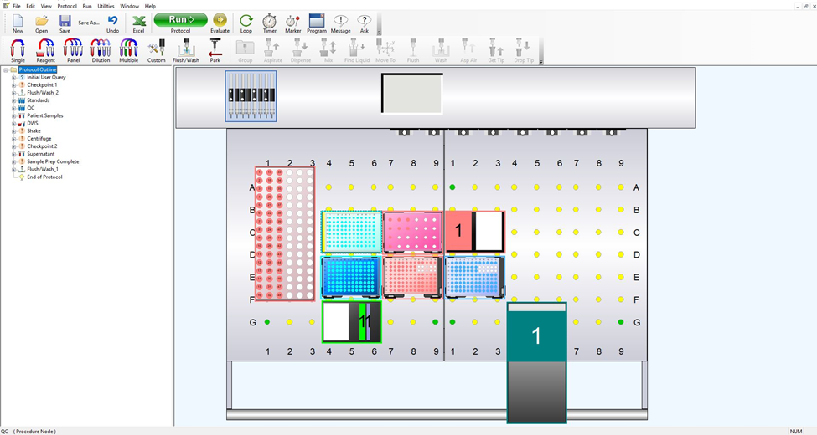

Figure S1 (b) Deck layout for the automation of the ADP sample preparation and analysis kit developed by Eureka (Commercial kit). The protocol shows the layout required for a vial-based protocol. Patient samples are housed on Columns 1-3, while calibrators were housed on the vial rack in Column 7, row B.
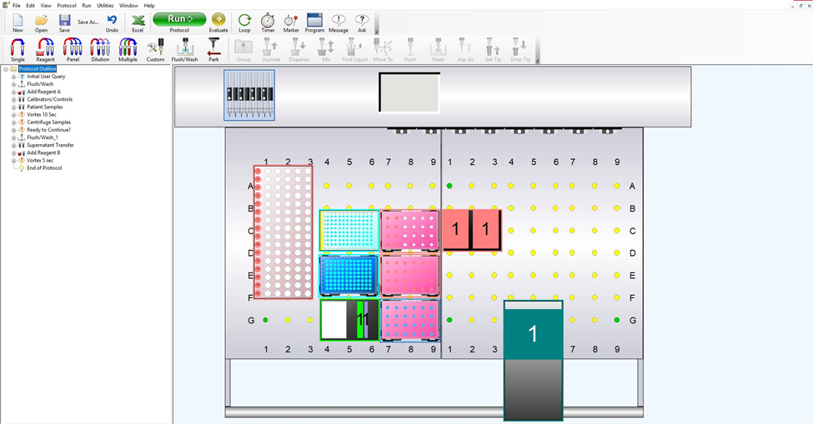
Figure S2. Running samples from the Eureka kit yielded noise when plotted on an overlay for relative intensity. No distinct chromatograms were observed whatsoever.
