Supporting Information

DNA sequence-specific ligands. XX. Synthesis, spectral properties, virological and biochemical studies of fluorescent dimeric trisbenzimidazoles DB₃P(n)¹

Albert F. Arutyunyan¹, Alexey A. Kostyukov², Vladislav A. Lushpa³, Konstantin S. Mineev³, Sergey P. Korolev⁴, Marina B. Gottikh⁴, Regina R. Klimova⁵, Alla A. Kushch⁵, Kseniya V. Kalabina⁶, Olga Yu. Susova⁶, Alexei L. Zhuze^{1,}*
¹Engelhardt Institute of Molecular Biology, Russian Academy of Sciences, Moscow 119991, Russia
² Emanuel Institute of Biochemical Physics, Russian Academy of Science, Moscow 119334, Russia
³Shemyakin and Ovchinnikov Institute of Bioorganic Chemistry, Russian Academy of Sciences, Moscow 117997, Russia
⁴Department of Chemistry and Belozersky Institute of Physicochemical Biology, Moscow State University, Moscow 119991, Russia
⁵Gamaleya National Research Center of Epidemiology and Microbiology, Ministry of Health of the Russian Federation, Moscow 123098, Russia
⁶FSBI N.N. Blokhin National Medical Research Center of Oncology, Moscow 115478, Russia

*Zhuze@eimb.ru
Figures S1 – S5
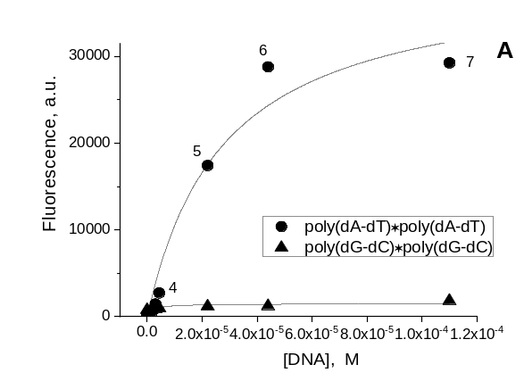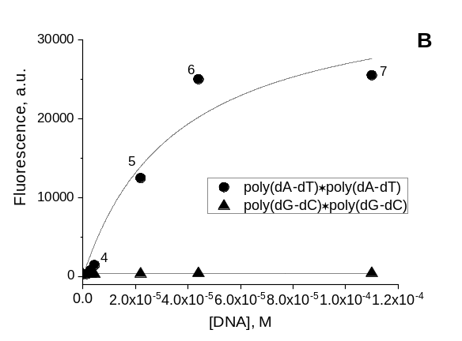
Fig. S1. A. Binding curves of DB₃P(2) in the absence and presence poly(dG-dC) *poly(dG-dC) and poly(dA-dT) *poly(dA-dT) in concentrations – 1- 0; 2 - 1.5; 3 - 3.0; 4 - 4.4; 5 - 22.0; 6 - 44.0; 7 -100 x 10⁻⁶ M b.p., respectively. The DB₃P(2) concentration 1.6 x 10⁻⁶ M. Buffer: 10 mM sodium phosphate (pH 7.4), 22⁰C. Optical path length 10 mm. B. Binding curves of DB₃P(4) in the absence and presence poly(dG-dC).poly(dG-dC) and poly(dA-dT).poly(dA-dT) in concentrations – 1- 0; 2 - 1.5; 3 - 3; 4 - 4.4; 5 - 13.2; 6 - 22; 7 - 44 x 10⁻⁶ M b.p., respectively. The DB₃P(4) concentration 1.6 x 10⁻⁶ M. Buffer: 10 mM sodium phosphate (pH 7.4), 22⁰C. Optical path length 10 mm.

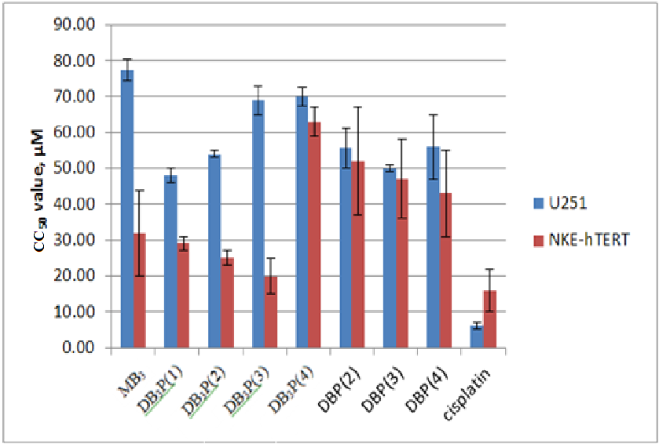

Fig. S2. Comparative cytotoxicity of monomeriс trisbenzimidazole MB₃, dimeric trisbenzimidazoles DB₃P(n) and dimeric bisbenzimidazoles DBP(n) [13] toward U251 and NKE-hTERT cell lines. Cell viability after the 72 h incubation with the compounds under study in the MTT test. CC₅₀ – the concentration of compound yielding 50% of control cell survival.
We need to emphasize that comparable cytotoxicity of DB₃P(4) toward U251 and NKE-hTERT cells caused by aggregation on cell membrane.
Cisplatin was used for comparison as a classical antitumor DNA-binding agent.

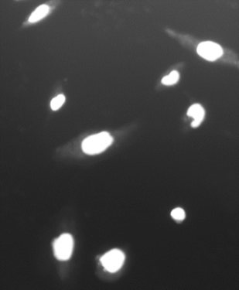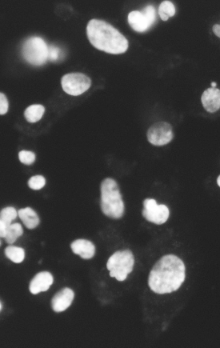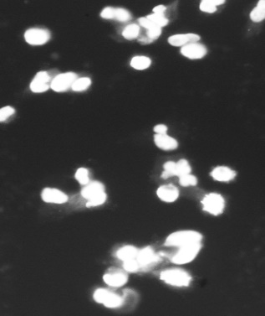
Hoechst 33258 МВ₃ DB₃P(1)
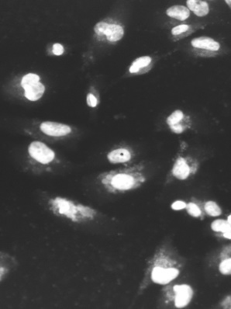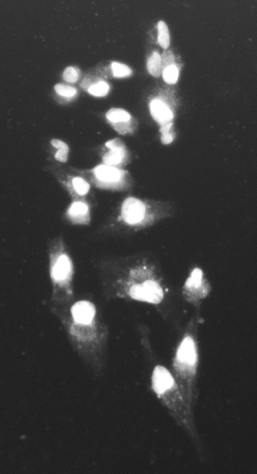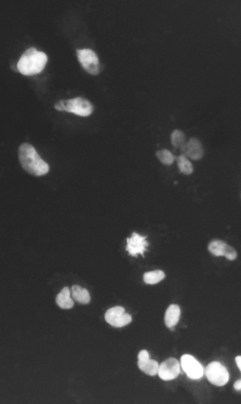
DB₃P(2) DB₃P(3) DB₃P(4)
Fig. S3. Penetration of 20 μM DB₃P(1–4), MB₃ & Hoechst 33258 into U251 cell nuclei in 1 day.

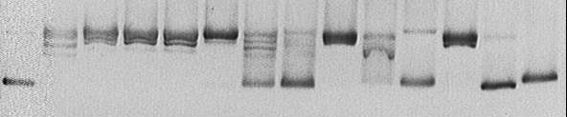
scDNA
topoisomers
relDNA
topo I 5 10 20 5 10 20 5 10 20 5 10 20 µM

MB₃ DB₃P(1) DB₃P(2) DB₃P(4)
Fig. S4 . Topo-inhibitory properties of the DB₃P(n) and MB₃.

.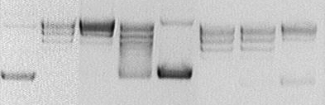
topoisomers
relDNA
scDNA
topo I 2,5 5 20 2,5 5 20 µM
DB₃P(2) DBP(2)
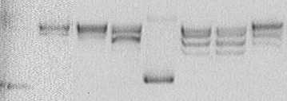
relDNA
topoisomers
scDNA
topo I 2,5 5 20 2,5 5 20 µM
DB₃P(4) DBP(4) Fig. S5. Comparison of the inhibitory activity of dimeric trisbenzimidazoles DB₃P(2), DB₃P(4) and dimeric bisbenzimidazoles DBP(2), DBP(4), respectively.

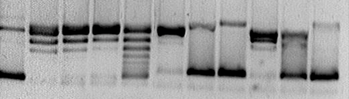
topoisomers
scDNA
relDNA
topoI 5 10 20 5 10 20 5 10 20 µM
Ht 33258 DB₃P(2) DB₃P(4)
Fig. S6. Inhibition of topo I by bis-benzimidazole Hoechstt 33258 and dimeric tris-benzimidazoles DB₃P(2,4).

¹H-NMR (300 MHz, DMSO-d₆) Spectral of synth. compounds (III – VI), MB₃
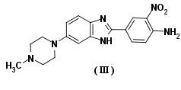
¹H-NMR compound (III)
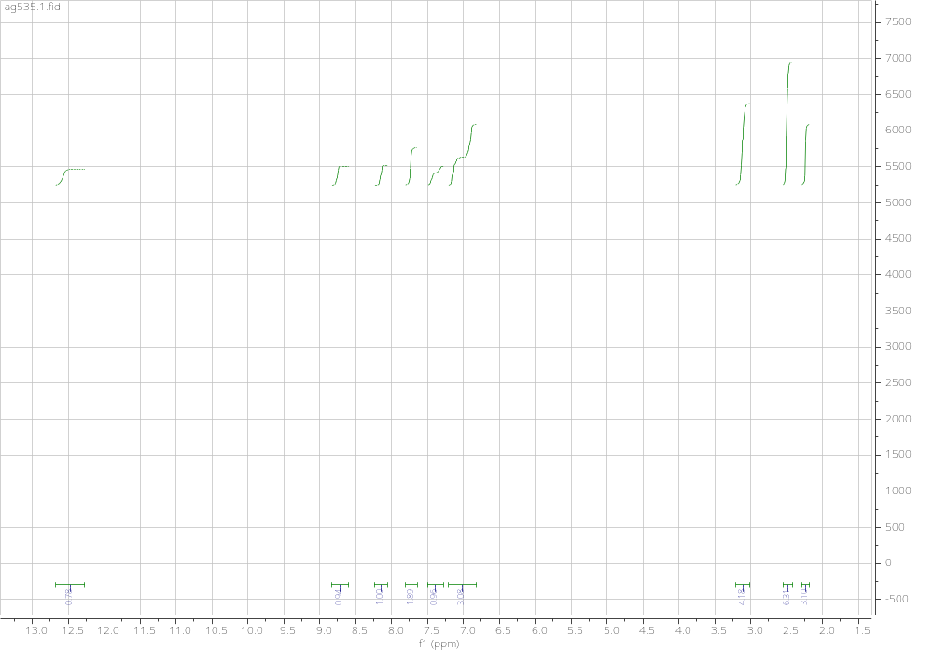

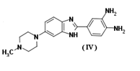
¹H-NMR compound (IV)
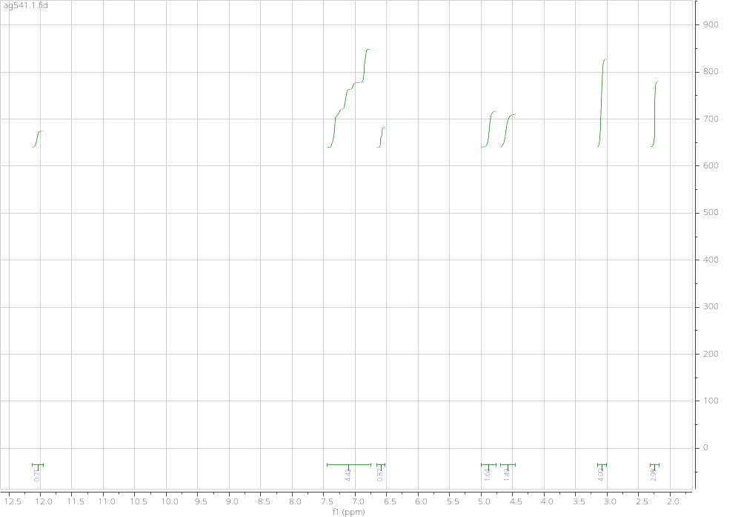

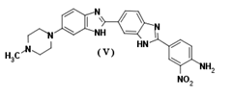
¹H-NMR compound (V)
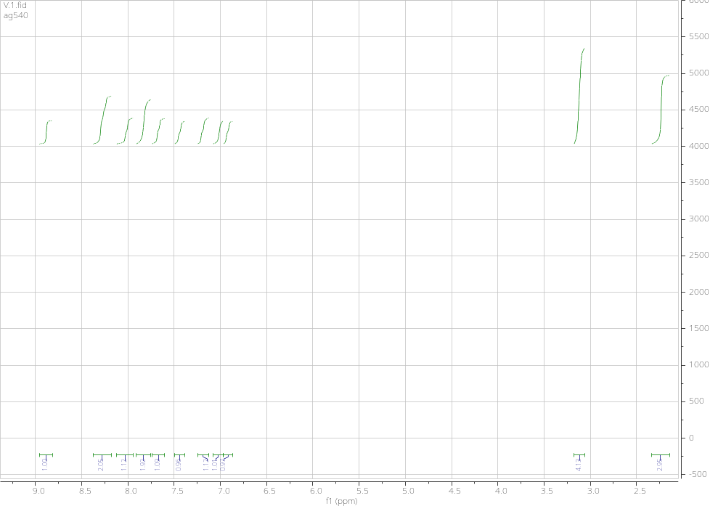

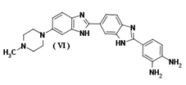
¹H-NMR compound (VI)
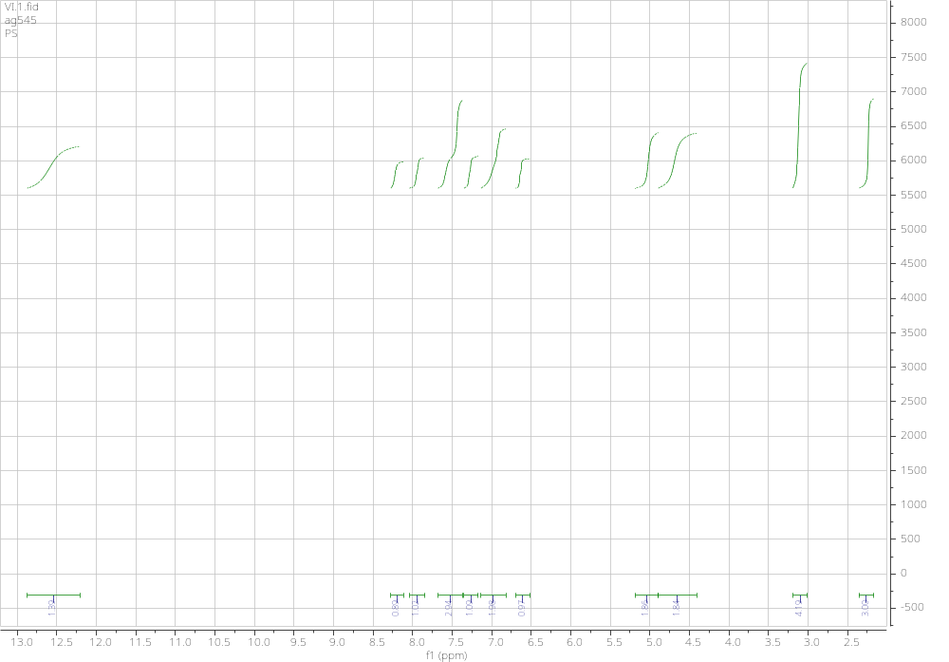

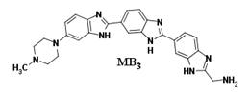
¹H-NMR compound MB₃
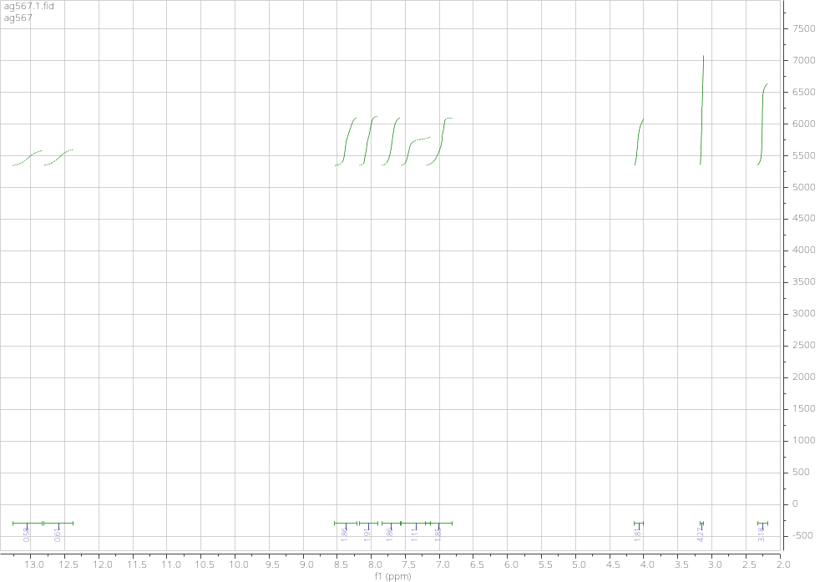

¹H-,¹³C–NMR (800 mH, DMSO-d₆): Spectral of synthetic compounds DB₃P(1, 2, 3, 4)
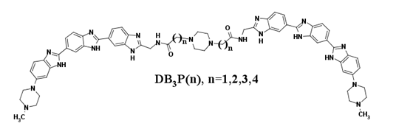
¹H-,¹³C–NMR DB₃P(1)
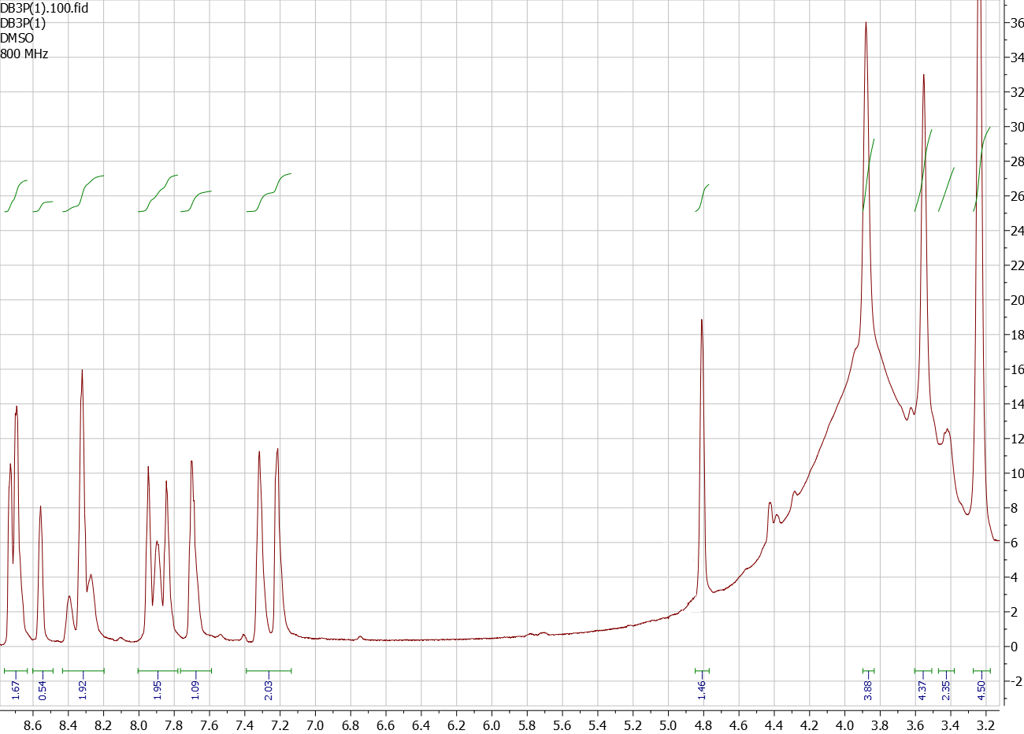
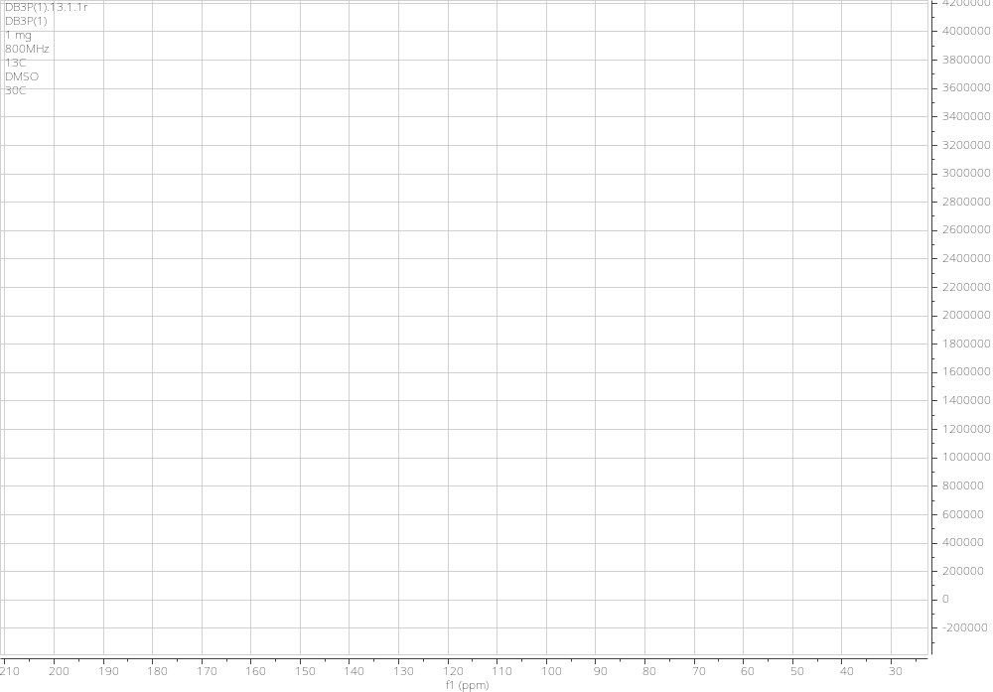

¹H-,¹³C-NMR DB₃P(2)
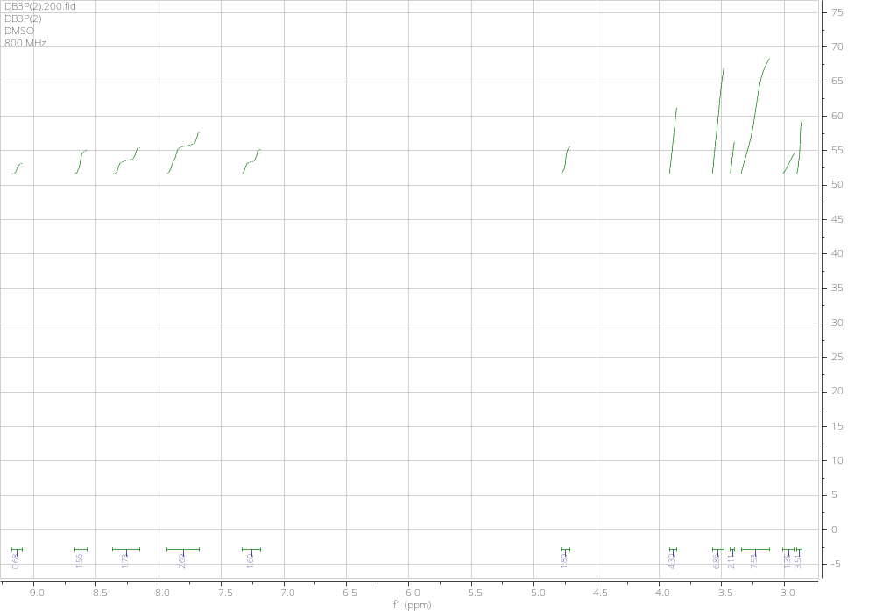
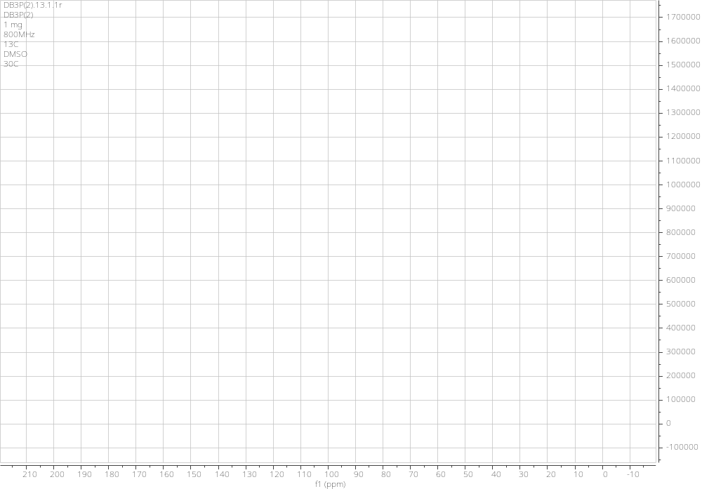

¹H-,¹³C-NMR DB₃P(3)
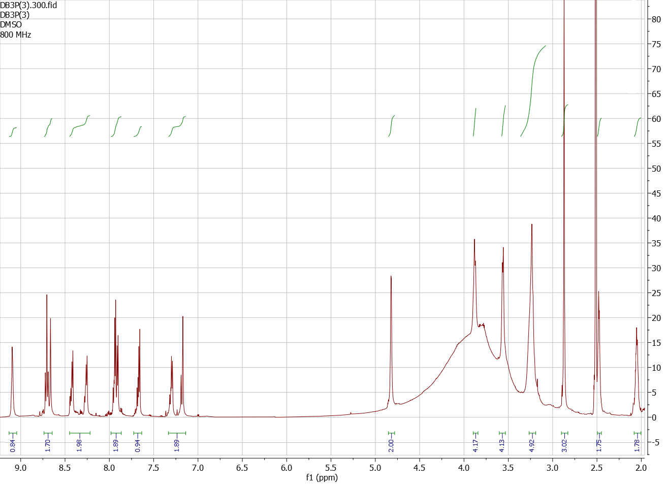
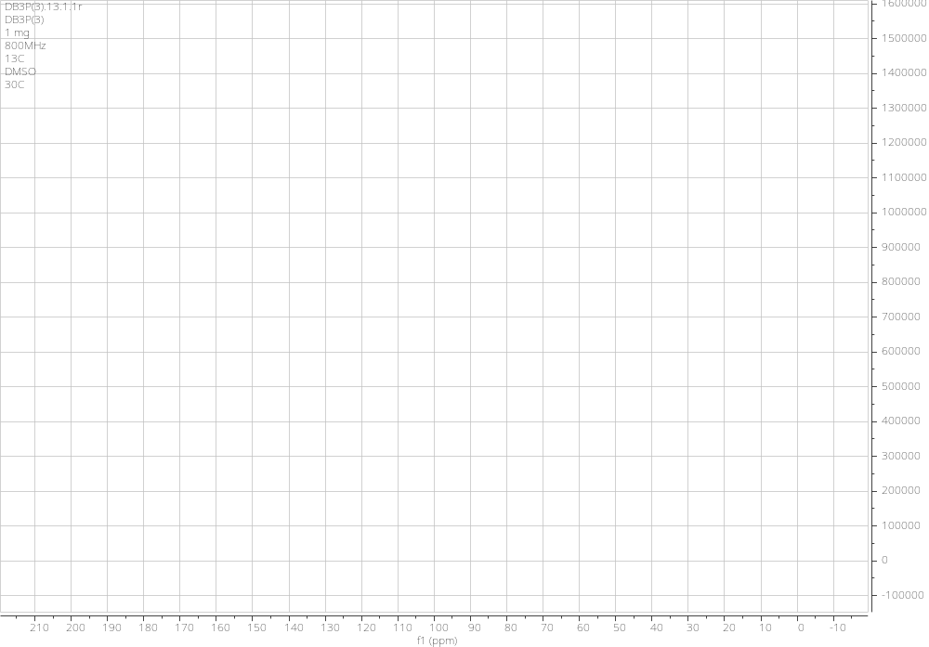

¹H-,¹³C-NMR DB₃P(4)
