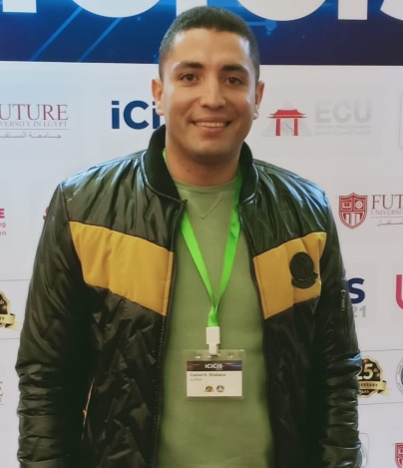
Gamal H. Shabana received the BEng. degree in Communication and the Master of Science degree from the Electronic Warfare Department, Military Technical College, Egypt 2016 and 2022, respectively. He has joined Technical Research Centre in 2017. He is a member of the researchers’ group in the Electronic Engineering Department. His research interest includes reconnaissance, eavesdropping systems, and jammers of remote detonation systems and ways to benefit from Artificial Intelligence in the fields of Electronic Warfare.

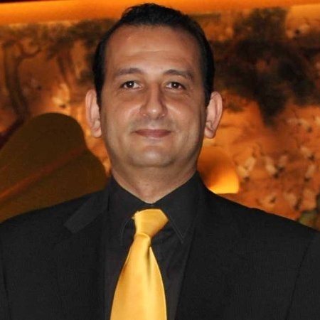
Ehab m. Shaheen received his BSc. and MSc. in Electrical Engineering both from Military Technical College, Cairo, Egypt in 1995 and 2000 respectively. In 2010, he received his PhD. degree from Carleton University, Ottawa, Canada. His doctoral thesis focused on the performance analysis of UWB communication systems in the presence of interference and noisy environments. He worked as an Associate Professor in the Electronic Warfare Department, at Military Technical College between 2010 till 2020. He is currently working in the Electrical and Computer Eng. Department, at Concordia University, Montreal, QC, Canada since 2021. His work focuses on Modulation and channel coding for wireless systems, signal processing for wireless communications, UWB systems, Navigation and Location technologies, Broadband wireless communication systems, and SWIPT-NOMA. He was the main author of the book "Understanding GPS Tracking/Acquisition Process with interference " LAP Lambert academic publishing 2019.

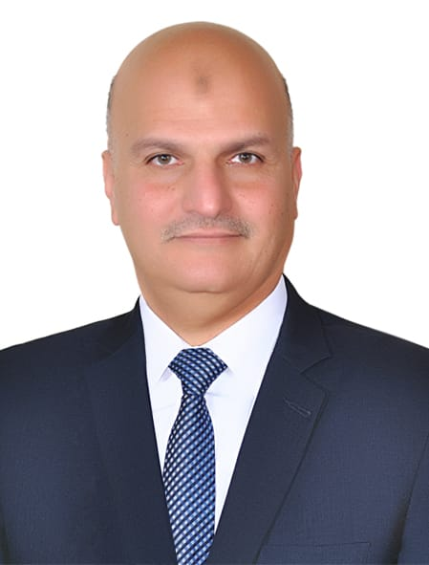
Mohamed Samir Abdel Latif Soliman received the BEng. degree in Communication and the Master of Science degree from the Military Technical College, Egypt 1993 and 2001, respectively. Between 1993 and 2006, he was an engineering officer in the Egyptian armed forces. Since 2006, he has been a Ph.D. student in the School of Electrical and Electronic Engineering at the University of Manchester. He received his Ph.D. from Manchester University in January 2009. From 2009 to 2020, he has been the chief of the Electronic Warfare Department at Military Technical College. He was promoted to Association Professor Doctor in Electrical and Computer Engineering from the Supreme Council of Universities, Cairo, Egypt in 2022. Now he is a faculty member at Military Technical College.

