Llew-Williams et al. Supplemental Information

Table S1. Raw data, measurements of water column variables – temperature, lectrical conductivity, and pH. From Llew-Williams (2022)

TEMPERATURE (° C)
Depth (m) | 15-Aug-18 | 20-Feb-19 | 13-Sep-19 | 1-Oct-19 | 19-Feb-20 | 17-Jun-20 | 23-Jul-20 | 20-Aug-20 | 17/Sep/20 | 15-Oct-20 | 18-Jun-21
0 | 24.80 | 1.80 | 19.44 | 18.64 | 2.85 | 20.17 | 25.40 | 23.32 | 19.46 | 14.90 | 21.22
1 | 25.10 | 4.00 | 19.71 | 18.34 | 3.75 | 20.09 | 25.44 | 23.55 | 19.62 | - | 21.21
2 | 25.10 | 4.10 | 19.70 | 18.22 | 4.18 | 19.48 | 25.40 | 23.56 | 19.62 | - | 21.18
3 | 25.00 | 4.01 | 19.71 | 18.07 | 4.43 | 18.84 | 23.45 | 23.51 | 19.59 | - | 20.62
4 | 24.10 | 4.28 | 19.69 | 17.92 | 4.58 | 16.54 | 20.78 | 23.52 | 19.61 | - | 18.36
5 | 24.20 | 4.38 | 17.93 | 15.78 | 4.64 | 13.55 | 17.80 | 21.52 | 19.60 | 15.22 | 17.48
6 | 19.50 | 4.45 | 14.05 | 12.98 | 4.65 | 12.19 | 15.75 | 18.15 | 19.52 | - | 13.88
7 | 16.70 | 4.48 | 11.80 | 10.50 | 4.70 | 11.14 | 14.50 | 15.61 | 16.67 | - | 11.62
8 | 12.30 | 4.48 | 9.20 | 8.84 | 4.74 | 9.68 | 13.06 | 13.86 | 14.19 | - | 9.94
9 | 10.90 | 4.52 | 8.40 | 7.86 | 4.72 | 8.88 | 11.40 | 12.09 | 12.57 | - | 9.08
10 | 9.10 | 4.58 | 7.30 | 7.08 | 4.77 | 8.06 | 9.95 | 10.05 | 11.37 | - | 8.66
11 | 8.90 | 4.59 | 6.80 | 6.71 | 4.86 | 7.20 | 8.90 | 8.86 | 10.01 | - | 8.49
12 | 7.50 | 4.62 | 6.98 | 6.40 | 4.90 | 7.15 | 7.98 | 8.22 | 8.83 | 7.98 | 6.88
13 | 7.10 | 4.67 | 6.18 | 6.05 | 5.05 | 6.83 | 7.65 | 7.64 | 7.70 | - | 6.46
14 | 6.50 | 4.80 | 5.89 | 6.00 | 5.13 | 6.42 | 7.29 | 7.21 | 6.95 | - | 6.19
14.25 | - | - | - | - | - | - | - | - | - | - | 6.26
14.5 | - | - | - | - | - | - | - | - | - | - | 6.03
14.75 | - | - | - | - | - | - | - | - | - | - | 6.76
15 | 6.50 | 5.07 | 5.76 | 5.96 | 5.37 | 6.07 | 6.99 | 6.54 | 6.61 | - | 6.29
15.25 | - | - | - | - | - | - | - | - | - | - | 6.30
15.5 | - | - | - | - | - | - | - | - | - | - | 6.11
15.75 | - | - | - | - | - | - | - | - | - | - | 5.84
16 | 6.30 | 5.27 | 5.80 | 5.97 | 5.66 | 6.12 | 6.36 | 6.44 | 6.77 | - | 5.76
16.25 | - | - | - | - | - | - | - | - | - | - | 5.84
16.5 | - | - | - | - | - | - | - | - | - | - | 5.70
16.75 | - | - | - | - | - | - | - | - | - | - | 5.88
17 | 5.80 | 5.74 | 5.87 | 6.08 | 5.86 | 6.27 | 6.58 | 6.25 | 6.33 | - | 6.94
17.25 | - | - | - | - | - | - | - | - | - | - | 6.04
17.5 | - | - | - | - | - | - | - | - | - | - | 5.96
17.75 | - | - | - | - | - | - | - | - | - | - | 5.96
18 | 6.00 | 5.88 | 5.83 | 6.35 | 5.96 | 6.45 | 6.55 | 6.42 | 6.39 | 6.81 | 5.85
19 | 6.20 | 6.03 | - | 6.50 | 6.09 | 6.10 | 6.65 | 6.50 | 6.39 | - | 5.93
20 | 6.30 | 6.20 | - | 6.64 | 6.24 | 6.20 | 6.90 | 6.58 | 6.46 | - | 6.06
20.5 | - | - | - | - | - | - | 6.95 | - | 6.69 | - | -
21 | 6.70 | 6.34 | - | 7.08 | 6.29 | 6.25 | - | 6.68 | - | - | 6.17
21.5 | - | - | - | - | - | - | - | 6.43 | - | - | -
22 | - | 6.44 | - | - | 6.40 | - | - | - | - | - | 6.33
22.5 | - | 6.90 | - | - | 6.42 | - | - | - | - | - | -

ELECTRICAL CONDUCTIVITY (µS/cm)
Depth (m) | 15-Aug-18 | 20-Feb-19 | 13-Sep-19 | 1-Oct-19 | 19-Feb-20 | 17-Jun-20 | 23-Jul-20 | 20-Aug-20 | 17/Sep/20 | 15-Oct-20 | 18-Jun-21
0 | 580 | 583 | 556 | 560 | 558 | 545 | 521 | 537 | 540 | 558 | 575
1 | 599 | 580 | 555 | 562 | 586 | 545 | 515 | 524 | 538 | - | 575
2 | 599 | 580 | 555 | 563 | 594 | 560 | 514 | 522 | 539 | - | 575
3 | 550 | 580 | 555 | 566 | 595 | 586 | 567 | 521 | 539 | - | 600
4 | 595 | 582 | 555 | 575 | 601 | 587 | 591 | 521 | 539 | - | 623
5 | 595 | 585 | 641 | 630 | 603 | 610 | 609 | 587 | 539 | 559 | 626
6 | 632 | 585 | 642 | 648 | 604 | 630 | 615 | 621 | 543 | - | 636
7 | 642 | 590 | 644 | 658 | 606 | 635 | 616 | 627 | 632 | - | 644
8 | 652 | 592 | 653 | 664 | 610 | 645 | 621 | 628 | 644 | - | 640
9 | 670 | 595 | 652 | 666 | 618 | 648 | 629 | 630 | 643 | - | 642
10 | 676 | 599 | 663 | 673 | 624 | 653 | 632 | 635 | 650 | - | 645
11 | 690 | 602 | 668 | 680 | 624 | 666 | 638 | 641 | 649 | - | 654
12 | 700 | 607 | 676 | 697 | 630 | 670 | 650 | 649 | 654 | 676 | 666
13 | 697 | 612 | 689 | 739 | 644 | 691 | 657 | 661 | 673 | - | 670
14 | 718 | 618 | 717 | 785 | 657 | 761 | 675 | 684 | 722 | - | 673
14.25 | - | - | - | - | - | - | - | - | - | - | 672
14.5 | - | - | - | - | - | - | - | - | - | - | 674
14.75 | - | - | - | - | - | - | - | - | - | - | 676
15 | 758 | 660 | 787 | 1110 | 715 | 983 | 718 | 837 | 802 | - | 680
15.25 | - | - | - | - | - | - | - | - | - | - | 683
15.5 | - | - | - | - | - | - | - | - | - | - | 680
15.75 | - | - | - | - | - | - | - | - | - | - | 715
16 | 1100 | 1060 | 1070 | 1420 | 1040 | 1180 | 1020 | 1170 | 926 | - | 741
16.25 | - | - | - | - | - | - | - | - | - | - | 787
16.5 | - | - | - | - | - | - | - | - | - | - | 843
16.75 | - | - | - | - | - | - | - | - | - | - | 919
17 | 1770 | 1690 | 1870 | 1890 | 1370 | 1440 | 1420 | 1650 | 1400 | - | 1170
17.25 | - | - | - | - | - | - | - | - | - | - | 1290
17.5 | - | - | - | - | - | - | - | - | - | - | 1460
17.75 | - | - | - | - | - | - | - | - | - | - | 1530
18 | 2290 | 1950 | 2040 | 2240 | 1770 | 1860 | 1730 | 1970 | 2070 | 1870 | 1690
19 | 2630 | 2370 |  | 2600 | 2280 | 1900 | 2170 | 2330 | 2320 | - | 1920
20 | 2870 | 2570 | - | 2630 | 2520 | 1920 | 2300 | 2490 | 2510 | - | 2250
20.5 | - | - | - | - | - | - | 2470 | - | 2570 | - | -
21 | 2850 | 2660 | - | 2630 | 2570 | 2330 | - | 2600 | - | - | 2560
21.5 | - | - | - | - | - | - | - | 2590 | - | - | -
22 | - | 2690 | - | - | 2660 | - | - | - | - | - | 2700
22.5 | - | 2290 | - | - | 2690 | - | - | - | - | - | -

pH
Depth (m) | 15-Aug-18 | 20-Feb-19 | 13-Sep-19 | 1-Oct-19 | 19-Feb-20 | 17-Jun-20 | 23-Jul-20 | 20-Aug-20 | 17/Sep/20 | 15-Oct-20 | 18-Jun-21
0 | 8.10 | 7.36 | 7.59 | 7.64 | 7.72 | 8.02 | 7.93 | 7.38 | 7.90 | 8.5 | 7.84
1 | 7.97 | 7.36 | 7.61 | 7.65 | 7.75 | 8.12 | 8.05 | 7.77 | 7.91 | - | 7.81
2 | 7.85 | 7.36 | 7.60 | 7.68 | 7.75 | 8.01 | 8.09 | 7.76 | 7.91 | - | 7.82
3 | 7.62 | 7.12 | 7.56 | 7.66 | 7.74 | 7.81 | 7.93 | 7.74 | 7.90 | - | 7.71
4 | 7.35 | 6.99 | 7.59 | 7.60 | 7.70 | 7.77 | 7.94 | 7.73 | 7.84 | - | 7.55
5 | 7.36 | 6.91 | 7.24 | 7.15 | 7.69 | 7.55 | 7.89 | 7.47 | 7.72 | 8.51 | 7.45
6 | 7.24 | 6.71 | 7.26 | 7.05 | 7.41 | 7.38 | 7.88 | 7.22 | 7.81 | - | 7.22
7 | 7.21 | 6.75 | 7.16 | 6.88 | 7.36 | 7.27 | 7.74 | 7.20 | 7.38 | - | 7.17
8 | 7.03 | 6.72 | 6.98 | 6.87 | 7.25 | 7.16 | 7.61 | 7.03 | 7.17 | - | 7.09
9 | 6.95 | 6.73 | 6.89 | 6.82 | 7.26 | 7.17 | 7.57 | 6.91 | 7.12 | - | 7.49
10 | 6.90 | 6.79 | 6.70 | 6.80 | 7.17 | 7.00 | 7.57 | 6.84 | 7.08 | - | 7.25
11 | 6.80 | 6.80 | 6.72 | 6.75 | 7.10 | 7.08 | 7.47 | 6.77 | 6.96 | - | 7.38
12 | 6.70 | 6.72 | 6.69 | 6.71 | 7.04 | 7.02 | 7.53 | 6.93 | 6.95 | 7.76 | 7.01
13 | 6.70 | 6.69 | 6.63 | 6.57 | 6.97 | 6.93 | 7.45 | 6.82 | 6.76 | - | 6.92
14 | 6.67 | 6.63 | 6.52 | 6.55 | 6.92 | 6.72 | 7.33 | 6.71 | 6.56 | - | 6.88
14.25 | - | - | - | - | - | - | - | - | - | - | 6.84
14.5 | - | - | - | - | - | - | - | - | - | - | 6.72
14.75 | - | - | - | - | - | - | - | - | - | - | 7.32
15 | 6.55 | 6.93 | 6.11 | 6.14 | 6.68 | 6.34 | 7.13 | 6.21 | 6.39 | - | 6.95
15.25 | - | - | - | - | - | - | - | - | - | - | 6.93
15.5 | - | - | - | - | - | - | - | - | - | - | 6.99
15.75 | - | - | - | - | - | - | - | - | - | - | 6.82
16 | 6.05 | 5.94 | 5.99 | 5.98 | 6.22 | 6.33 | 6.78 | 5.96 | 6.35 | - | 6.66
16.25 | - | - | - | - | - | - | - | - | - | - | 6.44
16.5 | - | - | - | - | - | - | - | - | - | - | 6.30
16.75 | - | - | - | - | - | - | - | - | - | - | 6.20
17 | 5.89 | 5.80 | 5.95 | 5.96 | 6.11 | 6.22 | 6.70 | 5.91 | 5.96 | - | 6.51
17.25 | - | - | - | - | - | - | - | - | - | - | 6.25
17.5 | - | - | - | - | - | - | - | - | - | - | 6.21
17.75 | - | - | - | - | - | - | - | - | - | - | 6.41
18 | 5.80 | 5.79 | 5.94 | 5.93 | 6.11 | 6.20 | 6.70 | 5.85 | 5.92 | 6.67 | 6.26
19 | 5.80 | 5.79 |  | 5.91 | 6.12 | 6.19 | 6.70 | 5.84 | 5.90 | - | 6.21
20 | 5.80 | 5.80 |  | 5.90 | 6.13 | 6.10 | 6.71 | 5.84 | 5.88 | - | 6.21
20.5 | - | - | - | - | - | - | 6.72 | - | 5.87 | - | -
21 | 5.89 | 5.80 | - | 5.88 | 6.14 | 6.13 | - | 5.85 | - | - | 6.21
21.5 | - | - | - | - | - | - | - | 5.85 | - | - | -
22 | - | 5.81 | - | - | 6.14 | - | - | - | - | - | 6.22
22.5 | - | 5.80 | - | - | 6.14 | - | - | - | - | - | -

Table S2. Raw data, measurements of water chemistry – calclium and alkalinity (data from E3 Laboratories). From Llew-Williams (2022)

Date | Depth (m) | Calcium (mg/L) | Alkalinity (CaCO3) (mg/L)
20-Feb-19 | 2 | 60.2 | 276
 | 9 | 60.1 | 279
 | 15 | 69.8 | 304
 | 20 | 188 | 1070
13-Sep-19 | 10 | 79.1 | 288
 | 15 | 84.6 | 320
 | 20 | 184 | 1020
1-Oct-19 | 0 | 56.5 | 245
 | 0 | 56.5 | 248
 | 10 | 71 | 293
 | 15 | 84.4 | 327
 | 20 | 87.5 | 401
29-Nov-19 | 5 | 60 | 290
 | 10 | 60.5 | 281
 | 12 | 60 | 282
 | 14 | 65.9 | 302
 | 16 | 88.4 | 410
 | 18 | 79 | 362
 | 20 | 141 | 823
19-Feb-20 | 0 | 66.2 | 266
 | 4 | 65.3 | 274
 | 10 | 68.8 | 283
 | 12 | 68.8 | 284
 | 14 | 71.4 | 296
 | 16 | 99.5 | 455
 | 18 | 132 | 694
 | 20 | 196 | 1160
 | 22 | 215 | 1390
17-Jun-20 | 0 | 54.4 | 244
 | 5 | 56.4 | 262
 | 10 | 68.5 | 297
 | 14 | 71.5 | 307
 | 16 | 91.44 | 421
 | 18 | 170 | 991
 | 20 | 193 | 1290
* | 22 | 102 | 555

Date | Depth (m) | Calcium (mg/L) | Alkalinity (CaCO3) (mg/L)
23-Jul-20 | 0 | 48.4 | 240
 | 2 | 48.5 | 241
 | 4 | 61.9 | 274
 | 6 | 65.1 | 290
 | 8 | 62.3 | 287
 | 10 | 66.9 | 293
 | 15 | 67.8 | 305
 | 20 | 186 | 1230
20-Aug-20 | 0 | 51.8 | 227
 | 2 | 50.7 | 248
 | 5 | 54.7 | 248
 | 10 | 69.3 | 297
 | 15 | 73.6 | 302
 | 18 | 119 | 635
 | 20 | 186 | 1190
28-Sep-20 | 2 | 49.8 | 254
 | 6 | 49.4 | 251
 | 12 | 69.7 | 306
 | 18 | 85.3 | 427
 | 22 | 198 | 1410
19-Oct-20 | 0 | 54.4 | 263
 | 4 | 51.8 | 246
 | 12 | 71.7 | 312
 | 18 | 165 | 923
18-Jun-21 | 13 | 67.5 | 300
 | 15 | 68.5 | 298
 | 17 | 129 | 666

Table S3. Raw data used in LSI calculations. From Llew-Williams (2022)

Date | Depth (m) | Calcium (mg/L) | Alkalinity (CaCO3) (mg/L) | Conductivity (uS/cm) | pH | Temperature | pHs | LSI
20-Feb-19 | 2 | 60.2 | 276 | 583 | 7.36 | 4.1 | 8.1 | -0.74
 | 9 | 60.1 | 279 | 595 | 6.73 | 4.5 | 8.1 | -1.37
 | 15 | 69.8 | 304 | 660 | 6.93 | 5.1 | 7.9 | -0.97
 | 20 | 188 | 1070 | 2570 | 5.8 | 6.2 | 7.2 | -1.4
1-Oct-19 | 0 | 56.5 | 245 | 560 | 7.64 | 18.6 | 7.8 | -0.16
 | 10 | 71 | 293 | 673 | 6.8 | 7.1 | 7.9 | -1.1
 | 15 | 84.4 | 327 | 1110 | 6.14 | 6.0 | 7.9 | -1.76
 | 20 | 87.5 | 401 | 2630 | 5.9 | 6.6 | 8 | -2.1
13-Sep-19 | 10 | 79.1 | 288 | 668 | 6.7 | 7.3 | 7.9 | -1.2
 | 15 | 84.6 | 320 | 787 | 6.11 | 5.8 | 7.8 | -1.69
* | 20 | 184 | 1020 | 2040 | 5.94 | 5.8 | 7.2 | -1.26
19-Feb-20 | 0 | 66.2 | 266 | 558 | 7.72 | 2.9 | 8.1 | -0.38
 | 4 | 65.3 | 274 | 601 | 7.7 | 4.6 | 8 | -0.3
 | 10 | 68.8 | 283 | 624 | 7.17 | 4.8 | 8 | -0.83
 | 12 | 68.8 | 284 | 630 | 7.04 | 4.9 | 8 | -0.96
 | 14 | 71.4 | 296 | 657 | 6.92 | 5.1 | 7.9 | -0.98
 | 16 | 99.5 | 455 | 1040 | 6.22 | 5.7 | 7.7 | -1.48
 | 18 | 132 | 694 | 1770 | 6.11 | 6.0 | 7.5 | -1.39
 | 20 | 196 | 1160 | 2520 | 6.13 | 6.2 | 7.2 | -1.07
 | 22 | 215 | 1390 | 2660 | 6.14 | 6.4 | 7.1 | -0.96
24-Jun-20 | 0 | 54.4 | 244 | 545 | 8.02 | 20.2 | 7.8 | 0.22
 | 5 | 56.4 | 262 | 610 | 7.55 | 13.6 | 7.9 | -0.35
 | 10 | 68.5 | 297 | 653 | 7 | 8.1 | 7.9 | -0.9
 | 14 | 71.5 | 307 | 761 | 6.72 | 6.4 | 7.9 | -1.18
 | 16 | 91.44 | 421 | 1180 | 6.33 | 6.1 | 7.8 | -1.47
 | 18 | 170 | 991 | 1860 | 6.2 | 6.5 | 7.2 | -1
 | 20 | 193 | 1290 | 1920 | 6.1 | 6.2 | 7.1 | -1
 | 22 | 102 | 555 | 1120 | 6.5 | 6.2 | 7.6 | -1.1

Date | Depth (m) | Calcium (mg/L) | Alkalinity (CaCO3) (mg/L) | Conductivity (uS/cm) | pH | Temperature | pHs | LSI
23-Jul-20 | 0 | 48.4 | 240 | 521 | 7.93 | 25.4 | 7.7 | 0.23
 | 2 | 48.5 | 241 | 514 | 8.09 | 25.4 | 7.7 | 0.39
 | 4 | 61.9 | 274 | 591 | 7.94 | 20.8 | 7.6 | 0.34
 | 6 | 65.1 | 290 | 615 | 7.88 | 15.8 | 7.7 | 0.18
 | 8 | 62.3 | 287 | 621 | 7.61 | 13.1 | 7.8 | -0.19
 | 10 | 66.9 | 293 | 632 | 7.57 | 10.0 | 7.8 | -0.23
 | 15 | 67.8 | 305 | 718 | 7.13 | 7.0 | 7.9 | -0.77
 | 20 | 186 | 1230 | 2300 | 6.72 | 7.0 | 7.1 | -0.38
20-Aug-20 | 0 | 51.8 | 227 | 537 | 7.38 | 23.3 | 7.7 | -0.32
 | 2 | 50.7 | 248 | 522 | 7.76 | 23.6 | 7.7 | 0.06
 | 5 | 54.7 | 248 | 587 | 7.47 | 21.5 | 7.7 | -0.23
 | 10 | 69.3 | 297 | 635 | 6.84 | 10.1 | 7.8 | -0.96
 | 15 | 73.6 | 302 | 837 | 6.21 | 6.5 | 7.9 | -1.69
 | 18 | 119 | 635 | 1970 | 5.85 | 6.4 | 7.6 | -1.75
 | 20 | 186 | 1190 | 2490 | 5.84 | 6.6 | 7.2 | -1.36
28-Sep-20 | 2 | 49.8 | 254 | 539 | 7.91 | 19.6 | 7.8 | 0.11
 | 6 | 49.4 | 251 | 543 | 7.81 | 19.5 | 7.8 | 0.01
 | 12 | 69.7 | 306 | 654 | 6.95 | 8.8 | 7.8 | -0.85
 | 18 | 85.3 | 427 | 2070 | 5.92 | 6.4 | 7.8 | -1.88
19-Oct-20 | 0 | 54.4 | 263 | 558 | 8.5 | 14.9 | 7.8 | 0.7
 | 4 | 51.8 | 246 | 559 | 8.51 | 15.2 | 7.9 | 0.61
 | 12 | 71.7 | 312 | 676 | 7.76 | 8.0 | 7.8 | -0.04
 | 18 | 165 | 923 | 1870 | 6.67 | 6.8 | 7.2 | -0.53
18-Jun-21 | 13 | 67.5 | 300 | 670 | 6.92 | 6.46 | 7.9 | -1
 | 15 | 68.5 | 298 | 680 | 6.95 | 6.29 | 7.9 | -0.98
 | 17 | 129 | 666 | 1170 | 6.51 | 6.94 | 7.4 | -0.88

Notes:
* | Horiba Data from 18 m
Bolded Values | Positive LSI Values

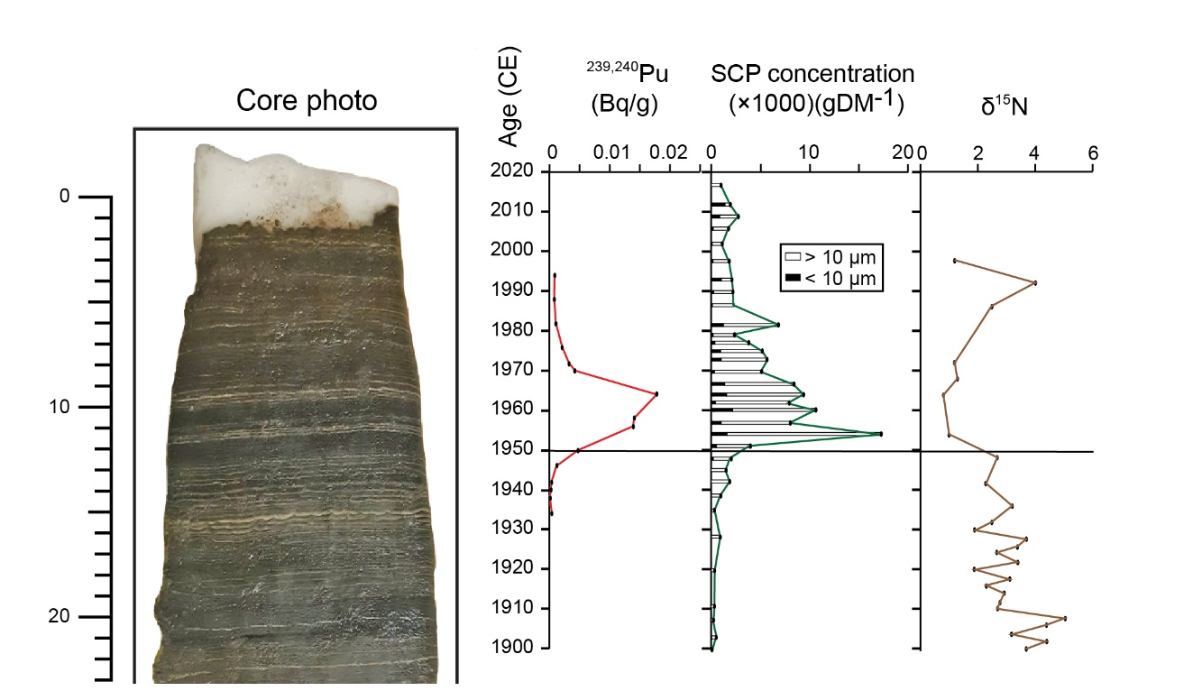
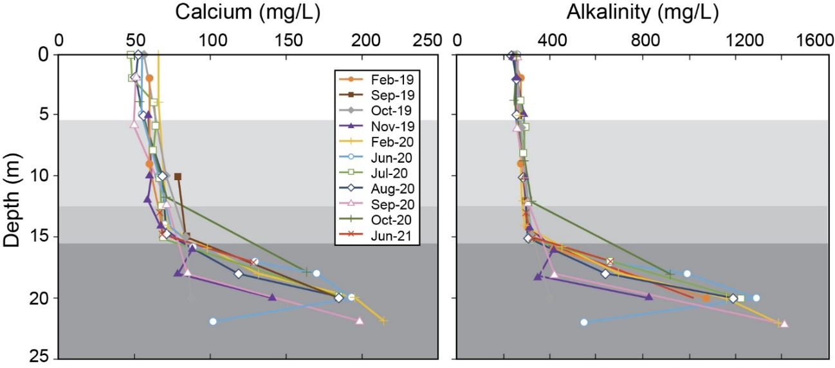
Fig. S1 Photograph of core CRA19-2FT-1FRA and plot of Pu activity (Bqg⁻¹), content of spheroidal carbonaceous particles (gDM⁻¹), and delta ¹⁵N in the varved sediments of Crawford Lake. Sharp increases in particulate and isotopic products of fossil fuel combustion – spheroidal carbonaceous particles (SCPs) and light isotopes of nitrogen (δ¹⁵N ‰) – identify the Great Acceleration. The base of the thin light-coloured lamina deposited in the summer of 1950 CE (Lafond et al., accepted) marks the proposed GSSP to define the base of the Anthropocene and coincides with the onset of nuclear fallout from bomb testing (²³⁹⁺²⁴⁰Pu). The lowermost of two dark bands separated by a triplet of prominent calcite laminae deposited in the summers of 1956, 1957 and 1958, are attributed to acidification associated with fossil fuel emissions, notably from steel mills in nearby Hamilton. In contrast, note the thick white laminae through the warm, dry 1930s. Modified from McCarthy et al. (accepted)

Fig. S2 Concentrations of a) calcium, and b) alkalinity in water sampled from discrete depths (Table S2) record hard water throughout the water column of Crawford Lake, but much higher concentrations below 16 m confirm the distinctiveness of the monimolimnion (darkest shading) from the overlying mixolimnion that was determined through 235 measurements of electrical conductivity (specific conductance), pH, and temperature between August 2018 and September 2021 (see Fig. 4). Modified from Llew-Williams (2022)

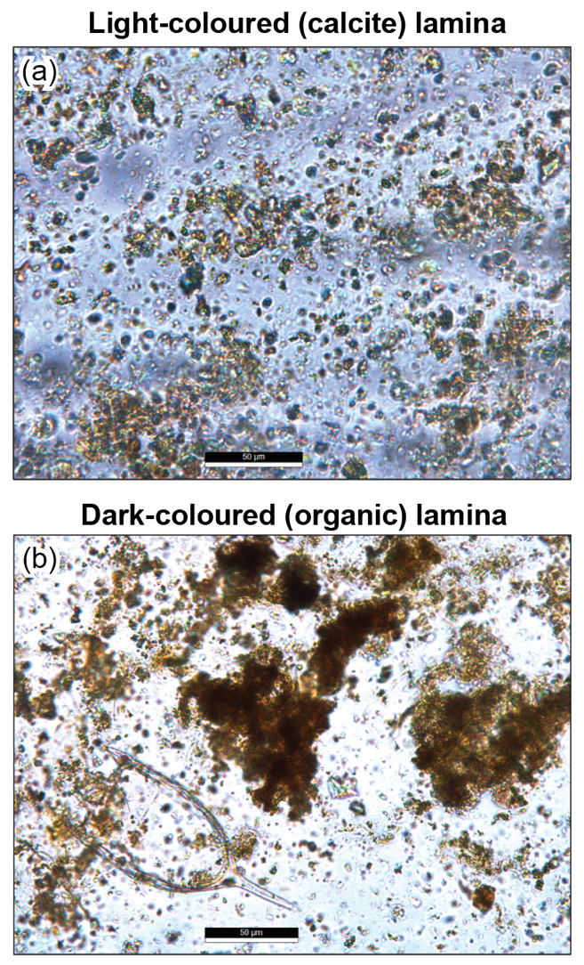
Fig. S3 The contents of the light (a) and dark (b) laminae from the thick 1935 varve from the 2011 CL core, analyzed and imaged at ×400 magnification (scale bar = 50 μm). A concentrated matrix of small calcite crystals (~5–25 μm) is evident in the sample taken from the lighter lamina. The dark lamina is dominated by amorphous and particulate organic matter, including the rotifer lorica shown at the bottom left, but also contains calcite crystals

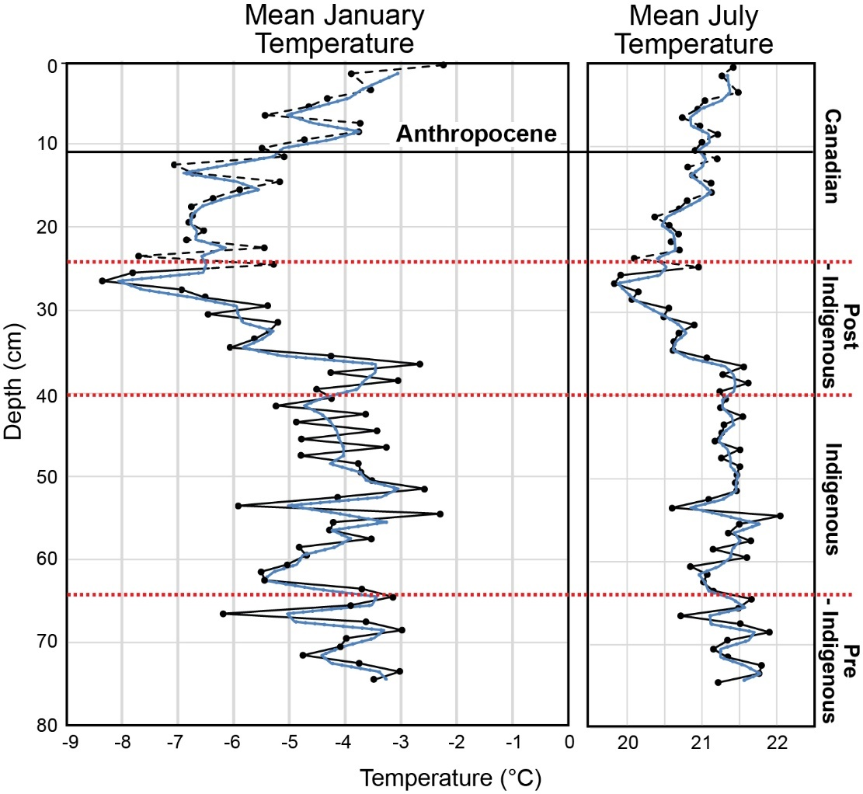

Fig. S4 Transfer function-based reconstructions of temperature (Table S4) and three point moving average (dotted blue line) for pollen records from core CL-19 (McCarthy et al., accepted; see supplemental data) using transfer functions of Bartlein and Whitlock (1993) for the region encompassing Crawford Lake. Rapid cooling is reconstructed beginning in the mid-16th century with the coldest conditions reconstructed in the mid-19th century, just before the Ambrosia rise recording widespread land clearing (note that reconstructions in the upper 25 cm of the core are dashed to indicate low reliability of reconstructed climate values due to alteration of vegetation by European colonists). See age model for core CL-19 in Fig. 8

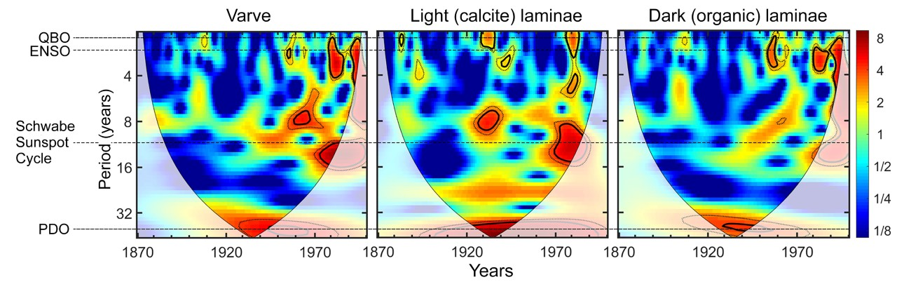
Fig. S5 Continuous wavelet transform analysis of variations in thickness of light and dark laminae in freeze core CRA19-2FT-B2 from the deep basin of Crawford Lake, with the average length of major climate cycles overlain to demonstrate their likely relationships to the observed varve records. The 11-year Schwabe Sunspot Cycle (SSC) and the Quasi-Biennial Oscillation (QBO) appear strongly associated with the precipitation and accumulation of calcite, whereas the 2–7 year El Niño Southern Oscillation (ENSO) appears to exert the greatest influence on the organic component of the varves. The 50–70-year periodicity of the Pacific Decadal Oscillation (PDO) is strongly expressed in both components, and the “Great Regime Shift” of 1976/1977 is particularly evident in the record of thickness of dark laminae. Modified from Lafond et al. (accepted)

