Appendix

Table A.1: Balance Test for Treatment and Control Groups, MPS

-9.44∗∗
 | Mean(Treatment) | Mean(Control) | Diff | SE | Obs
DA in 2019 | 376.86 | 377.15 | 0.29 | 11.21 | 523
DA in 2020: January-3rd March | 61.01 | 61.90 | 0.89 | 1.97 | 523
DA in 2020: 3rd March-21st April | 52.74 | 52.16 | -0.58 | 1.72 | 523
No. of COVID-19 cases (w5-39) | 1165.55 | 1139.28 | -26.27 | 69.99 | 523
Density (number of persons per hectare) | 124.13 | 114.68 |  | 4.55 | 523
Low deprivation houses | 0.15 | 0.16 | 0.01 | 0.01 | 523
Moderately deprived houses | 0.41 | 0.42 | 0.01 | 0.01 | 523
High deprivation houses | 0.43 | 0.42 | -0.02 | 0.02 | 523
Females | 50.48 | 50.64 | 0.15 | 0.13 | 523
Males | 49.52 | 49.36 | -0.15 | 0.13 | 523
Very low English speaking ability | 15.81 | 15.01 | -0.80 | 0.99 | 523
% low education | 30.41 | 30.62 | 0.21 | 0.70 | 523
Economically active: Unemployed | 5.85 | 5.66 | -0.19 | 0.12 | 523
% living in a couple | 45.54 | 46.48 | 0.94 | 0.63 | 523
Age 16-24 | 43.45 | 43.00 | -0.46 | 1.01 | 523
Age 25-44 | 123.47 | 120.36 | -3.11 | 2.00 | 523
Age 44-64 | 68.16 | 69.04 | 0.88 | 1.09 | 523
Age 65 and above | 33.46 | 34.99 | 1.53 | 0.94 | 523

Table A.2: Balance Test for Treatment and Control Groups, TVP
 | (1)
 | Mean(Treatment) | Mean(Control) | Diff | SE | Obs
Domestic abuse calls | 1.44 | 1.44 | 0.00 | 0.02 | 7034
Total calls | 1.65 | 1.68 | 0.03 | 0.03 | 7034
Has mobile number | 1.00 | 1.00 | 0.00 | 0.00 | 7034
Violence without injury | 0.91 | 0.92 | 0.00 | 0.02 | 7034
Violence with injury | 0.32 | 0.31 | -0.00 | 0.01 | 7034
Criminal damage | 0.14 | 0.15 | 0.01 | 0.01 | 7034
Other theft offences | 0.06 | 0.07 | 0.01 | 0.01 | 7034
Rape | 0.05 | 0.06 | 0.01 | 0.01 | 7034
Average victim age in last incident | 35.38 | 35.17 | -0.21 | 0.29 | 7034
Age under 25 | 0.24 | 0.23 | -0.00 | 0.01 | 7034
Age btw. 25 and 40 | 0.46 | 0.47 | 0.01 | 0.01 | 7034
Age over 40 | 0.31 | 0.30 | -0.01 | 0.01 | 7034
Female | 1.00 | 1.00 | 0.00 | 0.00 | 7034
White British | 0.35 | 0.33 | -0.01 | 0.01 | 7034
White Irish | 0.01 | 0.00 | -0.00 | 0.00 | 7034
White other | 0.36 | 0.34 | -0.02 | 0.01 | 7034
Black other | 0.03 | 0.03 | -0.00 | 0.00 | 7034
Mixed ethnicity | 0.00 | 0.01 |  | 0.00 | 7034
Asian Indian | 0.01 | 0.01 | -0.00 | 0.00 | 7034
Asian Bangladeshi | 0.00 | 0.00 | -0.00 | 0.00 | 7034
Asian Pakistani | 0.02 | 0.02 | 0.00 | 0.00 | 7034
Asian other | 0.04 | 0.04 | 0.00 | 0.00 | 7034
Black Caribbean | 0.01 | 0.01 | -0.00 | 0.00 | 7034
Black African | 0.01 | 0.01 | 0.00 | 0.00 | 7034
Asian Chinese | 0.00 | 0.00 | 0.00 | 0.00 | 7034

0.00∗

*** p<0.01 ** p<0.05 * p<0.1
None of the differences were found to be significant.

Table A.3: Effect of the intervention on DA calls-for-service, MPS

VARIABLES | (1)  All Calls | (2)  Calls by Victims | (3)  Calls by Third Party
Treatment Assignment | 0.361* | -0.110 | 0.517***
Residential Density Constant | (0.189)  0.006*** (0.001)  5.997*** (0.099) | (0.129)  0.002*** (0.000)  2.661*** (0.058) | (0.121)  0.003*** (0.001)  2.573*** (0.064)
Observations | 38,702 | 38,702 | 38,702
R-squared | 0.002 | 0.000 | 0.001

Note: Robust standard errors in parentheses. *** p< 0.01, ** p < 0.05, * p < 0.1. This is a weekly regression. The treatment assignment dummy changes to 1 in weeks where the postal sector received treatment. We controlled for residential density here because its difference was significant in the balance test in TableA.1. Postcode density from the 2011 Census of England and Wales is used here. The entire time period (2019-2020) was used here.

Table A.4: Effect of the intervention on DA calls-for-service, MPS
< < <
< < <

VARIABLES | (1)  All Calls | (2)  Calls by Victims | (3)  Calls by Third Party
Treatment Assignment | 0.228 | 0.039 | 0.259**
Linear Trend Constant | (0.202) 0.005** (0.002)  6.616*** (0.085) | (0.135)  -0.004*** (0.001)  3.029*** (0.051) | (0.130)  0.008*** (0.001)  2.677*** (0.057)
Observations | 38,702 | 38,702 | 38,702
R-squared | 0.002 | 0.000 | 0.001

Note: Robust standard errors in parentheses. *** p 0.01, ** p 0.05, * p 0.1. This is a weekly regression where the treatment assignment dummy changes to 1 in weeks where the postal sector received treatment. We included the entire data from 2019 for this because we wanted to include a linear time trend to control for the trends of increasing abuse over time. Only using intervention time period data wouldn’t have allowed the use of such a linear time trend.

Table A.5: Effect of the RCT on domestic abuse incidents suffered by the victims - Diff-in-diff - TVP

(1) (2)
VARIABLES DA incidents DA incidents

Treatment group | 0.000 | 0.000
 | (0.001) | (0.001)
Treatment group x post | -0.001 | -0.001
Post treatment | (0.001)  -0.010*** (0.001) | (0.001)  -0.010*** (0.001)
Linear time trend |  | 0.000
 |  | (0.000)
Constant | 0.026*** | 0.022
 | (0.000) | (0.044)
Observations | 541,618 | 541,618
R-squared | 0.001 | 0.001
Linear trend | NO | YES
Robust standard errors in parentheses
*** p 0.01, ** p 0.05, * p 0.1
Robust SE.

Figure A.1: Calls from Treatment and Control Areas, MPS
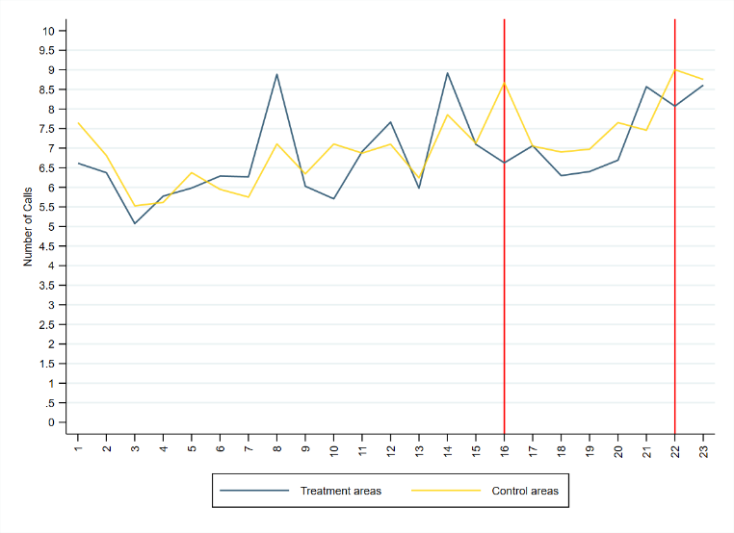
    - All Calls
    - Calls from Victims
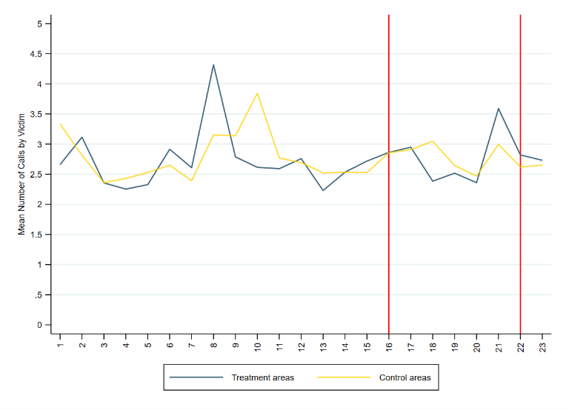
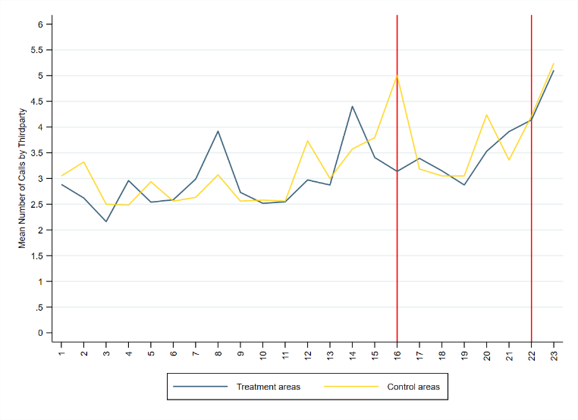
    - Calls from Third Party Callers
[
38
Note: The x-axis shows the week numbers. The graphs plot total DA calls-for-service, by victims and by third party callers from 2020.

Figure A.2: Silent Solution ads




Figure A.3: Reach and link clicks, Met campaign
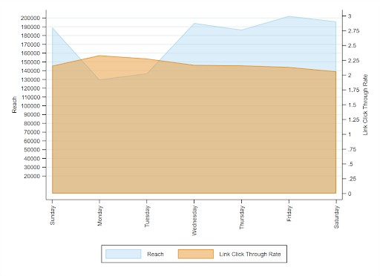

Figure A.4: Reach and link clicks by day of the week, TVP campaign
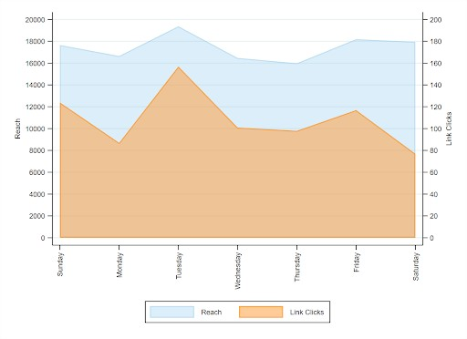

Figure A.5: Average weekly calls per victim, by treatment status
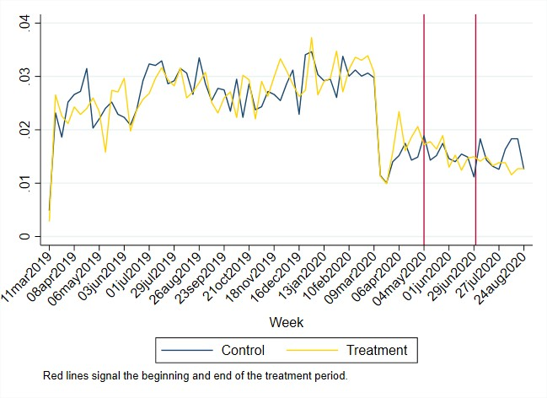

Figure A.6: Average weekly calls per victim, by treatment status
