Tables
Table 1 The details of questionnaire I
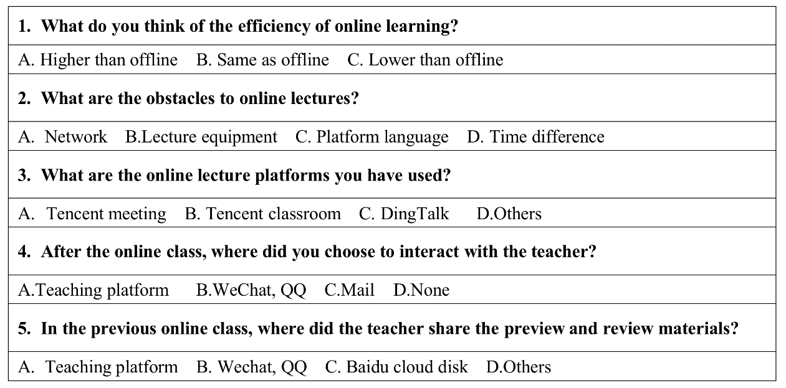
Table 2 Time difference between the countries and local time of the 64 overseas students of our university and China.
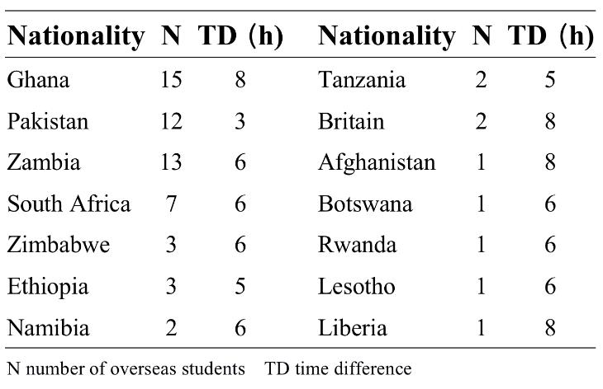
Table 3 Statistical analysis of exam scores before and after the use DingTalk
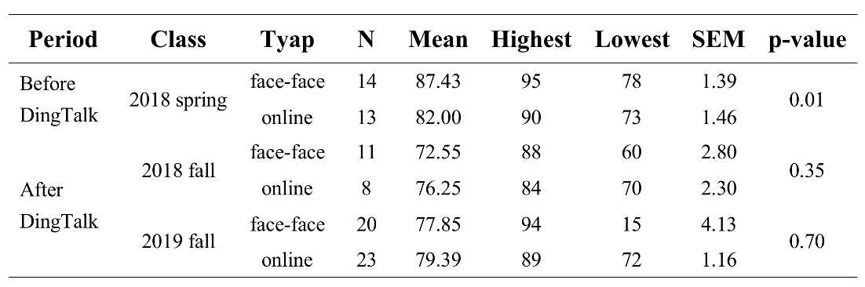
Table 4 Weekly percentage of playback students in 2019 fall biochemistry class
