Machine learning driven drug repurposing strategy for identification of potential RET inhibitors against non-small cell lung cancer
Priyanka Ramesh, Ramanathan Karuppasamy and Shanthi Veerappapillai *
Department of Biotechnology, School of Bio Sciences and Technology,
Vellore Institute of Technology, Vellore, Tamil Nadu, India.
*Corresponding author. Email: shanthi.v@vit.ac.in

Supplementary files
List of Tables
Table S1: List of packages and tuning parameter used for model generation
Table S2: Performance evaluation of validation phase of machine learning models in terms of precision, recall and F1 score.
Table S3: Binding free energy analysis of reference and screened compounds using Prime MM-GBSA. All energy terms were calculated in kcal/mol.
List of Figures
Fig. S1 Performance of RFECV against RET features.
Fig. S2 Receiver operating curve of ML models generated (a) prior parameter tuning and (b) after parameter tuning
Fig. S3 Binding mode analysis of (a) Vandetanib, (b) DB09313 and (c) DB00471 into the binding pocket of RET
Fig. S4 Key scaffold analysis of reference compound (a) Vandetanib and the lead compounds (b) DB09313 and (c) DB00471

Table S1: List of packages and tuning parameter used for model generation
S. No. | Machine learning classifier | Python Packages | Tuning Parameters
1 | Logistic Regression (LR) | sklearn 0.24.2  (from sklearn.linear_model import LogisticRegression) | C=1.0, penalty = ‘l2’, solver = ‘liblinear’
2 | Random Forest (RF) | sklearn 0.24.2  (from sklearn.ensemble import RandomForestClassifier) | bootstrap = True, max_depth = 100, max_features = 3, min_samples_leaf = 4, min_samples_split = 12, n_estimators = 1000
3 | Support Vector Machine (SVM) | sklearn 0.24.2  (from sklearn import svm) | C = 0.1, gamma = 0.0001, kernel = ‘rbf’
4 | Naïve Bayes (NB) | sklearn 0.24.2  (from sklearn.naive_bayes import GaussianNB) | Var_smoothing = 0.15199110829529336
5 | Gradient Boosting (XGB) | sklearn 0.24.2  (from sklearn.ensemble import GradientBoostingClassifier) | Learning_rate = 0.1, max_depth = 3, n_estimators = 250
6 | Decision Tree (DT) | sklearn 0.24.2  (from sklearn.tree import DecisionTreeClassifier) | Max_leaf_nodes = 85, min_samples_split = 2
7 | Neural Network (NN) | sklearn 0.24.2  (from sklearn.neural_network import MLPClassifier) | Alpha = 1e-09, hidden_layer = 10, max_iter = 1000, solver = ‘lbfgs’

Table S2: Performance evaluation of validation phase of machine learning models in terms of precision, recall and F1 score.
S. No | ML Models | External Validation |  |  | 5 – Fold Cross Validation |  |  | 10 – Fold Cross Validation
S. No | ML Models | Precision | Recall | F1 Score | Precision | Recall | F1 Score | Precision | Recall | F1 Score
1 | Logistic regression | 0.872 | 0.857 | 0.853 | 0.866 | 0.840 | 0.844 | 0.841 | 0.848 | 0.862
2 | Random forest | 0.851 | 0.891 | 0.874 | 0.840 | 0.885 | 0.871 | 0.901 | 0.870 | 0.902
3 | Support Vector Machine | 0.893 | 0.904 | 0.913 | 0.889 | 0.876 | 0.882 | 0.842 | 0.877 | 0.884
4 | Naïve bayes | 0.835 | 0.868 | 0.873 | 0.841 | 0.85 | 0.862 | 0.874 | 0.886 | 0.880
5 | Gradient Boosting | 0.858 | 0.827 | 0.862 | 0.843 | 0.870 | 0.857 | 0.888 | 0.848 | 0.871
6 | Decision tree | 0.772 | 0.753 | 0.745 | 0.745 | 0.725 | 0.722 | 0.709 | 0.726 | 0.742
7 | Neural network | 0.822 | 0.835 | 0.813 | 0.812 | 0.817 | 0.797 | 0.820 | 0.851 | 0.804

Table S3: Binding free energy analysis of reference and screened compounds using Prime MM-GBSA. All energy terms were calculated in kcal/mol.
S. No. | Compound ID | XP Gscore | dG Bind | Van der Waal’s  Energy | Coulomb’s Energy | Covalent Interaction | Lipophilicity | Solvation Energy
1 | Vandetanib (Reference) | -10.102 | -96.66 | -57.27 | -16.23 | 1.71 | -46.97 | 22.85
2 | DB09313 | -7.757 | -100.8 | -55.27 | -44.24 | 8.76 | -43.22 | 34.52
3 | DB00471 | -8.012 | -99.68 | -45.48 | -42.29 | 2.89 | -44.98 | 31.14
4 | DB05294 | -10.127 | -96.71 | -57.26 | -16.16 | 1.61 | -46.93 | 22.78
5 | DB13955 | -1.341 | -94.41 | -55.73 | -12.24 | 4.27 | -63.47 | 32.91
6 | DB00523 | -5.25 | -85.61 | -34.16 | -15.27 | 2.64 | -59.16 | 20.57
7 | DB11180 | -4.5 | -83.88 | -45.33 | -17.13 | 3.46 | -48.71 | 24.38
8 | DB03796 | -4.213 | -83.21 | -35.29 | -19.93 | 7.16 | -51.93 | 17.47
9 | DB00279 | -6.937 | -82.09 | -38.98 | -17.13 | 4.81 | -51.42 | 21.49
10 | DB13444 | -7.64 | -81.91 | -38.25 | -24.78 | -0.2 | -37.54 | 19.85
11 | DB00917 | -7.224 | -80.71 | -42.74 | -11.18 | 3.13 | -55.33 | 26.4
12 | DB00755 | -4.744 | -80.04 | -29.3 | -19.1 | 2.09 | -54.78 | 21.3
13 | DB05239 | -6.127 | -79.37 | -46.36 | -7.18 | 2.31 | -45.29 | 17.59
14 | DB08947 | -8.506 | -78.9 | -43.34 | -37.65 | 3.7 | -38.18 | 38.59
15 | DB04711 | -7.088 | -78.81 | -42.24 | -31.61 | -2.59 | -32.65 | 31.25
16 | DB00793 | -5.113 | -78.63 | -38.52 | 0.05 | 0.84 | -48.65 | 7.65
17 | DB09156 | -8.482 | -78.13 | -49.5 | -36.46 | 12.77 | -41.3 | 37.61
18 | DB00770 | -8.076 | -77.68 | -35.32 | -27.47 | 7.12 | -51.5 | 31.78
19 | DB11263 | -8.579 | -77.35 | -47.39 | -31.52 | 6.59 | -40.85 | 38.13
20 | DB01177 | -7.592 | -77.26 | -49.4 | -24.35 | 3.99 | -34.36 | 28.42
21 | DB11705 | -7.238 | -77.05 | -42.99 | -29.08 | 0.84 | -42.05 | 37.39
22 | DB13125 | -6.234 | -76.67 | -51.31 | 2.26 | -3.54 | -48.12 | 24.59
23 | DB01348 | -6.512 | -76.48 | -46.56 | -6.05 | 2.65 | -48.7 | 23.56
24 | DB11689 | -6.884 | -75.99 | -38.4 | -18.55 | 1.4 | -38.02 | 18.54
25 | DB06603 | -6.584 | -74.75 | -42.1 | -38.54 | 3.69 | -33.83 | 37.93
26 | DB08907 | -8.625 | -74.61 | -37.49 | -23.09 | 3.71 | -47.63 | 32.11
27 | DB13956 | -3.891 | -73.97 | -40.1 | -10.36 | 2.67 | -51.79 | 25.8
28 | DB11636 | -6.038 | -73.87 | -34.57 | -9.67 | 3.87 | -52.89 | 19.63
29 | DB06401 | -6.466 | -73.7 | -39.04 | -22.46 | 2.44 | -40.75 | 26.97
30 | DB09333 | -6.738 | -73.66 | -41.92 | -3.09 | 4.39 | -45.38 | 12.8
31 | DB09494 | -1.917 | -73.46 | -29.75 | -14.33 | 7.58 | -52.32 | 15.81
32 | DB00947 | -4.516 | -73.39 | -42.07 | -10.01 | 3.93 | -51.44 | 26.44
33 | DB03193 | -3.736 | -73.21 | -26.51 | -17.29 | 8.74 | -55.31 | 17.76
34 | DB00639 | -5.382 | -73.02 | -40.94 | -11.43 | 4.41 | -43.69 | 18.88
35 | DB00271 | -6.276 | -72.9 | -30.61 | -24.99 | -1.49 | -34.46 | 19.38
36 | DB01359 | -4.898 | -72.87 | -40.24 | -7.41 | 1.92 | -46.32 | 19.27
37 | DB01203 | -8.606 | -72.5 | -34.78 | -16.26 | 0.17 | -40.72 | 19.94
38 | DB00210 | -6.051 | -72.36 | -40.48 | -19.85 | 3.88 | -39.2 | 23.54
39 | DB00952 | -6.938 | -72.25 | -40.93 | 17.79 | 3.35 | -44.78 | -7.44
40 | DB11967 | -9.58 | -72.24 | -46.88 | -21.09 | 4.43 | -35.74 | 27.91
41 | DB13166 | -8.549 | -71.92 | -45.66 | -6.63 | 1 | -45.45 | 25.32
42 | DB04209 | -3.47 | -71.64 | -46.55 | 225.66 | 6.71 | -44.16 | -209.39
43 | DB00906 | -6.455 | -71.49 | -28.76 | -19.03 | 7.43 | -59.75 | 28.83
44 | DB00163 | -6.229 | -71.46 | -43.59 | -8.32 | -2.16 | -42.04 | 24.95
45 | DB09133 | -6.39 | -71.44 | -30.08 | -21.82 | -0.87 | -33.32 | 15.53
46 | DB14649 | -3.713 | -71.4 | -33.29 | -23.31 | 7.48 | -50.24 | 28.46
47 | DB09346 | -7.912 | -71.07 | -28.52 | -26.5 | 1.04 | -36.48 | 20.2
48 | DB01598 | -8.3 | -71.06 | -36.33 | -32.71 | 8.82 | -34.52 | 25.42
49 | DB11656 | -10.446 | -70.75 | -45.11 | -13.11 | 5.69 | -35.47 | 18.12
50 | DB09340 | -6.416 | -70.56 | -32.97 | -11.68 | 8.01 | -49.51 | 16.71
51 | DB09134 | -9.256 | -70.53 | -33.77 | -31.04 | 8.73 | -51.89 | 39.53
52 | DB08946 | -6.058 | -70.24 | -32.18 | -13.29 | 3.8 | -39.28 | 11.43
53 | DB00509 | -5.841 | -70.01 | -35.45 | -25.74 | 4.69 | -42.8 | 30.63
54 | DB04348 | -5.196 | -69.96 | -38.26 | -7.59 | 10.68 | -35.84 | 2.15
55 | DB09063 | -4.694 | -69.92 | -45.56 | 5.84 | 1.97 | -43.56 | 11.75
56 | DB09019 | -4.598 | -69.54 | -39.33 | -1.51 | 1.18 | -42.72 | 13.26
57 | DB00547 | -4.271 | -69.43 | -29.87 | -25.6 | 6.73 | -49.38 | 29.11
58 | DB09371 | -4.587 | -69.35 | -32.96 | -8.52 | 2.24 | -51.54 | 21.85
59 | DB14541 | -5.362 | -69.25 | -35.19 | -11.28 | 9.68 | -53.14 | 21.32
60 | DB01022 | -4.324 | -69.11 | -37.46 | -1.04 | 11.8 | -68 | 25.7
61 | DB14201 | -6.378 | -68.64 | -38.21 | -5.39 | 2.96 | -44.93 | 17.01
62 | DB14104 | -2.864 | -68.54 | -28.6 | -19.29 | 7.09 | -53.94 | 26.51
63 | DB00162 | -5.103 | -68.52 | -22.4 | -5.9 | 6.68 | -63.06 | 16.39
64 | DB00620 | -5.022 | -68.48 | -26.41 | -31.95 | 9.06 | -48.31 | 29.82
65 | DB14476 | -5.983 | -68.46 | -43.05 | -6.1 | 9.42 | -56.42 | 27.96
66 | DB01046 | -7.896 | -68.3 | -35.04 | -16.16 | 14.06 | -51.01 | 21.18
67 | DB06826 | -6.601 | -68.26 | -32.33 | -32.05 | 10.83 | -41.82 | 29.11
68 | DB00982 | -5.448 | -68.17 | -29.45 | -15.72 | 1.71 | -39.39 | 15.19
69 | DB04224 | -2.736 | -68.08 | -27.43 | -14.62 | 3.41 | -52.86 | 23.65
70 | DB01108 | -5.744 | -68.03 | -34.38 | -17.71 | 3.14 | -42.48 | 24.14
71 | DB04657 | -6.906 | -67.82 | -34.99 | -3.45 | 3.31 | -43.39 | 10.94
72 | DB00146 | -3.89 | -67.75 | -33.52 | -9.57 | 10.06 | -65.5 | 31.19
73 | DB00890 | -6.411 | -67.65 | -29.36 | -12.62 | 1.12 | -44.96 | 18.72
74 | DB08604 | -7.107 | -67.6 | -34.95 | -5.13 | 2.62 | -44.84 | 14.8
75 | DB00153 | -2.62 | -67.57 | -37.56 | -0.22 | 10.23 | -65.66 | 25.86
76 | DB09378 | -4.821 | -67.29 | -34.94 | -40.69 | 12.82 | -41.84 | 38.24
77 | DB00838 | -4.022 | -67.15 | -29.5 | -24.5 | 8.68 | -50.04 | 28.6
78 | DB09570 | -7.93 | -66.92 | -27.71 | -28.66 | 3.29 | -34.19 | 21.51
79 | DB00959 | -4.336 | -66.83 | -35.54 | -39.26 | 11.52 | -40.9 | 38.19
80 | DB01210 | -8.156 | -66.79 | -35.93 | -20.85 | 3.27 | -36.85 | 24.84
81 | DB04573 | -5.334 | -66.61 | -29.26 | -17.86 | 3.65 | -45.18 | 23.46
82 | DB11619 | -3.282 | -66.6 | -30.36 | -11.22 | 4.25 | -52.09 | 24.04
83 | DB04575 | -3.717 | -66.52 | -32.81 | -8.01 | 5.63 | -47.03 | 15.71
84 | DB01409 | -3.55 | -66.12 | -39.72 | 0.05 | 10.19 | -44.85 | 8.32
85 | DB13952 | -3.421 | -65.81 | -33.92 | -6.26 | 1.72 | -45.42 | 18.26
86 | DB13267 | -7.117 | -65.8 | -31.59 | -29.85 | 7.06 | -30.89 | 20.54
87 | DB09095 | -4.264 | -65.69 | -30.05 | -18.47 | 6.43 | -47.49 | 24.29
88 | DB00910 | -2.559 | -65.69 | -31.25 | -15.83 | 9.27 | -60.88 | 33.56
89 | DB11254 | -6.924 | -65.51 | -32.97 | -14.75 | 1.88 | -36.93 | 17.71
90 | DB00669 | -6.516 | -65.18 | -38.57 | 13.92 | 4.92 | -35.81 | -9.28
91 | DB00596 | -4.205 | -65.07 | -36.1 | -26.07 | 14.8 | -47.5 | 30.38
92 | DB06742 | -5.118 | -64.94 | -40.09 | -7.93 | 2.94 | -40.09 | 20.99
93 | DB03017 | -3.455 | -64.89 | -26.62 | -14.12 | 4.43 | -42.13 | 14.26
94 | DB12474 | -3.301 | -64.89 | -33.3 | -2.92 | 5.62 | -52.21 | 18.4
95 | DB13867 | -3.795 | -64.83 | -32.23 | -11.48 | 7.2 | -51.54 | 23.5
96 | DB11182 | -4.636 | -64.78 | -40.09 | -11.01 | 1.37 | -33.26 | 18.92
97 | DB01131 | -5.825 | -64.77 | -28.6 | -24.21 | 0.58 | -30.62 | 18.78
98 | DB01196 | -3.967 | -64.72 | -22.44 | -15.25 | 10.87 | -62.71 | 25.23
99 | DB00716 | -7.172 | -64.63 | -32.28 | -29.95 | 9.92 | -36.44 | 24.96
100 | DB00741 | -4.488 | -64.63 | -33.95 | -37.63 | 10.09 | -37.42 | 35.25
101 | DB11750 | -4.116 | -64.51 | -33.03 | -23.45 | 9.42 | -47.68 | 30.79
102 | DB08804 | -4.02 | -64.49 | -24.7 | 6.21 | 11.92 | -73.19 | 15.28
103 | DB00294 | -2.787 | -64.46 | -33.41 | -2.69 | 5.81 | -55.38 | 21.86
104 | DB00717 | -3.606 | -64.38 | -33.7 | -4.45 | 4.03 | -50.39 | 20.66
105 | DB00367 | -3.952 | -64.32 | -33.04 | -3.28 | 5.28 | -54.03 | 21.44
106 | DB08801 | -5.278 | -64.31 | -32.23 | -9.5 | 3.33 | -45.8 | 19.93
107 | DB09061 | -5.418 | -64.28 | -37.74 | -4.73 | 3.88 | -48.66 | 23.28
108 | DB00772 | -4.542 | -63.61 | -37.28 | -15.41 | 1.33 | -30.51 | 18.74
109 | DB01283 | -6.396 | -63.53 | -36.22 | -11.71 | 2.32 | -36.31 | 19.62
110 | DB13946 | -4.045 | -63.4 | -34.31 | -14.4 | 1.16 | -34.67 | 19.27
111 | DB14545 | -5.669 | -63.27 | -43.57 | -7.31 | 2.9 | -36.45 | 22.05
112 | DB00697 | -6.193 | -62.92 | -31.19 | -14.42 | 4.77 | -38.47 | 16.89
113 | DB12792 | -6.162 | -62.85 | -34.2 | -9.5 | 3.47 | -35.53 | 13.32
114 | DB00805 | -5.919 | -62.82 | -39.79 | -6.04 | 4.38 | -39.34 | 18.01
115 | DB00324 | -4.265 | -62.73 | -25.99 | -17.82 | 8.53 | -50.05 | 22.99
116 | DB00918 | -5.281 | -62.69 | -35.61 | 13.68 | 4.83 | -43.32 | -1.87
117 | DB13943 | -2.253 | -62.69 | -31.4 | -4.32 | 5.7 | -46.7 | 14.27
118 | DB00875 | -4.654 | -62.54 | -37.36 | -1.78 | 3.54 | -43.17 | 16.47
119 | DB13801 | -5.704 | -62.51 | -27.46 | -10.75 | 1.76 | -34.63 | 9.04
120 | DB09115 | -5.839 | -62.42 | -27.74 | -13.87 | 1.58 | -31.37 | 9.5
121 | DB01436 | -2.556 | -62.4 | -27.45 | -9.7 | 7.59 | -61.18 | 28.63
122 | DB11073 | -2.566 | -62.28 | -33.85 | 28.83 | 4.33 | -42.58 | -19.01
123 | DB00860 | -4.459 | -62.2 | -33.65 | -35.13 | 13.61 | -41.63 | 35.51
124 | DB15690 | -4.901 | -62.19 | -33.01 | -19.29 | 3.25 | -36.46 | 23.87
125 | DB00598 | -7.375 | -62.14 | -35.07 | -28.09 | 6.97 | -32.96 | 28.66
126 | DB06713 | -4.407 | -62.09 | -38.5 | -12.16 | 14.38 | -47.19 | 21.85
127 | DB01070 | -2.211 | -61.9 | -35.72 | -13.61 | 7.14 | -51.43 | 32.18
128 | DB00421 | -2.55 | -61.85 | -37.17 | -8.56 | 6.91 | -44.15 | 21.64
129 | DB06780 | -2.48 | -61.69 | -31.06 | -12.27 | 7.64 | -51.48 | 25.82
130 | DB05990 | -4.32 | -61.65 | -21.29 | -32.14 | 11.58 | -43.61 | 25.51
131 | DB01362 | -8.43 | -61.56 | -38.75 | -32.52 | 16.89 | -46.95 | 41.77
132 | DB13908 | -6.232 | -61.56 | -30.28 | -10.05 | 0.65 | -35.85 | 14.22
133 | DB06769 | -6.2 | -61.43 | -39.66 | -10.98 | 10.92 | -45.47 | 24.29
134 | DB00378 | -3.52 | -61.38 | -32.16 | -3.6 | 1.84 | -47.17 | 19.85
135 | DB00714 | -6.469 | -61.36 | -31.43 | -9.56 | -0.22 | -39.47 | 21.39
136 | DB15566 | -3.487 | -61.22 | -36.06 | -15.98 | 2.33 | -32.42 | 21.44
137 | DB00939 | -6.648 | -61.2 | -30.82 | -6.37 | 1.94 | -39.92 | 15.63
138 | DB00223 | -4.725 | -61.17 | -30.14 | -19.91 | 10.06 | -48.97 | 28.21
139 | DB00518 | -8.239 | -61.06 | -35.99 | -11.73 | 1.83 | -31.09 | 16.55
140 | DB13306 | -6.235 | -61.04 | -27.76 | -6.37 | 0.06 | -34.01 | 7.42
141 | DB12952 | -3.59 | -60.93 | -27.68 | -26.08 | 4.37 | -39.04 | 27.84
142 | DB08868 | -6.068 | -60.84 | -39.55 | 2.63 | 1.53 | -46.38 | 22.27
143 | DB13153 | -3.512 | -60.41 | -22.33 | -1.69 | 5.14 | -54.47 | 12.94
144 | DB09068 | -6.597 | -60.36 | -33.47 | -2.16 | 7.59 | -49.95 | 17.64
145 | DB00443 | -4.528 | -60.2 | -30.99 | -18.06 | 10.65 | -46.54 | 25.03
146 | DB06777 | -4.482 | -60.14 | -20.83 | -30.69 | 10.61 | -42.69 | 25.16
147 | DB02659 | -7.71 | -60.05 | -25.36 | -22.87 | 13.47 | -48.09 | 23.77
148 | DB00990 | -3.483 | -60.05 | -29.16 | -2.03 | 2.66 | -45.86 | 14.48
149 | DB08981 | -8.118 | -60.01 | -33.62 | -20.58 | 1.72 | -28.45 | 21.62
150 | DB00998 | -6.179 | -59.68 | -31.49 | -22.89 | 2.06 | -32.13 | 26.78
151 | DB11190 | -7.366 | -59.66 | -47.18 | -21.33 | 8.04 | -36.25 | 38.68
152 | DB13953 | -4.43 | -59.6 | -39.59 | -3.11 | 2.53 | -35.58 | 16.19
153 | DB07776 | -8.098 | -59.55 | -34.91 | -9.02 | 2.38 | -29.59 | 11.84
154 | DB01392 | -5.009 | -59.38 | -35.73 | -6.81 | 3.62 | -42.69 | 22.5
155 | DB14881 | -3.189 | -58.9 | -36.71 | -7.02 | 2.56 | -37.99 | 20.32
156 | DB00655 | -4.591 | -58.84 | -32.16 | -8.44 | 2.94 | -35.21 | 14.33
157 | DB09242 | -5.793 | -58.66 | -33.7 | -7.1 | 1.97 | -35.56 | 16.35
158 | DB04038 | -2.377 | -58.45 | -22.25 | -7.57 | 12.51 | -65.04 | 24.3
159 | DB00687 | -5.19 | -58.42 | -33.94 | -19.64 | 4.83 | -38.22 | 29.28
160 | DB04813 | -5.174 | -58.33 | -31.21 | -1.72 | 8.5 | -48.93 | 15.41
161 | DB11155 | -5.581 | -58.32 | -33.05 | -8.47 | 2.55 | -28.27 | 9.34
162 | DB14646 | -3.156 | -58.29 | -38.17 | -13.24 | 2.76 | -30.46 | 21.14
163 | DB01079 | -6.371 | -58.27 | -32.92 | -17 | 8.82 | -46.63 | 31
164 | DB04815 | -6.065 | -58.2 | -25.78 | -5.58 | -0.23 | -32.4 | 6.17
165 | DB01204 | -6.832 | -58.14 | -39.83 | -30.53 | 1.54 | -31.72 | 43.37
166 | DB00166 | -6.681 | -58.13 | -25.82 | -12.24 | 5.75 | -38.35 | 13.04
167 | DB09480 | -4.9 | -58.08 | -31.59 | -3.61 | 4.99 | -42.69 | 14.82
168 | DB13114 | -5.879 | -58.04 | -33.23 | 2.67 | 5.19 | -49.67 | 17.25
169 | DB00800 | -7.144 | -58.03 | -32.99 | -11.16 | 6.38 | -45.16 | 25.98
170 | DB00964 | -5.038 | -57.98 | -31.74 | -9.39 | 2.92 | -38.09 | 19.07
171 | DB09074 | -4.408 | -57.88 | -40.47 | -2.2 | 0.07 | -37.33 | 22.11
172 | DB05219 | -8.262 | -57.87 | -32.45 | -13.02 | 1.07 | -27.6 | 14.61
173 | DB00396 | -3.301 | -57.78 | -33.08 | -10.54 | 2.89 | -39.56 | 22.59
174 | DB06155 | -3.977 | -57.63 | -43.37 | -6.72 | 5.48 | -40.61 | 27.79
175 | DB06410 | -2.334 | -57.37 | -34.23 | -8.4 | 18.34 | -64.34 | 31.69
176 | DB09212 | -6.402 | -57.32 | -23.03 | -15.79 | 5.9 | -35.95 | 12.24
177 | DB00629 | -5.545 | -57.22 | -29.5 | -5.68 | -0.62 | -32.38 | 17.02
178 | DB00501 | -3.865 | -57.21 | -36.34 | -18.04 | 5.74 | -37.5 | 30.34
179 | DB09383 | -3.43 | -57.21 | -28.96 | -22.09 | 4.37 | -36.62 | 26.47
180 | DB12332 | -6.804 | -57.17 | -40.02 | -15.83 | 8.06 | -32.85 | 24.48
181 | DB00873 | -3.597 | -57.14 | -32.47 | -12.31 | 1.5 | -35.95 | 22.61
182 | DB08950 | -5.361 | -57.09 | -32.28 | -9.79 | 8.9 | -49.89 | 26.73
183 | DB00624 | -3.683 | -57.04 | -30.41 | -10.11 | 2.93 | -39.7 | 20.61
184 | DB00169 | -2.208 | -56.96 | -26.08 | -2.99 | 8.73 | -63.29 | 26.67
185 | DB00261 | -5.481 | -56.95 | -28.93 | -11.69 | 0.26 | -26.78 | 10.63
186 | DB11859 | -3.93 | -56.85 | -19.05 | -13.28 | 7.85 | -53.96 | 21.89
187 | DB05057 | -6.056 | -56.83 | -26.89 | -19.47 | 3.75 | -30.38 | 17
188 | DB00377 | -4.649 | -56.77 | -37.26 | 2.69 | 1.38 | -39.62 | 16.05
189 | DB00730 | -6.384 | -56.73 | -28.44 | -16.81 | 0.26 | -23.29 | 12.26
190 | DB00769 | -2.011 | -56.65 | -32.6 | -14.03 | 7.71 | -44.96 | 28.18
191 | DB09135 | -8.429 | -56.6 | -39.07 | -2.67 | 9.92 | -54.92 | 31.77
192 | DB01380 | -3.19 | -56.58 | -38.29 | -11.34 | 3.17 | -30.26 | 20.46
193 | DB14539 | -2.879 | -56.57 | -37.49 | -11.9 | 0.92 | -31.42 | 24.5
194 | DB09064 | -5.468 | -56.48 | -31.16 | -7.45 | 7.56 | -43.9 | 18.61
195 | DB14655 | -4.442 | -56.4 | -27.62 | 0.13 | 7.11 | -52.37 | 16.53
196 | DB00663 | -4.674 | -56.31 | -28.82 | -5.53 | 5.13 | -41.83 | 14.93
197 | DB11585 | -4.219 | -56.26 | -43.43 | 1.73 | 3.15 | -31.84 | 14.2
198 | DB00255 | -6.767 | -55.96 | -29.33 | -13.5 | 1.47 | -36.67 | 22.62
199 | DB00652 | -3.431 | -55.91 | -32.94 | -9.91 | 1.32 | -39.52 | 25.59
200 | DB00136 | -4.029 | -55.87 | -27.3 | -19.31 | 19.75 | -60.99 | 33.49
201 | DB13853 | -5.055 | -55.69 | -36.64 | 3.71 | 0.65 | -32.66 | 9.27
202 | DB00751 | -4.938 | -55.67 | -29.81 | -12.06 | 8.33 | -38.44 | 17.23
203 | DB14975 | -7.288 | -55.63 | -39.34 | -7.93 | 7.46 | -33.09 | 17.79
204 | DB00291 | -4.232 | -55.55 | -22.11 | -9.31 | 6.81 | -48.7 | 18.47
205 | DB09123 | -4.344 | -55.51 | -24.59 | -7.31 | 5.18 | -46.27 | 18.08
206 | DB01420 | -3.162 | -55.5 | -27.38 | -9.09 | 2.25 | -43.3 | 22.35
207 | DB13158 | -3.506 | -55.48 | -27.26 | -9.54 | 9.65 | -43.68 | 15.85
208 | DB09214 | -7.631 | -55.19 | -36.47 | -4.94 | 0.04 | -30.07 | 16.55
209 | DB11096 | -6.591 | -55.11 | -29.99 | 2.19 | 10.72 | -48.85 | 13.79
210 | DB00374 | -6.312 | -55.09 | -29.82 | -27.07 | 20.51 | -52.6 | 35.06
211 | DB00188 | -6.457 | -54.99 | -39.03 | -29.44 | 16.05 | -29.24 | 27.73
212 | DB13211 | -7.457 | -54.73 | -23.58 | -16.52 | 1.7 | -29.89 | 14.82
213 | DB09015 | -7.239 | -54.64 | -23.63 | -16.9 | 13.08 | -50.34 | 24.05
214 | DB01256 | -2.72 | -54.6 | -38.54 | -16.64 | 12.97 | -43.67 | 31.8
215 | DB00138 | -5.877 | -54.48 | -26.85 | -31.27 | 4.07 | -24.81 | 26.6
216 | DB09128 | -5.435 | -54.39 | -38.99 | -11.15 | 3.05 | -27.74 | 20.86
217 | DB12371 | -3.301 | -54.32 | -39.73 | -35.23 | 5.61 | -21.73 | 37.54
218 | DB00934 | -4.524 | -54.27 | -28.39 | -13.73 | 3.32 | -36.64 | 21.62
219 | DB06718 | -3.487 | -54.16 | -32.08 | -2.92 | 1.77 | -40.2 | 19.28
220 | DB01104 | -5.283 | -54.09 | -27.84 | -3.1 | 6.31 | -43.71 | 14.46
221 | DB00756 | -3.764 | -54.08 | -30.05 | -10.22 | 2.65 | -36.85 | 21.72
222 | DB01243 | -6.657 | -54.05 | -26.44 | -7.01 | -0.03 | -28.78 | 8.66
223 | DB09216 | -6.261 | -54.02 | -37.7 | -8.46 | 5.7 | -34.29 | 21.51
224 | DB06412 | -4.048 | -53.96 | -30.24 | -3.77 | 3.32 | -40.35 | 17.3
225 | DB00288 | -2.988 | -53.84 | -34.08 | -19.78 | 3.24 | -29.55 | 27.27
226 | DB02789 | -3.638 | -53.68 | -29.44 | -8.26 | 5.82 | -42.93 | 21.4
227 | DB01357 | -4.862 | -53.48 | -26.68 | -9.05 | 8.8 | -42.42 | 16.12
228 | DB00977 | -5.051 | -53.47 | -26 | -20.5 | 6.35 | -38.11 | 25.09
229 | DB01057 | -2.865 | -53.35 | -23.91 | 4.28 | 3.07 | -39.4 | 2.62
230 | DB12924 | -6.965 | -53.14 | -33.23 | -7.76 | 7.35 | -41.08 | 22.37
231 | DB00121 | -6.298 | -52.92 | -25.39 | -18.81 | 9.06 | -35.47 | 19.01
232 | DB14914 | -5.701 | -52.85 | -37.17 | -2.83 | 2.44 | -31.59 | 16.34
233 | DB13954 | -2.678 | -52.79 | -39.08 | 4.19 | 9.85 | -46.26 | 18.53
234 | DB12434 | -6.072 | -52.75 | -28.51 | -39.38 | 7 | -22.96 | 32.03
235 | DB00179 | -6.677 | -52.72 | -19.71 | -18.91 | 6.63 | -43.81 | 24.49
236 | DB01018 | -5.474 | -52.71 | -22.66 | -19.07 | 4.91 | -26.61 | 12.06
237 | DB04838 | -5.276 | -52.68 | -30.58 | -11.13 | 3.06 | -30.74 | 17.09
238 | DB00340 | -3.387 | -52.54 | -33.39 | 1.04 | 7.33 | -40.16 | 12.69
239 | DB00451 | -6.931 | -52.51 | -15.71 | -19.3 | 11.3 | -50.99 | 22.94
240 | DB11560 | -6.037 | -52.44 | -28.31 | -11.24 | 9.43 | -42.65 | 20.67
241 | DB03310 | -9.273 | -52.43 | -53.93 | -27.79 | 17.35 | -35.36 | 50.65
242 | DB00358 | -5.999 | -52.22 | -27.78 | -8.6 | 1.31 | -28.21 | 11.57
243 | DB13944 | -1.638 | -52.15 | -28.45 | -10.52 | 3.31 | -41.15 | 24.94
244 | DB01105 | -3.41 | -51.94 | -27.53 | -4.33 | 2.19 | -33.94 | 11.7
245 | DB09291 | -5.681 | -51.93 | -44.88 | -5.02 | 4.23 | -37.15 | 31.68
246 | DB00625 | -4.756 | -51.93 | -31.23 | -7.28 | 1.99 | -30.94 | 15.82
247 | DB00304 | -2.644 | -51.84 | -25.28 | -8.12 | 1.76 | -40.31 | 21.37
248 | DB01047 | -2.94 | -51.8 | -34.1 | -21.84 | 5.07 | -28.77 | 28.7
249 | DB00603 | -2.722 | -51.79 | -35.78 | 4.61 | 6.77 | -41.35 | 14.08
250 | DB00861 | -9.381 | -51.63 | -30.13 | -15.69 | -0.41 | -21.76 | 16.88
251 | DB00382 | -5.015 | -51.62 | -23.83 | -7.55 | 3.51 | -33.56 | 10.46
252 | DB11823 | -4.703 | -51.46 | -23.66 | -8.49 | 3.89 | -34.95 | 11.86
253 | DB01221 | -4.703 | -51.46 | -23.66 | -8.49 | 3.89 | -34.95 | 11.86
254 | DB13139 | -6.261 | -51.41 | -25.06 | -25.25 | 5.62 | -31.21 | 25.26
255 | DB01012 | -5.054 | -51.31 | -38.73 | -7.02 | 6.62 | -38.44 | 27.38
256 | DB00648 | -6.067 | -51.06 | -25.48 | 4.15 | 10.56 | -51.05 | 10.76
257 | DB04540 | -2.996 | -50.94 | -14.59 | 1.47 | 10.71 | -66.97 | 18.44
258 | DB14174 | -3.868 | -50.8 | -34.29 | 0.78 | 1.69 | -34.58 | 15.6
259 | DB13680 | -7.351 | -50.66 | -35.23 | -10.91 | 0.4 | -19.5 | 15.09
260 | DB00834 | -2.038 | -50.58 | -32.91 | -7.65 | 7.61 | -36.69 | 19.88
261 | DB13292 | -3.939 | -50.55 | -25.64 | -5.4 | 6.66 | -39.55 | 13.72
262 | DB01170 | -5.087 | -50.51 | -18.47 | -12.42 | 5.33 | -39.28 | 20.15
263 | DB01708 | -2.253 | -50.46 | -29.57 | -10.72 | 3.65 | -36.76 | 23.2
264 | DB13269 | -5.726 | -50.38 | -17.8 | -8.02 | 0.65 | -31.42 | 6.62
265 | DB00240 | -4.646 | -50.27 | -25.39 | -13.71 | 6.63 | -42.01 | 24.75
266 | DB06704 | -5.469 | -50.21 | -23.07 | -14.87 | 1.72 | -26.86 | 19.28
267 | DB00575 | -5.034 | -50.21 | -24.96 | -17.82 | 3.37 | -31.33 | 21.7
268 | DB01216 | -2.953 | -50.15 | -32.45 | -2.81 | 5.56 | -42.99 | 22.56
269 | DB01410 | -1.591 | -50.07 | -34.83 | -9.96 | 6.06 | -31.03 | 20.05
270 | DB08897 | -4.856 | -49.89 | -34.45 | 32.23 | 0.41 | -31.18 | -16.21
271 | DB01586 | -3.331 | -49.76 | -22.95 | -19.5 | 10.42 | -41.96 | 25.63
272 | DB14657 | -3.727 | -49.42 | -29.22 | -16.82 | 8.31 | -30.08 | 18.96
273 | DB00825 | -4.335 | -49.3 | -16.5 | -5.51 | 5.25 | -41 | 8.65
274 | DB01001 | -6.231 | -49.23 | -24.07 | -20.99 | 4.31 | -30.76 | 23.05
275 | DB14677 | -2.982 | -49.19 | -26.17 | -5.75 | 8.43 | -39.97 | 14.68
276 | DB00637 | -3.119 | -49.07 | -43.48 | -13.72 | 6.57 | -30.31 | 32.63
277 | DB01599 | -1.958 | -49.05 | -31.11 | -10.48 | 16.79 | -53.98 | 29.91
278 | DB14020 | -6.616 | -48.84 | -30.04 | -6.2 | 0.28 | -29.83 | 16.96
279 | DB00564 | -3.463 | -48.73 | -23.64 | -17.6 | -0.1 | -21.28 | 14.31
280 | DB00513 | -4.93 | -48.41 | -17.69 | -22.57 | 1.57 | -17.42 | 8.49
281 | DB00700 | -3.242 | -48.05 | -28.42 | -5.27 | 8.15 | -34.93 | 12.86
282 | DB00253 | -2.873 | -47.64 | -28.24 | 5.78 | 3.01 | -39.53 | 11.42
283 | DB06714 | -5.255 | -47.62 | -16.9 | -5.99 | 6.77 | -40.49 | 9.22
284 | DB11201 | -4.919 | -47.32 | -27.11 | -15.35 | 13.24 | -39.86 | 22.13
285 | DB00348 | -5.263 | -47.06 | -27.57 | -6.89 | 2 | -18.68 | 4.7
286 | DB00894 | -2.481 | -46.95 | -28.08 | 2.83 | 1.49 | -35.13 | 12.14
287 | DB00984 | -2.969 | -46.87 | -30.53 | 1.17 | 2.32 | -30.38 | 10.64
288 | DB14644 | -6.754 | -46.77 | -32 | -6.1 | 10.96 | -36.17 | 17.32
289 | DB01123 | -5.134 | -46.7 | -27.43 | -12.34 | 1.38 | -24.31 | 20.35
290 | DB12825 | -2.58 | -46.57 | -29.97 | -24.68 | 3.72 | -25.22 | 30.33
291 | DB02300 | -4.334 | -46.41 | -20.47 | -6.26 | 11.58 | -62.44 | 31.81
292 | DB08971 | -3.067 | -46.38 | -29.39 | -8.3 | 1.79 | -31.93 | 21.71
293 | DB01260 | -2.381 | -46.34 | -27.57 | -20.1 | 8.08 | -30.56 | 24.05
294 | DB01366 | -7.73 | -46.27 | -21.89 | -19.29 | 8.62 | -32.25 | 19.46
295 | DB00525 | -4.612 | -46.19 | -36.37 | -7.9 | 7.38 | -29.44 | 20.14
296 | DB05271 | -4.585 | -45.59 | -18.04 | -18.4 | 20.98 | -55.92 | 26.01
297 | DB12945 | -4.545 | -45.47 | -27.2 | -14.8 | 0.13 | -16.45 | 13.7
298 | DB00185 | -2.669 | -45.37 | -17.12 | -2.99 | 1.02 | -35.42 | 9.14
299 | DB13245 | -4.009 | -45.34 | -29.69 | -0.78 | 3.44 | -30.37 | 12.06
300 | DB01144 | -3.617 | -45.28 | -31.05 | 68.9 | 0.96 | -26.82 | -56.06
301 | DB08905 | -4.184 | -45.27 | -24.21 | -12.88 | 4.94 | -32.25 | 19.98
302 | DB00621 | -3.358 | -45.27 | -24.92 | -4.69 | 9.28 | -43.89 | 19.07
303 | DB09091 | -4.842 | -45.25 | -20.77 | -11.56 | 13.77 | -47.18 | 21.18
304 | DB12537 | -7.307 | -45 | -24.07 | -11.81 | 2.24 | -19.83 | 8.88
305 | DB08966 | -5.051 | -44.92 | -27.08 | -2.72 | 6.19 | -43.8 | 23.54
306 | DB01222 | -3.221 | -44.89 | -31.48 | -0.75 | 10.71 | -40.29 | 17.52
307 | DB01234 | -4.927 | -44.72 | -24.21 | -11.99 | 6.64 | -39.46 | 24.85
308 | DB01395 | -1.629 | -44.62 | -29.35 | 1.67 | 2.73 | -31.42 | 11.74
309 | DB09403 | -4.79 | -44.45 | -32.08 | 8.45 | 13.34 | -46.08 | 12.31
310 | DB06710 | -3.628 | -44.4 | -23.03 | -3.32 | 7.2 | -42.83 | 17.68
311 | DB09124 | -2.118 | -44.35 | -25.82 | 0.94 | 2.24 | -30.28 | 8.57
312 | DB06789 | -1.978 | -44.35 | -28.32 | 6.16 | 11.05 | -43.75 | 10.56
313 | DB00896 | -1.931 | -44.13 | -25.64 | -6.61 | 4.06 | -27.96 | 12.21
314 | DB11622 | -3.205 | -44.01 | -22 | -23.94 | 1.55 | -16.71 | 17.84
315 | DB00818 | -3.511 | -43.9 | -22.88 | -8.6 | 1.75 | -24.39 | 10.46
316 | DB06819 | -6.687 | -43.68 | -25 | -8.81 | 1.76 | -23.56 | 12.4
317 | DB01009 | -7.284 | -43.58 | -29.63 | -4.12 | 5.61 | -28.91 | 13.71
318 | DB09070 | -2.355 | -43.55 | -28.17 | -5.11 | 2.71 | -32.15 | 20.39
319 | DB06700 | -7.249 | -43.51 | -18.92 | -21.13 | 15.94 | -44.01 | 25.14
320 | DB12107 | -6.389 | -43.38 | -21.63 | -22.25 | 0.41 | -22.52 | 23.76
321 | DB09213 | -7.517 | -43.29 | -21.47 | -13.77 | 8.95 | -32.71 | 16.18
322 | DB01050 | -7.517 | -43.29 | -21.47 | -13.77 | 8.95 | -32.71 | 16.18
323 | DB12300 | -5.251 | -42.87 | -30.53 | 6.48 | 0.13 | -23.29 | 4.38
324 | DB01275 | -5.048 | -42.76 | -25.08 | -14.23 | 1.26 | -18.38 | 14.01
325 | DB13221 | -4.05 | -42.69 | -19.44 | -22.89 | 6.69 | -26.12 | 22.65
326 | DB14632 | -3.281 | -42.5 | -25.62 | -14.39 | 5.35 | -32.58 | 25.37
327 | DB00591 | -2.398 | -42.19 | -27.12 | -14.35 | 4.15 | -26.42 | 21.83
328 | DB12667 | -6.965 | -42.17 | -26.12 | -6.62 | 3.2 | -23.59 | 11.26
329 | DB00846 | -1.746 | -41.77 | -29.94 | 5.23 | 8.08 | -37.46 | 12.59
330 | DB08973 | -2.072 | -41.45 | -28.85 | 1.23 | 1.79 | -25.75 | 10.22
331 | DB03619 | -3.059 | -41.07 | -24.14 | -26.16 | 5.62 | -18.28 | 22.87
332 | DB06786 | -1.405 | -41.07 | -29.08 | 1.38 | 4.25 | -39.03 | 21.47
333 | DB01013 | -1.895 | -40.9 | -20.17 | -14.22 | 5.12 | -36.39 | 25.03
334 | DB01091 | -3.155 | -40.7 | -28.88 | -3.86 | 5.07 | -34.99 | 21.97
335 | DB00555 | -6.976 | -40.51 | -21.73 | -13.28 | 2.16 | -22.79 | 16.53
336 | DB01262 | -8.536 | -40.48 | -28.24 | -14.85 | 3.25 | -13.54 | 15.21
337 | DB01185 | -3.856 | -40.25 | -16.87 | -8.43 | 15.64 | -47.87 | 17.48
338 | DB00712 | -7.778 | -40 | -32.34 | -2.86 | 6.8 | -30.79 | 19.46
339 | DB00588 | -1.489 | -39.92 | -24.74 | -9.89 | 9.97 | -31.12 | 16.06
340 | DB00504 | -3.24 | -39.81 | -21.02 | -6 | 8.66 | -40.78 | 19.6
341 | DB01143 | -4.204 | -39.74 | -17.91 | -27.02 | 0.03 | -16.88 | 23.97
342 | DB14186 | -4.735 | -39.64 | -21.01 | -9.16 | 2.4 | -24.15 | 12.7
343 | DB00635 | -3.548 | -39.29 | -25.88 | -5.22 | 4.9 | -32.76 | 20.91
344 | DB00609 | -7.067 | -38.93 | -25.39 | -6.58 | 2.94 | -20.49 | 10.91
345 | DB04824 | -3.86 | -38.03 | -27.92 | -9.76 | 4.63 | -27.78 | 23.17
346 | DB00783 | -4.739 | -37.87 | -10.82 | -8.55 | 11.72 | -52.26 | 22.15
347 | DB05013 | -3.046 | -37.67 | -21.01 | -13.92 | 0.61 | -19.11 | 16.25
348 | DB06823 | -4.407 | -37.62 | -19.4 | -19.96 | 2.33 | -12.85 | 13.13
349 | DB09389 | -3.348 | -37.5 | -15.01 | -12.35 | 4.38 | -38.06 | 24.18
350 | DB14763 | -4.332 | -37.42 | -24.33 | -8.97 | 5.11 | -27.79 | 19.41
351 | DB13972 | -3.2 | -36.68 | -17.36 | -19.5 | 0.43 | -18.15 | 19.7
352 | DB00134 | -3.2 | -36.68 | -17.36 | -19.5 | 0.43 | -18.15 | 19.7
353 | DB02362 | -5.026 | -35.48 | -17.46 | -17.09 | 0.53 | -11.78 | 10.8
354 | DB14184 | -4.927 | -35.45 | -23.81 | -6.29 | 3.02 | -19.12 | 10.99
355 | DB12499 | -1.423 | -34.31 | -22.16 | 6.55 | 11.9 | -43.08 | 12.57
356 | DB09269 | -5.914 | -34.22 | -17.18 | -13.4 | 2.81 | -15.86 | 9.94
357 | DB00822 | -3.849 | -34.19 | -27.78 | -5.2 | 17.58 | -35.19 | 16.4
358 | DB00123 | -4.473 | -33.55 | -19.04 | -12.33 | 2.97 | -18.97 | 14.56
359 | DB01209 | -2.95 | -33.29 | -21.29 | -13.15 | 2.71 | -25.93 | 25.64
360 | DB00180 | -2.43 | -33.01 | -24.52 | -15.99 | 6.14 | -16.48 | 18.67
361 | DB01612 | -1.675 | -32.42 | -19.87 | -2.78 | 1.14 | -18.76 | 7.96
362 | DB00957 | -3.282 | -32 | -15.55 | -5.53 | 12.25 | -43.76 | 20.81
363 | DB00854 | -3.567 | -31.93 | -16.22 | -11.03 | 5.68 | -31.95 | 21.84
364 | DB00586 | -7.493 | -31.63 | -20.23 | 5.73 | 7.63 | -36.57 | 12.58
365 | DB00230 | -3.788 | -31.52 | -14.51 | -17.34 | 4.92 | -22.21 | 18.9
366 | DB09526 | -5.094 | -30.77 | -14.48 | -13.28 | 0.58 | -12.55 | 9.49
367 | DB00657 | -2.623 | -30 | -15.02 | -1.83 | 2.03 | -26.04 | 10.96
368 | DB09041 | -6.668 | -29.45 | -13.73 | -10.28 | 0.78 | -15.78 | 10.03
369 | DB14141 | -3.528 | -29.28 | -17.99 | -7.76 | 0.28 | -13.91 | 10.82
370 | DB14540 | -2.196 | -28.93 | -17.38 | -17.42 | 7.11 | -28.22 | 27.88
371 | DB00928 | -8.74 | -28.49 | -26.66 | -19.56 | 9.48 | -11.61 | 21.14
372 | DB00996 | -3.158 | -28.26 | -20.03 | -12.95 | 3.43 | -16.57 | 18.81
373 | DB00733 | -1.2 | -28.02 | -21.79 | 41.14 | 2.05 | -15.81 | -33.35
374 | DB00344 | -4.138 | -27.81 | -18.54 | -6.45 | 5.69 | -33.87 | 25.59
375 | DB00302 | -5.509 | -26.34 | -9.31 | -12.21 | 6.6 | -25.38 | 15.32
376 | DB02893 | -3.124 | -24.5 | -21.08 | 2.94 | -7.09 | -14.37 | 17.4
377 | DB04339 | -4.146 | -24.45 | -22.68 | -6.71 | -5.36 | -9.23 | 21.98
378 | DB14544 | -3.401 | -23.65 | -9.48 | -18.44 | 12.54 | -30.45 | 22.89
379 | DB00478 | -2.886 | -23.56 | -10.02 | -3.82 | 2.05 | -27.72 | 16.87
380 | DB09531 | -3.585 | -23.18 | -14.36 | 0.41 | 1.53 | -16.96 | 6.2
381 | DB11326 | -2.474 | -8.71 | -6.19 | -18.36 | 1 | 0 | 16.71

Fig. S1 Performance of RFECV against RET features

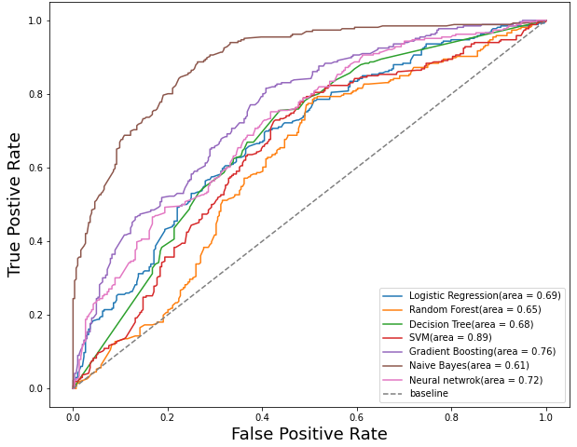
(a)
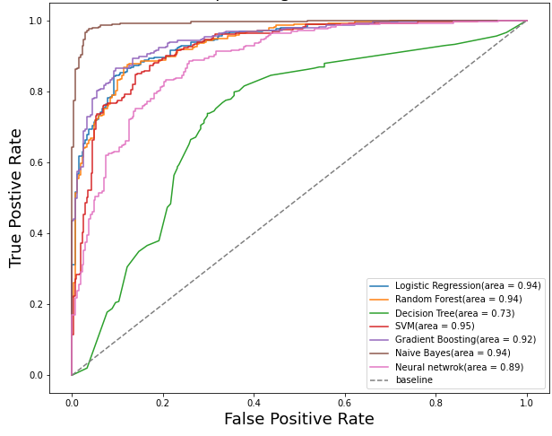
(b)
Fig. S2 Receiver operating curve of ML models generated (a) prior parameter tuning and (b) after parameter tuning

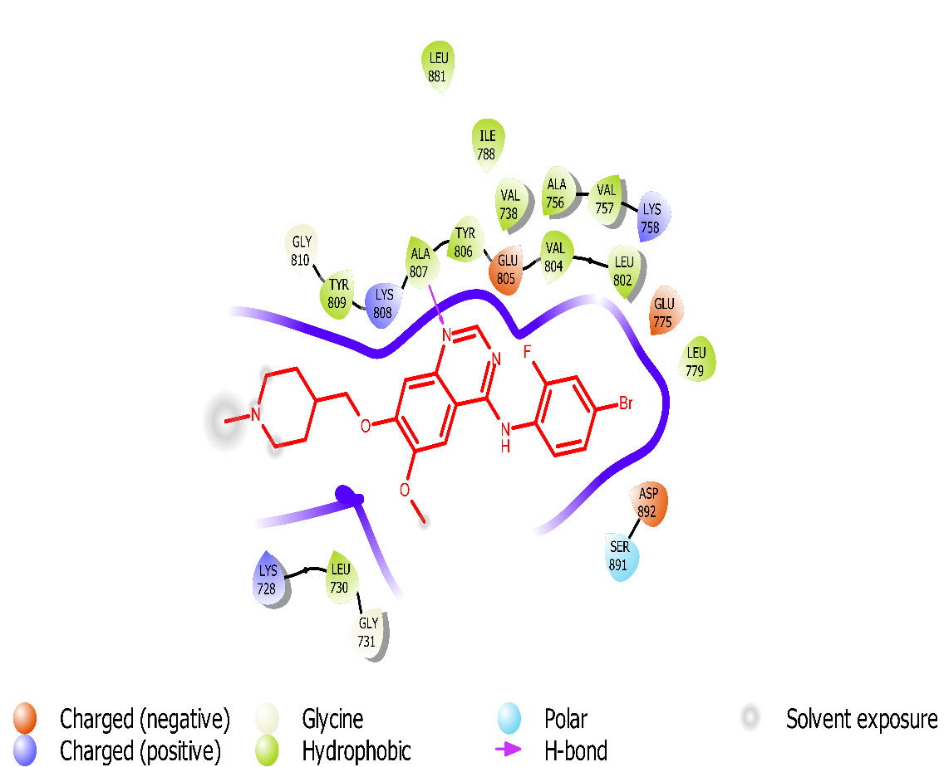
(a)
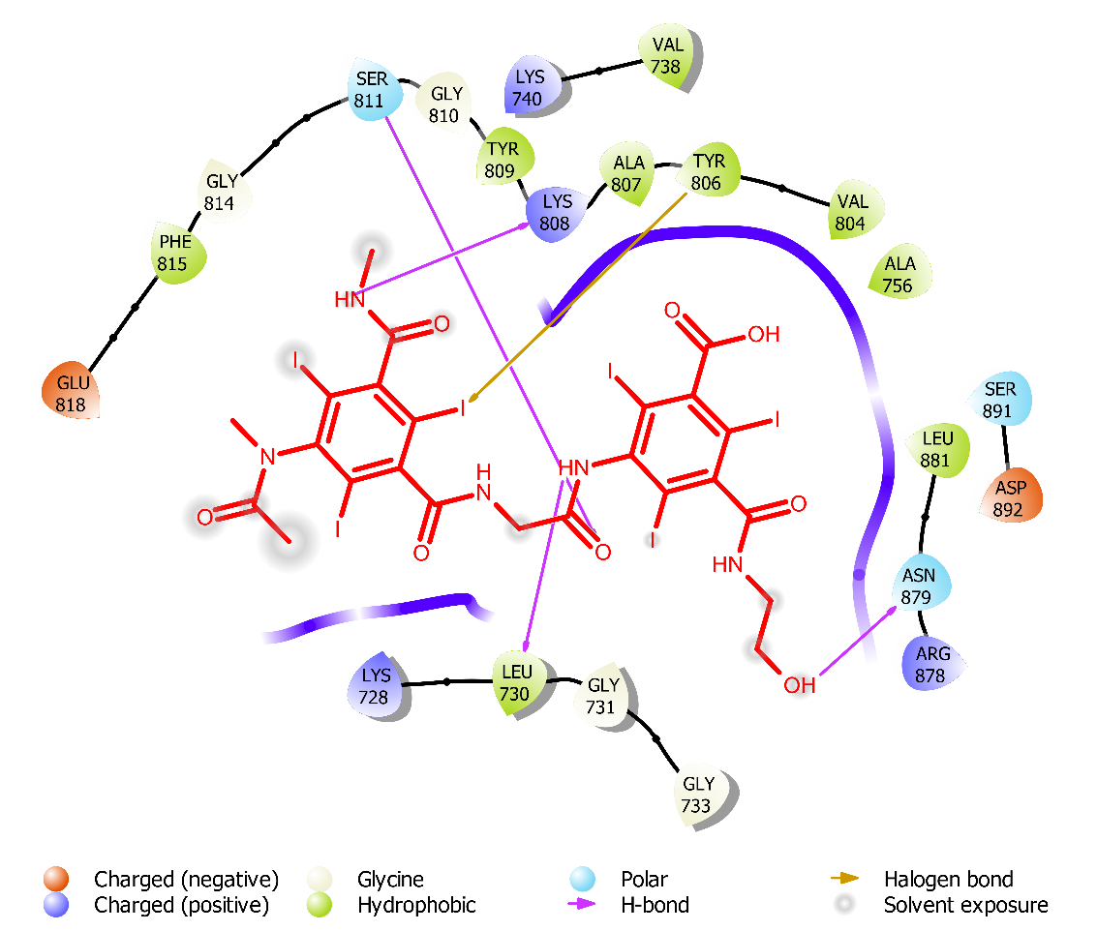
(b)
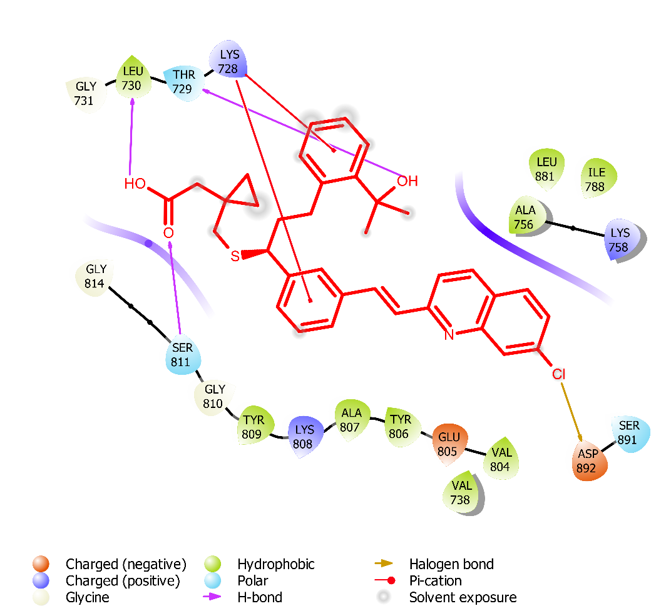
(c)
Fig. S3 Binding mode analysis of (a) Vandetanib, (b) DB09313 and (c) DB00471 into the binding pocket of RET

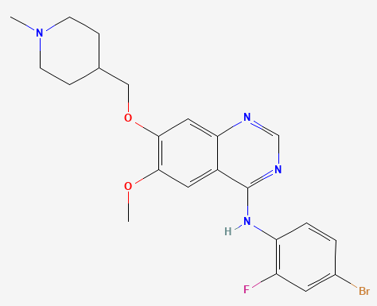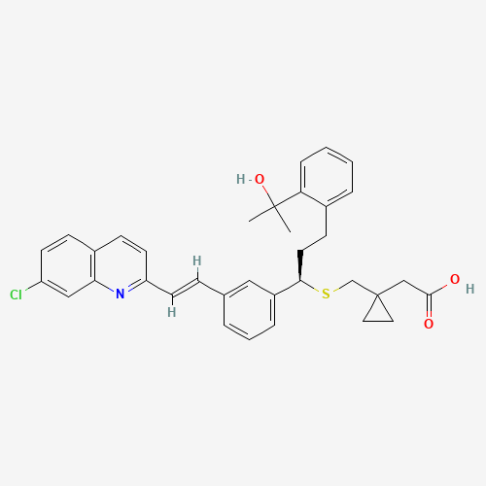
chloroquinoline scaffold
Anilinoquinazoline scaffold
- (b)
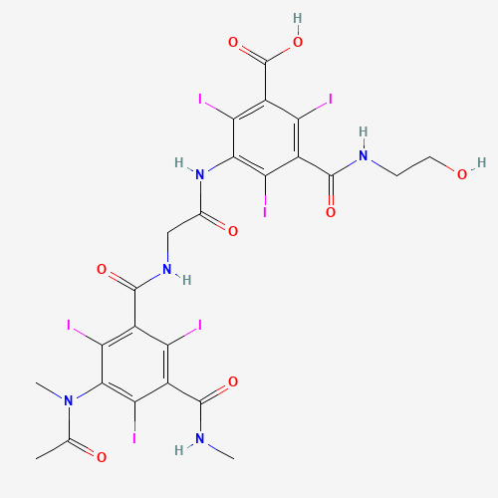
Tri-ionated Benzoate scaffold
(c)
Fig. S4 Key scaffold analysis of reference compound (a) Vandetanib and the lead compounds (b) DB09313 and (c) DB00471

