Supplementary Information
Water-soluble quaternized copolymers as eco-friendly cationic modifiers of cotton fabrics for salt-free reactive dyeing applications

Loukia Tsimpouki¹, Konstantinos Papapetros², Charalampos Anastasopoulos¹, Labrini Sygellou², Amaia Soto-Beobide², Konstantinos S. Andrikopoulos^{3,2}, George A. Voyiatzis², Georgios Bokias^{1*}, Joannis K. Kallitsis¹

¹Department of Chemistry, University of Patras, GR-26504, Patras, Greece
²Foundation for Research and Technology – Hellas (FORTH), Institute of Chemical Engineering Science (ICE-HT), Stadiou St., P.O. Box 1414, GR 265 04 Rio-Patras Greece
³Department of Physics, University of Patras, GR-265 04 Rio-Patras, Greece

S1. Assignment of Raman and FTIR bands of polymers
Table S1. Suggested assignment of the major vibrational bands appearing in the ATR-FTIR and Raman spectra of P(VBC-co-VBCTEAM_{x})
 | VBC |  | VBCTEAM
Assignment | ATR-FTIR  cm⁻¹ | Raman  cm⁻¹ | ATR-FTIR  cm⁻¹ | Raman  cm⁻¹
CH str 1-4 para ring | 3049 vw | 3054 s | 3054 vw | 3055 s
CH str 1-4 para ring |  | 3036 w–sh |  | ~3040 w–sh
CH₂ asym str [-CH₂Cl] | ~3010 w | 3006 m
CH₃ asym str |  |  | 2984 m | 2988 vs
CH₃ sym str |  |  | ~2940 vw–sh | 2947 vs
CH₂ sym str [-CH₂Cl] | 2957 vw–sh | 2958 m
CH₂ asym str, main chain (/tertiary amide) | 2918 m | 2912 m | ~2925 m | ~2925 w–sh
CH₂ sym str, main chain (/tertiary amide) | 2849 vw | 2853-2863 w | 2850 vw | 2855 w
1-4 para ring str | 1611 w | 1612 vs | 1612 ms | 1612 vs
1-4 para ring str | 1573 vw | 1577 vw | 1573 vw | 1574 vw
1-4 para ring str | 1510 m | 1511 vw | 1513 s | 1512 vw
CH₃ asym def |  |  | 1482 s | ~1482 w–sh
CH₂ def {quaternary amine} |  |  | 1454 s | 1457 m
CH₂ def [-CH₂Cl] | 1442 m | 1445 mw
Aliphatic bending modes | 1420 m | 1421 vw–sh
CH₃ def [quaternary amine] |  |  | 1396 s | 1394 vvw
Aliphatic bending modes |  |  | 1368 m | 1366 vvw
Aliphatic bending modes | 1312 vw | 1318 vw | 1306 vw | ~1310 w
CH₂ wagging [-CH₂Cl] | 1264 s | 1266 ms
CH in plain 1-4 para ring def | 1212 vw | 1212 m | 1217 w | 1215 m
Aliphatic bending modes |  |  |  | 1190 s
CH₂ twisting [-CH₂Cl] | 1182 vw | 1183 ms | 1184 w
Aliphatic bending modes |  |  | 1156 m | 1156 mw
CH₃ rocking [quaternary amine] |  |  | 1010 s | 1011 w
C-N asym [quaternary amine] |  |  | 930 vw | 928 mw
C-N asym [quaternary amine] |  |  | 903 w | 903 vw
CH out-of-plane 1-4 para ring def | 835 m–sh | 836 m | 845 w–sh | 844 mw
CH out-of-plane 1-4 para ring def | 821 s | 811 w–sh | 828 w | ~830 w–sh
CH₂ rocking or C-N sym [quaternary amine] |  |  | 782 vs | 787 w
CH₂ rocking [-CH₂Cl] | 743 w | 745 w
CH₂ rocking or C-N sym [quaternary amine] |  |  | 681 w | 681 m
C-Cl str [-CH₂Cl] | 671 vs | 675 m
In-plane 1-4 para ring def | 638 w | 638 m |  | 642 m
C-Cl def [-CH₂Cl] |  | 345 w

S2. Effect of X-Rays on fabrics
Irradiation of unmodified and modified fabrics with X-Rays results in alteration of the population of chemical species identified on the surface. The alteration is progressive, depends on time of irradiation as well as the existing modification. Macroscopically colour alteration may be visually observed at prolong irradiation times (Figure S1).
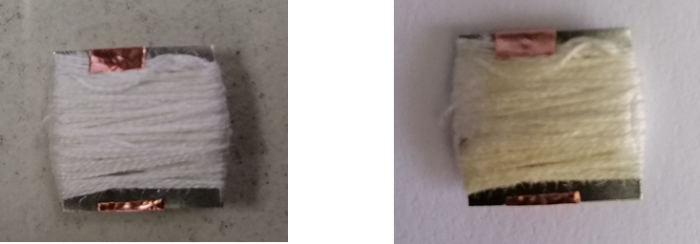
Figure S2.1. Color alteration of Cotton fibers before and after X-Ray irradiation in the XPS chamber.
The most affected elements were found to be Cl and N while C was the least affected. Systematic experiments on irradiated samples were performed in order to evaluate signal deterioration as a function of time. Indicative spectra of PVBC and PVBCTEAM in the C_{1s}, Cl_{2p} and N_{1s} spectral regions as a function of irradiation time are given in Figure S2.
Figure S2.2. Progressive intensity alterations of the XPS peaks from modified fabrics as a function of irradiation time.

In the C_{1s} envelope, the C-O-C band (286.6 eV) is only weakly affected while the intensity of all the other bands is basically constant with time. On the other hand, the intensity of the Cl_{2p} and the quaternary N_{1s} bands are critically affected by irradiation. Figure 3S depicts the intensity of the aforementioned bands as a function of irradiation time. From the two calibration curves appearing in the figure, it becomes clear that for a 15 mins measurement there is a ~25% decrease in the recorded intensity for both Cl_{2p} and N_{1s}. Corrected intensity values may be obtained taking into account the denoted fitting curves.
(a) | (b)
Figure S2.3. Calibration curve of the XPS intensity for (a) the Cl anion (197 eV) and (b) the quaternary N1s (402 eV) as a function of time.

Since N⁺ and Cl and Cl⁻ are the most critical elemental entities that define the physicochemical processes developed during of textile modification, a specific methodology was applied i.e. measuring first the Cl, Cl⁻ spectral region, next the N⁺, N region and finally the C region. All measurements were performed at the minimum time that allowed acceptable signal to be collected.

S3. Polymer exhaustion studies
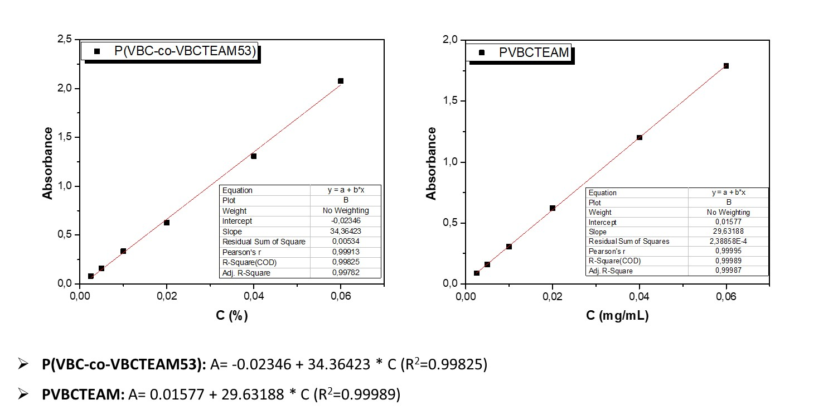

Figure S3. Calibration curves of PVBC-co-VBCTEAM53) (left) and PVBCTEAM (right) in aqueous alkaline solutions. The concentration is given as w/v.

S4. Dye exhaustion studies
Figure S4. UV-vis spectra (a) and calibration curve of Novacron Ruby NRS-3B in aqueous alkaline solutions. The concentration is given as w/v.

