Appendix A
Appendix A, Table 1: Participants Enrollment
Enrolled | 182
Excluded | 66
Exclusion reason
Did not enter any data | 27
Did not complete one or both surveys | 18
Diagnosis not confirmed by genetic testing | 7
Genetic testing information missing | 3
Gene not reported | 9
Confirmed to be asymptomatic carrier | 2
Included in analysis | 116

Appendix A, Figure 1: Age at survey submission (years)
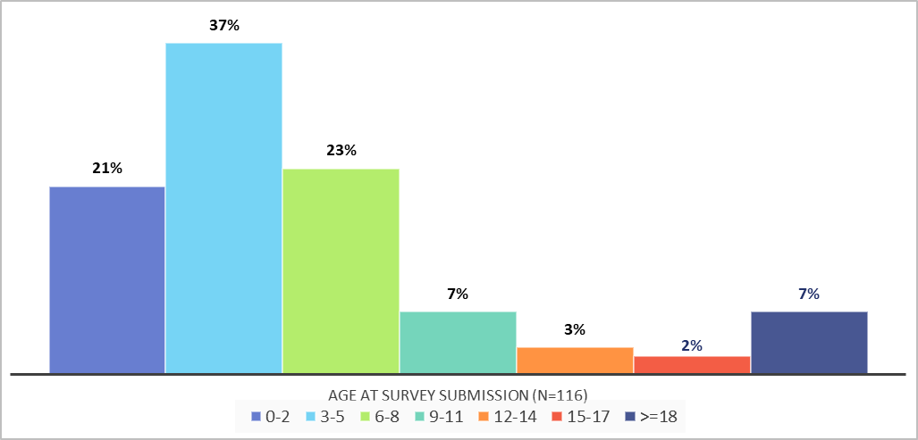

Appendix A, Table 2: Participant country by geographic region (N=116)
Region | Country | n (%)
Eastern Europe | Russia | 32 (27.59)
 | Belarus | 5 (4.31)
 | Romania | 3 (2.59)
 | Ukraine | 2 (1.72)
 | Bulgaria | 1 (0.86)
 | Czech Republic | 1 (0.86)
 | Hungary | 1 (0.86)
 | Poland | 1 (0.86)
North America | United States of America (USA) | 36 (31.03)
Western Europe | Germany | 3 (2.59)
 | Italy | 3 (2.59)
 | United Kingdom | 3 (2.59)
 | Austria | 2 (1.72)
 | France | 2 (1.72)
 | Spain | 2 (1.72)
 | Greece | 1 (0.86)
Latin America and the Caribbean | Argentina | 3 (2.59)
 | Brazil | 3 (2.59)
 | Mexico | 2 (1.72)
 | Ecuador | 1 (0.86)
Near East | Israel | 3 (2.59)
Central Asia | Kazakhstan | 1 (0.86)
 | Turkmenistan | 1 (0.86)
Oceania | Australia | 2 (1.72)
Asia | India | 1 (0.86)
Unknown | Not reported | 1 (0.86)

Appendix A, Table 3: Type of genetic testing used to determine diagnosis (N=116)
Testing type | n (%)
Whole Exome sequencing | 28 (24.14)
Mitochondrial DNA sequencing | 26 (22.41)
Whole genome sequencing | 22 (18.97)
Don't know | 11 (9.48)
Other | 11 (9.48)
Gene panel | 8 (6.90)
Targeted gene analysis | 8 (6.90)
Not reported | 2 (1.72)
Appendix A, Table 4: Specialists seen (Nª=105)
Specialist type | n (%)
Neurologist | 82 (78.10)
Physical therapist | 67 (63.81)
Geneticist | 55 (52.38)
Cardiologist | 51 (48.57)
Occupational therapist | 50 (47.62)
Nutritionist | 48 (45.71)
Speech therapist | 46 (43.81)
Gastroenterologist | 32 (30.48)
Pulmonologist | 30 (28.57)
Not reported | 6 (5.71)
Other | 4 (3.81)

a. Living patients only

Appendix A, Figure 2: Number of interventions (Nª=114)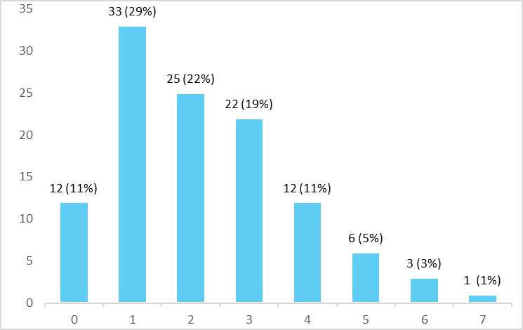
- N=number of participants who responded to questions about interventions.

