Synthesis and characterization of Zn based bi metallic micro porous MOF composites for effective formaldehyde sensing at room temperature.

A. Jagan Mohan Reddy^{1&2}, P. Nagaraju³, E. Namratha¹ , M. S. Surendra Babu^{1*}

-------------------------------------------------------------------------------------------------------------------------------------------------------------------------

¹ Department of Chemistry, School of Science, GITAM(Deemed to be University), Hyderabad Campus, Hyderabad, 502 329, Telangana, India. corresponding author, Email:smanabol@gitam.edu.

² Departments of Chemistry, CMR Technical Campus, Medchal, Hyderabad, 501401, India.

³ Departments of Physics, CMR Technical Campus, Medchal, Hyderabad, 501401, India.

S1. Experimental section.
S1.1. Fabrication of gas sensor device.
In this work, we report a simple fabrication method for preparing a gas sensor device by the drop cast method on a glass substrate. The solvent and its evaporating times are the most important factors influencing the uniformity of the film. Among various solvents, ethanol was chosen as the best solvent for preparing a stable suspension of bimetallic MOF. In detail, the MOF suspensions were prepared by dissolving approximately 5 to 10 mg MOF in 1 to 2 ml of ethanol followed by sonication for 20 minutes. MOF sensing layers were drop-coated on the glass substrate; electrical links were made by applying the silver paste on two sides and subsequently dried in an oven for 24 hours.
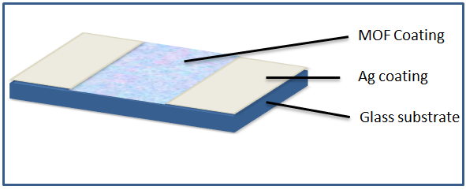
Fig. S1. Schematic illustration of a gas sensing device.

The response (S) of the sensor is expressed as:

$$S=\frac{R_{a}}{R_{g}}$$

Here R_{a} and R_{g} are the resistance values in pure air and target gases respectively [29].

Gas sensing measurements were carried out in a fully automatic gas sensing unit at room temperature. Typical experimental gas sensing unit set-up consists of a vacuum-sealed tubular container with an inlet for the carrier gas, a heating unit for VOC vapour generation and a resistance recorder system as shown in figure S2. As prepared gas sensor was placed into a measurement board in the measuring unit. After that, the target gas (formaldehyde or other VOCs) were introduced by injecting a definite volume of a liquid analyte with a microsyringe onto VOC vapour generating heating unit in the test chamber. The sensing measurements were carried out by repeatedly exposing the sensors to the target gas in a closed chamber.
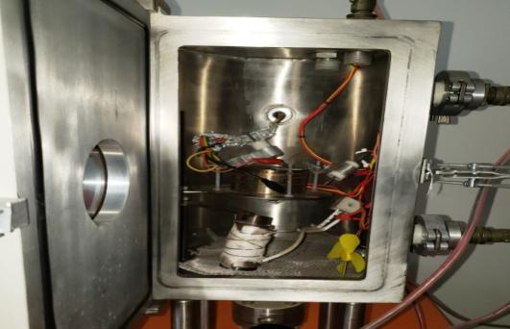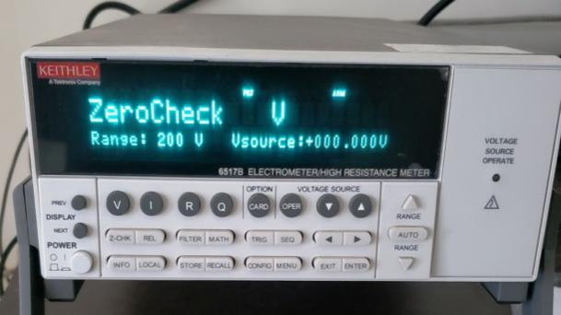
Fig. S2. Gas sensing setup images

S2. Characterization
S2.1 SEM and EDX analysis
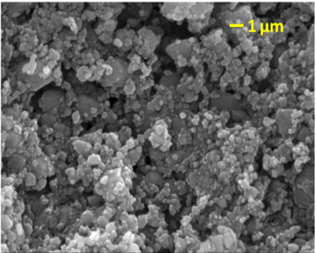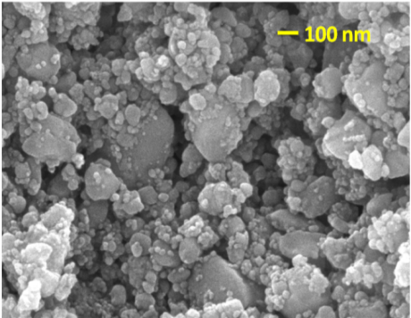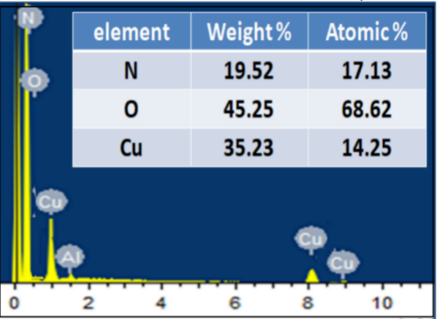
Fig. S3 SEM and EDX images of Cu(NA)

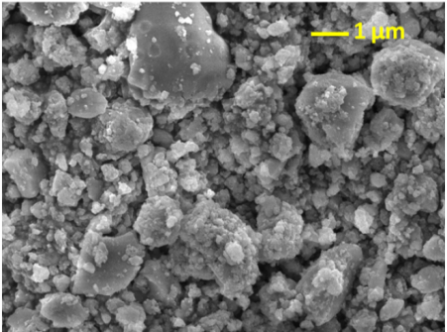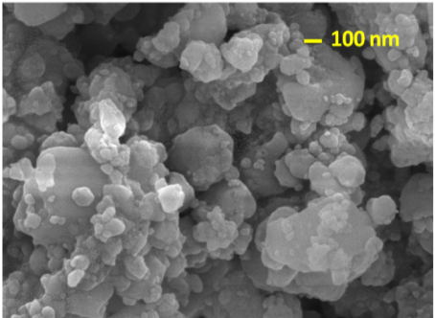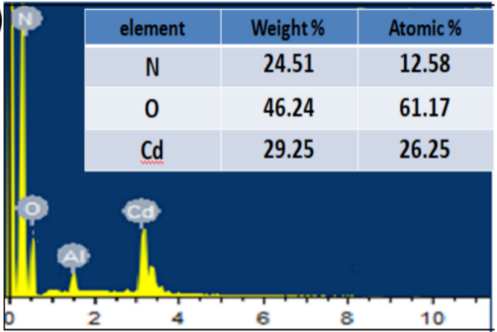
Fig. S4 SEM and EDX images of Cd(NA).

S2.3 XPS analysis

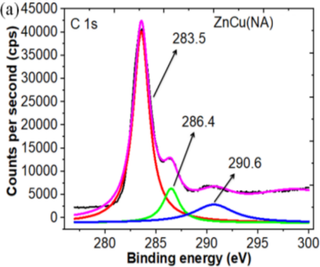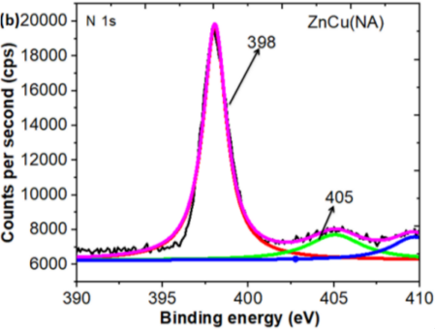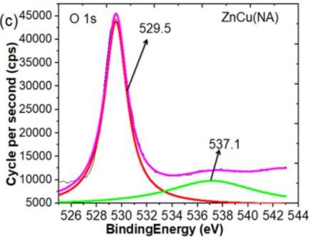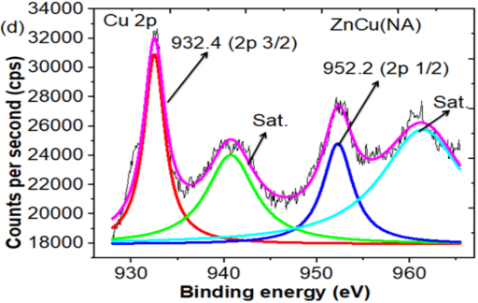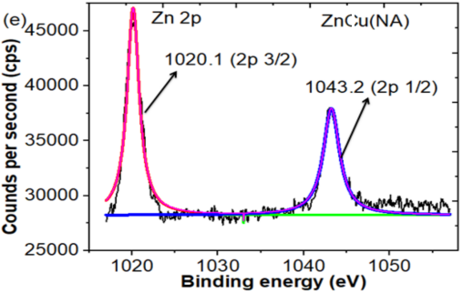

Fig. S5 (a) C 1s, (b) N 1s, (c) O 1s, (d) Cu 2p and (e) Zn 2p core-level XPS spectra of ZnCu(NA) MOF

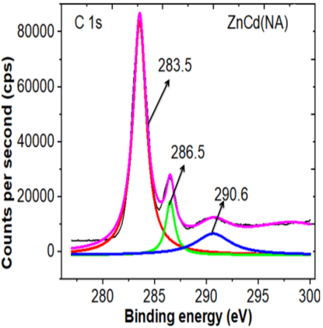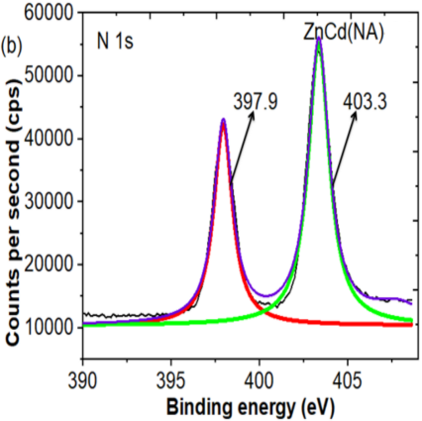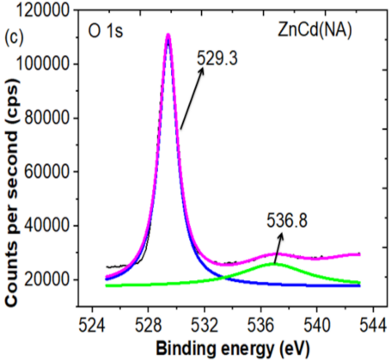
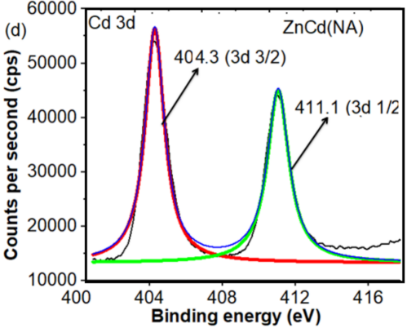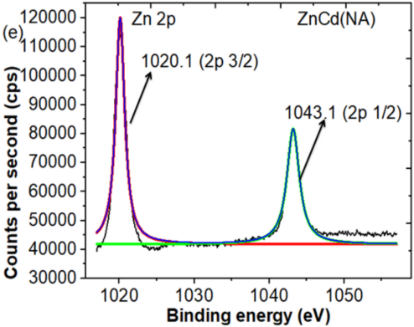
Fig. S6 (a) C 1s, (b) N 1s, (c) O 1s, (d) Cd 3d and (e) Zn 2p core-level XPS spectra of ZnCd(NA) MOF

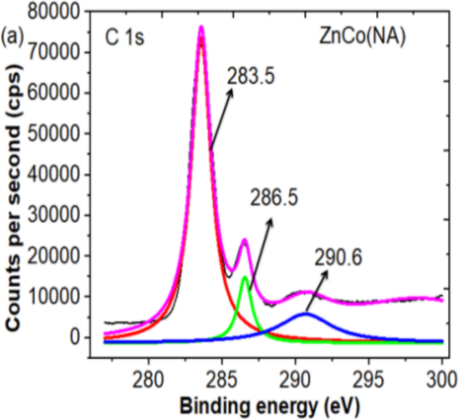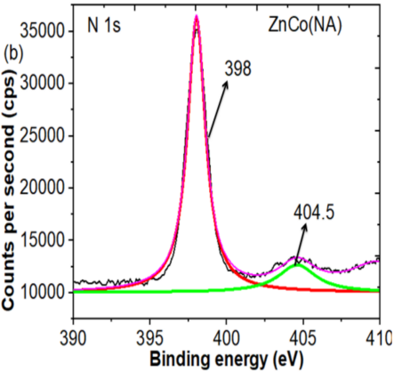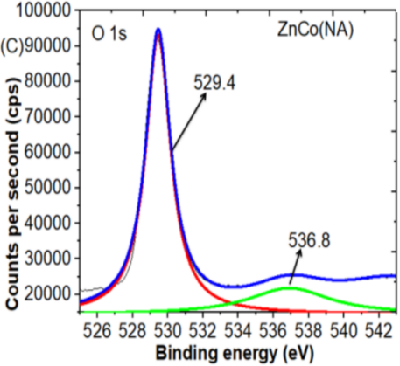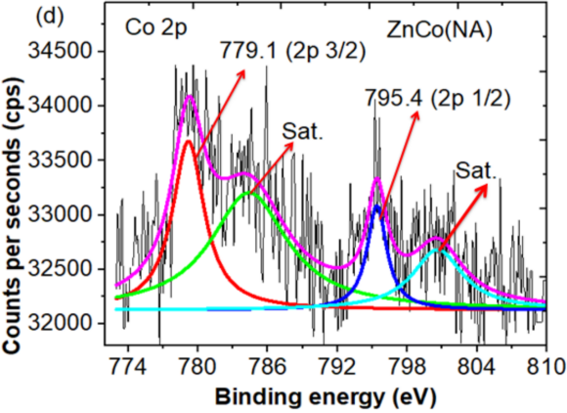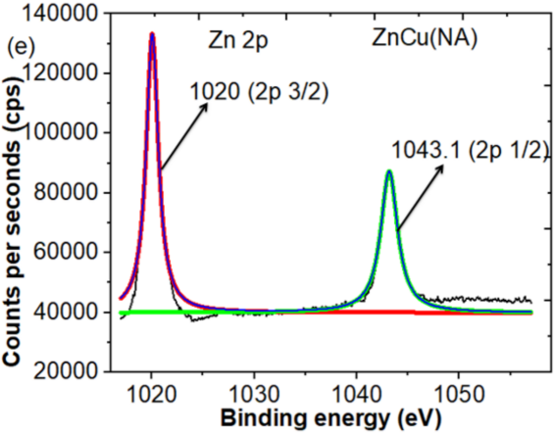
Fig. S7 (a) C 1s, (b) N 1s, (c) O 1s, (d) Co 2p and (e) Zn 2p core level XPS spectra of ZnCo(NA) MOF.
S2.3 BET analysis
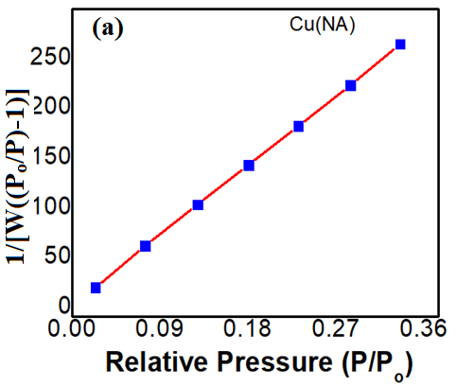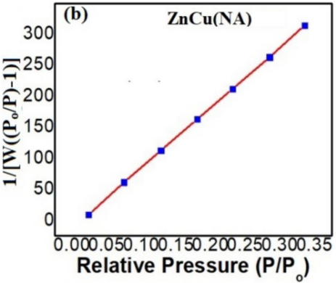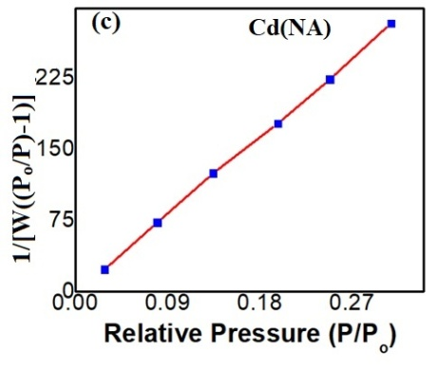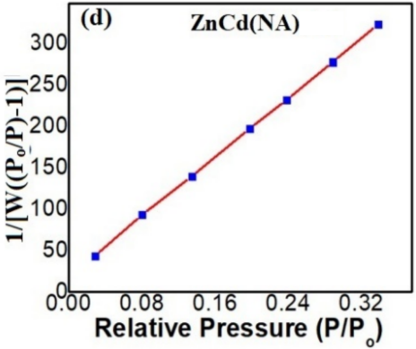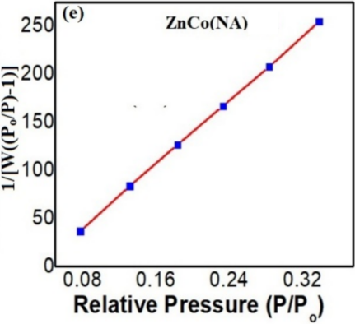
Fig. S8 BET graphs of (a) Cu(NA), (b) ZnCu(NA), (c) Cd(NA), (d) ZnCd(NA) and (e) ZnCo(NA)

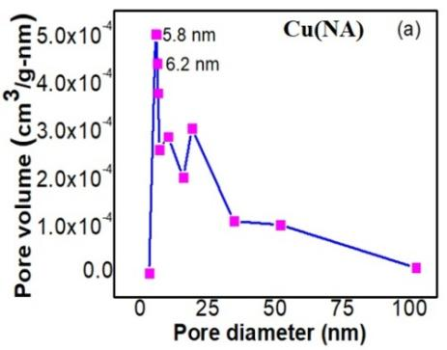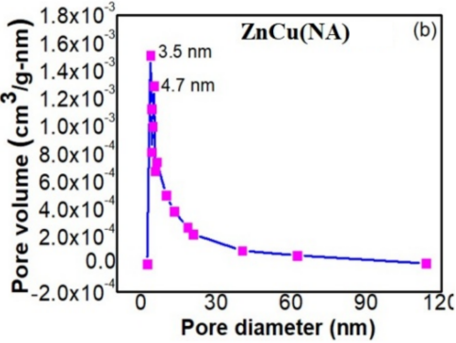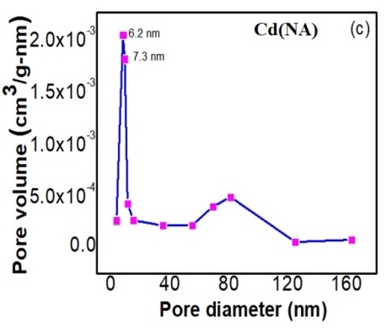
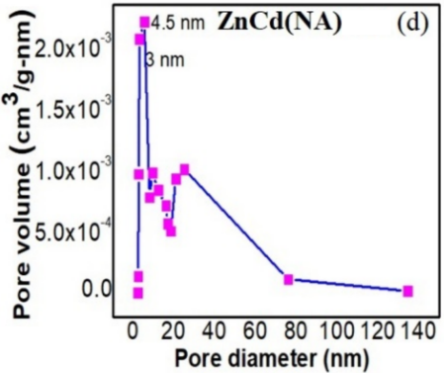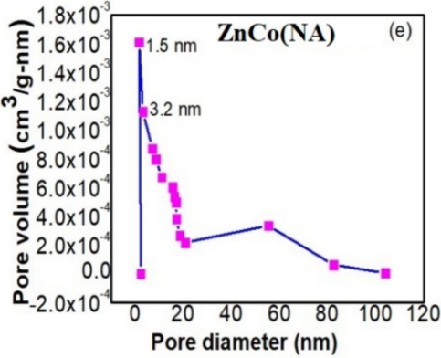
Fig. S9 BJH graphs of (a) Cu(NA), (b) ZnCu(NA), (c) Cd(NA), (d) ZnCd(NA) and (e) ZnCo(NA)
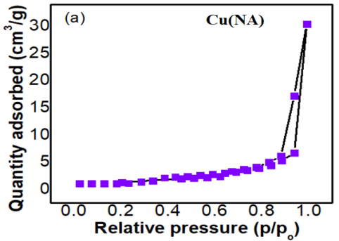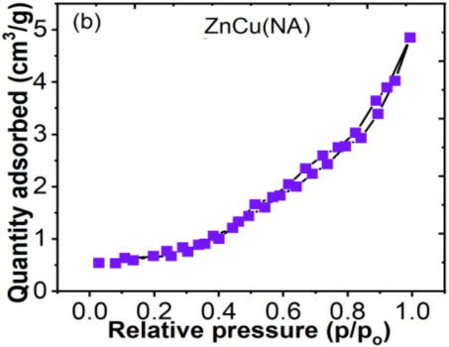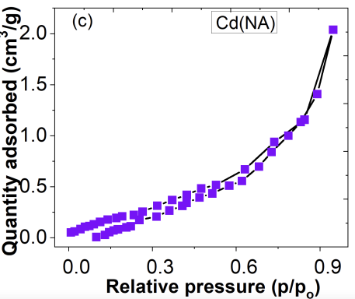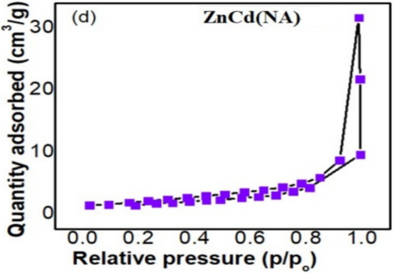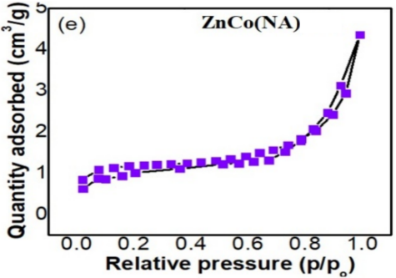
Fig. S10 Adsorption and desorption grphs of (a) Cu(NA), (b) ZnCu(NA), (c) Cd(NA), (d) ZnCd(NA) and (e) ZnCo(NA)

S3. Gas sensing
The dynamic resistance curves of all synthetic MOFs to various reducing gases are recorded, such as formaldehyde, xylene, acetone, ethanol and toluene, in the concentration range of 1-50 ppm. Typical n-type sensing behaviour was observed for all MOFs; the sensor resistance decreases after the measured gas supply is introduced. If the gas supply is stopped and dry air is introduced, it returns to the original resistance value. In the sensing mechanism, in the ambient air, the oxygen particles on the MOF surface extract the adsorbed electrons from the MOF conductive band and form a layer of electron depletion below the MOF surface. This inhibits the conduction path of the MOF and determines the overall resistance of the original MOF sensor. The provided reducing gas interacts with the pre-adsorbed oxide ions to generate volatile molecules, returning the adsorbed electrons to the conduction band of the MOF. Therefore, the sensor resistance decreases. For clarity, the formation of the oxygen adsorption depletion layer and the subsequent reaction of formaldehyde sensing are summarized in the following reactions [38-40].
O_{2 (gas)} → O_{2 (ads)}
O_{2 (ads)} + $e^{−}$ → $O_{2 (ads) }^{−}$
$O_{2 (ads) }^{−}+ e^{−}$ →${ 2O}_{(ads)}^{−}$
${ O}_{(ads)}^{−}$+ $e^{−}$ → ${ O}_{(ads)}^{2−}$
HCHO(_{ads)} +${ 2O}_{(ads)}^{2−}$→ CO₂ + H₂O + 4e-

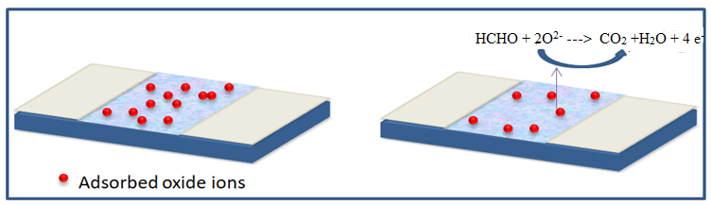
Figure 7. Formaldehyde sensing mechanism schematic illustration.

After exposure to the analyte gas, the response time is needed to reach 90% of the highest response. After the analyte gas is removed, it specifies the recovery time or the amount of time needed for the sensor to return to 10% of its initial response. The sensor's response time and recovery times are measured based on the transient response.

Table. S1 Response, Response times and recovery times of Cu(NA), ZnCu(NA), Cd(NA), ZnCd(NA) and ZnCo(NA) of formaldehyde at 1, 5, 10, 25 and 50 ppm concentrations.
Target gas | Concentration  (ppm) | Sensing  material | Response/  Response time/  Recovery time | Sensing  material | Response/  Response time/  Recovery time | Sensing  Material | Response/  Response time/  Recovery time | Sensing  material | Response/  Response time/  Recovery time | Sensing  material | Response/  Response time/  Recovery time
Formaldehyde | 1 | Cu(NA) | 1.1/  22/  21 | ZnCu(NA) | 2.37/  16/  25 | Cd(NA) | 1.1/  11/  9 | ZnCd(NA) | 1.8/  24/  26 | ZnCo(NA) | 3.2/  16/  15
Formaldehyde | 5 | Cu(NA) | 1.42/  21/  22 | ZnCu(NA) | 4.19/  19/  27 | Cd(NA) | 1.15/  14/  28 | ZnCd(NA) | 3.34/  20/  25 | ZnCo(NA) | 5.2/  14/  27
Formaldehyde | 10 | Cu(NA) | 1.45/  20/  30 | ZnCu(NA) | 6.16/  15/  31 | Cd(NA) | 1.2/  16/  25 | ZnCd(NA) | 4.4/  21/  32 | ZnCo(NA) | 8.6/  16/  25
Formaldehyde | 25 | Cu(NA) | 2.04/  16/  32 | ZnCu(NA) | 10/  13/  30 | Cd(NA) | 2.02/  16/  38 | ZnCd(NA) | 7.14/  17/  36 | ZnCo(NA) | 15.4/  18/  29
Formaldehyde | 50 | Cu(NA) | 3.74/  17/  29 | ZnCu(NA) | 18.6/  9/  35 | Cd(NA) | 3.13/  15/  35 | ZnCd(NA) | 8.36/  18/  39 | ZnCo(NA) | 28.3/  17/  40
Ethanol | 1 to 50 | Cu(NA) | ND | ZnCu(NA) | ND | Cd(NA) | ND | ZnCd(NA) | ND | ZnCo(NA) | ND
xylene | 1 to 50 | Cu(NA) | ND | ZnCu(NA) | ND | Cd(NA) | ND | ZnCd(NA) | ND | ZnCo(NA) | ND
Tolune | 1 to 50 | Cu(NA) | ND | ZnCu(NA) | ND | Cd(NA) | ND | ZnCd(NA) | ND | ZnCo(NA) | ND
acetone | 1 to 50 | Cu(NA) | ND | ZnCu(NA) | ND | Cd(NA) | ND | ZnCd(NA) | ND | ZnCo(NA) | ND

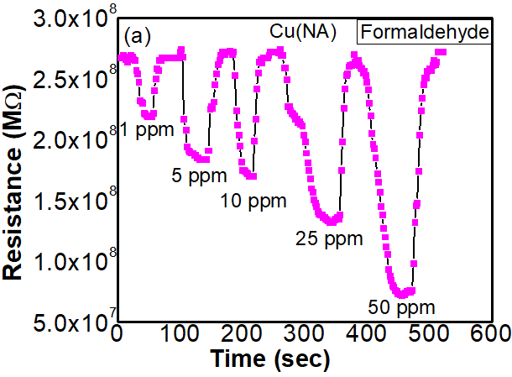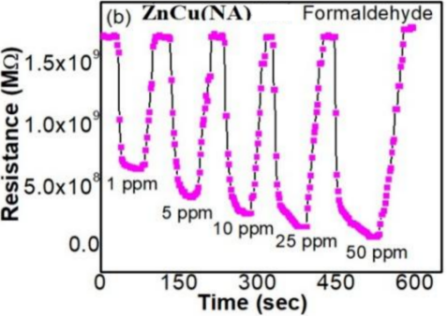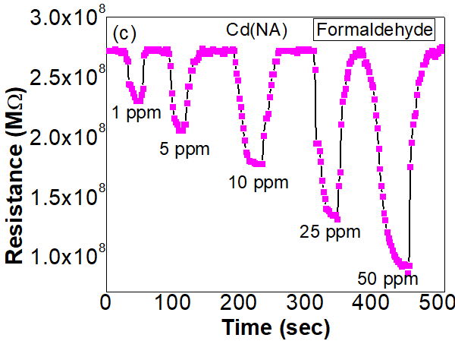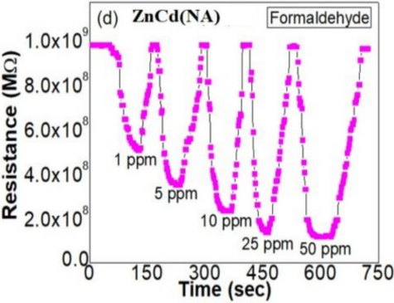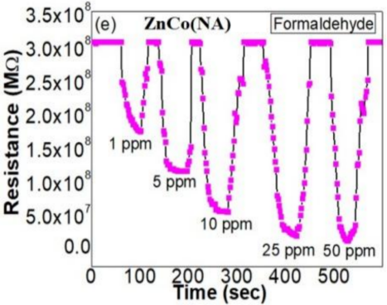
Fig. S11 Formaldehyde resistance graphs of (a) Cu(NA), (b) ZnCu(NA), (c) Cd(NA), (d) ZnCd(NA) and (e) ZnCo(NA)
References

- X. Ma, X. Zhou, Y. Gong, N. Han, H. Liu, Y. Chen, MOF-derived hierarchical ZnO/ZnFe₂O₄ hollow cubes for enhanced acetone gas-sensing performance, RSC Adv., 7 (2017) 34609-34617.

