The changing in lactate dehydrogenase for the serum survival predictor for treatment with polymyxin B-immobilized fiber column-direct hemoperfusion in patients with acute exacerbation of idiopathic interstitial pneumonias

Supplementary materials

Motoyasu Kato¹, Shun Nakazawa¹, Takashi Akimoto¹, Soichiro Soma¹, Eri Hayakawa¹, Yuta Arai¹, Misa Tateyama¹, Hiroaki Motomura¹, Tomoko Yamada¹, Yusuke Ochi¹, Issei Sumiyoshi¹, Junko Watanabe¹, Hiroaki Ihara¹, Shinsaku Togo¹, Shinichi Sasaki¹, Arata Azuma², Kazuhisa Takahashi¹

¹Department of Respiratory Medicine, Juntendo University Graduate School of Medicine, Tokyo, Japan
²Graduate School of Pulmonary Medicine, Nippon Medical School, Tokyo Japan

Supplementary Figures
Figure S1
(A) (B)
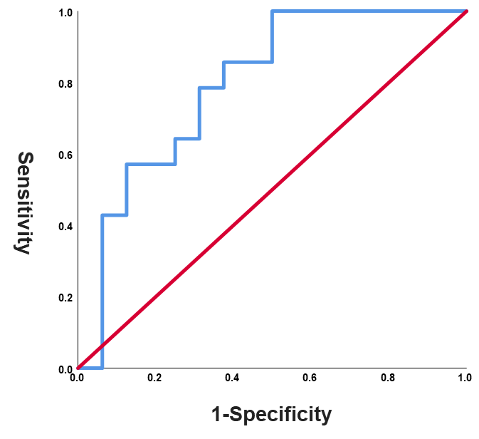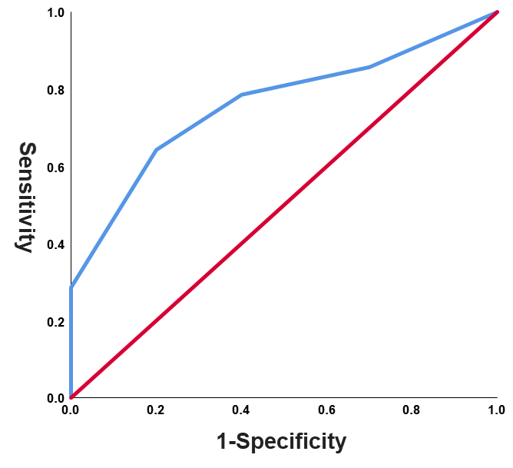
Figure S2
(A) (B)
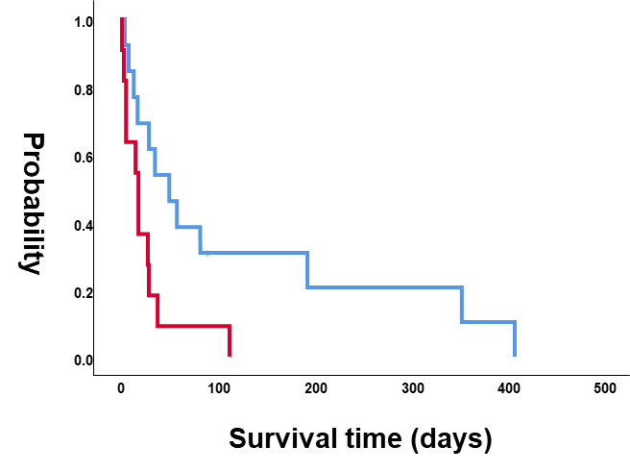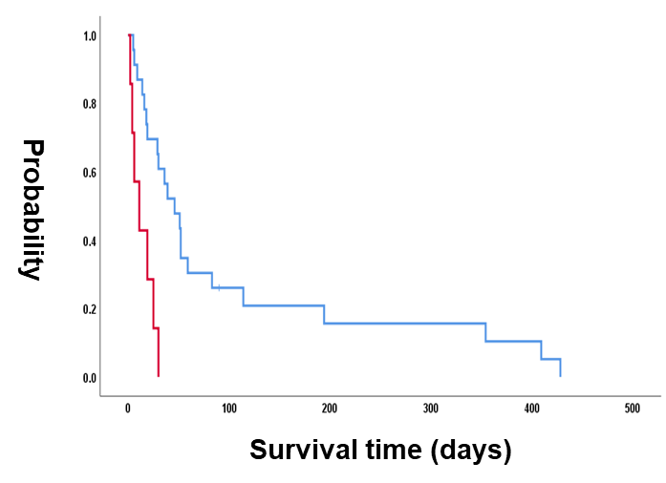
(C) (D)
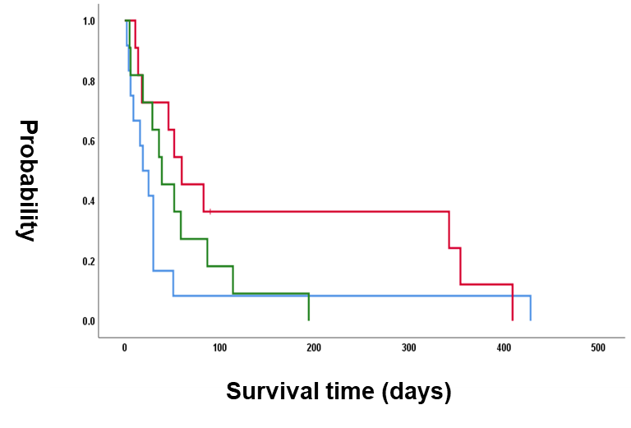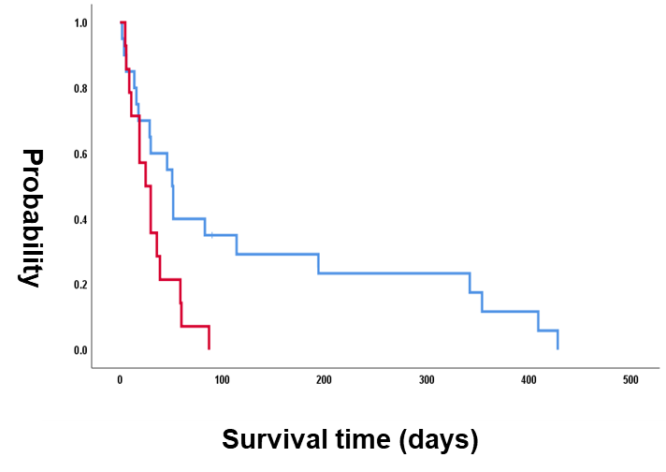
Supplementary Figure Legends
Figure S1
Receiver operating characteristic curve analysis
Receiver operating characteristic (ROC) curve analyses to determine the optimal cut-off values of (A) FVC and (B) GAP index. The sensitivity or true positive rate is plotted on the y-axis and false positive rate, or 1-specificity, is plotted on the x-axis. The area under the curve (AUC) is equivalent to the numerator of the Mann–Whitney U statistic for the comparison of the marker distributions between the survival and the non-survival group after the initiation of PMX-DHP therapy.
Figure S2
Survival curves. (A) Difference in survival time since the initiation of PMX-DHP therapy between patients with low and high FVC levels prior to the development of AE-IIPs. Blue and red lines indicate the number of patients and survival of patients with low and high FVCs, respectively. (B) Difference in survival time since the initiation of PMX-DHP therapy between patients with low and high GAP indices. Blue and red lines indicate the number of patients and survival of patients with low and high GAP indices, respectively. (C) Difference in survival time since the initiation of PMX-DHP therapy among patients with the clinical AE-IIPs types: idiopathic, infection-triggered, and non-infection triggered. Blue, red, and green lines indicate the number of patients and survival of patients with non-infection-triggered, infection-triggered, and idiopathic IIPs. (D) Difference in survival time since the initiation of PMX-DHP between patients who received PMX-DHP within and after 48 h. Blue and red lines indicate the number of patients and survival of the patients who received therapy within and after 48 h, respectively. p-value was calculated using the log-rank test in all analyses.

Supplementary Table

Supplementary Table 1. The difference in serum markers associated with interstitial pneumonia between survival over and within 30 days
 | Total  N = 33 | Survival ≥ 30 days  N = 18 | Survival < 30 days  N = 15 | p-value
Baseline serum markers  KL-6, IU/L | 791 (289-2922) | 711 (289-2922) | 969 (304-2674) | 0.5551
SP-D, ng/mL | 219 (84-484) | 199 (94-484) | 264 (84-414) | 0.8003
LDH, IU/L | 242 (158-897) | 240 (167-897) | 242 (158-482) | 0.5993
WBC, /µL | 9700 (3900-15700) | 8800 (3900-14200) | 10500 (5700-15700) | 0.1887
Neutrophil, /µL | 7300 (2450-14200) | 6001 (2450-11520) | 8245 (4176-14200) | 0.0503
Lymphocyte, /µL | 1377 (157-3884) | 1461 (315-2430) | 1377 (157-3884) | 0.5337
CRP, mg/dL | 1.55 (0.1-16.92) | 1.62 (0.13-12.63) | 1.51 (0.15-16.92) | 0.9237
Platelet, /µL | 21.5 (4.3-47.8) | 22.3 (4.3-41.1) | 20.2 (9.6-47.8) | 0.9515
D-dimer, ng/mL | 1.8 (1.0-8.3) | 1.4 (1.0-3.0) | 2.0 (1.0-8.3) | 0.0654
Δ Serum markers between PMX-DHP initiated day and baseline  KL-6, IU/L | 334 (-114-4753) | 245 (-114-2904) | 408 (-10-4753) | 0.6162
SP-D, ng/mL | 245 (-126-2886) | 240 (-126-1318) | 406 (60-2886) | 0.3336
LDH, IU/L | 89 (-500-549) | 100 (-500-549) | 80 (15-391) | 0.8509
WBC, /µL | 2450 (-4000-8700) | 3300 (-3000-8700) | 2200 (-4000-7500) | 0.7272
Neutrophil, /µL | 2596 (-3045-8280) | 3096 (-3045-8280) | 1070 (-4580-8676) | 0.6365
Lymphocyte, /µL | -557 (-2169-696) | -568 (-1294-696) | -430 (-2169-423) | 0.8333
CRP, mg/dL | 6.65 (-10.56-26.71) | 5.08 (-3.09-26.71) | 9.11 (-10.56-17.66) | 0.9676
Platelet, /µL | 0.8 (-12.0-16.0) | 1.4 (-10.7-16.0) | 0.8 (-12.0-8.3) | 0.2898
D-dimer, ng/mL | 1.7 (0.2-41.4) | 1.8 (0.2-41.4) | 1.1 (0.4-41.0) | 0.5346

Abbreviations: CRP: C-related peptide, KL-6: Krebs von den Lungen-6, LDH: lactate dehydrogenase, SP-D: Surfactant Protein-D, WBC: white blood cell.

