Appendix A
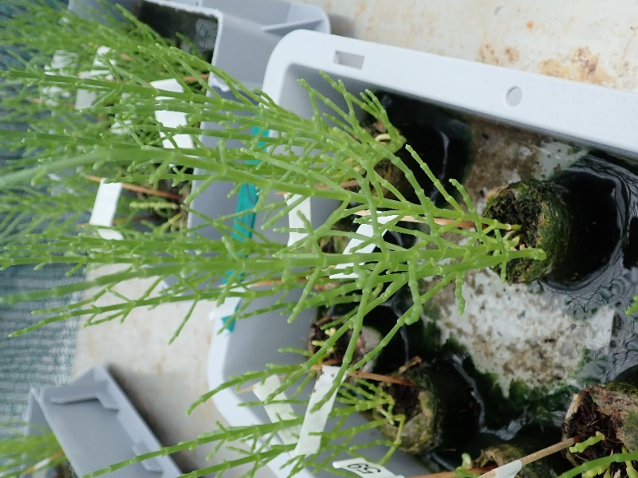
Figure A1. Picture of a growth tray (equals one unit per treatment) stocked with 9 growth taps containing each about 5 Salicornia plants.

