TOC
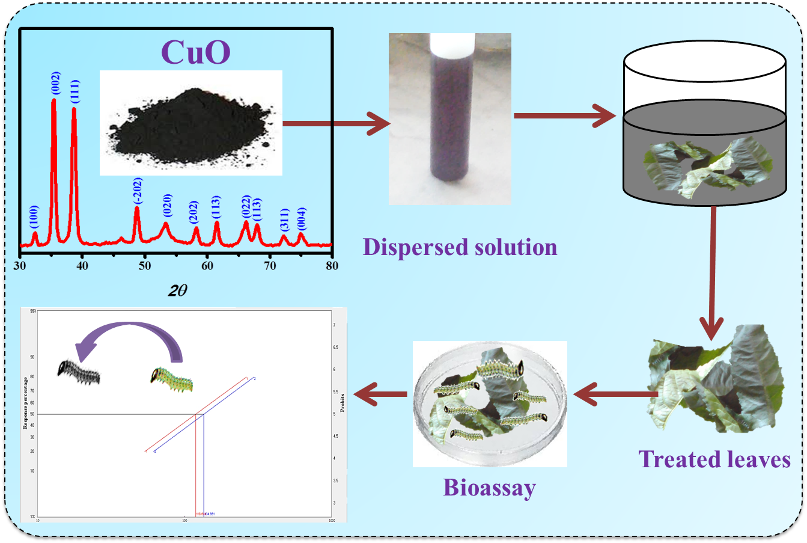

Facile Synthesized copper oxide micro/-nanostructures via wet chemical methods and their prospective activity as alternative insecticides on Fall Armyworm (Spodoptera Frugiperda)

