Additional Files
Additional files was submitted alongside this manuscript with title:
- Additional file 1.png
Title: Geographic distribution and the number of leukemia patients diagnosed at SGH from 2009-2018 and originating from Central Java or YSR provinces (N = 950).
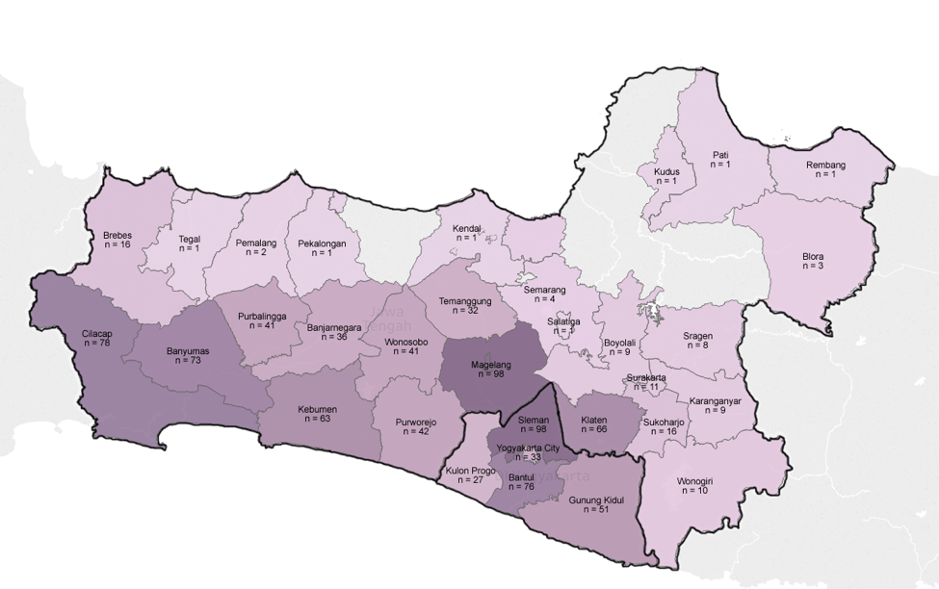

- Additional file 2.png
Title: Geographic distribution and the number of solid tumor patients diagnosed at SGH from 2009-2018 and originating from Central Java or YSR provinces (N = 391).
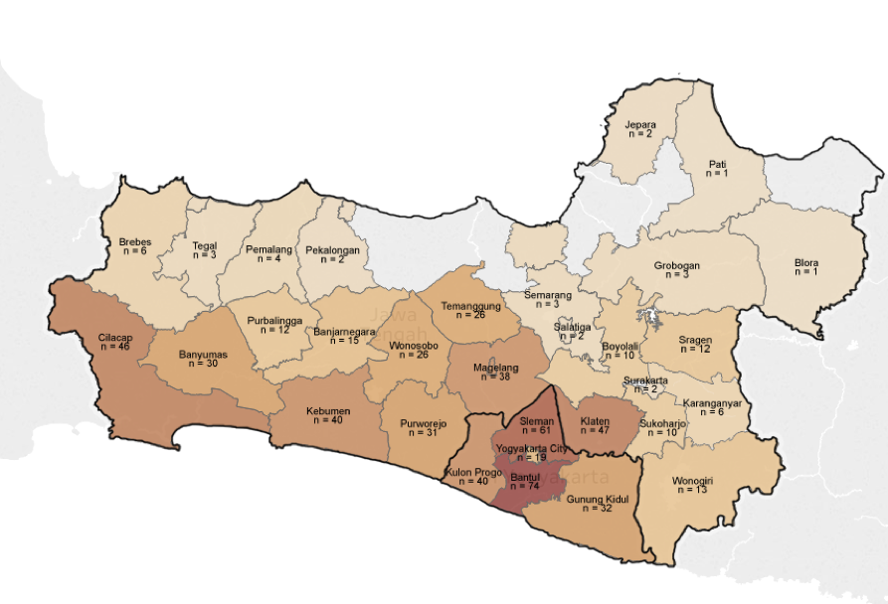

- Additional file 3.png
Title: Geographic distribution and the number of retinoblastoma patients diagnosed at SGH from 2009-2018 and originating from Central Java or YSR provinces (N = 93).
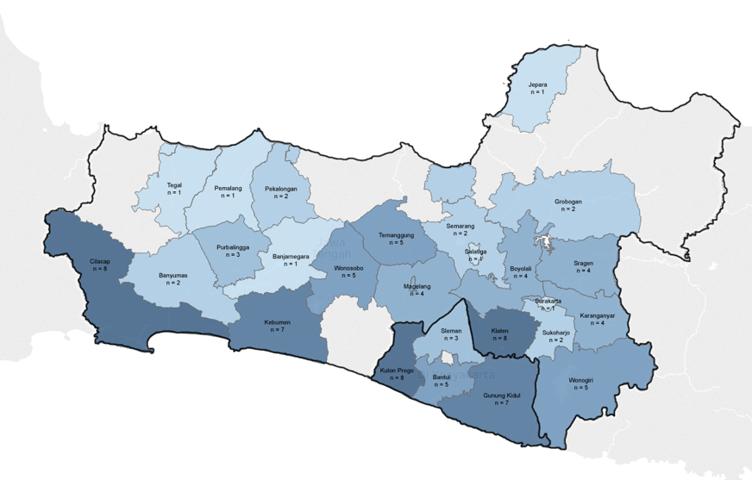

- Additional file 4.png
Title: Geographic distribution and the number of lymphomas and reticuloendothelial neoplasms patients diagnosed at SGH from 2009-2018 and originating from Central Java or YSR provinces (N = 118).
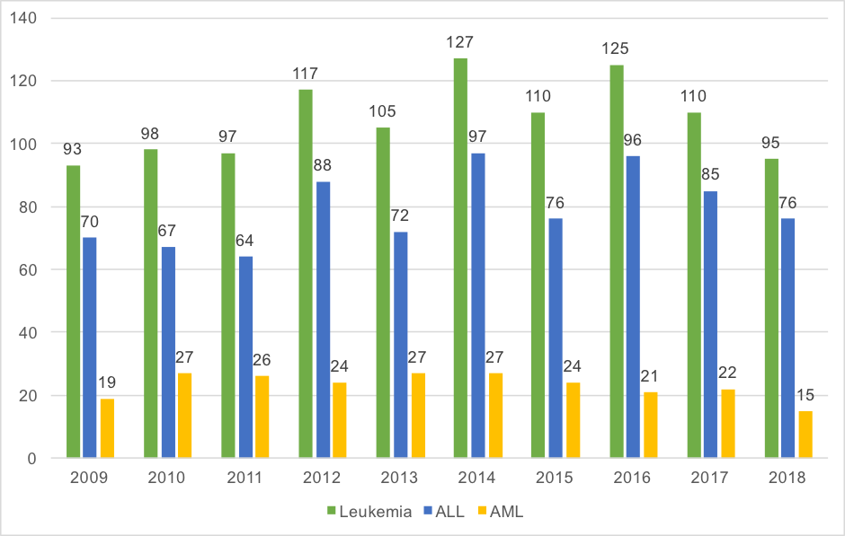

- Additional file 5.png
Title: Number of children diagnosed with leukemia, further divided into acute lymphoblastic leukemia and acute myeloid leukemia, per year at SGH from 2009 – 2018 (N = 1,077)

- Additional file 6.png
Title: Number of children diagnosed with solid tumor, further divided into retinoblastoma, Non Hodgkin lymphoma, and rhabdomyosarcoma, per year at SGH from 2009 – 2018 (N = 679).
