Supporting Information

Hemostatic, antiextravasation, and prehealing drug droplet directional transportation of antibacterial Janus wound plaster based on the structural and wettability gradients
Jing Lin^{a,}*, Zihan Hua^{a,d}, Zhen Yaoª, Minmin Xiong^{b}, Fei Huª, Songyin Huang^{b,*}, Shudong Lin^{c,*}, Xinchuan Weiª

a School of Chemistry and Chemical Engineering, Guangzhou University, Guangzhou 510006, P. R. China
b Biotherapy Center, Sun Yat-Sen Memorial Hospital, Sun Yat-Sen University, P. R. China
c Guangzhou Institute of Chemistry, Chinese Academy of Sciences, Guangzhou 510650, P.R.China
d School of Chemistry and Chemical Engineering, Guangxi University, Nanning 530004, P.R.China

This PDF file includes:
Fig. S1 EDS spectra of the (a) hydrophilic membrane (PVA/CS/Ag) and (b) hydrophobic membrane (TPU), (c) UV-vis absorption spectra of silver triangular sheet solution, (d) TEM images of a silver triangular sheet, (e) Ftir spectra, (e) XRD patterns, (g) XPS spectra of the pure PVA, CS, crosslinked hydrophilic membrane (PVA / CS /Ag) and hydrophobic membrane (TPU), (h) High-solution C1s, O1s, N1s XPS spectra of the hydrophobic membrane (top) and hydrophilic membrane (CS/PVA/Ag) (bottom).
Fig. S2 (a) Dynamic whole-blood clotting model. (b) Absorption ratio of the hydrophilic membrane treated for different periods. (c) Apparent Zeta potential of the 3% CS solution.
Fig. S3 Solid content of the liquid drug before and after transportation.
Fig. S4 Images of the plate count of different samples in the antibacterial assay.
Fig. S5 Collagen area after treatment with the different materials at different times (days).
Table 1 ICP-OES silver content of crosslinked hydrophilic layer membrane (PVA/CS/Ag)

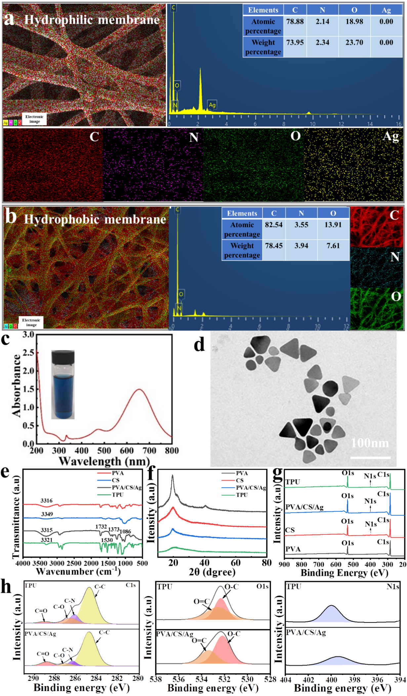
Fig. S1 EDS spectra of the (a) hydrophilic membrane (PVA/CS/Ag) and (b) hydrophobic membrane (TPU), (c) UV-vis absorption spectra of silver triangular sheet solution, (d) TEM images of a silver triangular sheet, (e) Ftir spectra, (e) XRD patterns, (g) XPS spectra of the pure PVA, CS, crosslinked hydrophilic membrane (PVA / CS /Ag) and hydrophobic membrane (TPU), (h) High-solution C1s, O1s, N1s XPS spectra of the hydrophobic membrane (top) and hydrophilic membrane (CS/PVA/Ag) (bottom).

FESEM-EDS shows that the C, O, and N were well distributed in the hydrophilic film (PVA/CS/Ag). The hydrophilic membrane was loaded with Ag in the fiber and on the fiber surface of the membrane, as shown in (Fig. S1 a). Considering the high antibacterial performance and cost of silver. Therefore, the content of Ag introduced was extremely low, which is difficult to measure. ICP-OES revealed a silver content of 0.0019% (Table 1). For the hydrophobic film (TPU), all elements (C, O, and N) were well distributed (Fig. S1 b). The UV-VIS absorption spectra of the silver nano-triangle suspension showed obvious characteristic absorption peaks at 333nm and 654 nm (Fig. S1 c). TEM showed no agglomerating phenomenon in the triangular slices. Most were triangular or almost triangular, and some tips were truncated. Hence, the UV absorption spectrum showed a blue shift. The size of triangular silver nanoparticles was approximately 40–50 nm (Fig. S1 d). The chemical functional groups of pure PVA, pure CS, crosslinked PVA/CS/Ag membrane, and TPU membrane were analyzed by FT-IR spectroscopy (Fig. S1 e). Compared to pure PVA and pure CS, the C–O–C asymmetric stretching vibration peaks appeared in the PVA/CS/Ag membrane at 1086 cm⁻¹, and O–H and N–H stretching vibration peaks appeared at 3321 cm⁻¹. Hence, the acetal reaction occurred in the PVA/CS/Ag nanofiber membrane. Glutaraldehyde was crosslinked successfully with CS/PVA. For TPU, the characteristic peaks at 1528cm⁻¹ and 3330cm⁻¹ were caused by the in-plane bending vibrations and stretching vibration of N–H, respectively. XRD revealed the presence of PVA, CS, and TPU in the Janus composite membrane (Fig. S1 f). Three characteristic XRD peaks were observed at 11.36°, 19.48°, and 22.42° 2θ for pure PVA. For pure CS, two peaks were observed at 11.16° and 19.92° 2θ. These wide peaks of CS and PVA indicate the amorphous phase properties of the polymers. For hydrophilic films (PVA/CS/Ag), there was a wide peak at 19.82° 2θ. The disappearance of the peak observed at 11.16° 2θ may be due to intermolecular hydrogen bonding when CS and PVA are mixed. The PVA peaks at 11.36 and 22.42° 2θ also disappeared with increasing CS content in the blend because of intermolecular hydrogen bonding between the blends. For the hydrophobic membrane (TPU), the characteristic XRD peak was observed at 20.54° 2θ. Surface chemical components of pure PVA, pure CS, hydrophilic film (CS/PVA/Ag), and hydrophobic film (TPU) were determined by XPS (Fig. S1 g). Each spectrum has its chemical component. On the C1s XPS spectrum, TPU was fitted to four peaks at 284.78eV, 286.36eV, 286.98eV, and 288.83 eV, corresponding to C–C/C–H, C–N, C–O, and C=O, respectively. PVA/CS/Ag was fitted to four peaks at 284.78eV, 286.18eV, 286.58eV, and 289.08eV, corresponding to C–C/C–H, C–N, C–O, and C=O, respectively. On the O1s XPS spectrum, TPU was fitted to two peaks at 532.28eV and 533.58eV, corresponding to O–C and O=C, respectively. PVA/CS/Ag was fitted to two peaks at 532.18eV and 533.38eV, corresponding to O–C and O=C, respectively. On the N1s XPS spectrum, TPU was fitted to one peak at 399.42eV, corresponding to –NHCO. PVA/CS/Ag was fitted to one peak at 399.98eV, corresponding to –NH₂.

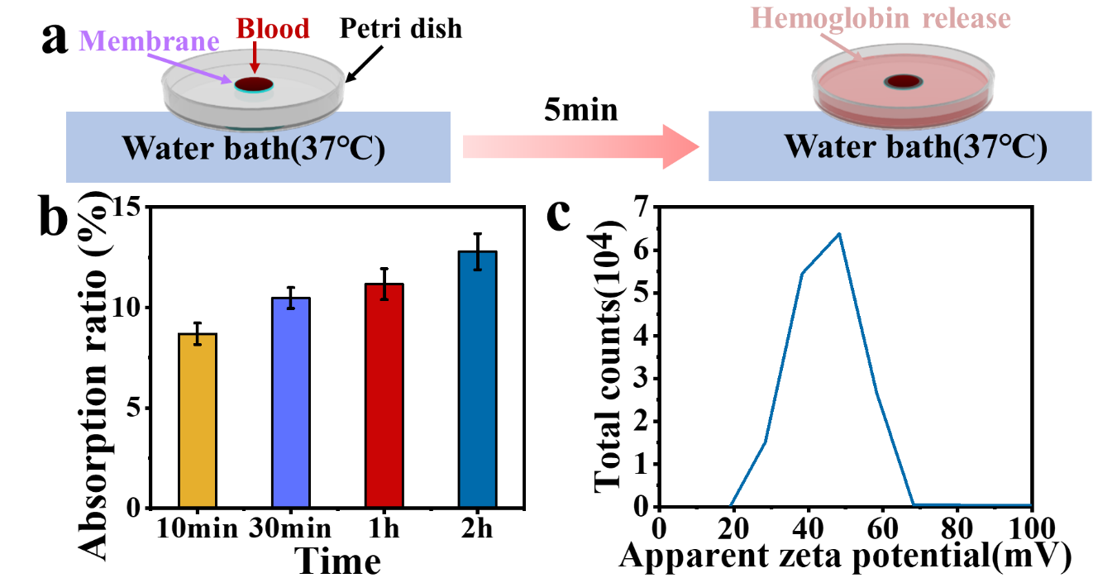
Fig. S2 (a) Dynamic whole-blood clotting model. (b) Absorption ratio of the hydrophilic membrane treated for different periods. (c) Apparent Zeta potential of the 3% CS solution.

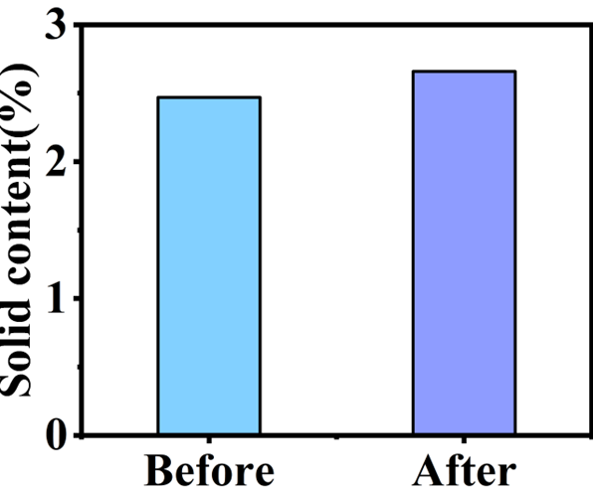
Fig. S3 Solid content of the liquid drug before and after transportation.

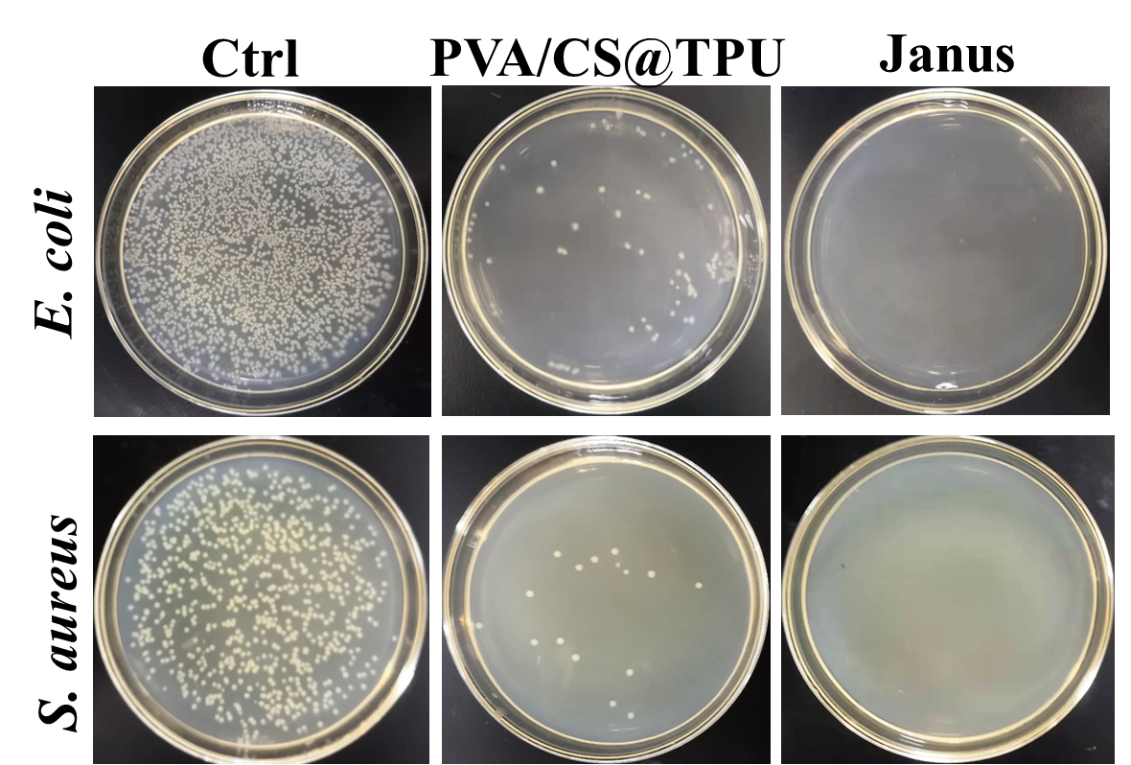
Fig. S4 Images of the plate count of different samples in the antibacterial assay.

Fig. S5 Collagen area after treatment with the different materials at different times (days).

Table 1 ICP-OES silver content of crosslinked hydrophilic layer membrane (PVA/CS/Ag).
Sample | Element | Element content
hydrophilic membrane | Ag | 0.0019%

Corresponding authors: linjin00112043@126.com/linjing@gzhu.edu.cn(Jing Lin); huangsy@mail.sysu.edu.cn(Songyin Huang); linsd@gic.ac.cn(Shudong Lin).

