Directly Monitoring the Shift in Corrosion Mechanisms of a Model FeCrNi Alloy Driven by Electrical Potential
Tingkun Liu¹, Cheng-Han Li¹, Matthew Olszta², Jinhui Tao^{1*}, Arun Devaraj^{1*}
¹Physical and Computational Sciences Directorate, Pacific Northwest National Laboratory
²Energy and Environment Directorate, Pacific Northwest National Laboratory
* Corresponding author: Jinhui.tao@pnnl.gov; arun.devaraj@pnnl.gov

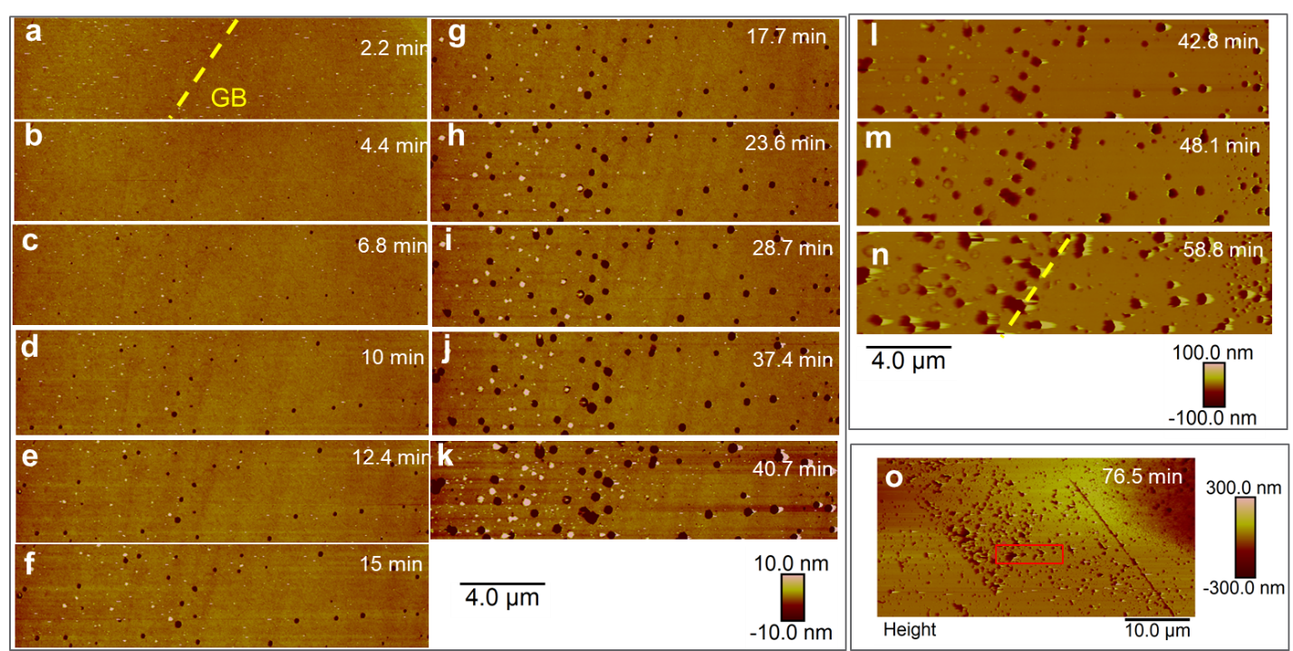
Figure S1. (a–o) In situ AFM images of the nonbiased sample etched in 0.5 M DCl up to 76.5 min. The red rectangle in (o) represents the region for in situ monitoring (a–n). The scanning area of in situ measurement is 5 × 20 μm². The vertical scale of images (a–k) is from −10 nm to 10 nm. The vertical scale of images (i–n) is from −100 nm to 100 nm. The vertical scale of image (o) is from −300 nm to 300 nm.

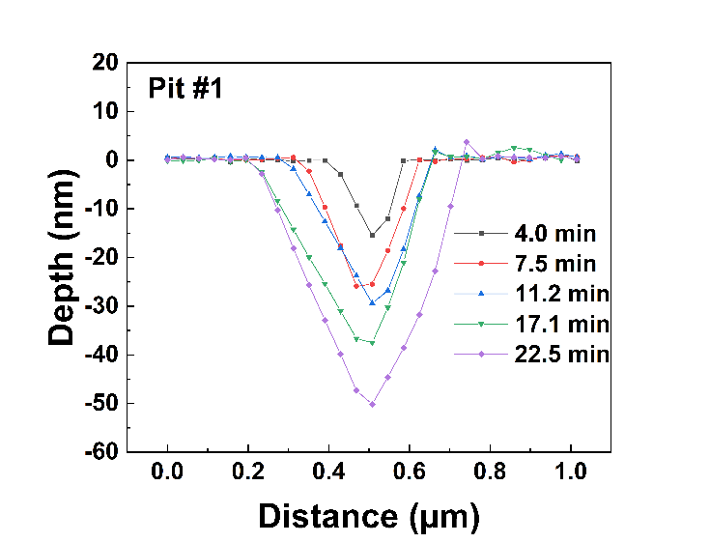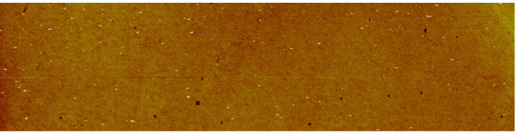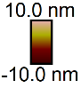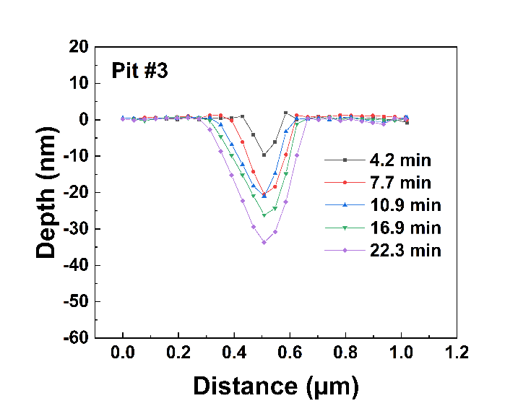
4.4 min
1
3
2
4
5
6
b
c
a
Figure S2. (a) Selected corrosion pits of the nonbiased sample illustrated on the 4.4 min AFM image for quantitative analysis, and the representative time-dependent pit profiles of (b) Pit #1 and (c) Pit #3 along the horizontal plane.
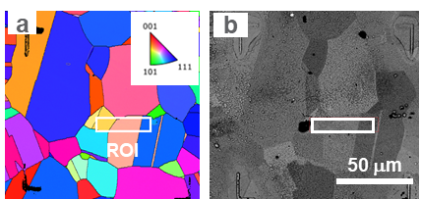
Figure S3. EBSD IPF images showing the ROI of the in situ EC-AFM scan area of the biased sample: (a) SEM BSE image of the same location after electrochemical corrosion. The IPF color code is projected to the surface normal. EBSD results show Grain 1, Grain 2, and Grain 3 are close to the [012], [124], and [323] orientations.

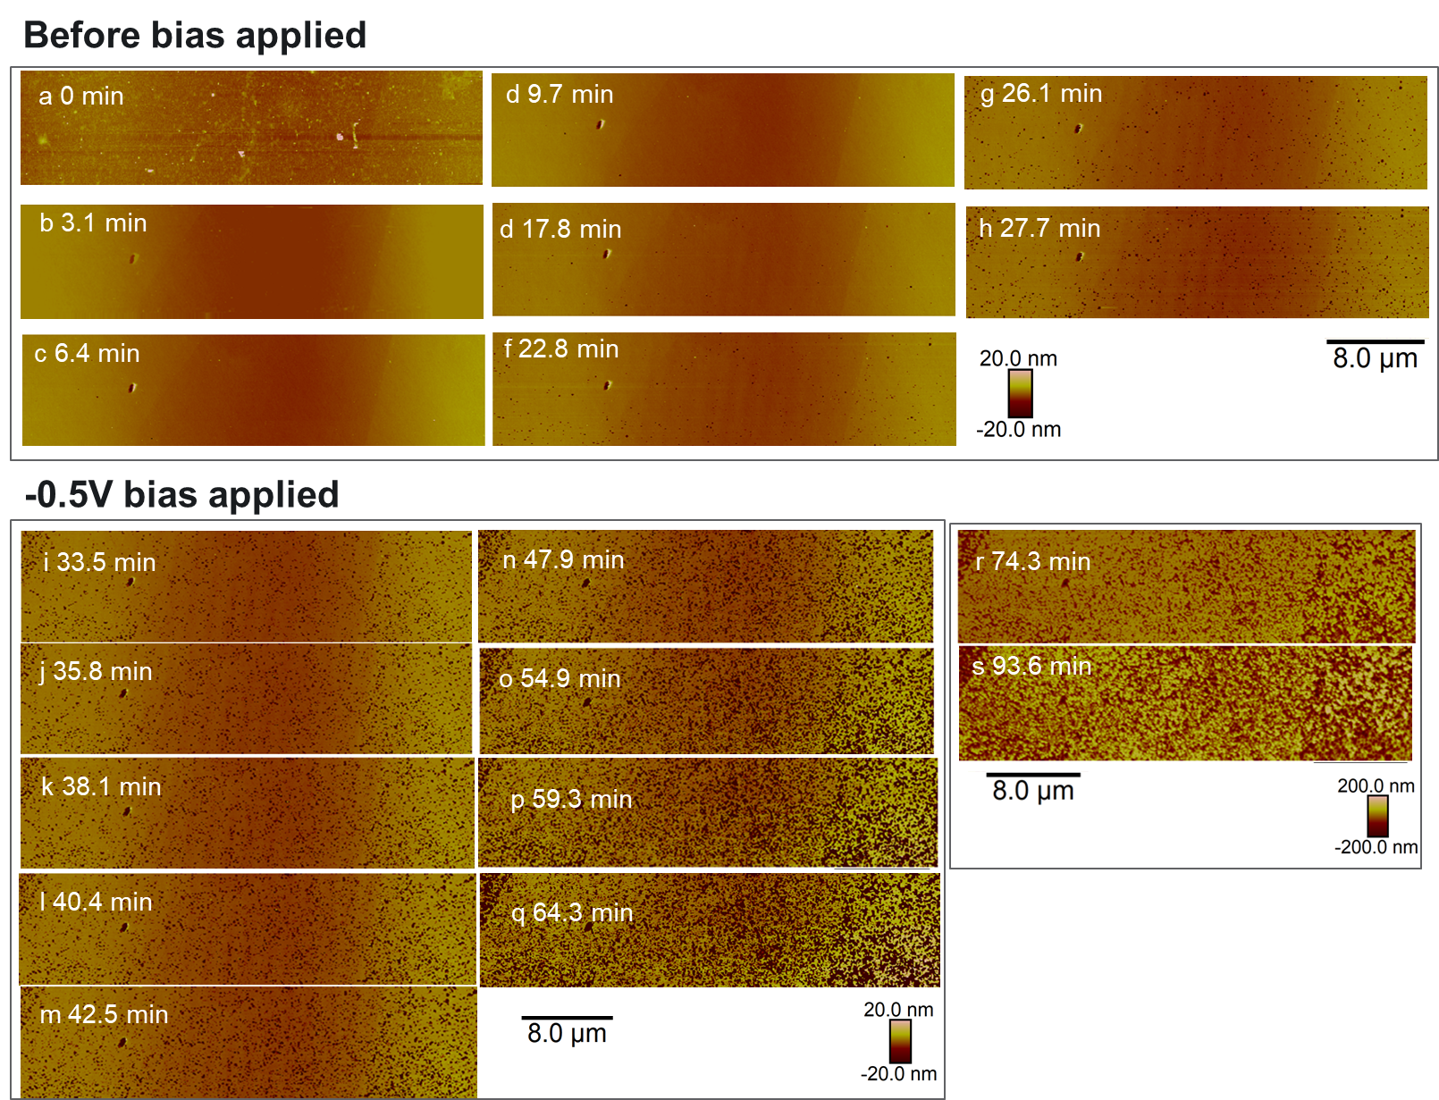
Figure S4. In situ EC-AFM images of the biased sample corroded in 0.5 M DCl: (a–h) before bias is applied and (i–s) after a −0.5 V bias is applied. The scan area of the in situ measurement is 10 × 40 um². The vertical scale of images (a–q) is from −20 nm to 20 nm. The vertical scale of images (r and s) is from −200 nm to 200 nm.
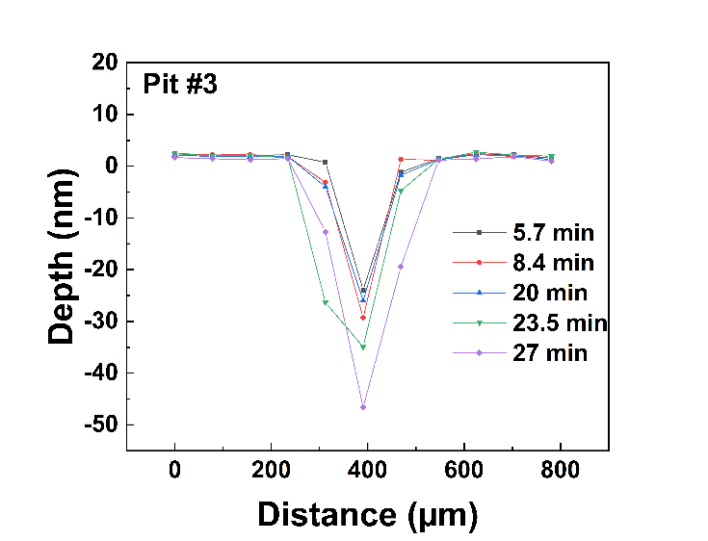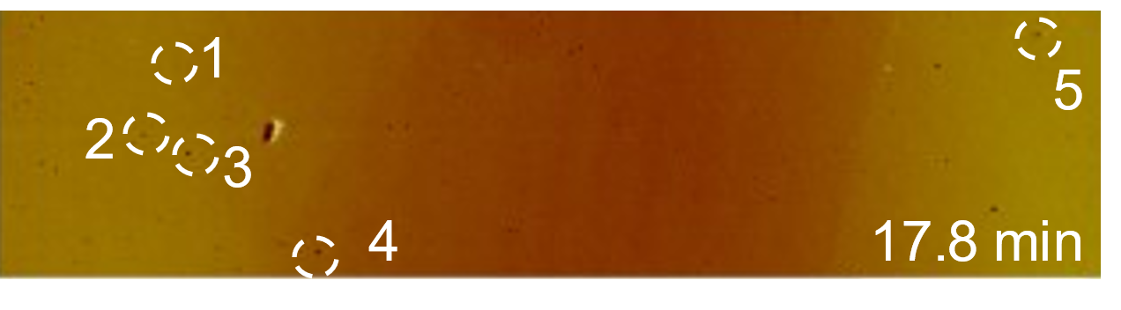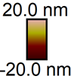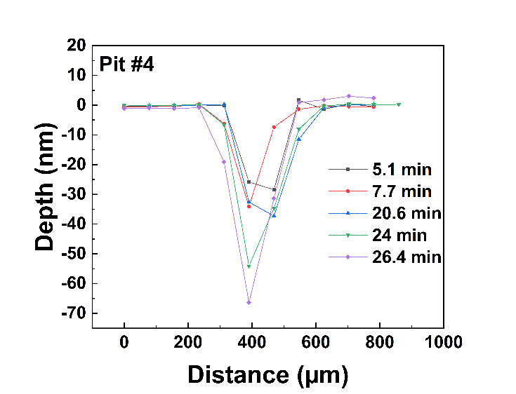
b
c
a
Figure S5. a) Selected corrosion pits of the biased sample illustrated on the 17.8 min AFM image for quantitative analysis, and the representative time-dependent pit profiles of (b) Pit #3 and (c) Pit #4 along the horizontal plane.
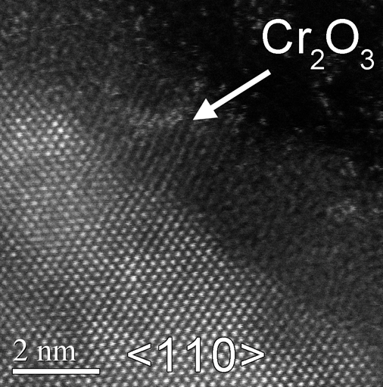
Figure S6. TEM image of the biased sample showing Cr₂O₃.

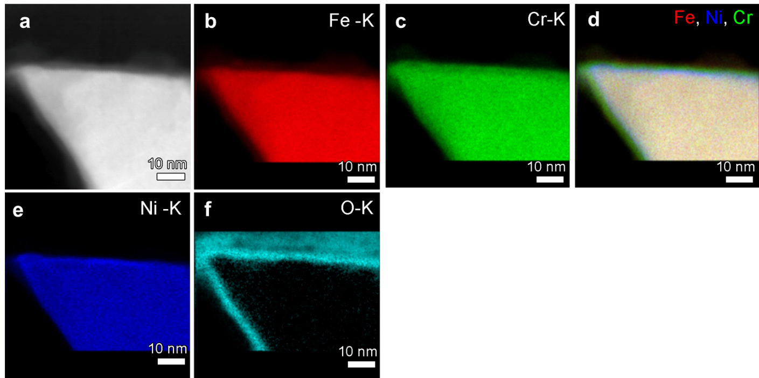
Figure S7. TEM EDS mapping of the nonbiased sample: (a) TEM image of the mapping region, (b) Fe mapping, (c) Cr mapping, (d) mixed mapping of Fe, Ni, and Cr, (e) Ni mapping, (f) O mapping.

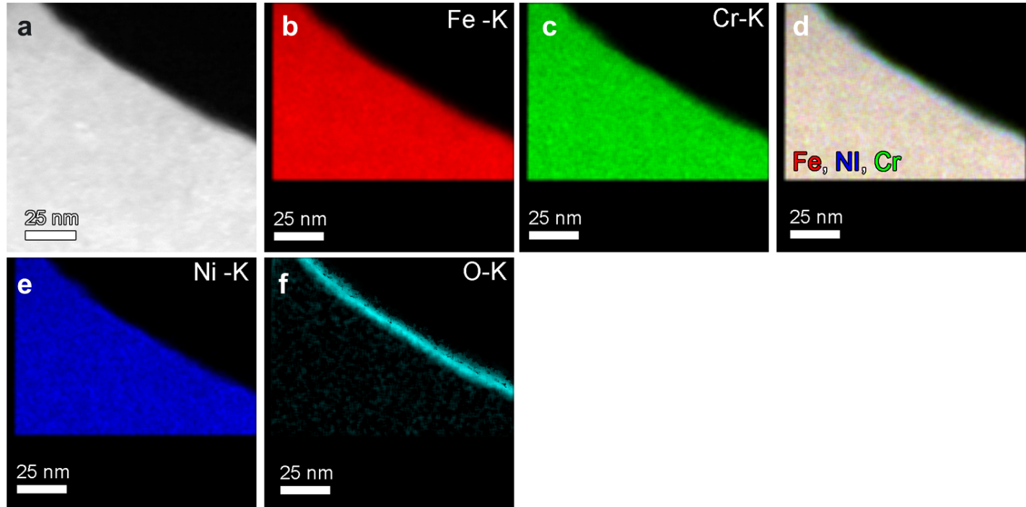
Figure S8. TEM EDS mapping of the biased sample: (a) TEM image of the mapping region, (b) Fe mapping, (c) Cr mapping, (d) mixed mapping of Fe, Ni, and Cr, (e) Ni mapping, (f) O mapping.

