Halogenation of IAA by touch stimulus for rapid and differential growths of the Madeira vine

Ma-Hsuan Ma^{1,2}, Erdembayalag Batsaikhan¹, Chun-Ming Wu³, Chih-I Luo², Ni-Jhen Chen², Jeng-Der Chung⁴, Ching-Te Chien⁴, Yu-Han Tsai⁴, Wen-Hsien Li^{1,*}

¹Department of Physics, National Central University, Taoyuan 32001, Taiwan
²High school division, Taipei Fuhsing Private School, Taipei 10688, Taiwan
³National Synchrotron Radiation Research Center, Hsinchu 30076, Taiwan
⁴Taiwan Forestry Research Institute, Taipei 10066, Taiwan

*Correspondence: Wen-Hsien Li (whli@phy.ncu.edu.tw)

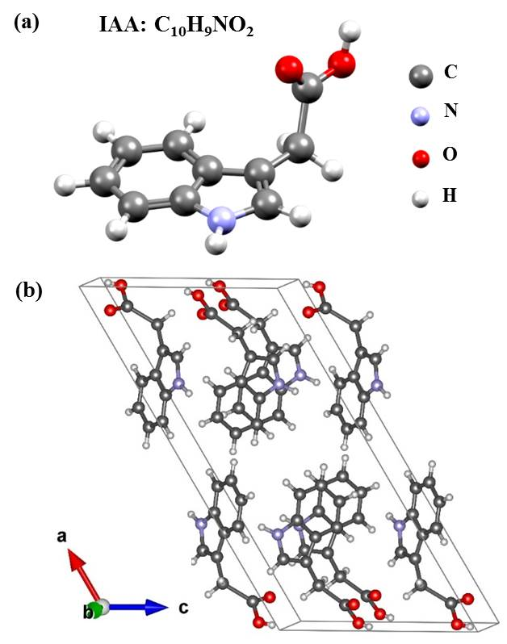
SUPPORTING MATERIALS

Fig. S1 Molecular and crystallized structures of IAA. (a) Molecular structure of IAA. (b) Crystallized structure of IAA in the monoclinic P12₁/c1 spatial symmetry, with lattice constants of a = 19.941(2) Å, b = 5.849(1) Å, c = 10.305(2) Å and β = 121.99(1)º.

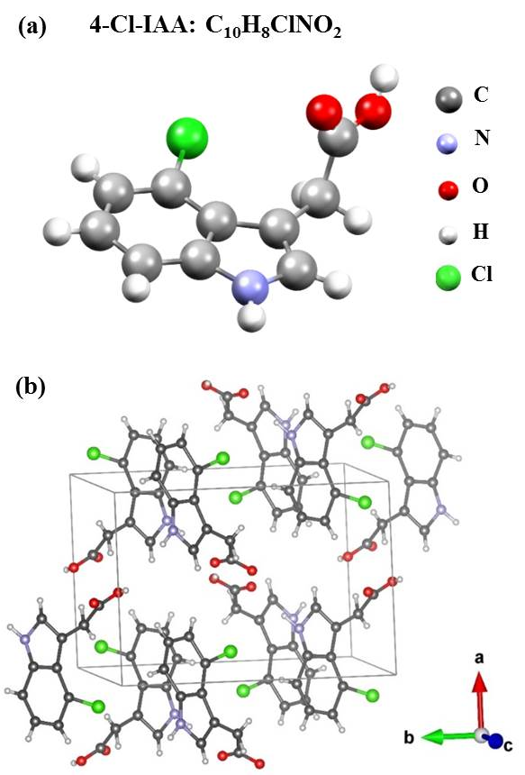

Fig. S2 Molecular and crystallized structures of 4-Cl-IAA. (a) Molecular structure of 4-Cl-IAA. (b) Crystallized structure of 4-Cl-IAA in the monoclinic P12₁/c1 spatial symmetry, with lattice constants of a = 11.252(1) Å, b = 16.907(2) Å, c = 8.328(1) Å and β = 97.24(2)º.

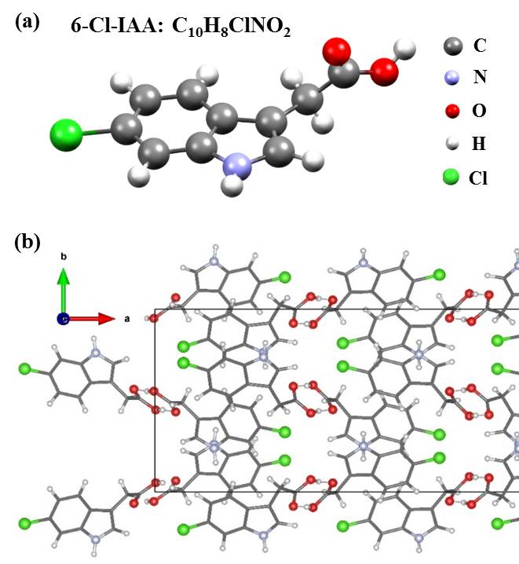

Fig. S3 Molecular and crystallized structures of 6-Cl-IAA. (a) Molecular structure of 6-Cl-IAA. (b) Crystallized structure of 6-Cl-IAA in the orthorhombic Pbca symmetry, with lattice constants of a = 61.079(1) Å, b = 15.286(1) Å and c = 7.674(1) Å.

