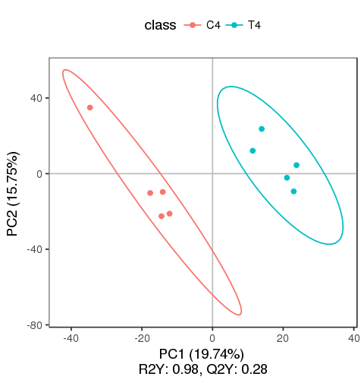
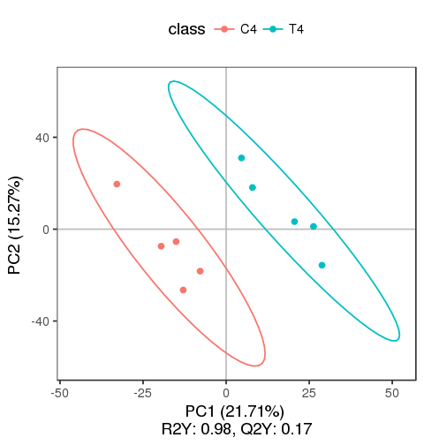

supplement Fig.2 The partial least squares discriminant analysis of each periods in negative ion modes (Left) and positive ion modes (right). The results demonstrated that in the PLS-DA model of each group, R2Y was close to 1, which indicated that each group could explain the grouping well.

