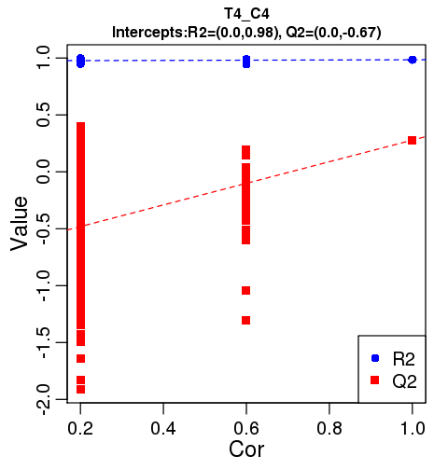
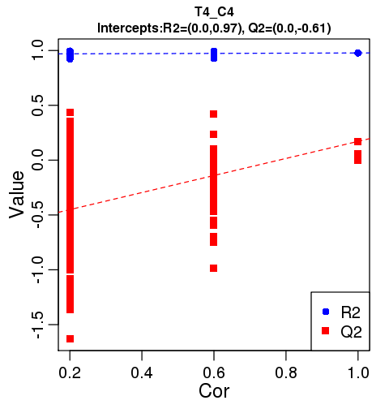

supplement Fig.3 The results of the sort verification in negative ion modes (Left) and positive ion modes (right). The results demonstrated that the grouping model at days 1, 7, 28 were not “over-fitting.”.

