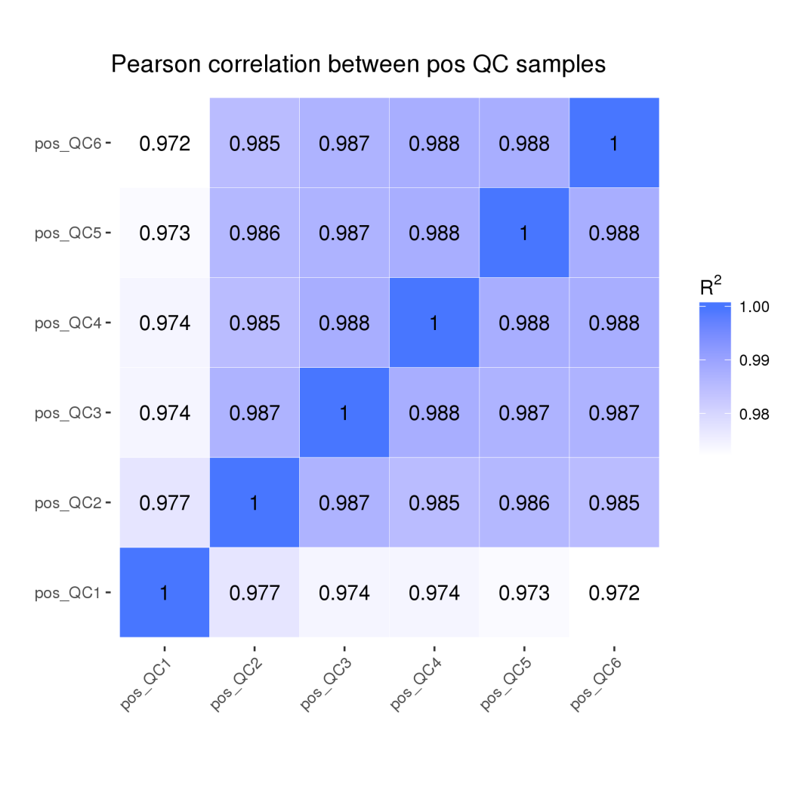
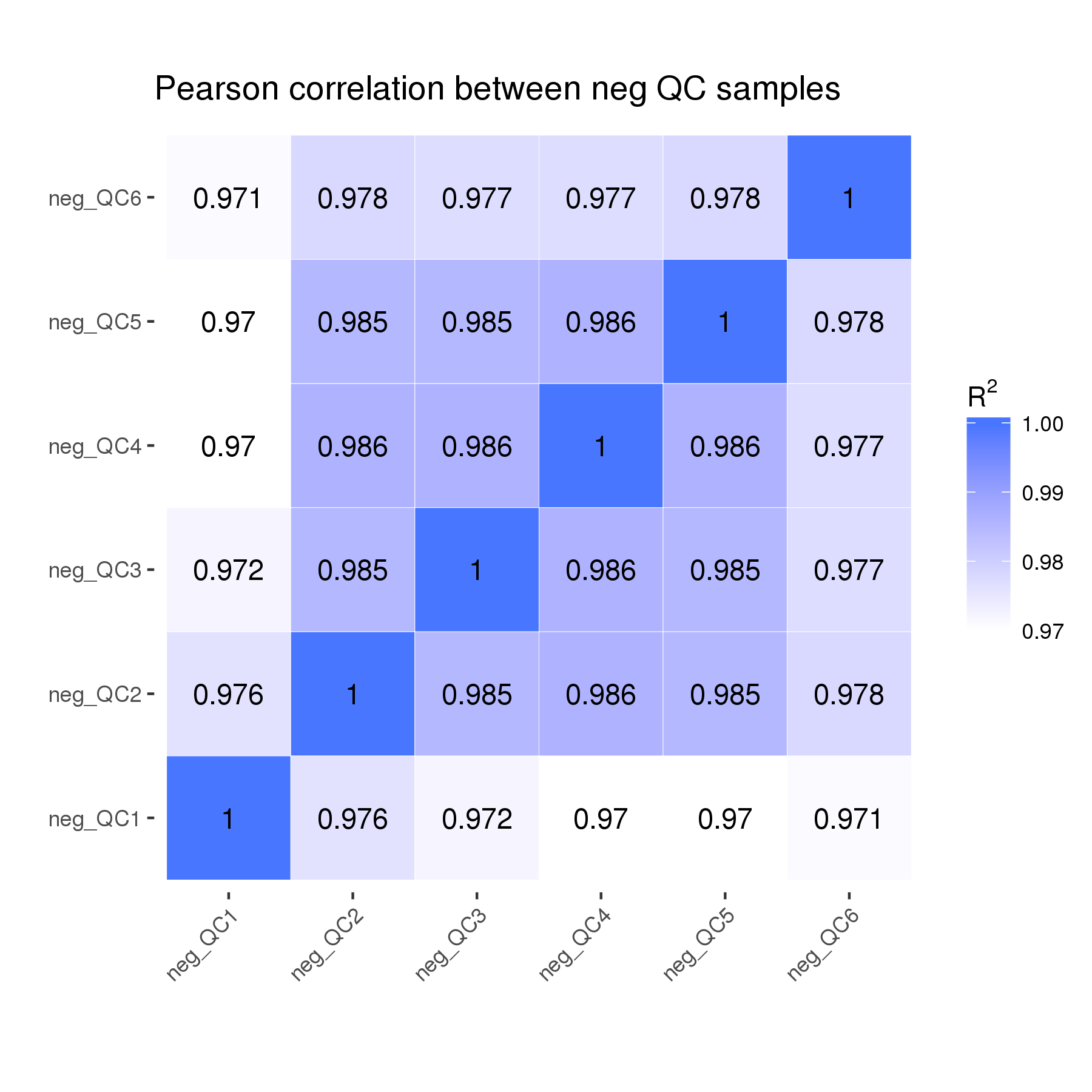
supplement Fig.1 the results of QC samples measuring in positive and negative ion modes.

