Supplementary Information

Quasi-seamless stitching for large-area micropatterned surfaces enabled by Fourier spectral analysis of moiré patterns

Woo Young Kim¹, Bo Wook Seo¹, Sang Hoon Lee¹, Tae Gyung Lee¹, Sin Kwon², Won Seok Chang^{3,4}, Sang-Hoon Nam⁵, Nicholas X. Fang^{5,6}, Seok Kim^{1,7}*, Young Tae Cho^{1,7}*
¹Department of Smart Manufacturing Engineering, Changwon National University, South Korea
²Department of Printed Electronics, Korea Institute of Machinery and Materials, South Korea
³Department of Nano Manufacturing Technology, Korea Institute of Machinery and Materials, South Korea
⁴Department of Nanomechatronics, University of Science and Technology, South Korea
⁵Department of Mechanical Engineering, Massachusetts Institute of Technology, United States
⁶Department of Mechanical Engineering, University of Hong Kong, Hong Kong
⁷Department of Mechanical Engineering, Changwon National University, South Korea
*Corresponding author: kimseok@changwon.ac.kr; ytcho@changwon.ac.kr

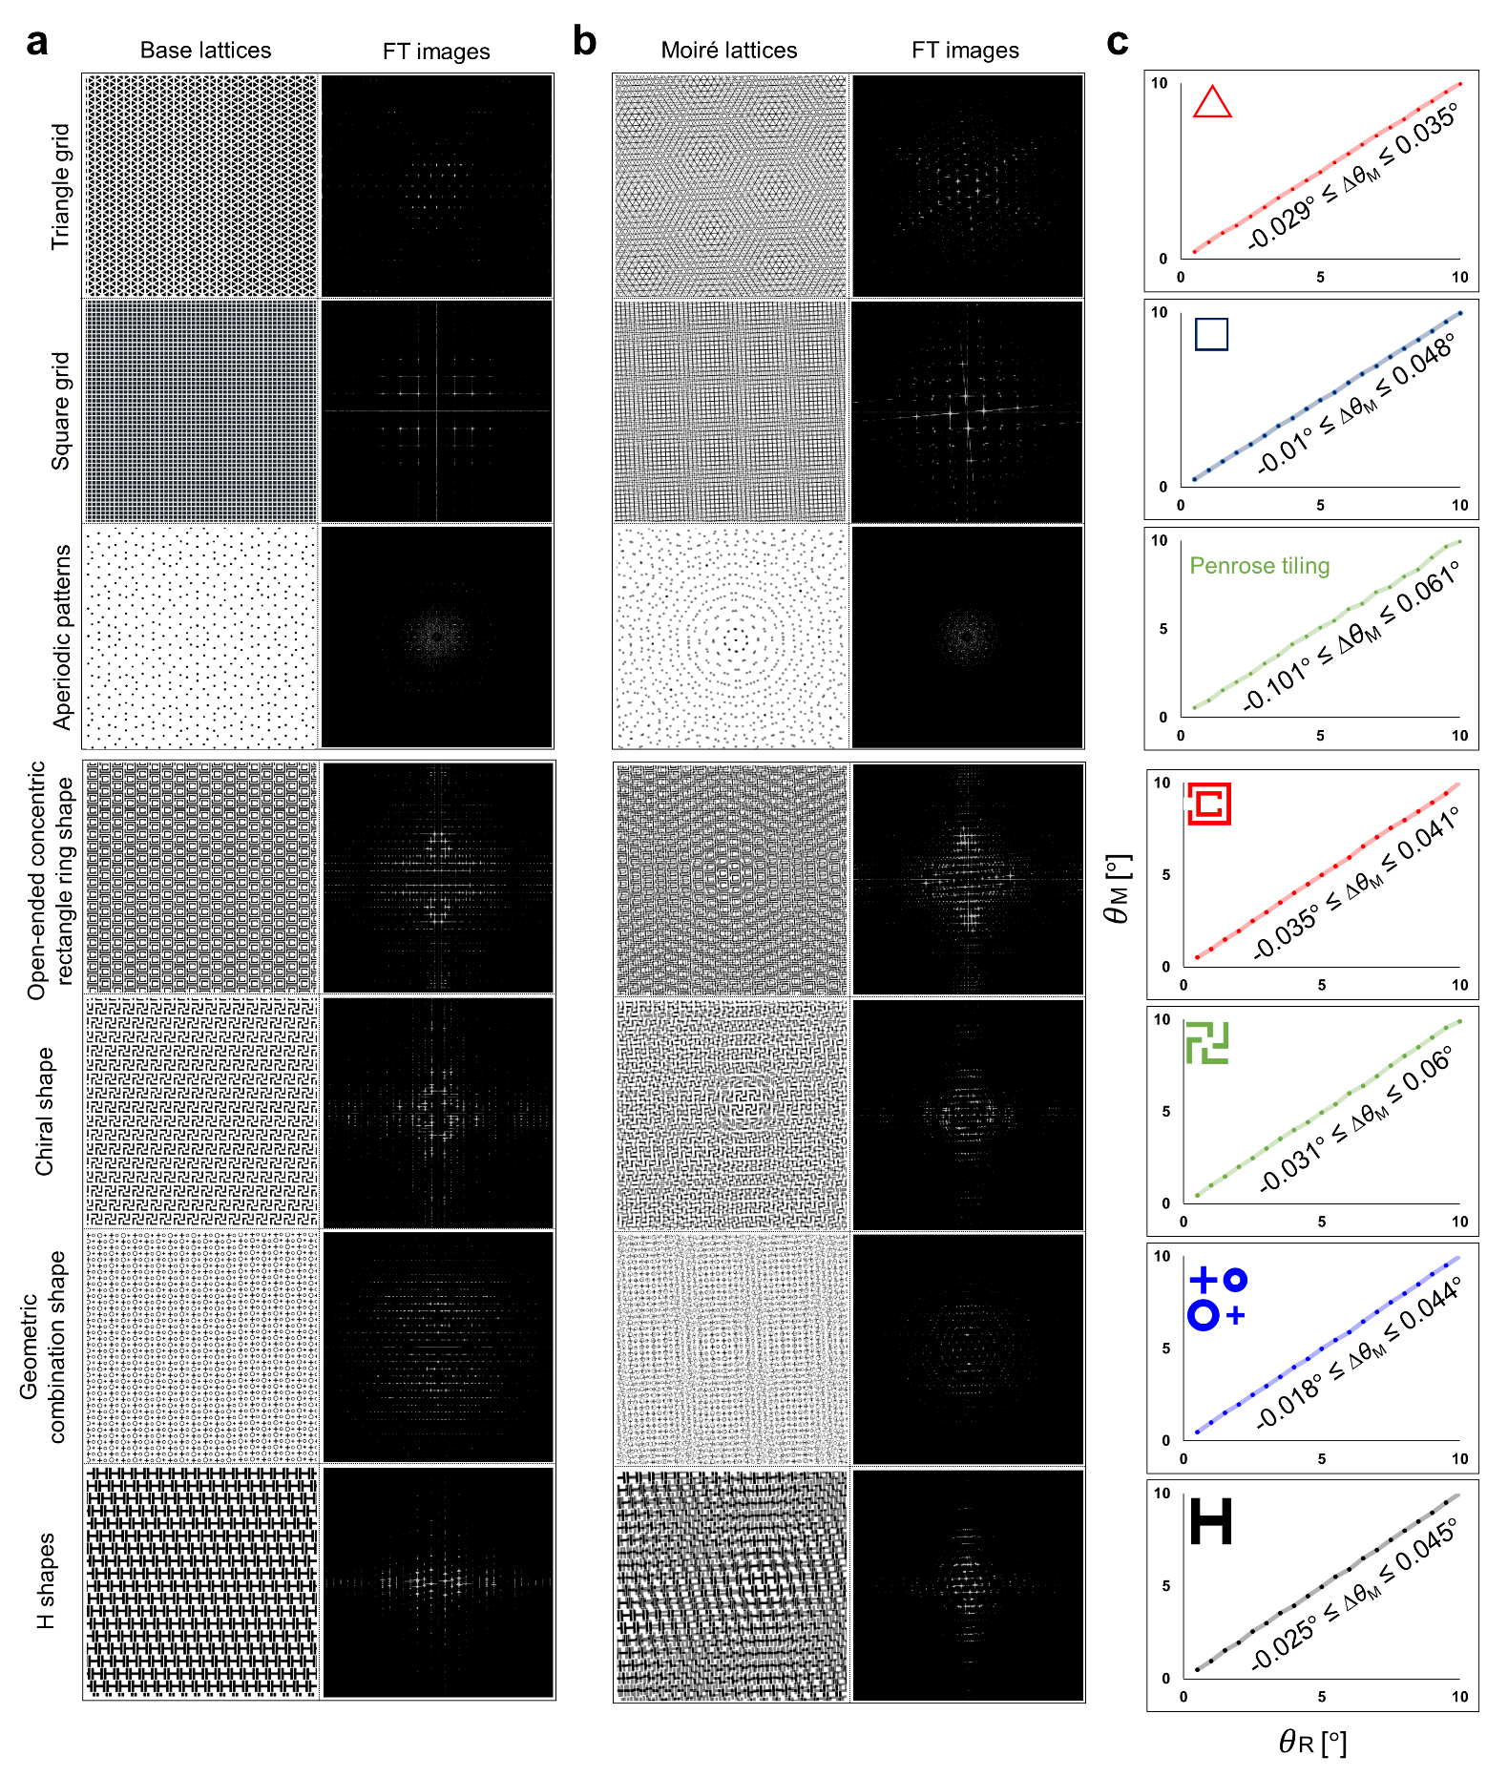
Supplementary Figure. 1 Simulated results for the extraction of the rotational offset using Fourier spectral analyses of the moiré lattices formed by two identical overlapped patterns. Simulated images and corresponding FTed images of a base and b moiré lattices of various complicated patterns such as aperiodic patterns of Penrose tiling and classical patterns for metasurfaces. c The measured rotation angle (θ_{M}) as a function of the input rotation angle (θ_{R}).
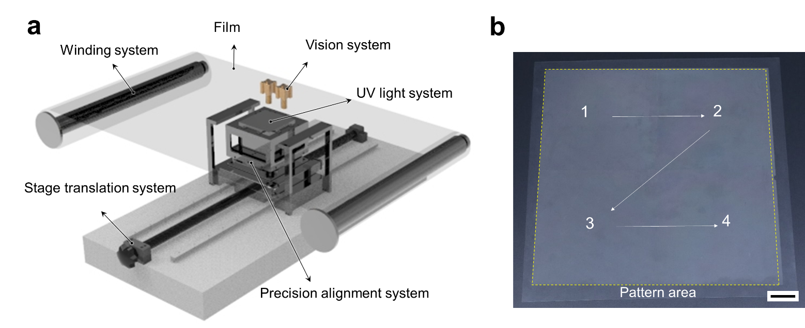
Supplementary Figure. 2 Systems for the SPA process. a Schematic of the roll-to-plate printing system used to fabricate quasi-seamless large-area microstructured surfaces using the SPA process, which was comprised of the precise motorized stages and vision system. b The representative printing result of large-area micropatterned surfaces (200 × 200 mm²). Scale bar: 20 mm.

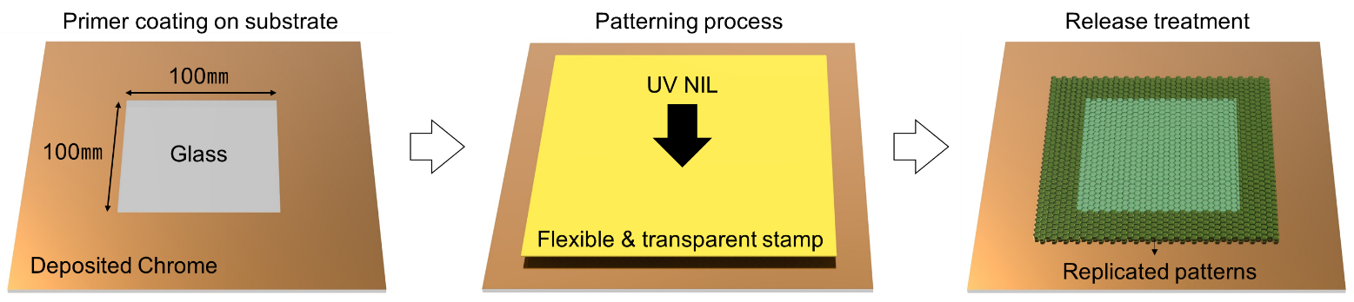
Supplementary Figure. 3 Schematic of the SPA stamp fabrication.

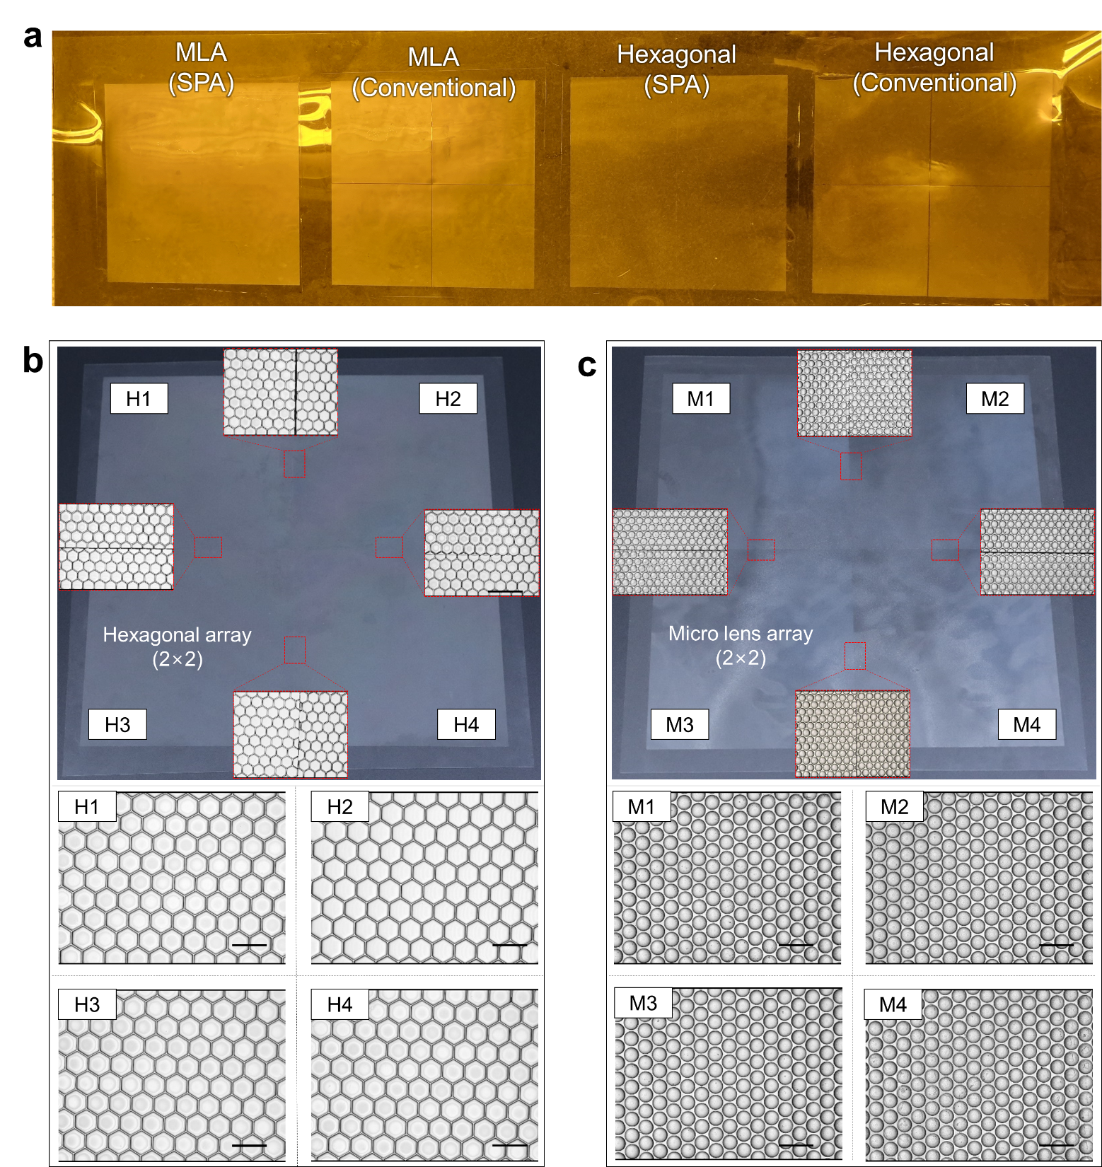
Supplementary Figure. 4 Large-area microstructured surfaces using step-and-repeat stitching based on the SPA process. a Photographs of the multiple-stitched micropatterned surfaces using the SPA and conventional manual process. 3D profiles of the SPA-based stitched microstructured surfaces with quasi-seamlessness composed of b interconnected hexagonal microcavities and c MLA films. Scale bar: 100 µm.

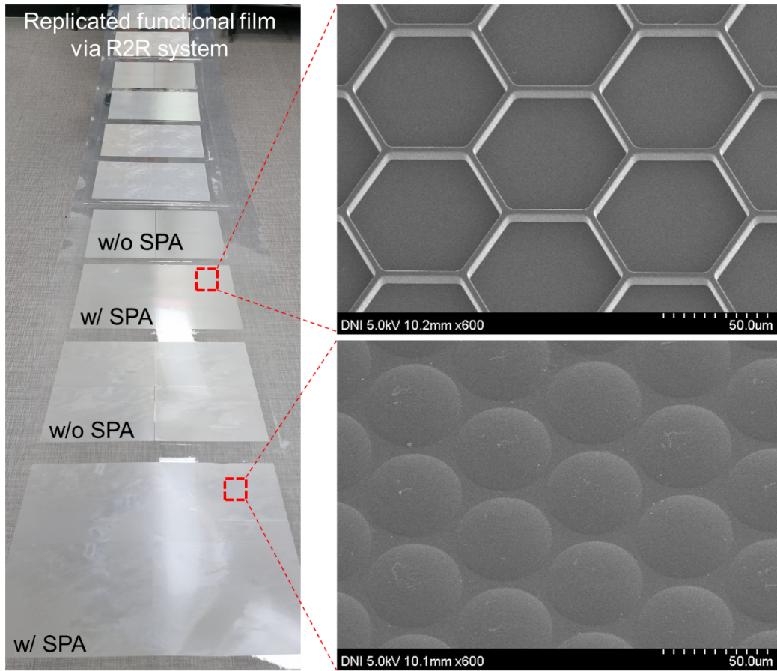
Supplementary Figure. 5 R2R-NIL replicated microstructured surfaces.

