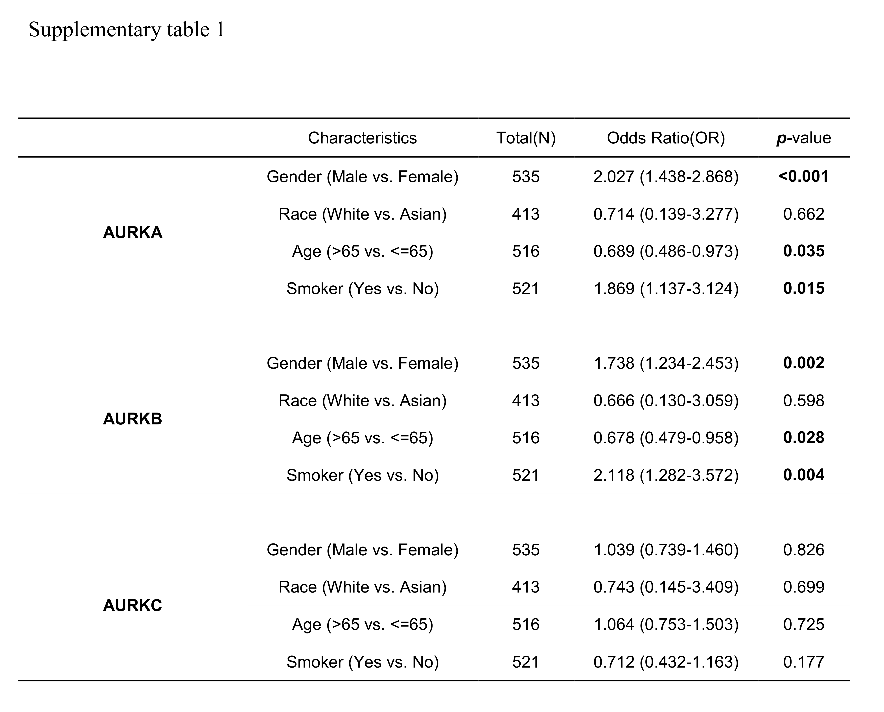
Supplementary table1.
Logistic regression analysis of the relationship between clinicopathological characteristics and theAURKs expression levels in LUAD.

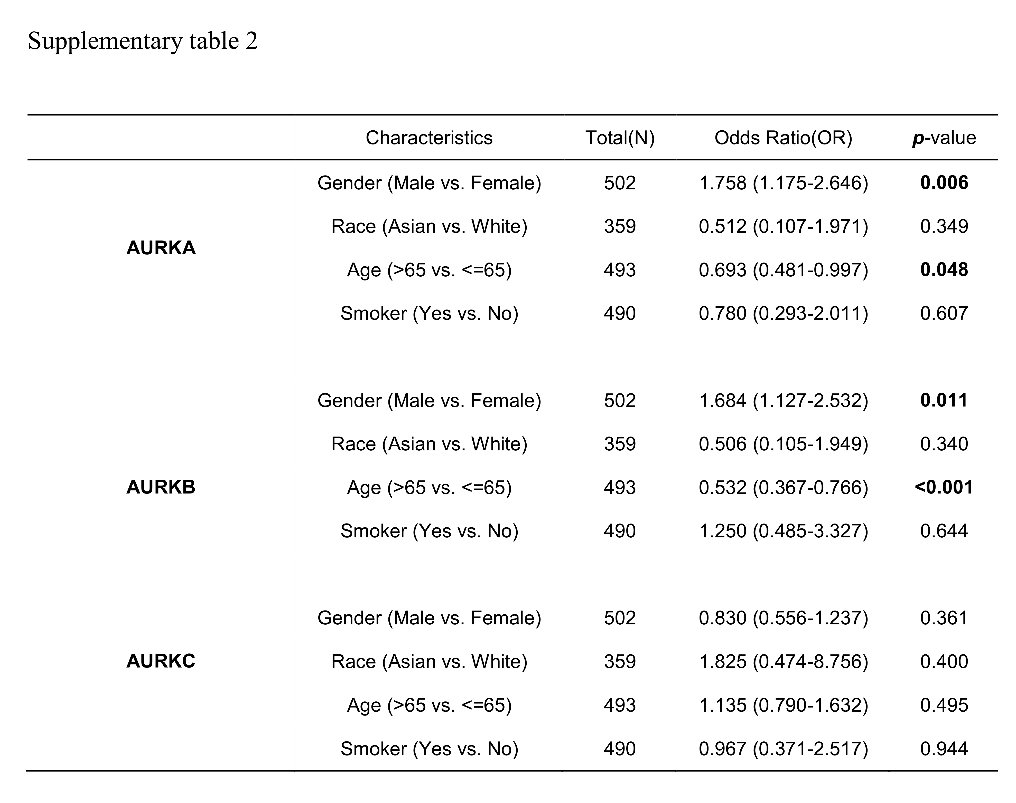
Supplementary table2.
Logistic regression analysis of the relationship between clinicopathological characteristics and theAURKs expression levels in LUSC patients.

