Supplemental Tables SVI/B:
International Classification of Diseases, Tenth Edition, Clinical Modification (ICD-10-CM) Codes Used To Identify Baseline Comorbidities, Procedures and In-Hospital Outcomes
 | ICD-10 codes
Diagnosis codes (primary and secondary)
Severe vision impairment or blindness (SVI/B) | H540X33, H540X34, H540X35, H540X43, H540X44, H540X45, H540X53, H540X54, H540X55, H541132, H541142, H541152, H541223, H541224, H541225, H542X22, H540
Comorbidities
Coronary artery disease | I25
Dyslipidemia | E78
Old or Previous MI | I252
Old or Previous CABG | Z951
Congestive Heart Failure | I5022, I5032, I5042.
Protein Energy Malnutrition | E45, E46, E42, E43, E44, E440, E441
Frailty/Age related Debility | R54
Chronic obstructive pulmonary disease | J41, J42, J43, J44
Baseline oxygen use | Z9981
Old or Previous stroke | I63
Hypertension | I10
Atrial Fibrillation | I480, I481, I482, I4891
Peripheral vascular disease | I739, I738
Diabetes Mellitus Type 1&2 | E10, E11
Obesity | E660, E6601, E6609, E661, E662, E668, E669, Z6831, Z684.
Chronic liver Disease | I50
Chronic Kidney Disease | N18
Dialysis Dependent | Z992
Chronic liver disease | K70, K71, K72, K73, K74, K75, K76, K77
Electrolyte abnormalities | E870, E871, E872, E873, E874, E875, E876
Nicotine Use | Z87891, F172
Anemia | D50, D51, D52, D53, D55, D56, D57, D58, D59, D60, D61, D62, D63, D64
Previous Percutaneous Coronary Intervention | Z9861
History of Congenital Heart Disease | Q20, Q21, Q22, Q23, Q24, Q25, Q26
Hypothyroidism | EO3
Alcohol Abuse | F10
Illicit drug use | F11
Abbreviations: MI: Myocardial infarction, CABG: Coronary artery bypass graft, STEMI: ST-segment elevation myocardial infarction, NSTEMI: Non ST-segment elevation myocardial infarction.

Missing values imputed using multivariable imputation by chained equations (i.e., MICE) method:
Sex | 13 | <0.001%
Median income | 46 | <0.001%

Regression used for Outcomes Model

Multivariable regression models were built by including confounders signiﬁcantly associated with outcomes on univariable analysis with a cutoff p value of 0.1.

- Forward conditional step wise entry with P < 0.10
- Variables used in initial model age, gender, Insurance status, median income, hospital region, location, teaching status and Charlson comorbidities index
- Outcome variable READMITED
- Age
- Gender
- Insurance status
- Median income
- Hospital location
- Hospital teaching status
- Hospital region
- Charlson comorbidities measures
- AHRQ comorbidity measure: Congestive heart failure
- AHRQ comorbidity measure: Chronic pulmonary disease
- AHRQ comorbidity measure: Dementia
- AHRQ comorbidity measure: Peripheral Vascular Disease
- AHRQ comorbidity measure: Hypertension
- AHRQ comorbidity measure: Liver disease
- AHRQ comorbidity measure: Lymphoma
- AHRQ comorbidity measure: Metastatic cancer
- AHRQ comorbidity measure: Neurological disorders
- AHRQ comorbidity measure: Chronic kidney disease
- AHRQ comorbidity measure: Solid tumor without metastasis
- AHRQ comorbidity measure: Peptic ulcer disease excluding bleeding
- AHRQ comorbidity measure: Valvular disease

- AHRQ comorbidity measure: cardiac arrhythmias
- AHRQ comorbidity measure: coronary artery disease
- AHRQ comorbidity measure: HIV/AIDS
- AHRQ comorbidity measure: Rheumatoid arthritis/collagen vascular diseases
- AHRQ comorbidity measure: Diabetes

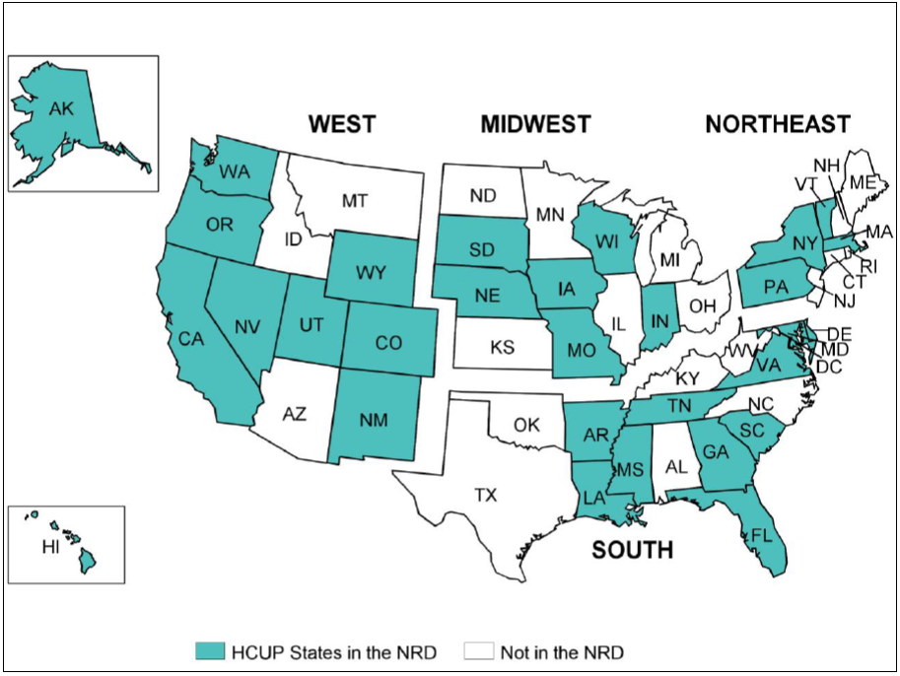
Figure 1 : Map Graphic of States (U.S.A.) Participating in the Nationwide Readmission Database 2017

