CHAPTER 4 Supplementary Information

Decisions about ages: SQB2 has the most age data. Samples from SQB2 were preferentially selected unless other age data suggested another source would provide a more accurate age model. For the radiocarbon samples shown below, I selected the radiocarbon age in SQB2 (sample SQB-02, 1155, 20 at 254 cm) because it was younger than the other two samples in a similar stratigraphic position. Whereas it is easier for a detrital sample to be older than the stratigraphic horizon that it was deposited in (having resided in the watershed for an unknown amount of time prior to deposition), it is difficult for a detrital sample to be younger than the horizon. This means that the youngest detrital sample at a horizon is likely to be the most accurate representation of the time of deposition. Note the low-amplitude variability in the CT traces for each core are similar and can be used to stratigraphically correlate sections.
Figure S1. The sample in bold was used for this study because it is the youngest detrital sample at this stratigraphic location in the core. Sample depths are composite depths (which are not event-free).
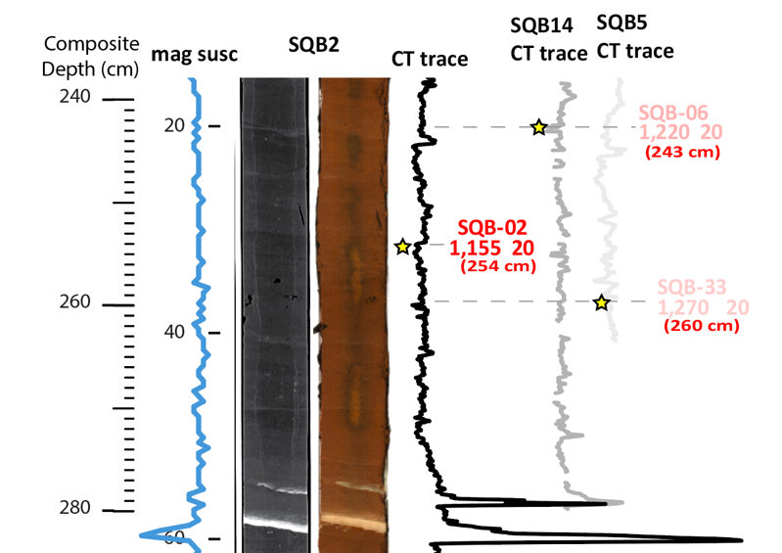

Radiocarbon sample 9 is from SQB5. The relationship between these two sections (in SQB5 and SQB2) is shown below.
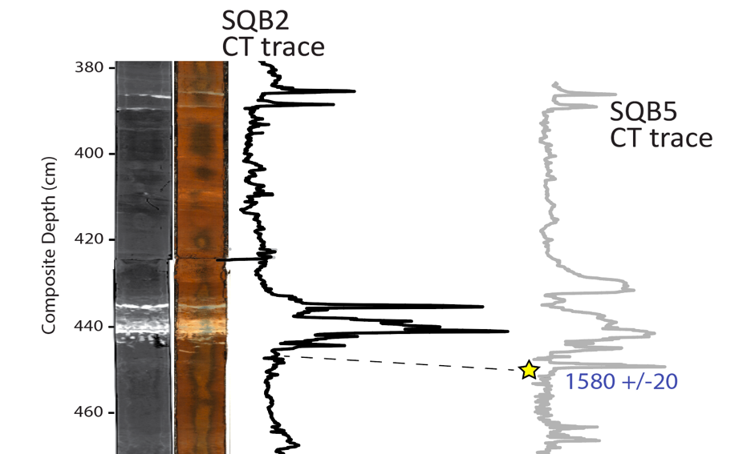
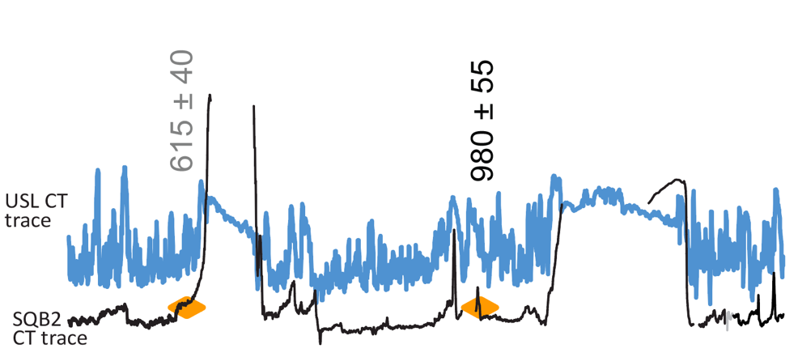
Radiocarbon sample 16 (980 +/-55) is from Upper Squaw Lake. It was included in the age model because there are no ages for this stratigraphic section in Lower Squaw Lake. The placement of this sample in SQB2 was determined as shown in the figure below.

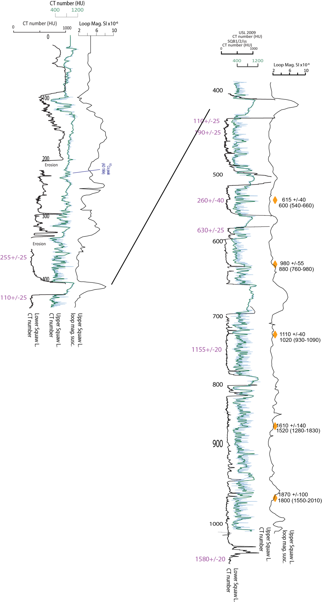
Downcore detailed comparison between Upper and Lower Squaw Lake:

