Supplementary Material

Unsupervised hierarchical clustering of 31,000 autistic individuals identifies three distinct groups of language comprehension abilities

Andrey Vyshedskiy^{1,2*}, Rohan Venkatesh ², Edward Khokhlovich ³

¹ Boston University, Boston, MA 02215, USA
² ImagiRation, Boston, MA 02135, USA
³ Independent researcher, Newton, MA 02459, USA

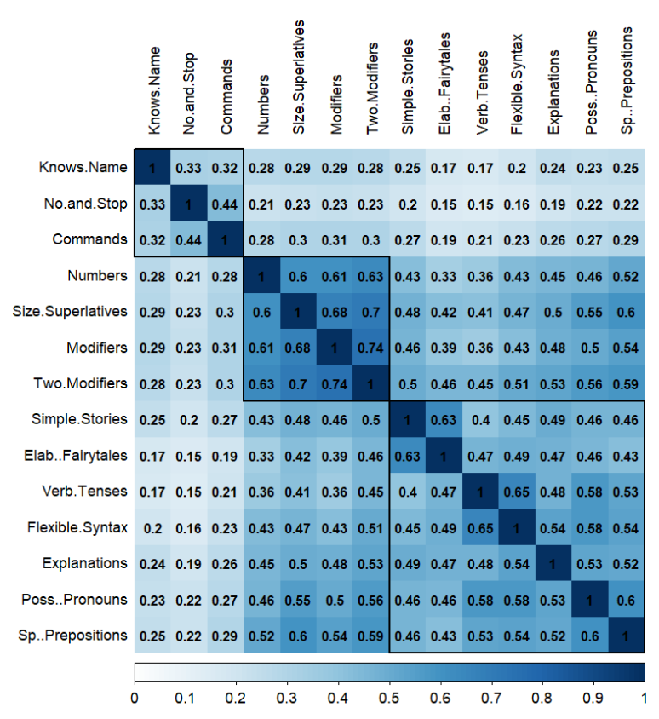
Figure S1. Spearman's correlation between 14 language comprehension abilities. The three clusters of abilities identified by the unsupervised hierarchical cluster analysis are indicated with black squares.

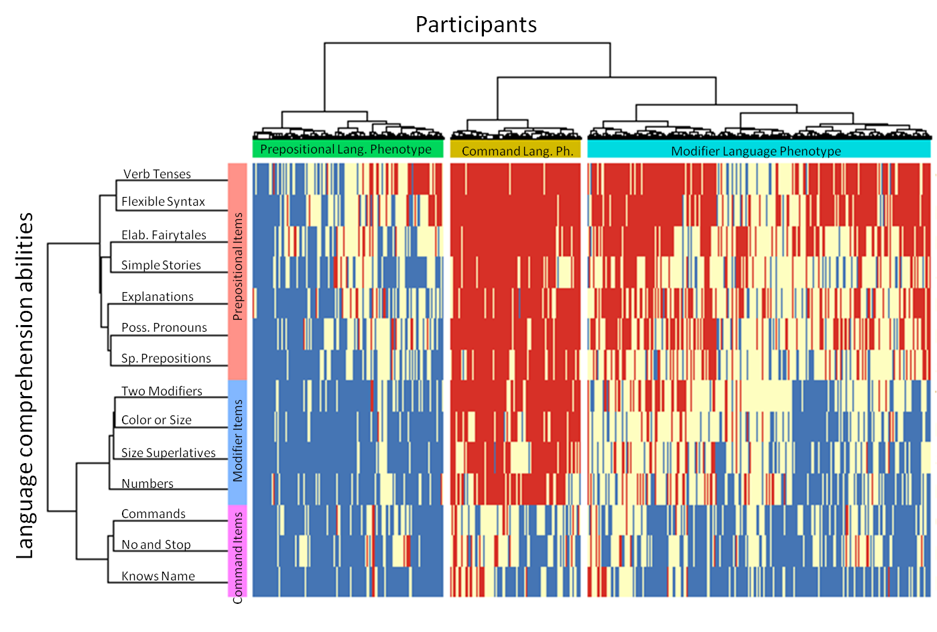Figure S2. Two dimensional heatmap relating 17,940 participants (of 4 to 6 years of age) to their language comprehension abilities. The 14 language comprehension abilities are shown as rows. The dendrogram representing language comprehension abilities is shown on the left. Participants are shown as 17,940 columns. The dendrogram representing participants is shown on the top. Blue color indicates the presence of a skill (the “very true” answer), red indicates the lack of skill (the “not true” answer), and white indicates the “somewhat true” answer.

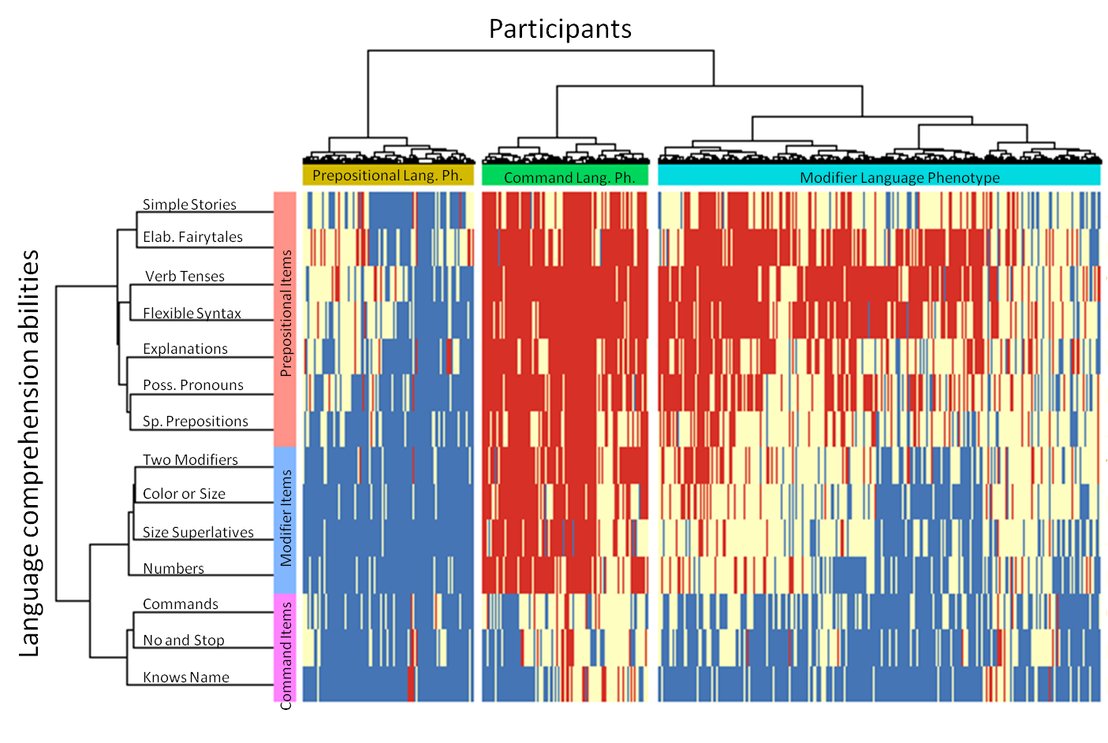Figure S3. Two dimensional heatmap relating 13,905 participants (of 6 to 21 years of age) to their language comprehension abilities. The 14 language comprehension abilities are shown as rows. The dendrogram representing language comprehension abilities is shown on the left. Participants are shown as 13,905 columns. The dendrogram representing participants is shown on the top. Blue color indicates the presence of a skill (the “very true” answer), red indicates the lack of skill (the “not true” answer), and white indicates the “somewhat true” answer.

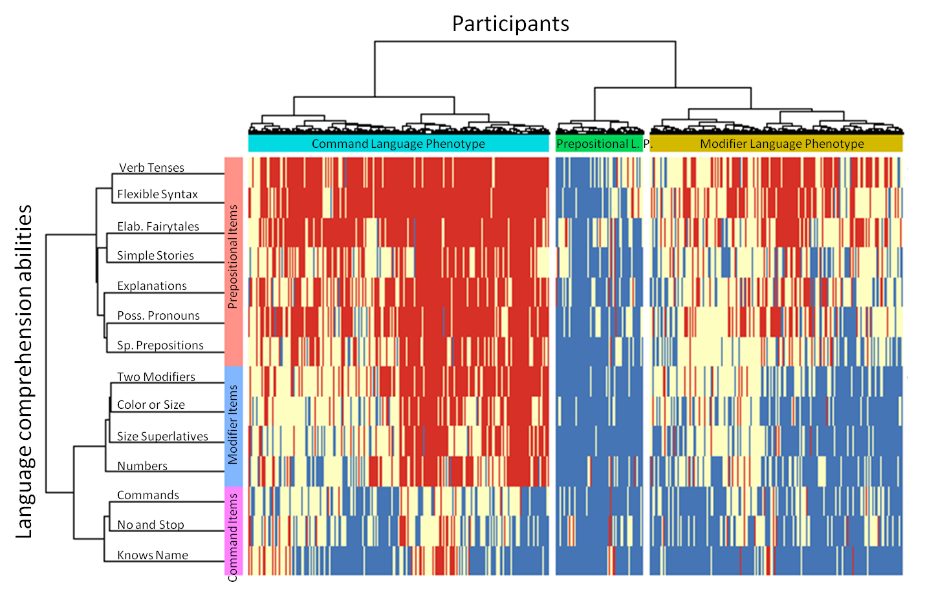Figure S4. Two dimensional heatmap relating 31,845 participants (of 4 to 21 years of age, first evaluation) to their language comprehension abilities. The 14 language comprehension abilities are shown as rows. The dendrogram representing language comprehension abilities is shown on the left. Participants are shown as 31,845 columns. The dendrogram representing participants is shown on the top. Blue color indicates the presence of a skill (the “very true” answer), red indicates the lack of skill (the “not true” answer), and white indicates the “somewhat true” answer.

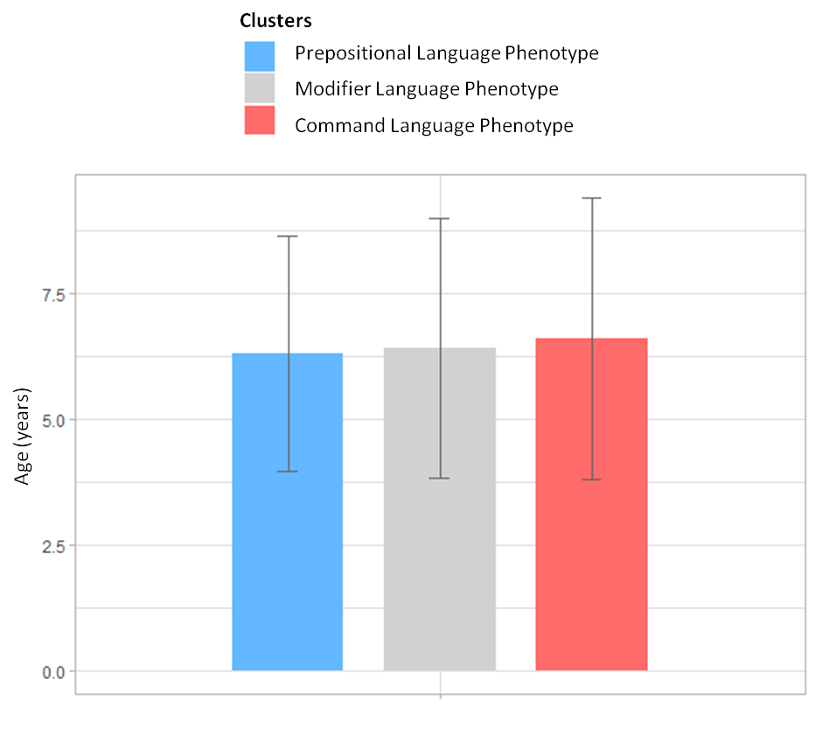
Figure S5. Language comprehension phenotype clusters show no statistically significant difference in age.

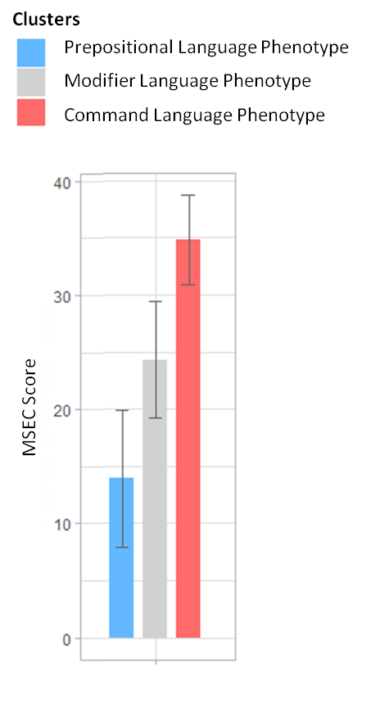
Figure S6. Language comprehension phenotype clusters show significant differences in MSEC score (p < 0.0001). Lower scores indicate milder symptoms.

Participant Cluster | Expressive Language  (Max score=28) | Sociability  (Max score=40) | Sensory Awareness  (Max score=36) | Health  (Max score=75) | MSEC score  (Max score=40)
Prepositional Language Phenotype | 6.3(5.3) | 9.4(8.3) | 7.2(5.7) | 12(8.8) | 13.9(6)
Modifier Language Phenotype | 11.8(5.5) | 12.3(7.5) | 13.0(6.0) | 15.9(9.6) | 24.3(5.1)
Command Language Phenotype | 18.3(5.3) | 15.5(7.4) | 18.8(6.5) | 18.5(10.3) | 34.8(3.9)
Table S1: Language comprehension phenotype clusters show significant differences in properties that were not used for clustering, such as expressive language, sociability, sensory awareness, and health (p < 0.0001). Lower scores indicate milder symptoms

