Supplementary Material
Design, synthesis and biological evaluation of esculetin derivatives as potential anti-HBV agents
Zhen Ye¹, Tong-Shi-Yao Zhao², Shan-Bin Li², Xian-Li Zhou², Qin Luo³, Jiang-Ke Qin⁴, Cheng-Qin Liang¹, Ping Wang⁵, Guang-Bo Ge⁵

¹College of Pharmacy, Guilin Medical University, Guilin 541199, Guangxi, China
²College of Biotechnology, Guilin Medical University, Guilin 541199, Guangxi, China
³Science Experiment Center, Guilin Medical University, Guilin 541199, Guangxi, China
⁴State Key Laboratory for the Chemistry and MoLecular Engineering of Medicinal Resources, School of Chemistry and Pharmaceutical Sciences of Guangxi Normal University, Guilin 541004, Guangxi, China
⁵Shanghai Frontiers Science Center for Traditional Chinese Medicine Chemical Biology, Institute of Interdisciplinary Integrative Medicine Research, Shanghai University of Traditional Chinese Medicine, Shanghai 201203, China

These authors contributed equally: Zhen Ye, Tong-Shi-Yao Zhao
Cheng-Qin Liang
cqliang@glmc.edu.cn
Ping Wang
wangping12@dicp.ac.cn
Guang-Bo Ge
geguangbo@dicp.ac.cn

Contents of Supporting Information
No.. | Contents
1 | Figure S1.¹H NMR spectrum of 1a (Recorded in DMSO)
2 | Figure S2. ¹³C NMR spectrum of 1a (Recorded in DMSO)
3 | Figure S3.¹H NMR spectrum of 1b (Recorded in CDCl₃)
4 | Figure S4. ¹³C NMR spectrum of 1b (Recorded in CDCl₃)
5 | Figure S5.¹H NMR spectrum of 1c (Recorded in CDCl₃)
6 | Figure S6. ¹³C NMR spectrum of 1c (Recorded in CDCl₃)
7 | Figure S7.¹H NMR spectrum of 1d (Recorded in CDCl₃)
8 | Figure S8. ¹³C NMR spectrum of 1d (Recorded in CDCl₃)
9 | Figure S9.¹H NMR spectrum of 2a (Recorded in MeOD)
10 | Figure S10. ¹³C NMR spectrum of 2a (Recorded in MeOD)
11 | Figure S11.¹H NMR spectrum of 2b (Recorded in MeOD)
12 | Figure S12. ¹³C NMR spectrum of 2b (Recorded in MeOD)
13 | Figure S13.¹H NMR spectrum of 2c (Recorded in MeOD)
14 | Figure S14. ¹³C NMR spectrum of 2c (Recorded in MeOD)
15 | Figure S15.¹H NMR spectrum of 2d (Recorded in MeOD)
16 | Figure S16. ¹³C NMR spectrum of 2d (Recorded in MeOD)
17 | Figure S17.¹H NMR spectrum of 3a (Recorded in MeOD)
18 | Figure S18. ¹³C NMR spectrum of 3a (Recorded in MeOD)
19 | Figure S19.¹H NMR spectrum of 3b (Recorded in CDCl₃)
20 | Figure S20. ¹³C NMR spectrum of 3b (Recorded in CDCl₃)
21 | Figure S21.¹H NMR spectrum of 3c (Recorded in CDCl₃)
22 | Figure S22. ¹³C NMR spectrum of 3c (Recorded in CDCl₃)
23 | Figure S23.¹H NMR spectrum of 3d (Recorded in CDCl₃)
24 | Figure S24. ¹³C NMR spectrum of 3d (Recorded in CDCl₃)
25 | Figure S25.¹H NMR spectrum of 4a (Recorded in CDCl₃)
26 | Figure S26. ¹³C NMR spectrum of 4a (Recorded in CDCl₃)
27 | Figure S27.¹H NMR spectrum of 4b (Recorded in MeOD)
28 | Figure S28. ¹³C NMR spectrum of 4b (Recorded in MeOD)
29 | Figure S29.¹H NMR spectrum of 4c (Recorded in CDCl₃)
30 | Figure S30. ¹³C NMR spectrum of 4c (Recorded in CDCl₃)
31 | Figure S31.¹H NMR spectrum of 4d (Recorded in CDCl₃)
32 | Figure S32. ¹³C NMR spectrum of 4d (Recorded in CDCl₃)
33 | Figure S33.¹H NMR spectrum of 5a (Recorded in MeOD)
34 | Figure S34. ¹³C NMR spectrum of 5a (Recorded in MeOD)
35 | Figure S35.¹H NMR spectrum of 5b (Recorded in MeOD)
36 | Figure S36. ¹³C NMR spectrum of 5b (Recorded in MeOD)
37 | Figure S37.¹H NMR spectrum of 5c (Recorded in CDCl₃)
38 | Figure S38. ¹³C NMR spectrum of 5c (Recorded in CDCl₃)
39 | Figure S39.¹H NMR spectrum of 5d (Recorded in CDCl₃)
40 | Figure S40. ¹³C NMR spectrum of 5d (Recorded in CDCl₃)
41 | Figure S41.¹H NMR spectrum of 6a (Recorded in MeOD)
42 | Figure S42. ¹³C NMR spectrum of 6a (Recorded in MeOD)
43 | Figure S43.¹H NMR spectrum of 6b (Recorded in MeOD)
44 | Figure S44. ¹³C NMR spectrum of 6b (Recorded in MeOD)
45 | Figure S45.¹H NMR spectrum of 6c (Recorded in MeOD)
46 | Figure S46. ¹³C NMR spectrum of 6c (Recorded in MeOD)
47 | Figure S47.¹H NMR spectrum of 6d (Recorded in Pyr)
48 | Figure S48. ¹³C NMR spectrum of 6d (Recorded in Pyr)
49 | Figure S49.¹H NMR spectrum of 7a (Recorded in MeOD)
50 | Figure S50. ¹³C NMR spectrum of 7a (Recorded in MeOD)
51 | Figure S51.¹H NMR spectrum of 7b (Recorded in MeOD)
52 | Figure S52. ¹³C NMR spectrum of 7b (Recorded in MeOD)
53 | Figure S53.¹H NMR spectrum of 7c (Recorded in MeOD)
54 | Figure S54. ¹³C NMR spectrum of 7c (Recorded in MeOD)
55 | Figure S55.¹H NMR spectrum of 8a (Recorded in MeOD)
56 | Figure S56. ¹³C NMR spectrum of 8a (Recorded in MeOD)
57 | Figure S57.¹H NMR spectrum of 8b (Recorded in MeOD)
58 | Figure S58. ¹³C NMR spectrum of 8b (Recorded in MeOD)
59 | Figure S59.¹H NMR spectrum of 8c (Recorded in MeOD)
60 | Figure S60. ¹³C NMR spectrum of 8c (Recorded in MeOD)

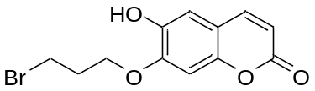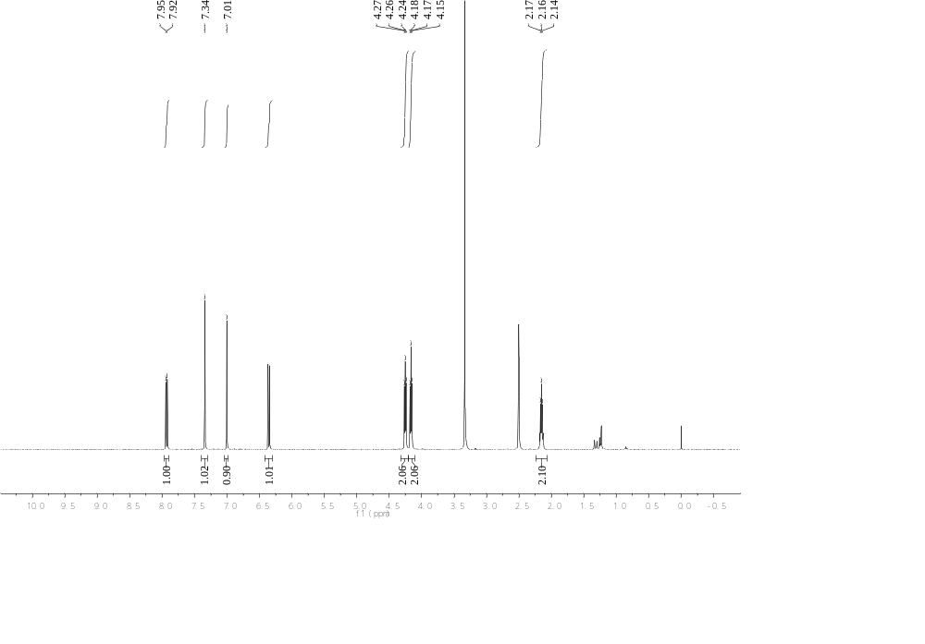
Figure S1.¹H NMR spectrum of 1a (Recorded in DMSO)

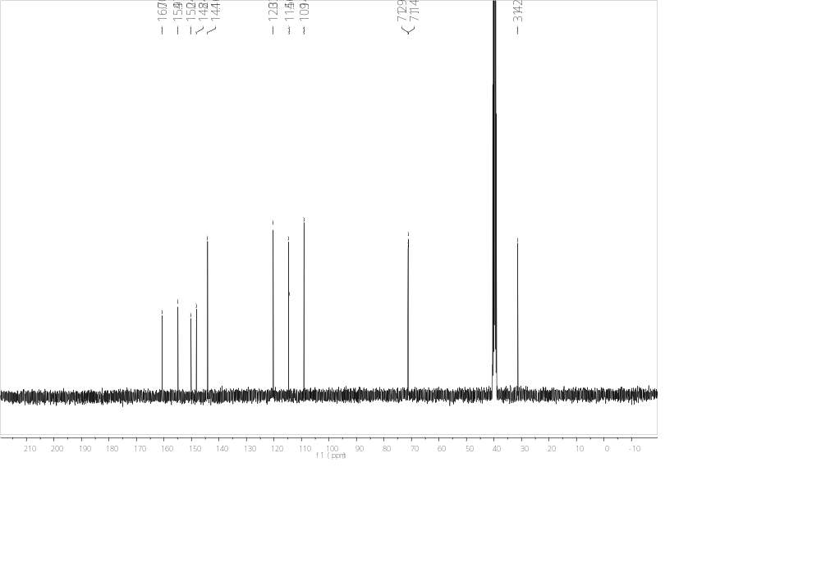
Figure S2. ¹³C NMR spectrum of 1a (Recorded in DMSO)

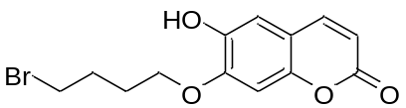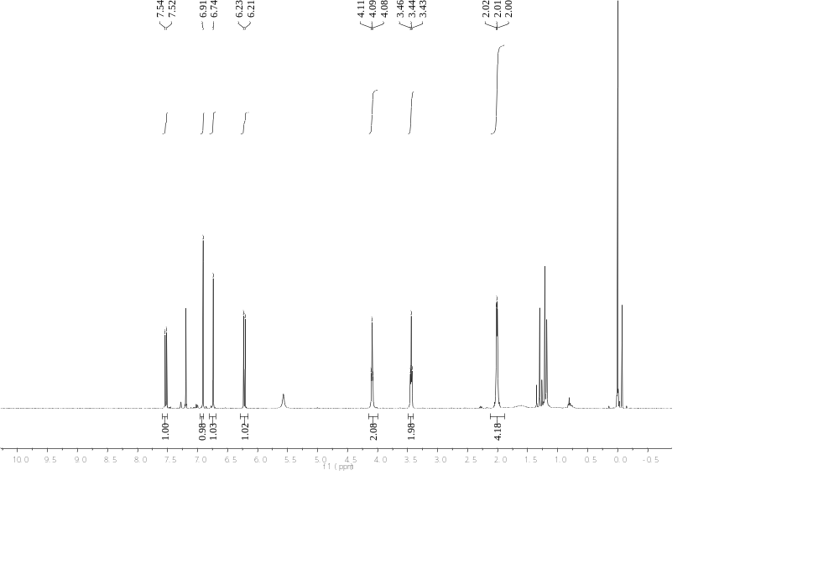
Figure S3.¹H NMR spectrum of 1b (Recorded in CDCl₃)

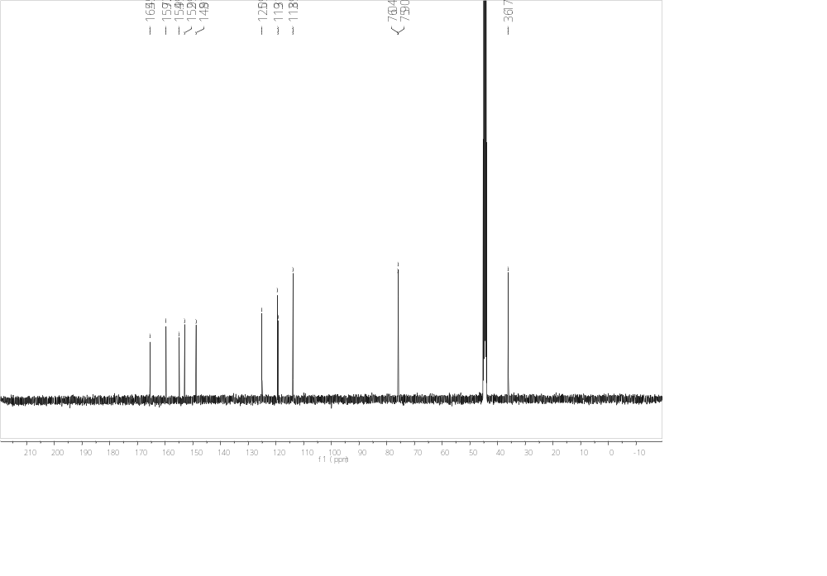
Figure S4. ¹³C NMR spectrum of 1b (Recorded in CDCl₃)

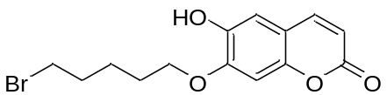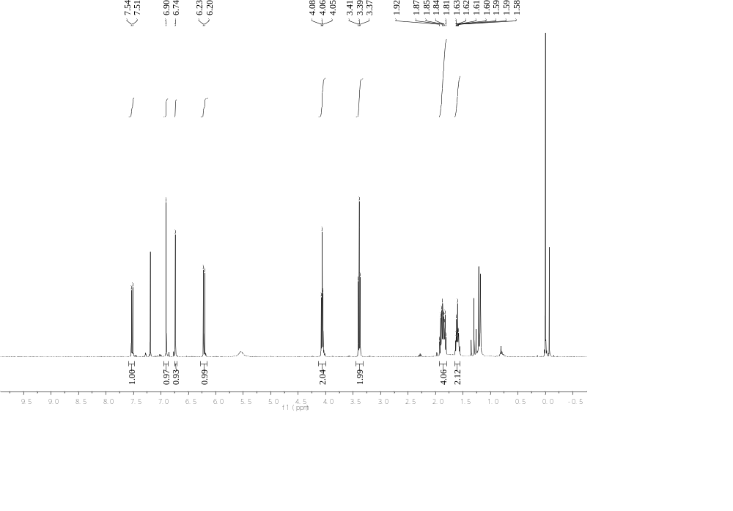
Figure S5.¹H NMR spectrum of 1c (Recorded in CDCl₃)
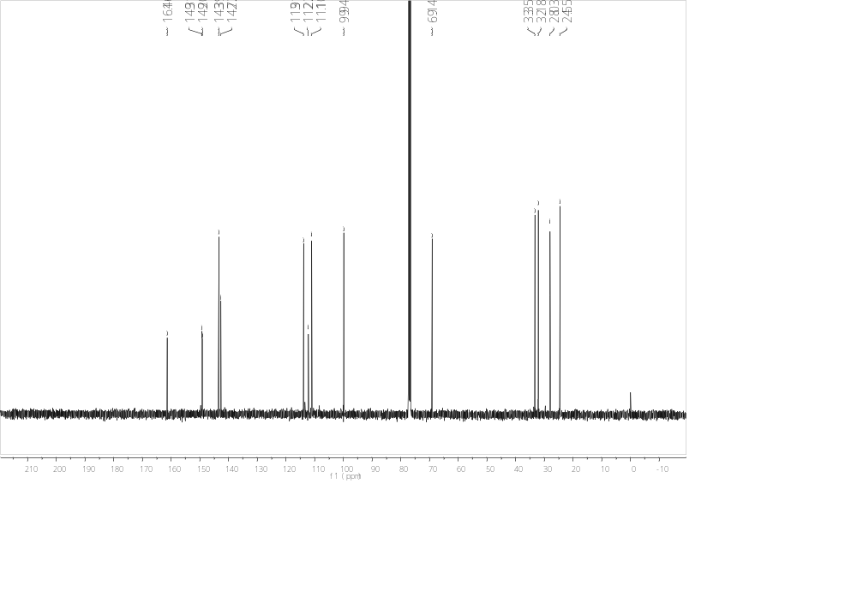
Figure S6. ¹³C NMR spectrum of 1c (Recorded in CDCl₃)

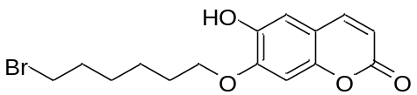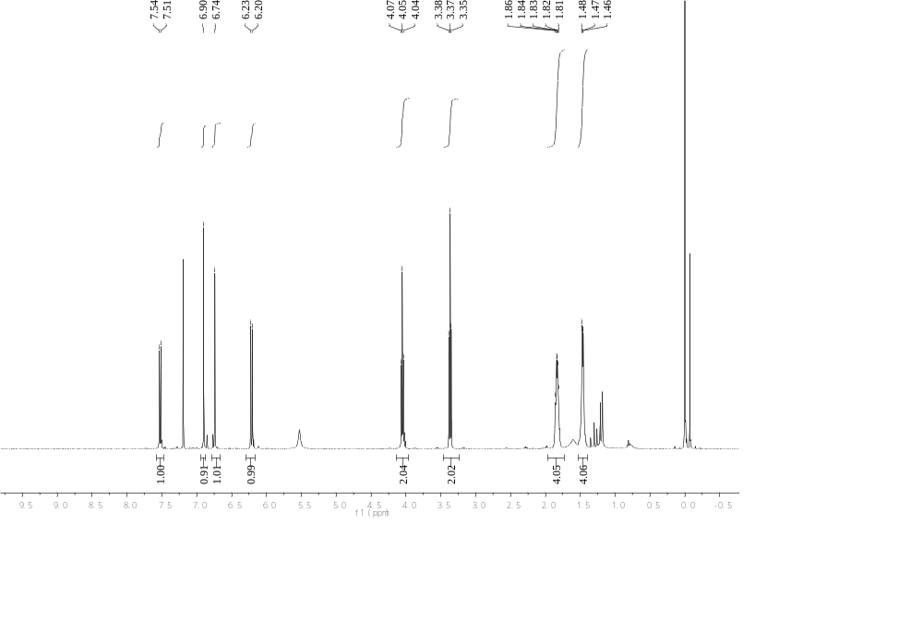
Figure S7.¹H NMR spectrum of 1d (Recorded in CDCl₃)

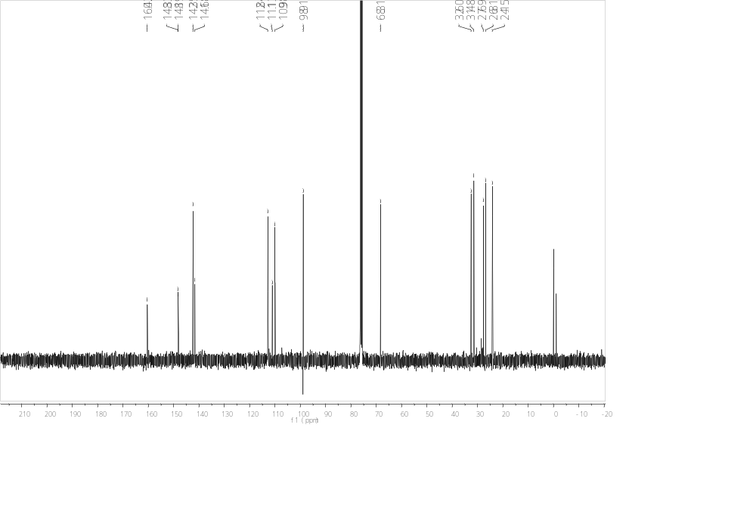
Figure S8. ¹³C NMR spectrum of 1d (Recorded in CDCl₃)

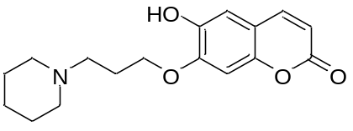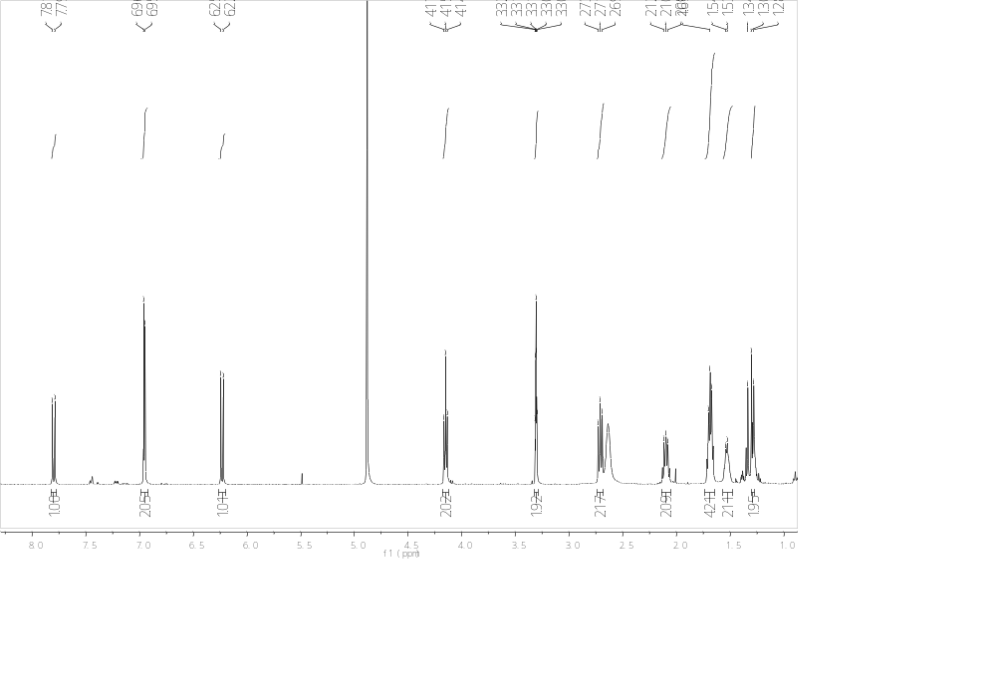
Figure S9.¹H NMR spectrum of 2a (Recorded in MeOD)

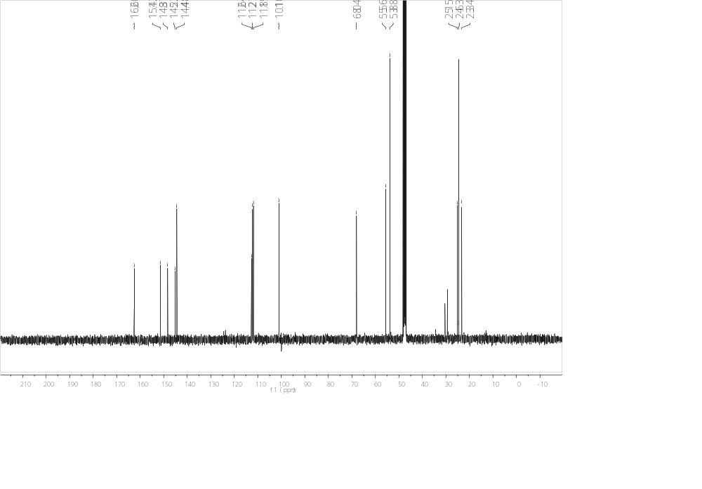
Figure S10. ¹³C NMR spectrum of 2a (Recorded in MeOD)

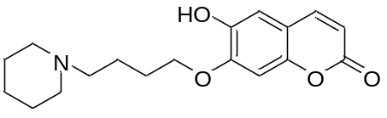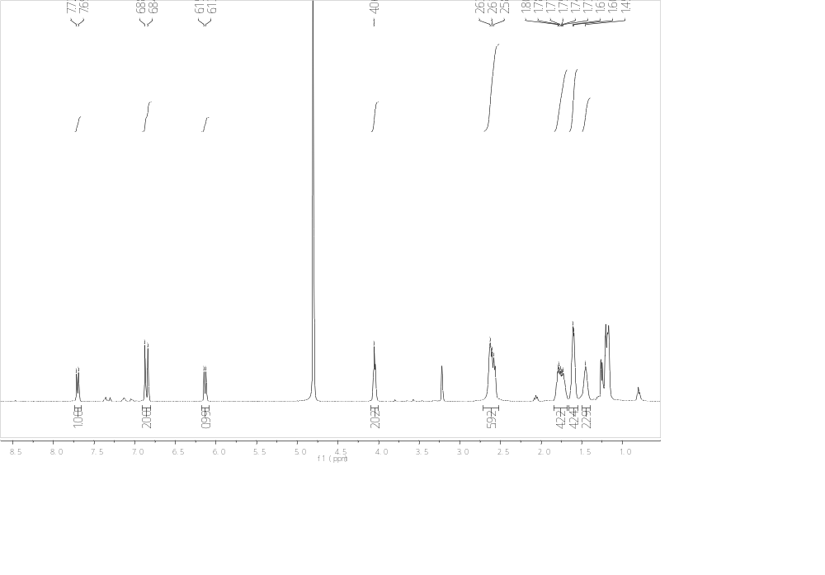
Figure S11.¹H NMR spectrum of 2b (Recorded in MeOD)

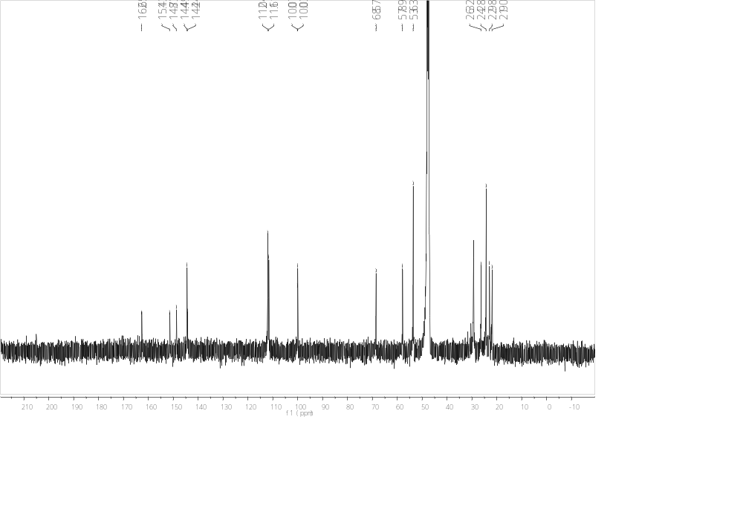
Figure S12. ¹³C NMR spectrum of 2b (Recorded in MeOD)

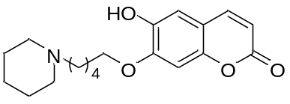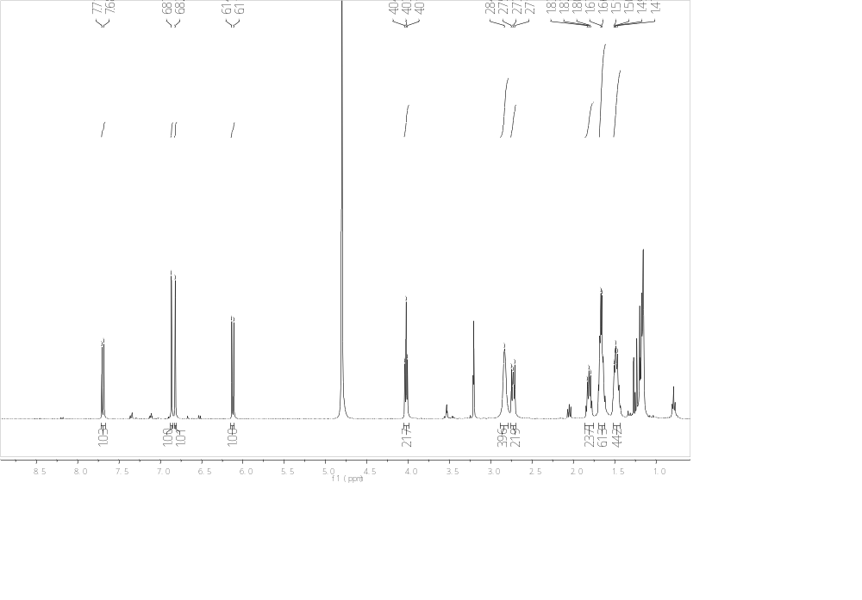
Figure S13.¹H NMR spectrum of 2c (Recorded in MeOD)

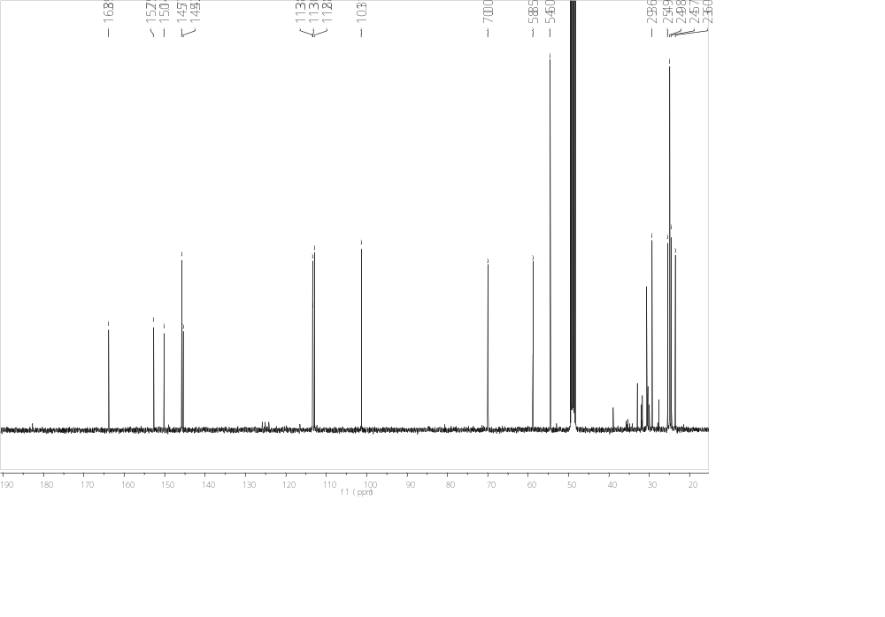
Figure S14. ¹³C NMR spectrum of 2c (Recorded in MeOD)

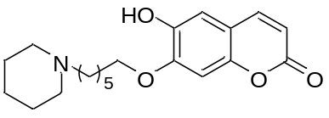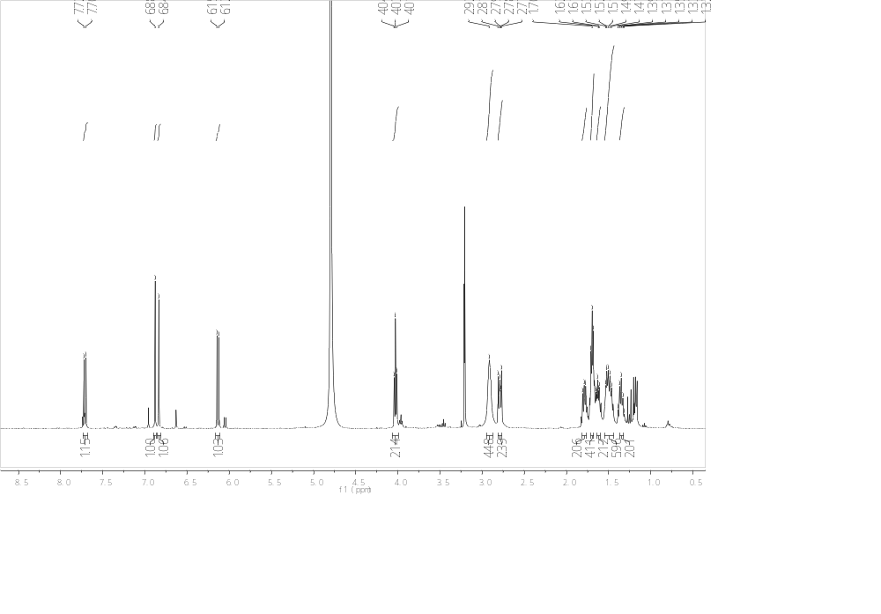
Figure S15.¹H NMR spectrum of 2d (Recorded in MeOD)

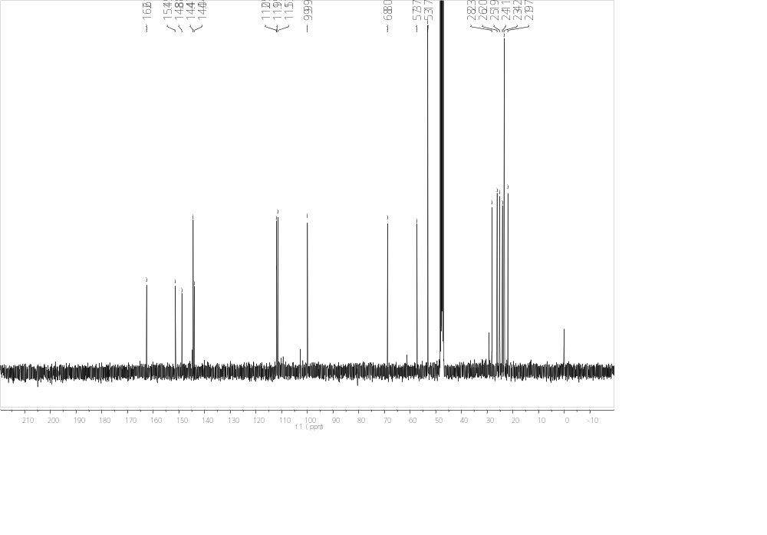
Figure S16. ¹³C NMR spectrum of 2d (Recorded in MeOD)

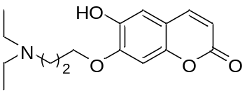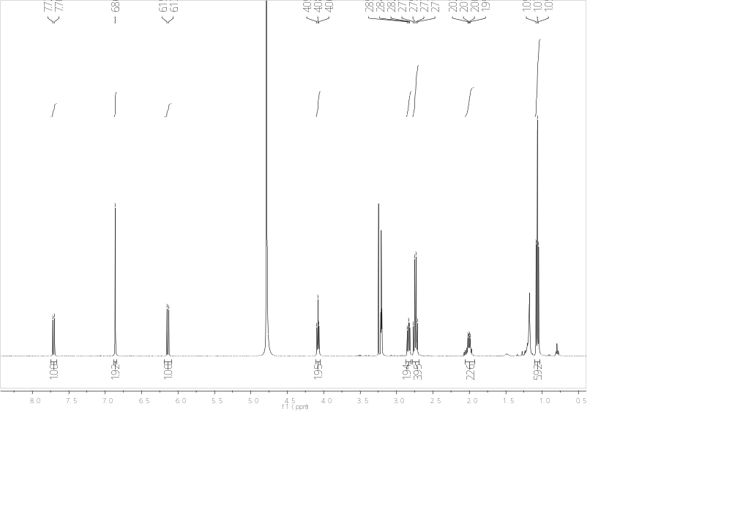
Figure S17.¹H NMR spectrum of 3a (Recorded in MeOD)

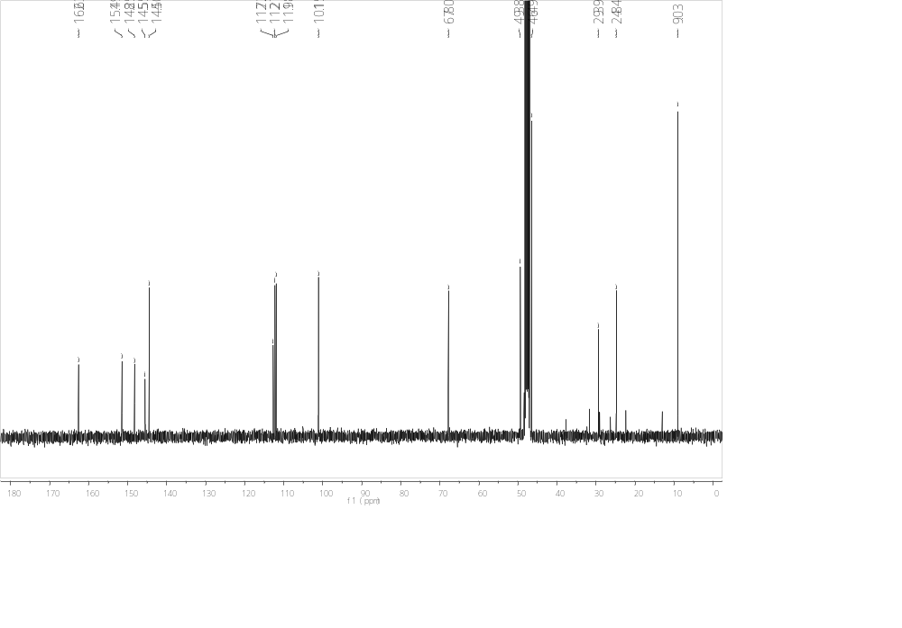
Figure S18. ¹³C NMR spectrum of 3a (Recorded in MeOD)

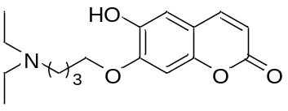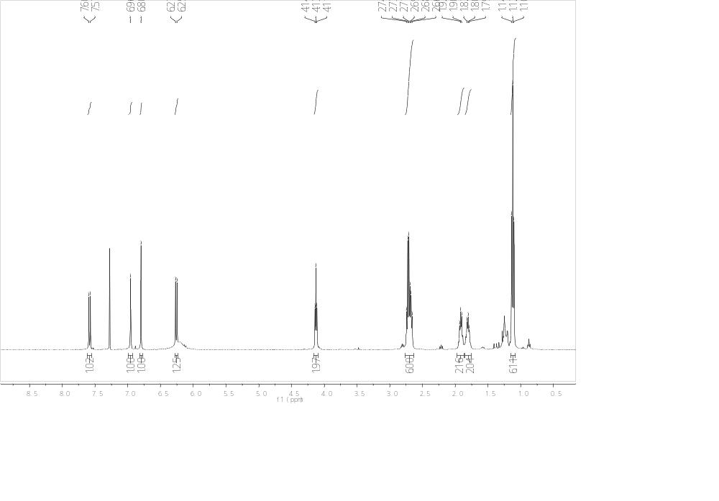
Figure S19.¹H NMR spectrum of 3b (Recorded in CDCl₃)

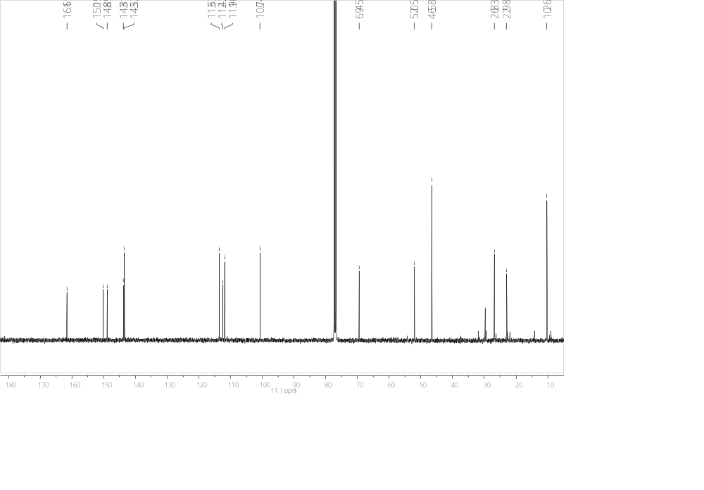
Figure S20. ¹³C NMR spectrum of 3b (Recorded in CDCl₃)

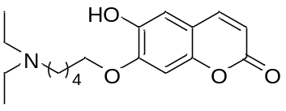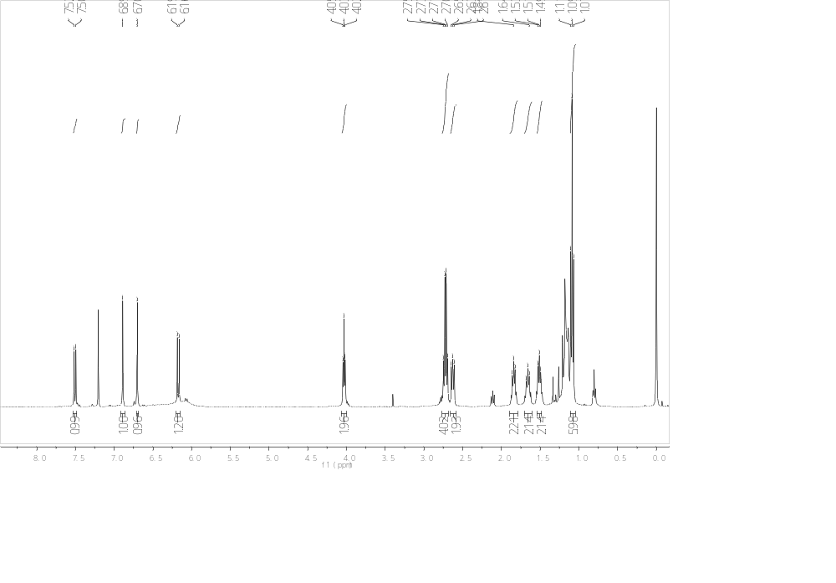
Figure S21.¹H NMR spectrum of 3c (Recorded in CDCl₃)

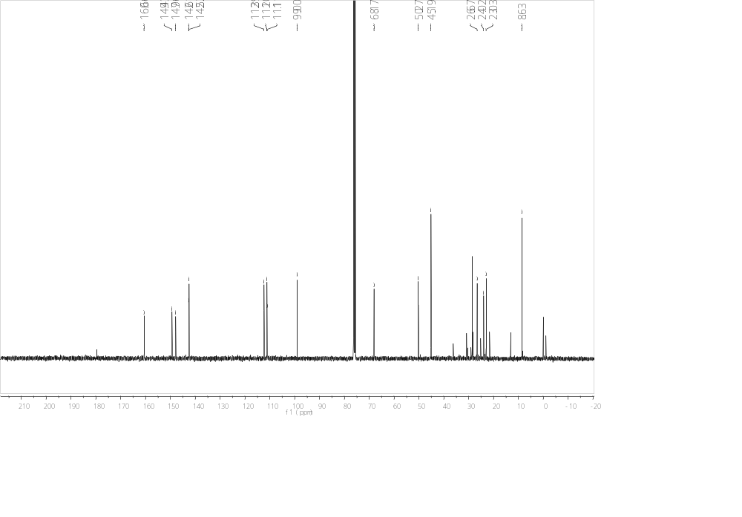
Figure S22. ¹³C NMR spectrum of 3c (Recorded in CDCl₃)

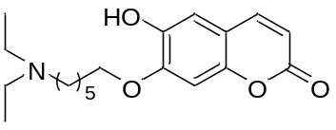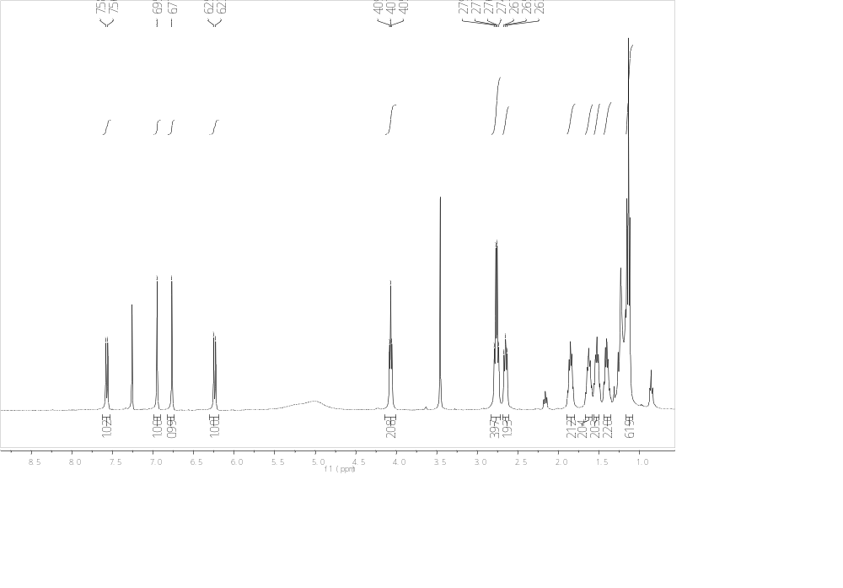
Figure S23.¹H NMR spectrum of 3d (Recorded in CDCl₃)

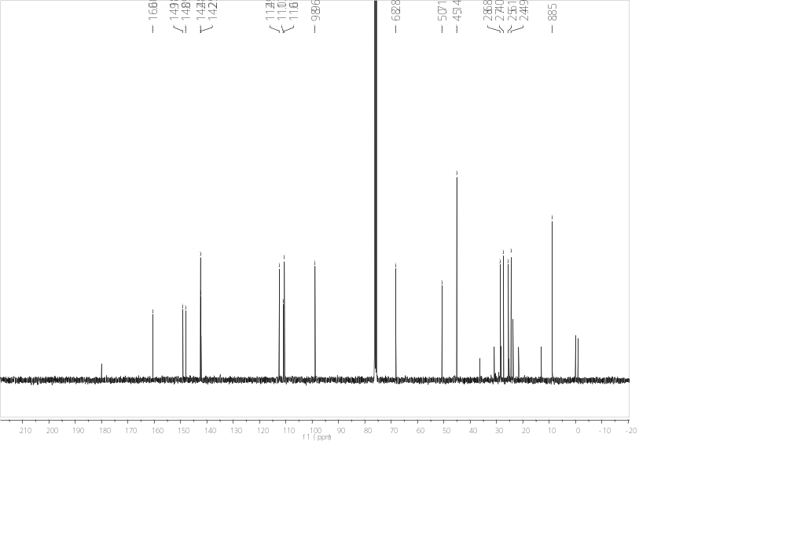
Figure S24. ¹³C NMR spectrum of 3d (Recorded in CDCl₃)

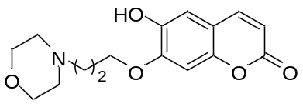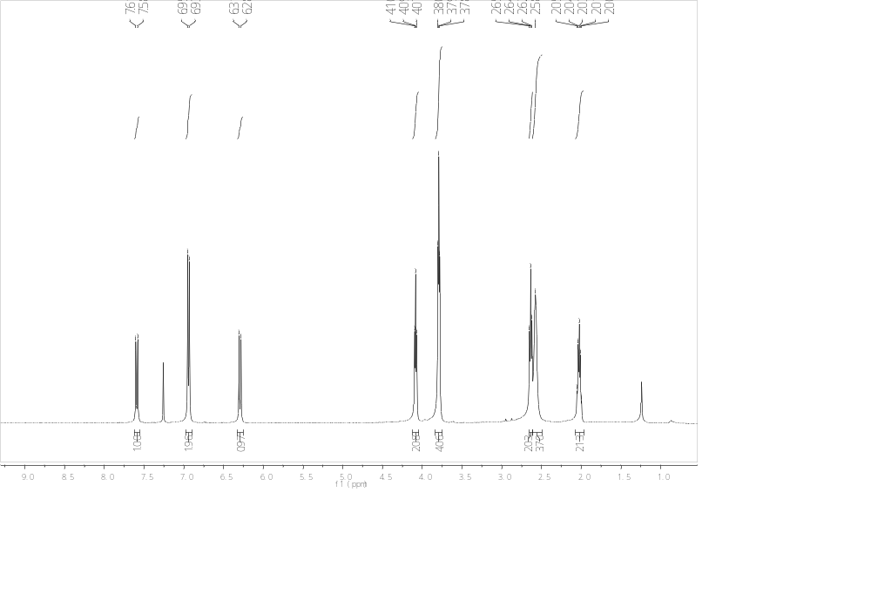
Figure S25.¹H NMR spectrum of 4a (Recorded in CDCl₃)

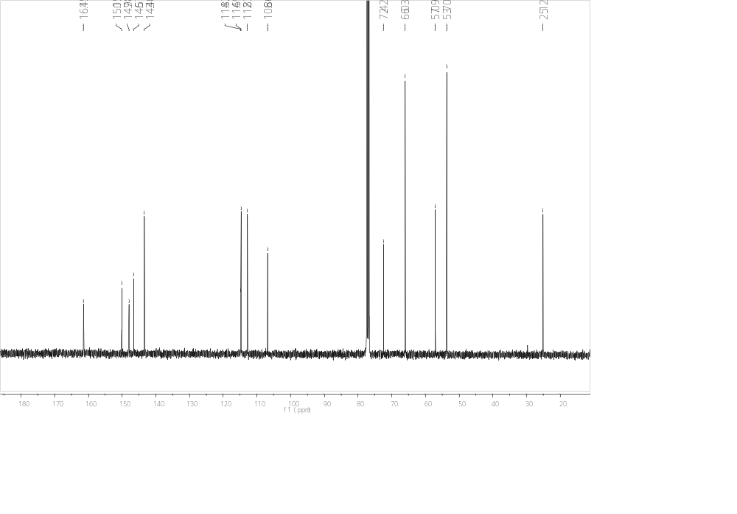
Figure S26. ¹³C NMR spectrum of 4a (Recorded in CDCl₃)

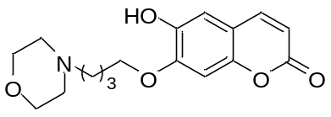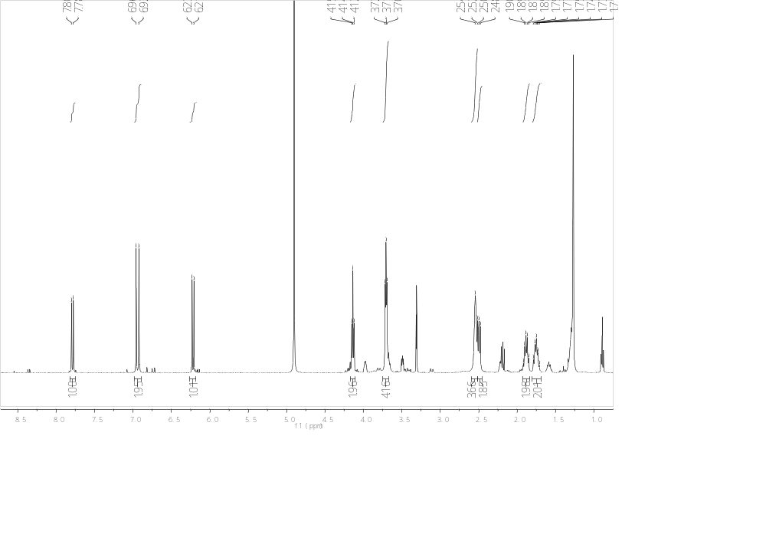
Figure S27.¹H NMR spectrum of 4b (Recorded in MeOD)

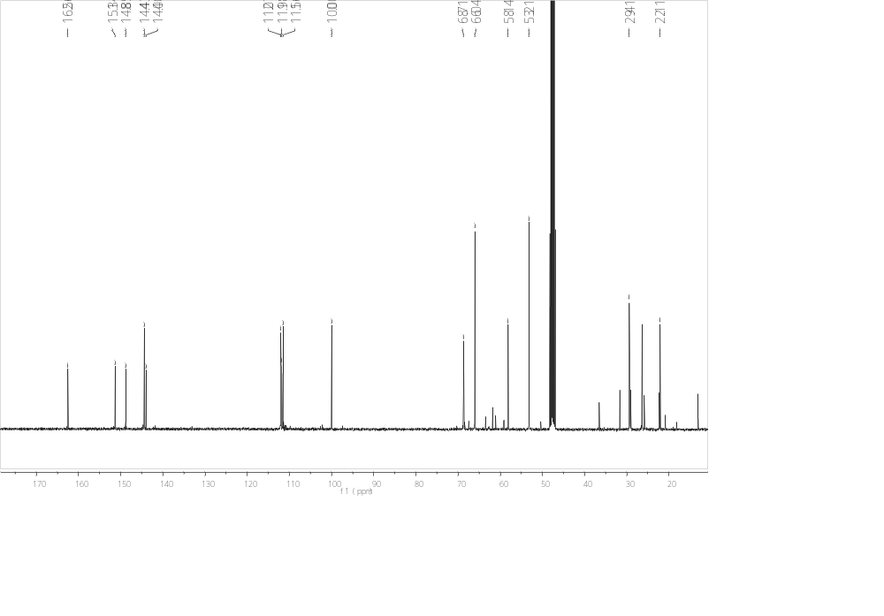
Figure S28. ¹³C NMR spectrum of 4b (Recorded in MeOD)

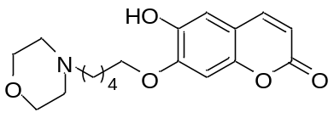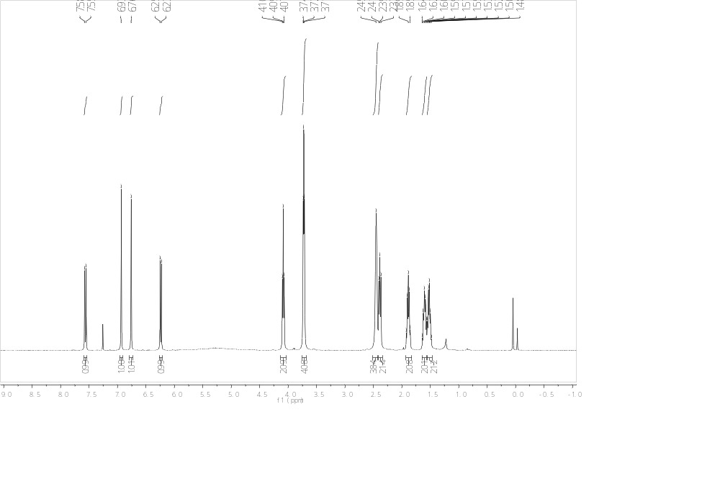
Figure S29.¹H NMR spectrum of 4c (Recorded in CDCl₃)

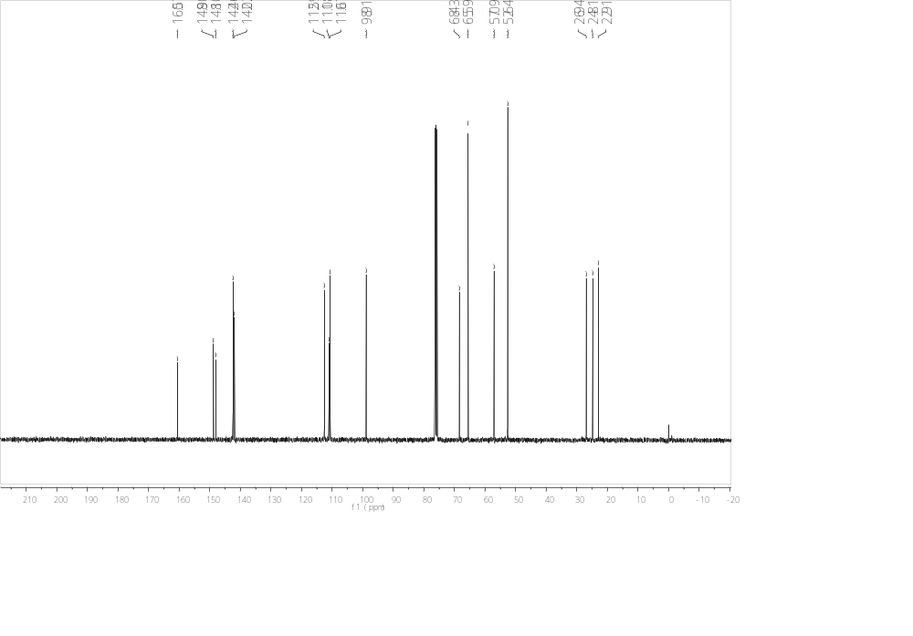
Figure S30. ¹³C NMR spectrum of 4c (Recorded in CDCl₃)

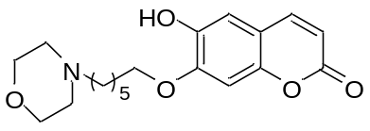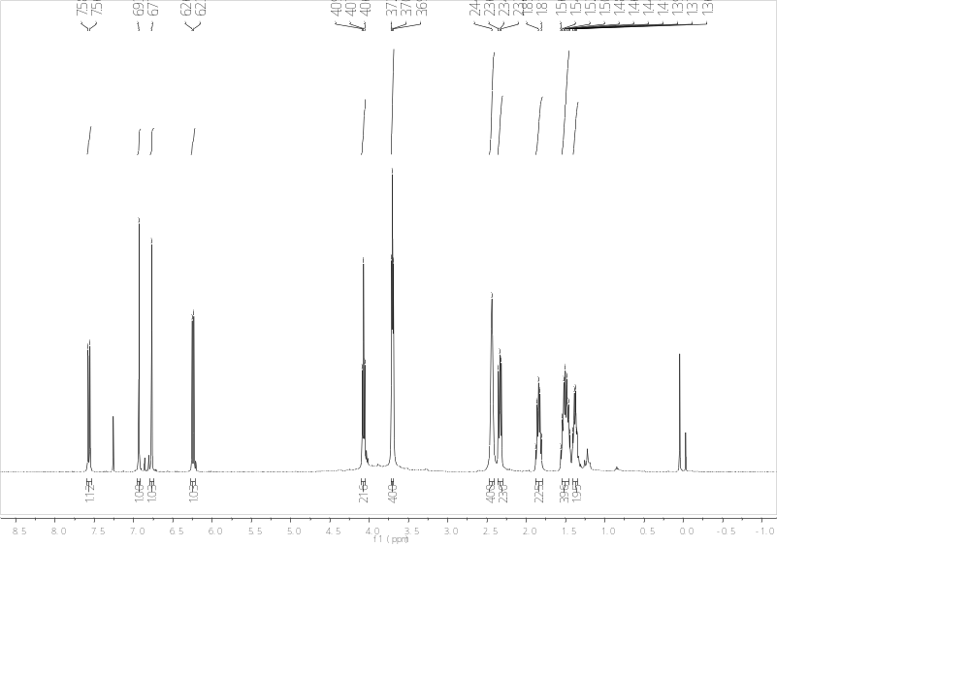
Figure S31.¹H NMR spectrum of 4d (Recorded in CDCl₃)

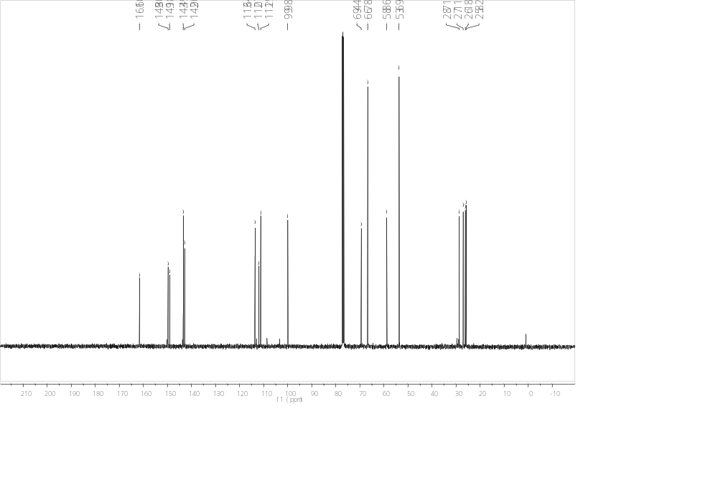
Figure S32. ¹³C NMR spectrum of 4d (Recorded in CDCl₃)

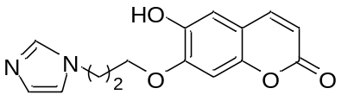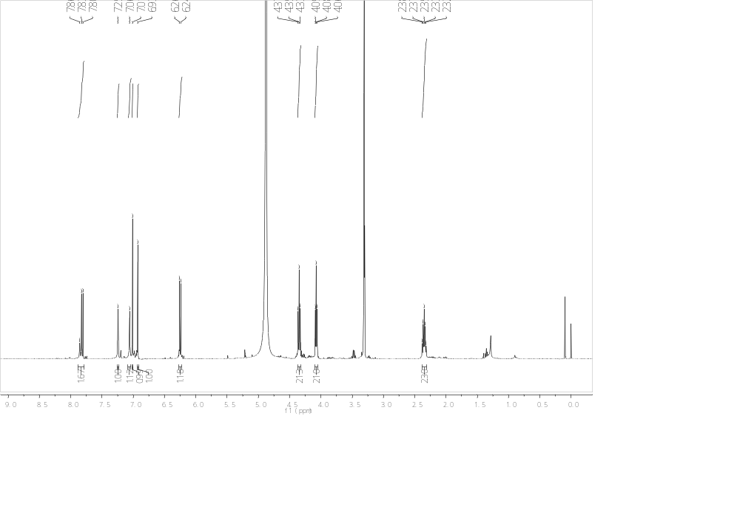
Figure S33.¹H NMR spectrum of 5a (Recorded in MeOD)

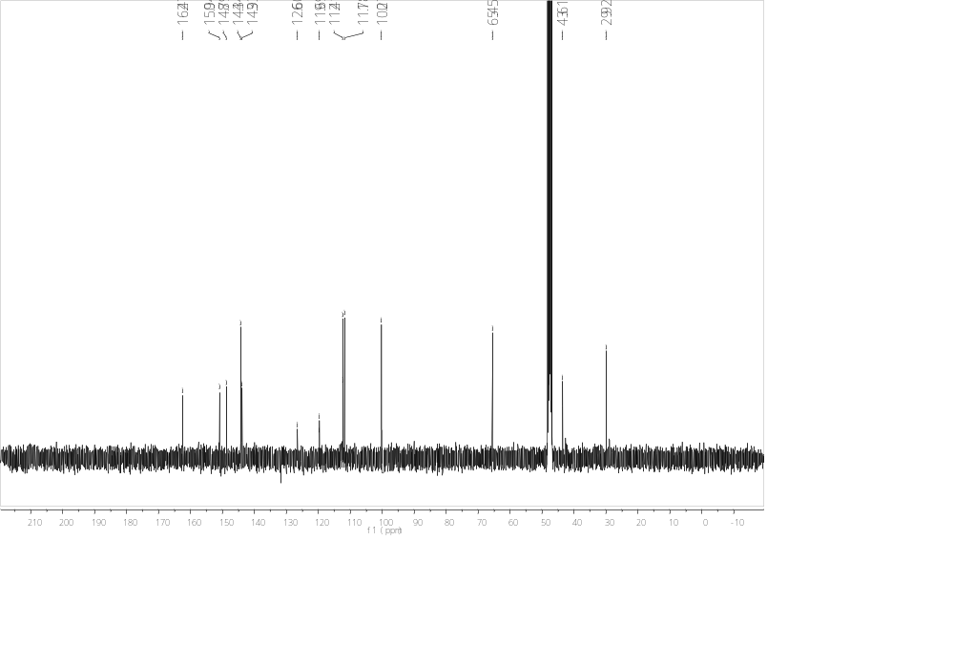
Figure S34. ¹³C NMR spectrum of 5a (Recorded in MeOD)

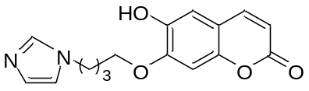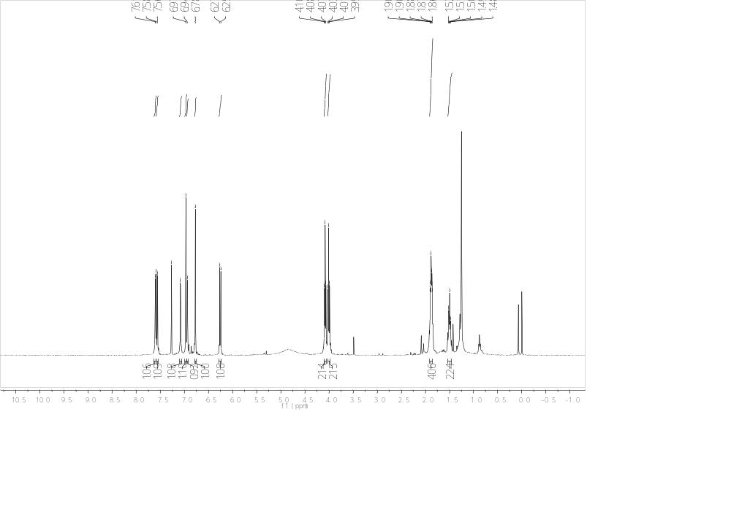
Figure S35.¹H NMR spectrum of 5b (Recorded in MeOD)

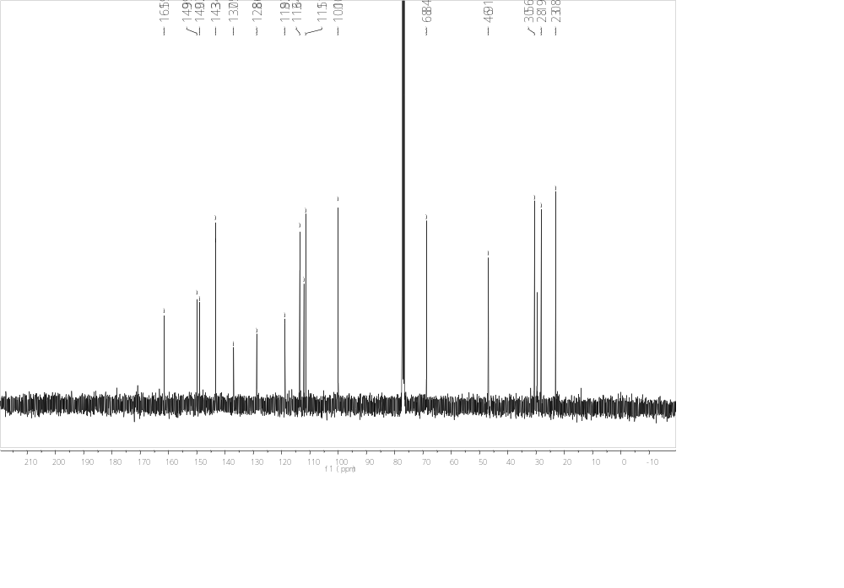
Figure S36. ¹³C NMR spectrum of 5b (Recorded in MeOD)

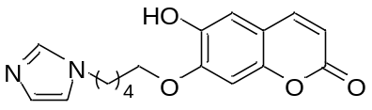
Figure S37.¹H NMR spectrum of 5c (Recorded in CDCl₃)

Figure S38. ¹³C NMR spectrum of 5c (Recorded in CDCl₃)

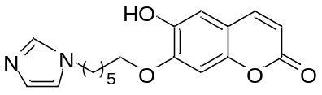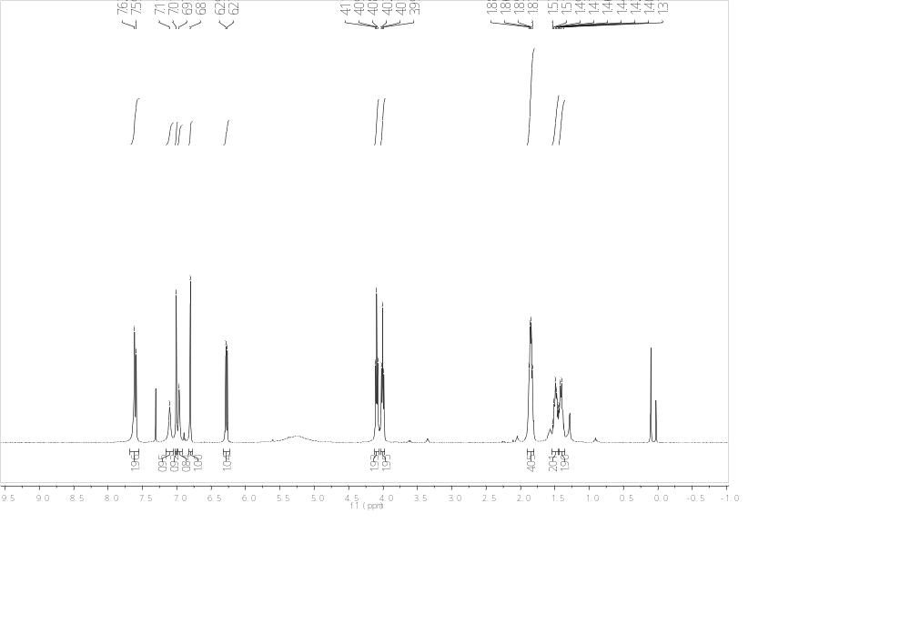
Figure S39.¹H NMR spectrum of 5d (Recorded in CDCl₃)

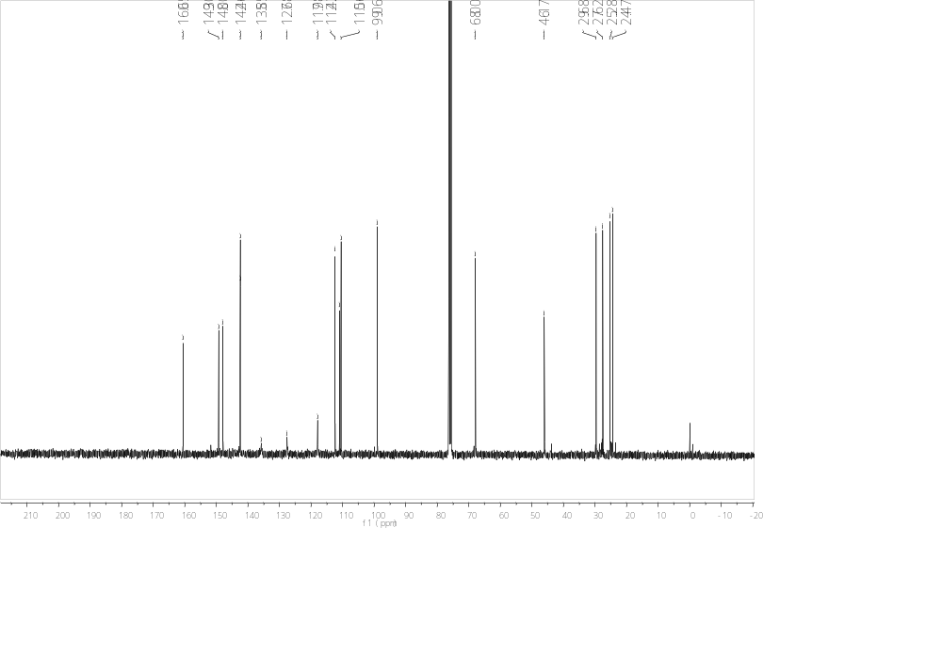
Figure S40. ¹³C NMR spectrum of 5d (Recorded in CDCl₃)

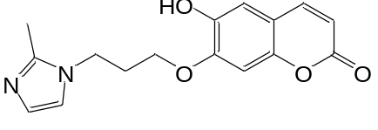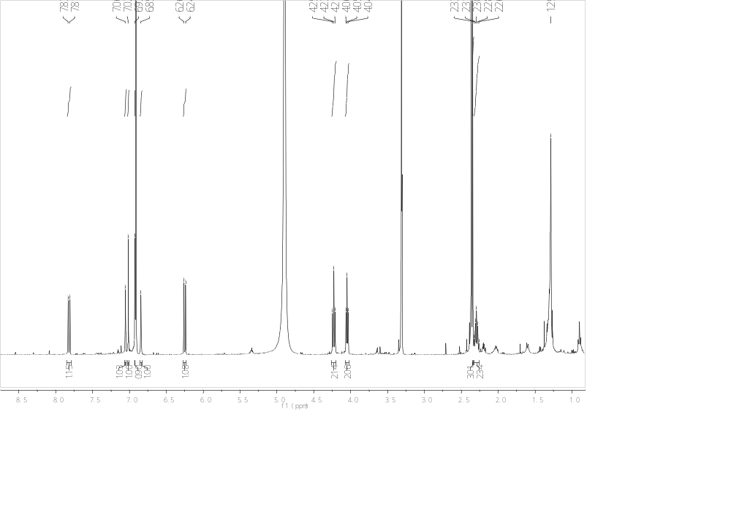
Figure S41.¹H NMR spectrum of 6a (Recorded in MeOD)

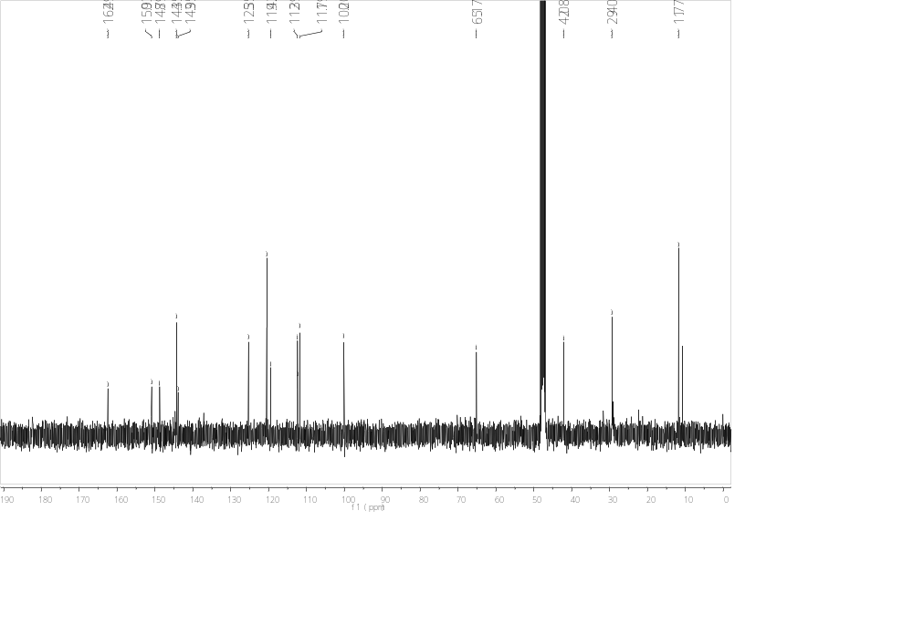
Figure S42. ¹³C NMR spectrum of 6a (Recorded in MeOD)

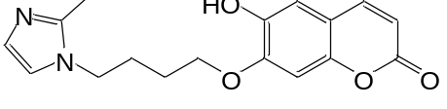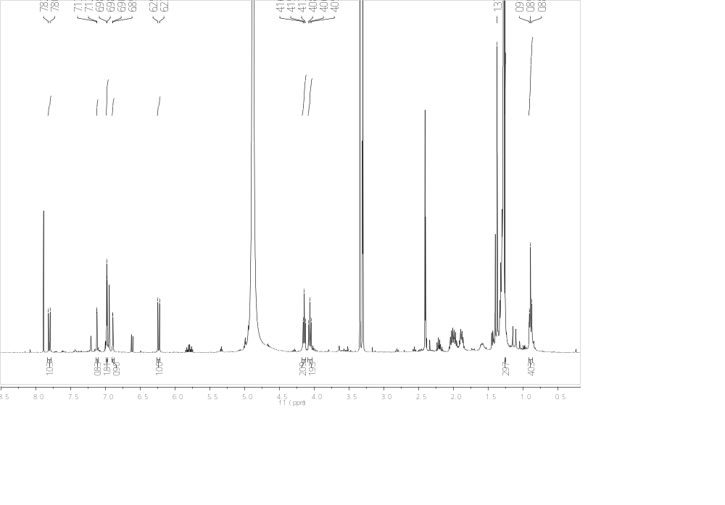
Figure S43.¹H NMR spectrum of 6b (Recorded in MeOD)

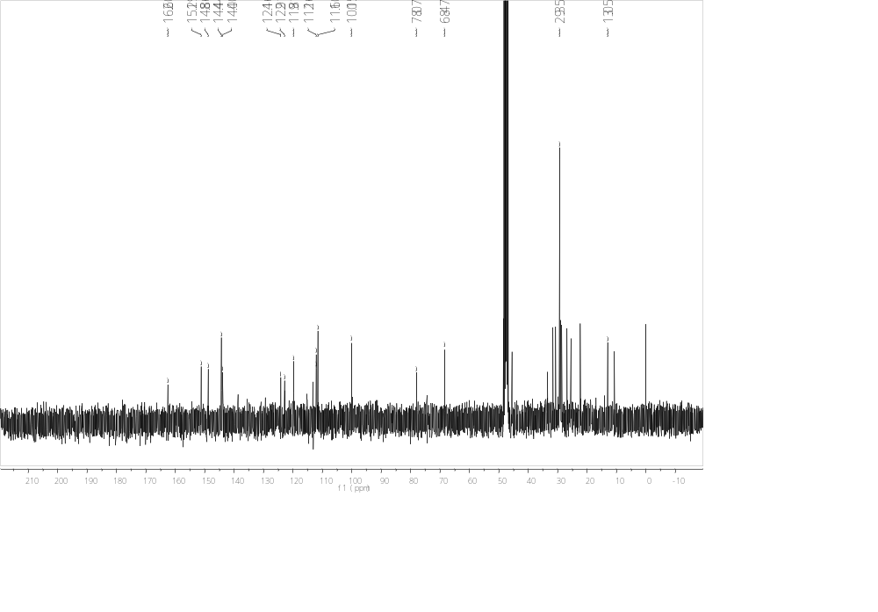
Figure S44. ¹³C NMR spectrum of 6b (Recorded in MeOD)

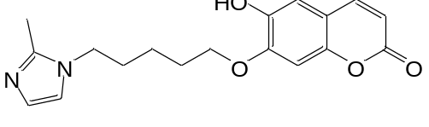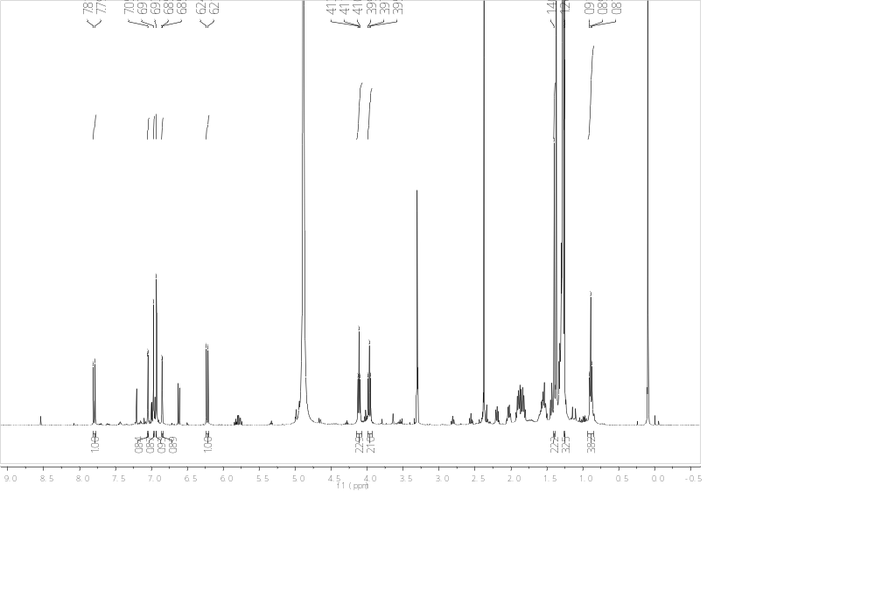
Figure S45.¹H NMR spectrum of 6c (Recorded in MeOD)

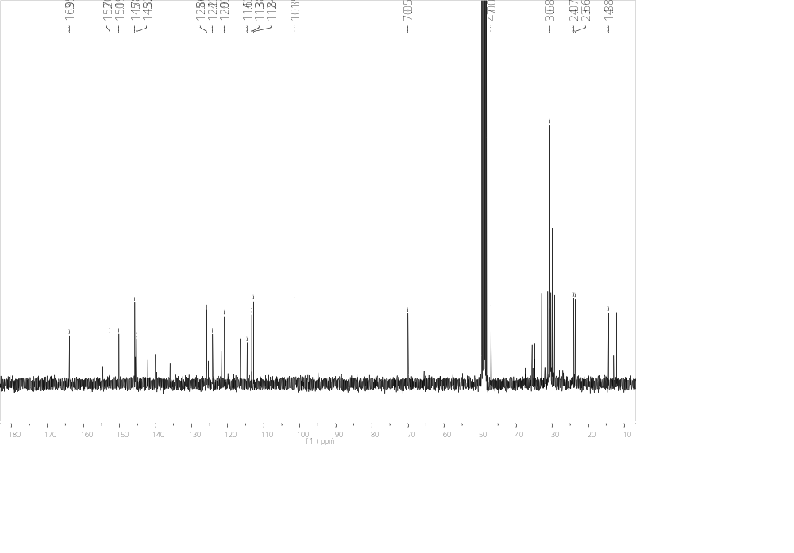
Figure S46. ¹³C NMR spectrum of 6c (Recorded in MeOD)

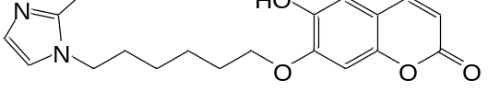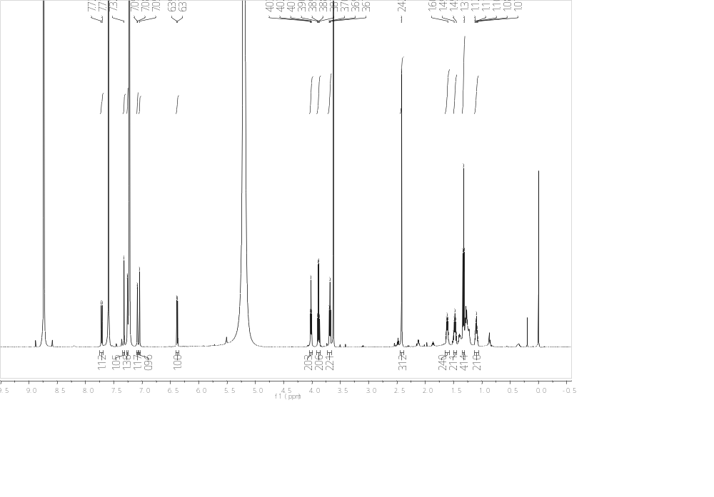
Figure S47.¹H NMR spectrum of 6d (Recorded in Pyr)

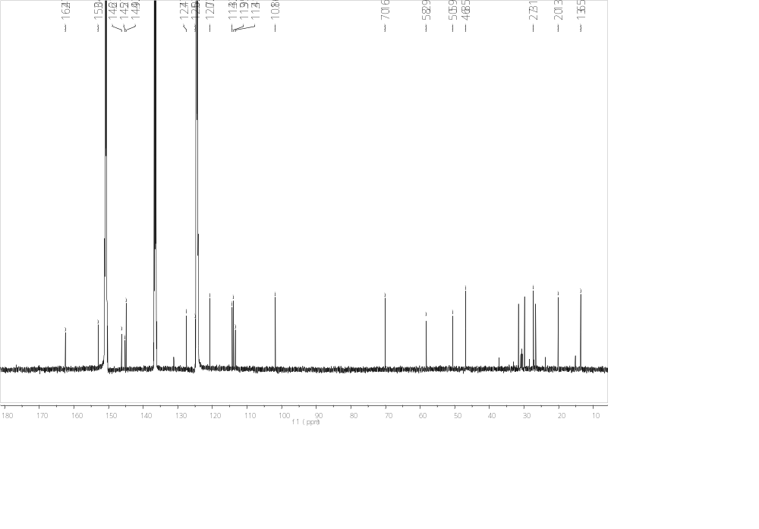
Figure S48. ¹³C NMR spectrum of 6d (Recorded in Pyr)

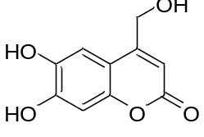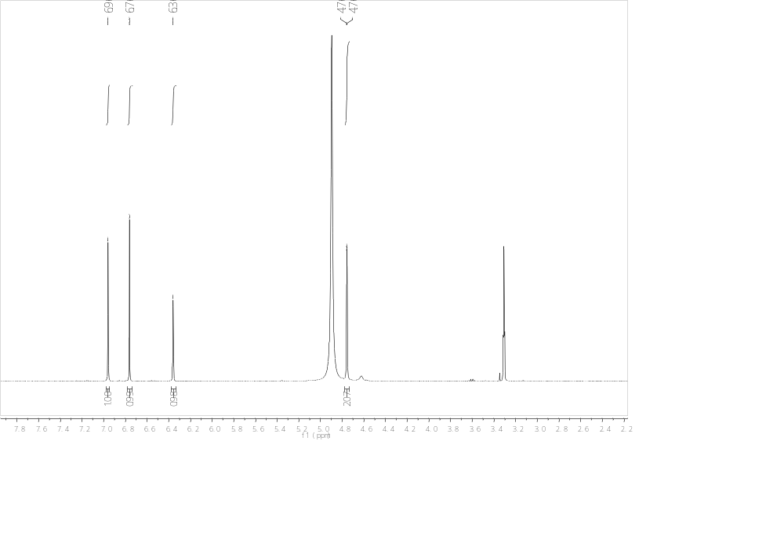
Figure S49.¹H NMR spectrum of 7a (Recorded in MeOD)

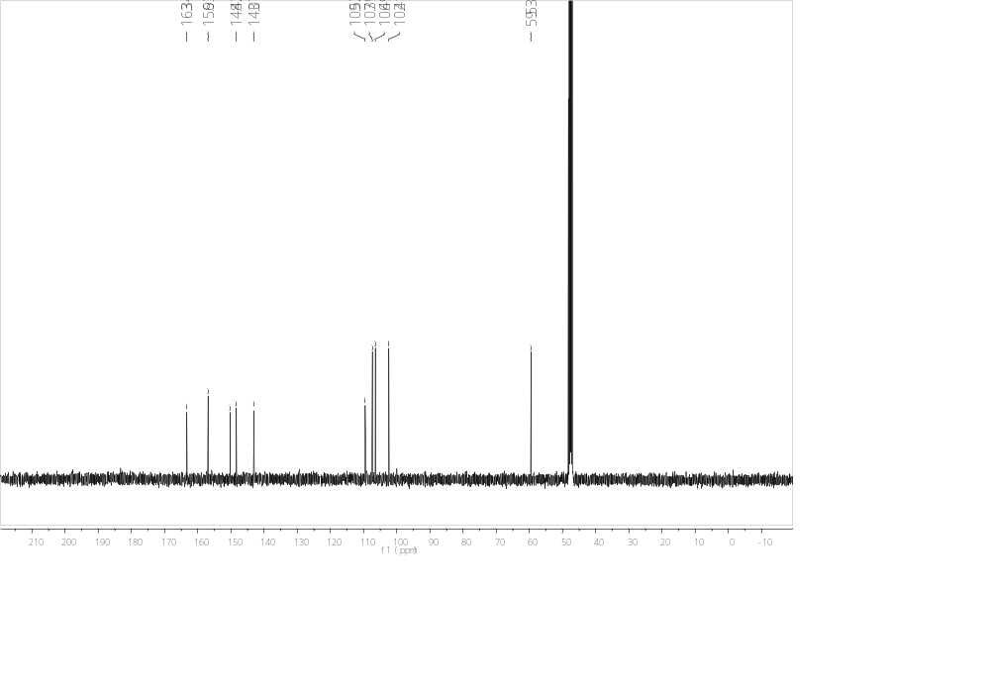
Figure S50. ¹³C NMR spectrum of 7a (Recorded in MeOD)

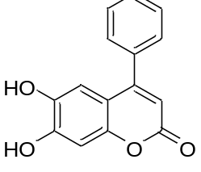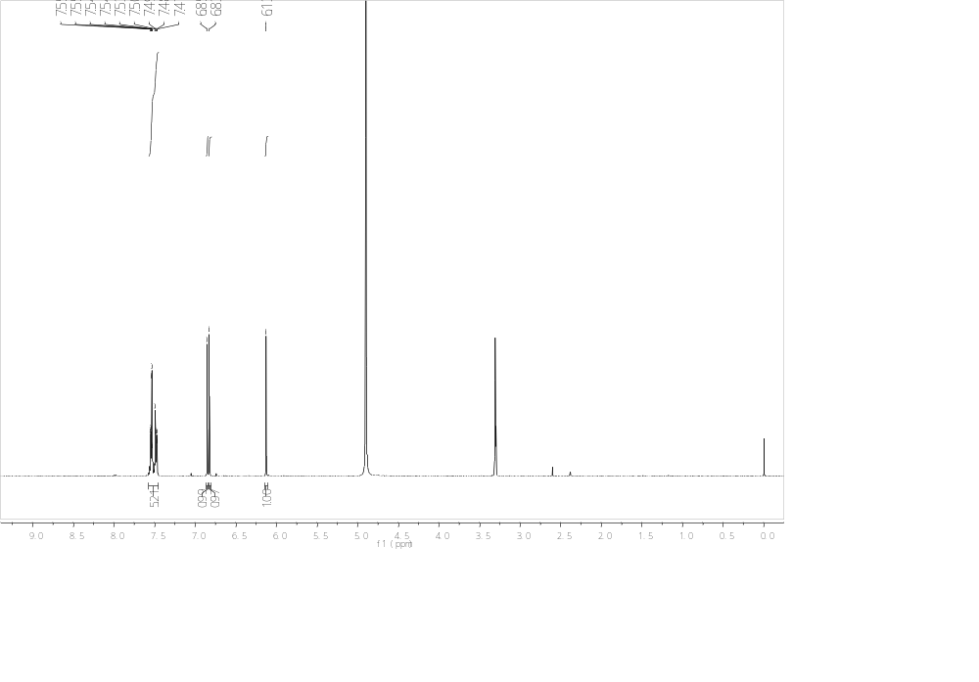
Figure S51.¹H NMR spectrum of 7b (Recorded in MeOD)

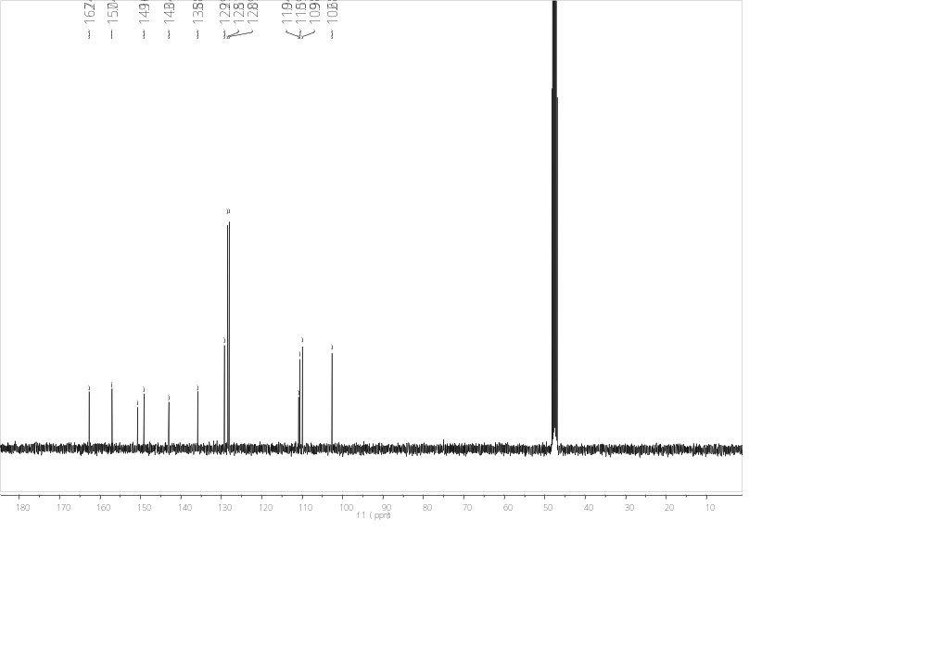
Figure S52. ¹³C NMR spectrum of 7b (Recorded in MeOD)

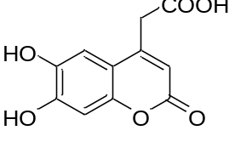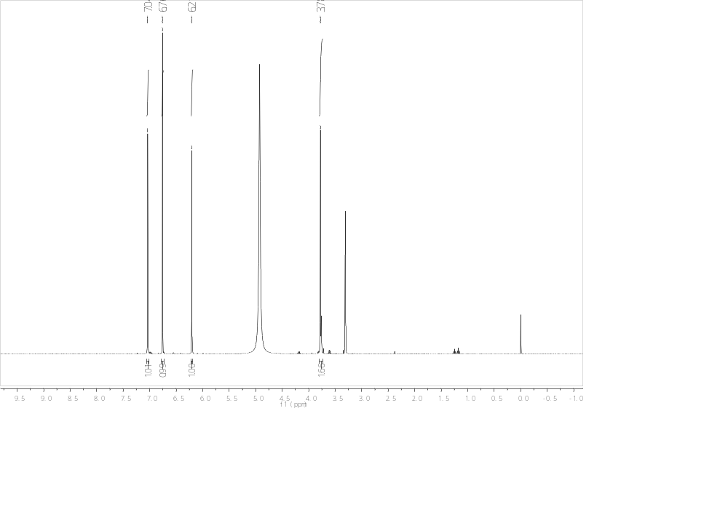
Figure S53.¹H NMR spectrum of 7c (Recorded in MeOD)

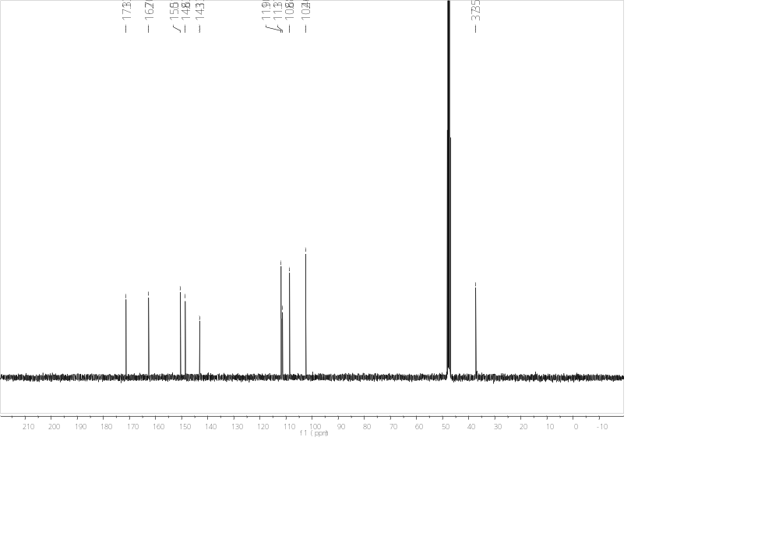
Figure S54. ¹³C NMR spectrum of 7c (Recorded in MeOD)
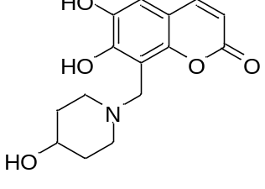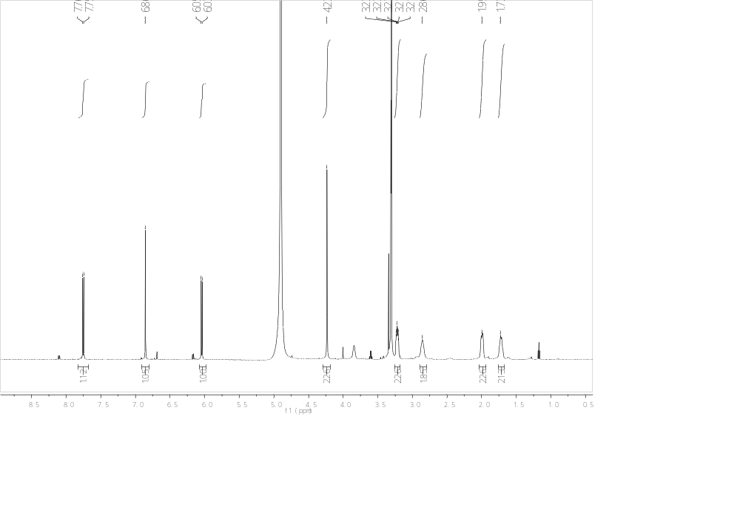
Figure S55.¹H NMR spectrum of 8a (Recorded in MeOD)

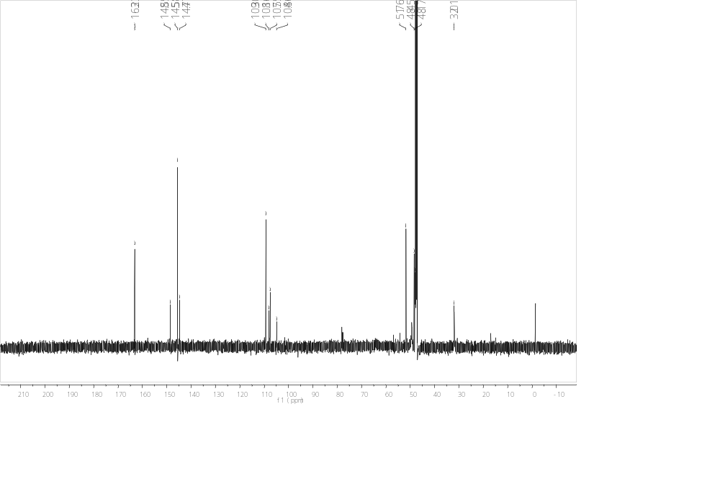
Figure S56. ¹³C NMR spectrum of 8a (Recorded in MeOD)

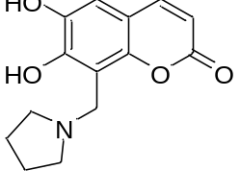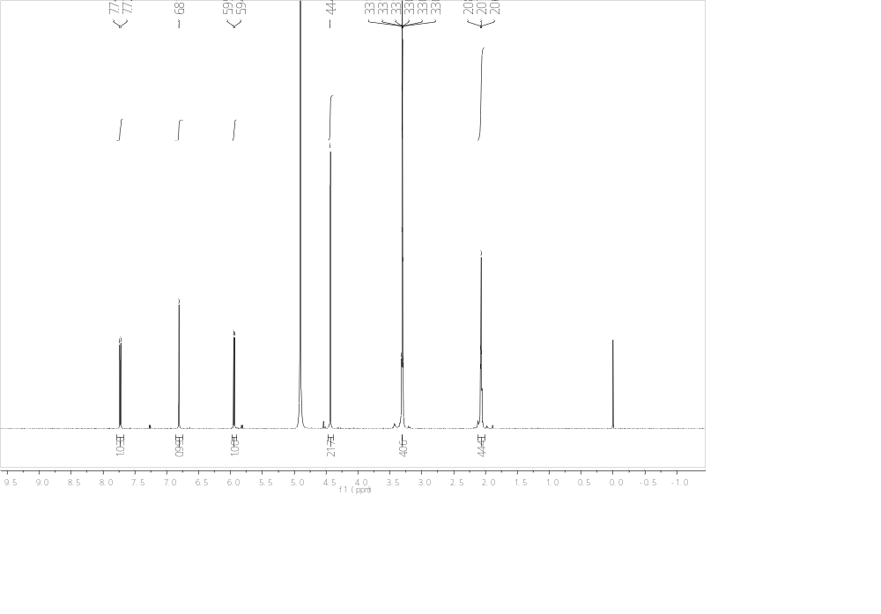
Figure S57.¹H NMR spectrum of 8b (Recorded in MeOD)

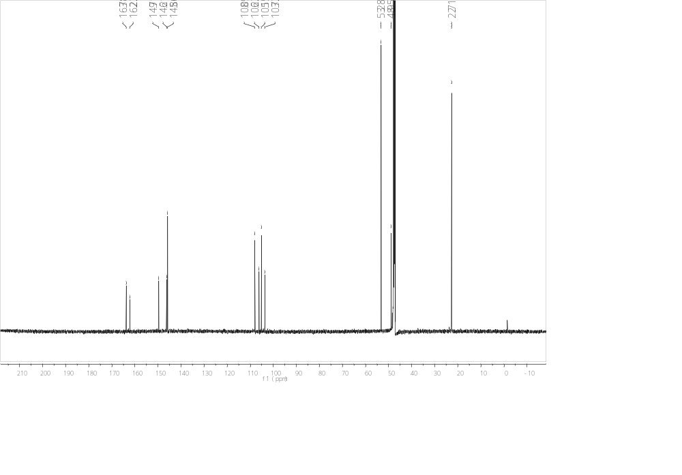
Figure S58. ¹³C NMR spectrum of 8b (Recorded in MeOD)

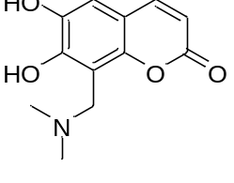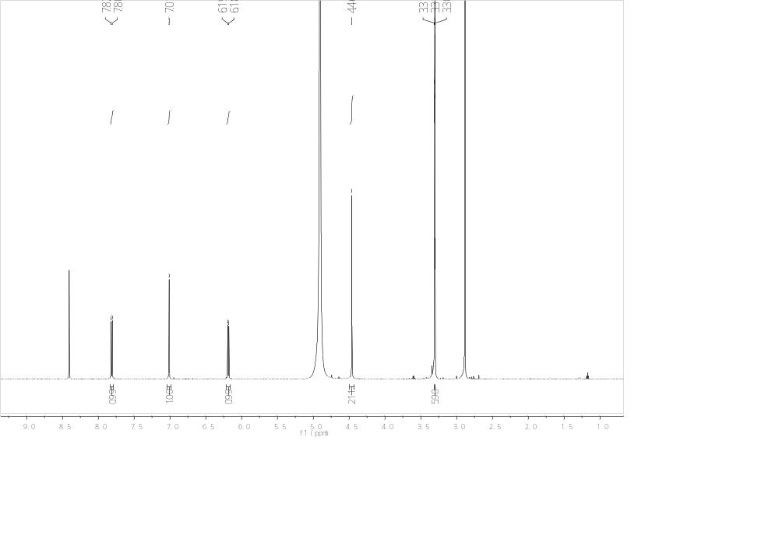
Figure S59.¹H NMR spectrum of 8c (Recorded in MeOD)

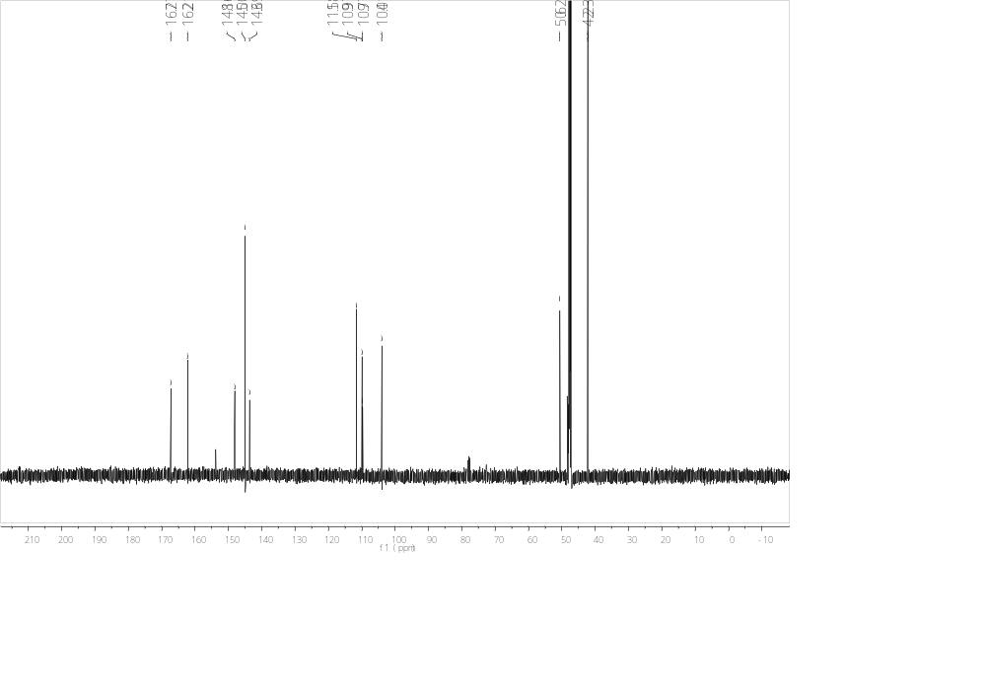
Figure S60. ¹³C NMR spectrum of 8c (Recorded in MeOD)

