Table 1. Fazekas grade and score criterion of WML.

 | Score | Imaging performance | Grade(A+B) |  | Representative images (T2 FLAIR)
 | Score | Imaging performance | score | grade | Representative images (T2 FLAIR)
( A )  PVWM | 0  1  2  3 | No lesion  Thin layer lesion like cap or pencil  Like smooth halo  Irregular paraventricular high signal extending to deep white matter | 1-2  3-4  5-6 | 1  2  3 | 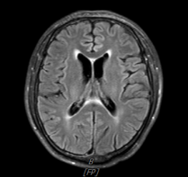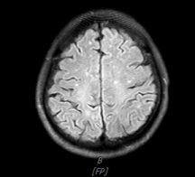  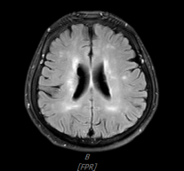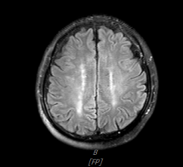  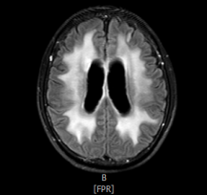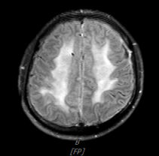
( B ) DWM | 0  1  2  3 | No lesion  Punctate lesion  The lesion begins to fuse  Large area fusion of lesions | 1-2  3-4  5-6 | 1  2  3

Abbreviations: PVWM: periventricular white matter hyperintensities; DWM: deep white matter signal.Images were obtained from patients included in our study.

