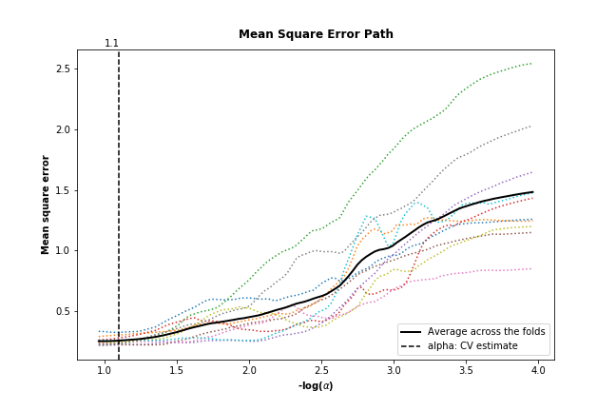
Appendix B:

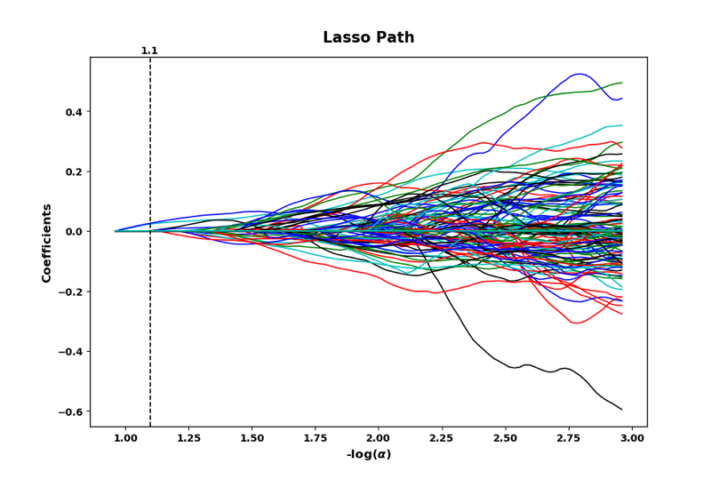
(a)mean square error path of –log(α) with 10-fold cross validation

(b) radiomics features LASSO coefficients versus –log(α)

Radiomics features selection via the least absolute shrinkage and selection operator (LASSO) binary logistic regression model. (a) The optimal value of α was selected using 10-fold cross validation via minimum average mean square error (MSE). MSE is plotted versus –log(α). The colored dotted lines stand for MSE along the full path of α values for each fold. The black solid line is the MSE across the folds. The black dashed vertical line represents the optimal α value, which is expressed via –log(α) with 1.1. (b)The above figure included all radiomics features LASSO coefficient profiles. The coefficient of features was plotted against the –log(α). The vertical dotted line was drawn at the selected value using 10-fold cross-validation, where the optical α value resulted in valuable non-zero coefficients.

