CRISPR/Cas9-assisted ssDNA recombineering for site-directed mutagenesis and saturation mutagenesis

Guoyi Zhang, Junyu Wang, Yiwen Li, Guangdong Shang*

Jiangsu Key Laboratory for Microbes and Functional Genomics, College of Life Sciences, Nanjing Normal University, Jiangsu Province, P. R. China.

*To whom correspondence should be addressed at: No.1 Wenyuan Rd., Xixia District, Nanjing 210023, Jiangsu Province, P. R. China. Phone: +86 25 85898332. Fax: +86 25 85891526. E-mail: shanggd@hotmail.com.
ORCiD: 0000-0001-6142-3785

Guoyi Zhang and Junyu Wang contributed equally to this work.

Vector construction
The left and right homologous arms (HAs) were amplified from upstream of downstream of the aacC1 locus of E. coli LS-GR (Song et al. 2010) via primers set C251–C252 and C253–C254, respectively. Then overlap-extension PCR (OE-PCR) with C251–C254 was performed to splice the two fragments. The amplicon was digested with SacI–KpnI and cloned into the same treated pGR (Song et al. 2010), yielding pLS4532. The cas9 gene with two NdeI sites eliminated was isolated as a NdeI–XhoI fragment from pLS3816 (Wu et al. 2019) and cloned into the same sites of pLS1652 (Chen et al. 2016), resulting in pLS4534. In pLS4534, the cas9 is under the tight control of L-rhamnose-inducible promoter. A chloramphenicol resistance gene cat was amplified from pBAD322C (Cronan 2006) with primers C255–C256, digested with SaII–PstI, and ligated with the BamHI–XhoI fragment conaining rhaRS-P_{rhaB}-cas9 isolated from pLS4534 and ligated into the BamHI-PstI sites of pBluescript II KS(–), getting pLS4535. The BamHI-PstI fragmet was subsequently excised out and cloned into the corresponding sites of pLS4532, obtaining R6K replicon-based rhaRS-P_{rhaB}-cas9-cat cassette knock-in plasmid pLS4536.
For cloning of cas9-mKKR, with pLS3535 (Li et al. 2019) as a template, four fragments (1.6 kb, 512 bp, 216 bp, and 234 bp) inside cas9 were amplified with primers C260A–C260B, C260C–C260D, C260E–C260F, and C260G–C260H, respectively. The primers C260A and C260H were designed upstrteam and downstream of the two HindIII sites of cas9. The four fragments were OE-PCR spliced firstly using 512 bp, 216 bp and 234 bp as templates and primers C260C–C26H, then the generated 871 bp was combined with the 1.6 kb, and spliced through OE-PCR with primers C260A–C260H and high-fidelity Taq polymerase. The 2.4 kb amplicon was cloned into pMD19-T Simple, rendering pLS4540. The cas9-mKKR fragment was isolated as a HindIII fragment and used to replace the large fragment of pLS4536 which treated with calf intestinal alkaline phosphatase forming pLS4542 with correct HindIII cloning direction.
The general E. coli expression vector pET system-based bla opal mutation
plasmid was as follows. With pLS3545 (Li et al. 2019) as a template, C274F–C274R and C275F–C275R PCR amplified a 227 bp fragment and a 771 bp fragment, respectively. The two fragements were combined as templates and OE-PCR using primers C274F–C275R. The amplicon was digesed with NdeI–HindIII and was used to replace the nanA gene of pLS2825 (Gao et al. 2019), resulting in pLS4544.
For plasmid compatibility, the sgRNA expression plamid was cloned into broad host range of pBBR1 replicon-based vector. With pLS3661 (Wu et al. 2020) as a template, the gentamicn resistance gene aacC1 and kanamycin resistance gene kan were amplified with primers C281–C282 and C283–C284, respectively. The BamHI–SacI digested aacC1 was ligated with the BamHI–SacI pBRR1 replicon fragment of pNG247.1 (Graf and J. Altenbuchner, 2013), obtaining pLS4545. The BamHI–PstI digested kan was ligated into pLS4545, getting pLS4546. Then BamHI–PstI fragment
of pLS4546 was subsequently replaced by the sgRNA scaffold fragment exicised from pLS3545 (Li et al. 2019), generating pLS4547. The bla spacer and scaffold fragment was amplified from pLS3545 (Li et al. 2019) with primers C285–C286, digested with SpeI–PstI and cloned into the same sites of pLS4547, yielding The bla sgRNA expression vector pLS4569.
The bla fragment was PCR amplified with primers C287–C288 and pLS3545 (Li et al. 2019) as a template, digested with PstI–SacI and replaced the PstI–SacI aacC1 fragment of pLS4547, giving pLS4576. The nanA E192 spacer sgRNA expression vector pLS4580 was constructed by amplifying the nanA E192 spacer and scaffold fragment from pLS3545 (Li et al. 2019) with primers C289–C286, followed by digesting the fragment with SpeI–PstI and cloned into the same enzyme sites of pLS4576. The nanA S208 spacer sgRNA expression vector pLS4582 was constructed by amplifying the nanA S208 spacer and scaffold fragment from pLS3545 (Li et al. 2019) with primers C291–C286, followed by digesting the fragment with SpeI–PstI and cloned into the same enzyme sites of pLS4576.

Supplementary Table 1 Strains and plasmids used in this study
Strain or plasmid | Characteristics | Source
Strains
Escherichia coli
DH10B | F–mcrA (mrr-hsdRMS-mcrBC) φ80dlacZ M15 lacX74 deoR recA1 araD139(ara-leu)7697 galU galK rpsL endA1 nupG | Life Technologies (Carlsbad, CA, USA)
LS-GR | DH10B ΔendA::araC-P_{araB}-  αβγ-recA, aacC1 | (Song et al. 2010)
LS4515 | LS-GR ΔaacC1::rhaRS-P_{rhaB}-  cas9, cat | This study
LS4516 | LS-GR ΔaacC1::rhaRS-P_{rhaB}  -cas9-mKKR, cat | This study
LS4517 | LS4516 ΔnanA::neo | This study
LS4518 | LS4516 ΔnanA | This study
plasmids
pBluescript II KS(–) | cloning vector, pUC, Ap | Invitrogen, USA
pMD19-T Simple | TA cloning vector, pUC, Ap | Takara, Dalian, China
pBAD322C | araC-P_{araB}, cat, pMB1 | (Cronan 2006)
pNG247.1 | MekR/P_{mekA}, lacZ, pBBR1, Am^{R} | (Graf and J. Altenbuchner, 2013)
pGR | endA HA, araC-P_{araB}-redαβγ-  recA, aacC1, R6K, Ap^{R} | (Song et al. 2010)
pLS1652 | rhaRS-P_{rhaB}-I-SceI, pUC, Ap^{R} | (Chen et al. 2016)
pLS2825 | nanA, pET, Km^{R} | (Gao et al. 2019)
pLS3535 | araC-P_{araB}-cas9-recA-P_{lac}-red, p15A, Cm^{R} | (Li et al. 2019)
pLS3545 | dnaG sgRNA expression plasmid, pUC, Ap^{R} | (Li et al. 2019)
pLS3661 | P_{tac}, lacI_{Q}, I-SceI, S, aacC1, R6K, Km^{R} | (Wu et al. 2020)
pLS3816 | cas9, pUC, Ap^{R} | (Wu et al. 2019)
pLS4532 | HA of aacC1, R6K, Ap^{R} | This study
pLS4534 | rhaRS-P_{rhaB}-cas9, pUC, Ap^{R} | This study
pLS4535 | rhaRS-P_{rhaB}-cas9-cat, pUC, Ap^{R} | This study
pLS4536 | HA of aacC1, rhaRS-P_{rhaB}-cas9-  cat, R6K, Ap^{R} | This study
pLS4540 | cas9-mKKR, pUC, Ap^{R} | This study
pLS4542 | HA of aacC1, rhaRS-P_{rhaB}-cas9-  mKKR-cat, R6K, Ap^{R} | This study
pLS4544 | bla opal mutation, pET, Km^{R} | This study
pLS4545 | aacC1, pBBR1 | This study
pLS4546 | kan, aacC1, pBBR1 | This study
pLS4547 | sgRNA cassette, pBBR1, Gm^{R} | This study
pLS4569 | bla sgRNA expression, pBBR1, Gm^{R} | This study
pLS4576 | sgRNA cassette, pBBR1, Ap^{R} | This study
pLS4580 | nanA E192 sgRNA expression, pBBR1, Ap^{R} | This study
pLS4582 | nanA S208 sgRNA expression, pBBR1, Ap^{R} | This study

Supplementary Table 2 Primers and mutagenic oligos used in the study
Name | Sequence (5'3') | Purpose
C251 | GGAGAGCTCGGTGAATATGCAGCGGAGATTC | Construction of pLS4532
C252 | GATGTAGCCGTCAAGTTGTCATAACTGCAGTCTCGGATCCATCATAACCCGTATGTGCAAC | Construction of pLS4532
C253 | GTTGCACATACGGGTTATGATGGATCCGAGACTGCAGTTATGACAACTTGACGGCTACATC | Construction of pLS4532
C254 | GGAGGTACCCTCGAGGTCGCTCCATCCACCGATGG | Construction of pLS4532
C255 | GGAGTCGACGCGTTTAAGGGCACCAATAAC | Construction of pLS4535
C256 | GGACTGCAGTCTTGAAATAAGATCACTACCGGG | Construction of pLS4535
C260A | GAAGAACATCATCAAGACTTGACTC
C260B | CCTTATTGTCTATTGAATCGTCTGCAAGGAAACTTTGTGGAACAATG | Construction of pLS4540 containing cas9-mKKR
C260C | CATTGTTCCACAAAGTTTCCTTGCAGACGATTCAATAGACAATAAGG | Construction of pLS4540 containing cas9-mKKR
C260D | CATAGACAAACTCCGATTCAAGTGCTGGATATTTCTTAATCAAAGC | Construction of pLS4540 containing cas9-mKKR
C260E | GCTTTGATTAAGAAATATCCAGCACTTGAATCGGAGTTTGTCTATG | Construction of pLS4540 containing cas9-mKKR
C260F | CCCATTAGTTTCGATTAGAGGGGCTTTGCGAATCTCTCCATTTGC | Construction of pLS4540 containing cas9-mKKR
C260G | GCAAATGGAGAGATTCGCAAAGCCCCTCTAATCGAAACTAATGGG | Construction of pLS4540 containing cas9-mKKR
C260H | GAAGTCCCAGTCTTTTTTACGAGC | Construction of pLS4540 containing cas9-mKKR
KI1 | ATGAAATTCGCCTCAATCCCG | E. coli  LS4515 and E. coli  LS4516 genotyping
C262 | GTCAGCAATTTCGCCAGCAGAC | E. coli  LS4515 and E. coli  LS4516 genotyping
C263 | AGACATGTATGTGGACCAAG | E. coli  LS4515 and E. coli  LS4516 genotyping
C264 | TTGGAGAATCCGCCTGTCTG | E. coli  LS4515 and E. coli  LS4516 genotyping
C265F | ATGAGTACTGCACTCGCAACG | E. coli  LS4515 and E. coli  LS4516 genotyping
C265R | TCATGCTGCCACCTTCTGCTC | E. coli  LS4515 and E. coli  LS4516 genotyping
C266 | CTCCATTTTAGCTTCCTTAGC | E. coli  LS4515 and E. coli  LS4516 genotyping
C267 | GAAGGGCGCTATTCGGAGCTG | E. coli  LS4515 and E. coli  LS4516 genotyping
C274F | GGACATATGAATACATTCAAATATGTATCC | Construction of pLS4535
C274R | CCAGTTCGATGTAACCCACTCATGCACCCAACTGATCTTCAGC | Construction of pLS4535
C275F | GCTGAAGATCAGTTGGGTGCATGAGTGGGTTACATCGAACTGG | Construction of pLS4535
C275R | GGAAAGCTTTTACCAATGCTTAATCAGTGAG | Construction of pLS4535
C277 | TTCAACATTTCCGTGTCGCC | bla opal mutation and bla repair plasmid sequencing
C281 | GGAGGATCCGGAACTGCAGTCGAATTGACATAAGCCTGTTC | Construction of pLS4545
C282 | GGAGAGCTCTTAGGTGGCGGTACTTGGGTC | Construction of pLS4545
C283 | GGAGGATCCTCAAAGCCACGTTGTGTCTC | Construction of pLS4546
C284 | GGACTGCAGCTTAGAAAAACTCATCGAGC | Construction of pLS4546
C285 | GGAACTAGTGCGCCAGCCCATGATGTTGTGTTTTAGAGCTAGAAATAGC | Construction of pLS4569
C286 | GGGCTAGTCTGCAGATAAAACG | Construction of pLS4569
C200 | CCTGAGCAAACTGGCCTCAG | sgRNA expression plasmid sequencing
C287 | GGACTGCAGAATACATTCAAATATGTATCC | Construction of pLS4576
C288 | GGAGAGCTCTTACCAATGCTTAATCAGTGAG | Construction of pLS4576
C291 | GGAAGACTAGTTACGACGAAATCTTCGCCTCGTTTTAGAGCTAGAAATAGC | Construction of pLS4580
C292 | GGAACTAGTAGATCAGTTGGGTGCATGAGGTTTTAGAGCTAGAAATAGC | Construction of LS4582
RC403 | TTGTGCACGGTTGAGATGGCG | ΔnanA targeting DNA PCR
RC404 | CAACAGCGTCTCTGCTACCTG | ΔnanA targeting DNA PCR
RC405 | CAGGGCGATTAAAACGAAATC | ΔnanA genotyping
RC406 | GCATATTGCGATCGTTGATGCG | ΔnanA genotyping
RC407 | A*G*A*A*ACGCTGGTGAAAGTAAAAGATGCTGAAGATCAGTTGGGAGCTCGAGTAGGATACATCGAACTGGATCTCAACAGCGGTAAGATCCTTGAGAGT | bla repair lagging  oligo
RC408 | A*C*T*C*TCAAGGATCTTACCGCTGTTGAGATCCAGTTCGATGTATCCTACTCGAGCTCCCAACTGATCTTCAGCATCTTTTACTTTCACCAGCGTTTCT | bla repair leading oligo
RC415 | C*A*G*A*TCCGTCGTGAACATCCTGATCTTGTGCTCTATAACGGATATGATAACATTTTTGCAAGTGGTCTGCTGGCGGGCGCTGATGGTGGTATCGGCAGTACCTA | NanA E192N CRM
RC416 | A*A*T*C*TTCGCCTCTGGTCTGCTGGCGGGCGCTGATGGTGGTATTGGTGGTACATATAACATCATGGGCTGGCGCTATCAGGGGATCGTTAAGGCGCTG | NanA S208G CRM
RC417 | C*A*G*A*TCCGTCGTGAACATCCTGATCTTGTGCTCTATAACGGATATGATNNKATTTTTGCAAGTGGTCTGCTGGCGGGCGCTGATGGTGGTATCGGCAGTACCTA | NanA E192 CRSM
RC418 | A*A*T*C*TTCGCCTCTGGTCTGCTGGCGGGCGCTGATGGTGGTATTGGTNNKACATATAACATCATGGGCTGGCGCTATCAGGGGATCGTTAAGGCGCTG | NanA S208 CRSM
R1176 | TACAACATTCCAGCCCTGAG | NanA variant sequencing
The restriction enzyme recognition sequences in primers are underlined; the nucleotides used for mKKR mutagenesis are underlined in bold. In the mutagenic oligo, phosphorothioated linkages are indicated as *; the introduced mutagenic nucleotides are in red; the 20-nt spacer sequences are in blue; the triplets for target Aa mutation are underlined. For E192N CRM mutagenic oligo RC415, a total of 10 nucleotide changes was introduced including nine seed sequences (1, 2, 3, 6, 9, 12, 14, 15 and 18); the PAM sequence remained. For S208G CRM mutagenic oligo RC415, a total of five nucleotide changes was introduced including one nt seed sequence (at the second position) and PAM mutation (AGGATG). For E192 CRSM mutagenic oligo RC417, a total of 11 nucleotide changes was introduced containing NNK; For S208 CRSM mutagenic oligo RC418, a total of seven nucleotide changes was introduced containing NNK

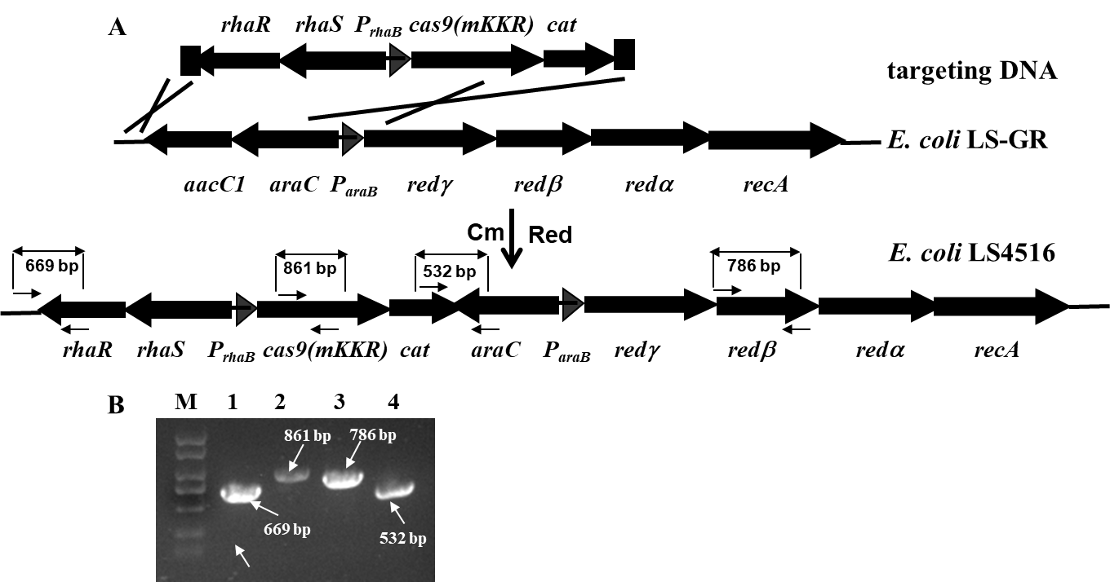

Supplementary Figure 1. E. coli LS4516 generation and genotype analysis. A. Scheme shown the recombineering-mediated rhaRS-P_{rhaB}-cas9-cat cassette knock-in. The 7.8 kb homologous arm (HA)-flanked cassette was isolated as a SacI-XhoI fragment from pLS4542 and electroporated into recombinase-proficient electrocompetent cells of E. coli LS-GR, recombinase-catalyzed homologous recombination resulted in the knock-in strain E. coli LS4516 under Cm selection. B. PCR analysis of the cassette knock-in strain E. coli LS4516. Lanes 1: KI1–C262 amplified the 669 bp upstream junction region; lane 2: C263–C264 amplified the 861 bp cas9-mKKR containing region; lane 3: C265F–C265R amplified the 786 bp redβ region; lane 4: C266–C267 amplified the 532 bp downstream junction region. M, DL2000 DNA molecular marker with sizes (in kb): 2.0, 1.5, 1.0, 0.75, 0.5, 0.25, 0.1.

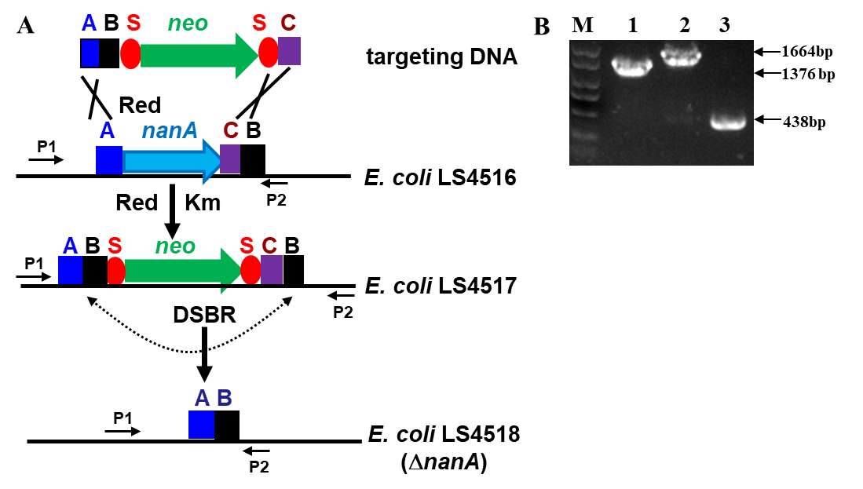

Supplementary Figure 2. Deletion of chromosomal nanA gene and genotype analysis of the deletion mutant. A. Scheme shown the coupling of recombineering and I-SceI for nanA deletion. Targeting DNA cassette consisting of 50 bp upstream and 50bp downstream HAs (A and C), 50 bp sequence behind C (B), kanamycin resistance gene (neo), and two I-SceI recognition sites (S) was amplified from pKD4 (Datsenko and Wanne, 2000) with primers RC403–RC404 using E. coli LS2801 genomic DNA as template. The targeting DNA was subsequently electroporated into recombinase-proficient electrocompetent cells of E. coli LS4516 induced with 0.2% (w/v) L-arabinose. The cassette was integrated into the chromosome of E. coli LS4516 while delelting nanA via recombinase-catalyzed homologous recombnation between the HAs in the cassette and their allele in the chromosome. After genotype confirmation, temperature sentitive plasmid pST98AS (Posfai et al. 1999) was transformed into the generated E. coli LS4517, and the resultant strain was cultured, added with 25 μg/ml (w/v) heat-treated chloramphenicol to induce the expression of meganuclease I-SceI. The cells were subsequently plated on LB agar plate with Cm, and the resulted clones were duplicated on LB agar plate with and without kanamycin. Km^{S} clones were genotyped with PCR using primers RC405–RC406 for deletion genotype confirmation. Finally, pST98AS was cured by growing the culture, plating the cells on LA LB agar plate with Cm, and growth overnight at 42 ℃. One Ap^{S} clone was characterized by PCR amplification of the ΔnanA genotype and named as E. coli LS4518. B. PCR analysis for strain confirmation. Lanes 1, 2, 3, indicate the amplicons with RC405–RC406 primers and E. coli DH10B, E. coli LS4517 and E. coli LS4518 genomic DNA as templates, respectively. The arrows point to the expected amplicons with sizes shown. M, DL2000 DNA molecular marker.

References
Chen Z, Ling W, Shang G (2016) Recombineering and I-SceI-mediated Pseudomonas
putida KT2440 scarless gene deletion. FEMS Microbiol Lett 363:fnw231
Cronan JE (2006) A family of arabinose-inducible Escherichia coli expression vectors
having pBR322 copy control. Plasmid 55:152–157
Datsenko KA, Wanner BL (2000) One-step inactivation of chromosomal genes in
Escherichia coli K-12 using PCR products. Proc Natl Acad Sci U S A 97:6640–6645
Gao X, Zhang F, Wu M, Wu Z, Shang G (2019) Production of N-Acetyl-D-
neuraminic acid by whole cells expressing Bacteroides thetaiotaomicron N-acetyl-D-glucosamine 2-epimerase and Escherichia coli N-acetyl-D-neuraminic acid aldolase. J Agric Food Chem 67:6285–6291
Graf N, Altenbuchner J (2013) Functional characterization and application of a tightly
regulated MekR/PmekA expression system in Escherichia coli and Pseudomonas
putida. Appl Microbiol Biotechnol 97:8239–8251
Li J, Sun J, Gao X, Wu Z, Shang G (2019) Coupling ssDNA recombineering with
CRISPR-Cas9 for Escherichia coli DnaG mutations. Appl Microbiol Biotechnol 103:3559–3570
Posfai G, Kolisnychenko V, Bereczki Z, Blattner FR (1999) Markerless gene
replacement in Escherichia coli stimulated by a double-strand break in the chromosome. Nucleic Acids Res 27:4409–4415
Song J, Dong H, Ma C, Zhao B, Shang G (2010) Construction and functional
characterization of an integrative form λ Red recombineering Escherichia coli strain. FEMS Microbiol Lett 309:178–183
Wu M, Xu Y, Yang J, Shang G (2020) Homing endonuclease I-SceI-mediated
Corynebacterium glutamicum ATCC 13032 genome engineering. Appl
Microbiol Biotechnol 104:3597–3609
Wu Z, Chen Z, Gao X, Li J, Shang G (2019) Combination of ssDNA recombineering
and CRISPR-Cas9 for Pseudomonas putida KT2440 genome editing. Appl Microbiol Biotechnol 103:2783–2795

