Supplementary Information

Dissolved-Cl₂ Triggered Redox Reaction Enables High-performance Perovskite Solar Cells

Yujie Luo^{1,2}, Kaikai Liu^{1,2}, Liu Yang¹, Wenjing Feng,¹ Lingfang Zheng,¹ Lina Shen,¹ Yongbin Jin,¹ Zheng Fang,¹ Peiquan Song,¹ Wanjia Tian,¹ Peng Xu,¹ Yuqing Li,¹ Chengbo Tian¹, Liqaing Xie^{1,*} & Zhanhua Wei^{1,*}

¹ Xiamen Key Laboratory of Optoelectronic Materials and Advanced Manufacturing, Institute of Luminescent Materials and Information Displays, College of Materials Science and Engineering, Huaqiao University, Xiamen 361021, P.R. China

² These authors contributed equally to this work.
E-mails: lqxie@hqu.edu.cn; weizhanhua@hqu.edu.cn

Supplementary Fig. 1 | Test of CO₂ in Cl₂-CF using saturated barium hydroxide aqueous solution. When Ba(OH)₂ was added into Cl₂-CF and CF, a white precipitate of barium carbonate (BaCO₃) was generated in Cl₂-CF. In contrast, no obvious change was observed in CF.

Supplementary Fig. 2 | Test of Cl⁻ in Cl₂-CF using silver nitrate aqueous solution. When silver nitrate was added to Cl₂-CF, it became turbid immediately.

Supplementary Fig. 3 | Moistened starch potassium iodide test paper was placed above the Cl₂-CF solvent and turned blue, proving the existence of Cl₂ in Cl₂-CF.

Supplementary Fig. 4 | Photographs of perovskite precursor compounds dissolved in CF and Cl₂-CF.
Supplementary Fig.5 | UV-vis absorption spectra of (a) PbI₂ and (b) MAI dissolved in CF and Cl₂-CF.

Supplementary Fig. 6 | UV-vis spectra of (a) MABr and (b) HABr dissolved in CF and Cl₂-CF.

Supplementary Fig. 7 | UV-vis spectra of MACl dissolved in CF and Cl₂-CF.
Supplementary Fig. 8 | SEM images for (a) PVSK, (b) PVSK-CF, and (c) PVSK-Cl₂-CF. 2D AFM images of (d) PVSK, (e) PVSK-CF, and (f) PVSK-Cl₂-CF. The scan area of the AFM images is 5 × 5 μm². 3D AFM images of (g) PVSK, (h) PVSK-CF, and (i) PVSK-Cl₂-CF. The scan area of the 3D images is 5 × 5 μm².
Supplementary Fig. 9 | XRD patterns of PVSK, PVSK-CF, and PVSK-Cl₂-CF. (a) 12° to 15°, (b) 12.2° to 13.0°, (c) 5° to 40°.

Supplementary Fig. 10 | SEM images of the bottom surface of (a) PVSK, (b) PVSK-CF, and (c) PVSK-Cl₂-CF.

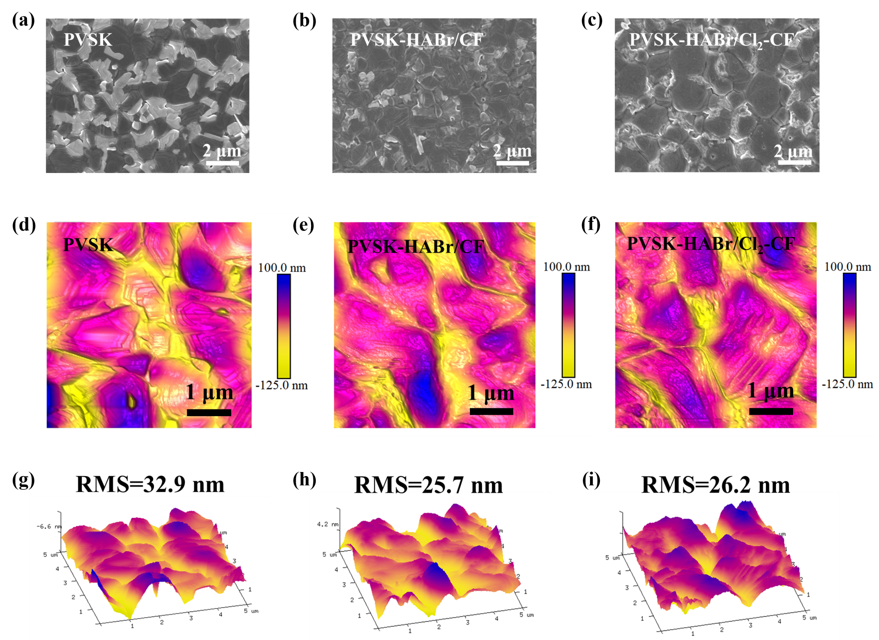
Supplementary Fig. 11 | SEM images for (a) PVSK, (b) PVSK-HABr/CF, and (c) PVSK-HABr/Cl₂-CF. 2D AFM images of (d) PVSK, (e) PVSK-HABr/CF, and (f) PVSK-HABr/Cl₂-CF (scan area: 5 × 5 μm²). 3D AFM images of (g) PVSK, (h) PVSK-HABr/CF, and (i) PVSK-HABr/Cl₂-CF (scan area: 5 × 5 μm²).

Supplementary Fig. 12 | XRD patterns of PVSK, PVSK-HABr/CF, and PVSK-HABr/Cl₂-CF and HA₂FAPb₂Br₂I₅.

Supplementary Fig. 13 | Azimuthally integrated scattering of grazing-incidence wide-angle X-ray scattering (GIWAXS) characterization.

Supplementary Fig. 14 | XPS for (a) Cl 2p and (b) Pb 4f spectra of PVSK, PVSK-HABr/CF, and PVSK-HABr/Cl₂-CF.

Supplementary Fig. 15 | Tuac plot of (a) PVSK, (b) PVSK-HABr/CF, and (c) PVSK-HABr/Cl₂-CF.

Supplementary Fig. 16 | Schematic illustration of the perovskite films for (a) PVSK, (b) PVSK-HABr/CF, and (c) PVSK-HABr/Cl₂-CF.

Supplementary Fig. 17 | Cross-sectional SEM images of the (a) PVSK, (b) PVSK-HABr/CF, and (c) PVSK-HABr/Cl₂-CF based devices.

Supplementary Fig. 18 | Statistics of (a) FF, and (b) J_{SC} of the devices based on PVSK, PVSK-HABr/CF, and PVSK-HABr/Cl₂-CF.

Supplementary Fig. 19 | IPCE spectra and the integrated J_{SC} of the PVSK, PVSK-HABr/CF, and PVSK-HABr/Cl₂-CF based perovskite device. (a) 300 to 900 nm, (b) 770 to 830 nm.

Supplementary Fig. 20 | J-V curves and hysteresis of the (a) PVSK, (b) PVSK-HABr/CF, and (c) PVSK-HABr/Cl₂-CF based devices.

Supplementary Fig. 21 | Steady-state power output at the maximum power point of PVSK, PVSK-HABr/CF, and PVSK-HABr/Cl₂-CF based devices.

Supplementary Table S1 | Fitted parameters of TRPL results of PVSK, PVSK-HABr/CF, and PVSK-HABr/ Cl₂-CF perovskite film.
 | 𝜏₁ (ns) | 𝜏₂ (ns) | A₁ | A₂ | 𝜏_{avg} (ns)
PVSK | 188.8 | 901.3 | 498.7 | 1009.7 | 834.6
PVSK-HABr/CF | 389.6 | 1176.8 | 377.9 | 880.0 | 1078.9
PVSK-HABr/Cl₂-CF | 342.8 | 1712.4 | 238.2 | 913.8 | 1644.5

