Extended Data and Figures for

Mutual regulation mechanism of the O-GlcNAcylation enzyme pair
revealed by Cryo-EM structure of human OGT–OGA complex

Ping Lu^{1,2,3,#}, Yusong Liu^{2,3,4,#} , Maozhou He^{2,3}, Ting Cao^{2,3}, Mengquan Yang^{1,2,3}, Shutao Qi^{2,3}, Hongtao Yu^{2,3,*}, Haishan Gao^{2,3,*}

¹College of Life Sciences, Zhejiang University, Hangzhou, Zhejiang, China
²School of Life Sciences, Westlake University, Hangzhou, Zhejiang, China
³Westlake Laboratory of Life Sciences and Biomedicine, Hangzhou, Zhejiang, China
⁴School of Life Sciences, Fudan University, Shanghai, China

#These authors contributed equally to this work
*Correspondence: yuhongtao@westlake.edu.cn or gaohaishan@westlake.edu.cn

This PDF file includes:
Extended Data Fig. 1 to 10
Extended Data Table 1
Supplementary Videos 1 to 2
Extended Data Fig. 1 | Purification and characterization of human OGT. a, Gel filtration profiles of human OGT protein expressed and purified from insect cells (magenta curve) and E. coli (blue curve). b, O-GlcNAcylation assay of recombinant OGT wild type (WT) or its catalytically inactive H508A mutant using TAB1 as the substrate in the presence or absence of UDP-GlcNAc. CBB, Coomassie brilliant blue.

Extended Data Fig. 2 | Cryo-EM analysis of human OGT homodimer. a, Representative Cryo-EM micrograph of human OGT. b, Representative 2D class averages of human OGT. c, Cryo-EM image processing flowchart for human OGT homodimer, with the final EM map colored by local resolution. d, Gold-standard FSC curve of the final EM map of the OGT homodimer.

Extended Data Fig. 3 | Representative cryo-EM density maps of key structural elements of human OGT. a, Local density maps of TPRs and the dimerization interface for human OGT. b, Local density maps of selected structural elements of human OGT GTD.

Extended Data Fig. 4 | Characterization of human OGT and its 4A mutant. a, Gel filtration profiles of human full-length OGT wild type (WT; blue curve) and 4A mutant (brown curve). b, Representative 2D class averages of OGT WT (left panel) and 4A mutant (right panel).

Extended Data Fig. 5 | Cryo-EM analysis of human OGT–OGA complex. a, Gel filtration profile of human OGT–OGA complex expressed and purified from E. coli. Coomassie-stained gel of protein-containing fractions is shown below. The asterisk indicates a contaminating protein. b, Representative cryo-EM micrograph of the OGT–OGA complex. c, Representative 2D class averages of the OGT–OGA complex. d, Cryo-EM data processing flowchart of human OGT–OGA complex. The three major classes (Conformer I, II, and III) of human OGT–OGA complex are shown. Densities of OGT and OGA are colored in gray and red, respectively.

Extended Data Fig. 6 | Representative cryo-EM density maps of key structural elements of the OGT–OGA complex. a, Local density maps of TPRs and the dimer interface of the OGT–OGA complex. b, Local density maps of OGT GTD and the GHD and IDR of OGA. c,

Extended Data Fig. 7 | Interactions between OGT TPRs and the flexible region of OGA. a, Close-up view of OGT TPR7 (colored in purple) interacting with residues 423–427 of OGA (colored in yellow). b, Close-up view of OGT TPR8 and TPR9 (colored in purple) interacting with residues 420–424 of OGA (colored in yellow). c, Close-up view of OGT TPR10 and TPR11 (colored in purple) interacting with residues 415–419 of OGA (colored in yellow). d, Close-up view of OGT TPR12, TPR13 and TPR13.5 (colored in purple) interacting with residues 410–414 of OGA (colored in yellow).

Extended Data Fig. 8 | The asparagine ladder of human OGT TPR contributes to cellular O-GlcNAcylation. a, Binding between full-length OGT and the indicated GST-OGA fragments. The input and proteins bound to beads were analyzed by SDS-PAGE followed by Coomassie blue staining. Asterisk indicates a contaminating protein. b, Binding between GST-OGA (residues 370–440) and the indicated OGT proteins. The input and proteins bound to beads were analyzed by SDS-PAGE followed by Coomassie blue staining. WT, wild type. c, 293 cells with the endogenous OGT loci tagged with HaloTag were treated with or without HaloPROTAC and transfected with the indicated Myc-OGT plasmids. Total cell lysates were blotted with the indicated antibodies. d, Quantification of the relative cellular O-GlcNAc levels in c. Mean ± SEM (n = 3 independent experiments, p<0.01).

Extended Data Fig. 9 | In vitro O-GlcNAcylation assay by OGT. Recombinant OGT and its indicated mutant proteins were incubated with TAB1 in the absence or presence of UDP-GlcNAc. The reaction mixtures were analyzed by SDS-PAGE followed by blotting with the anti-O-GlcNAc antibody or Coomassie brilliant blue (CBB) staining. WT, wild type; WB, Western blot.

Extended Data Fig. 10 | Preliminary cryo-EM analysis of human OGA. a, Representative 2D class averages of human full-length OGA. b, The homodimer of the catalytic domain of human OGA (PDB: 5M7R) fitted into the low-resolution EM map.

Extended Data Table 1 | Cryo-EM data collection, refinement, and validation statistics

 | OGT | The OGT–OGA complex
 |  | II | I | III
Data Collection and Processing
Microscope | FEI Titan Krios
Magnification | 105,000
Voltage | 300
Electron dose (e⁻/Å²) | 50
Detector | Gatan K3 Summit
Defocus range (um) | -1.8 to -2.3
Pixel size (Å/pixel) | 0.861
Micrographs (no.) | 5,539 | 5,744
Initial particles (no.) | 6,266,880 | 5,316,274
Final particles (no.) | 145,243 | 114,543 | 85,916 | 54,789
Symmetry imposed | C1 | C1
Map resolution (Å) | 3.69 | 3.92 | 5.68 | 5.86
FSC threshold | 0.143 | 0.143 | 0.143 | 0.143
Model composition
Protein residues | 2034 | 2419 | / | /
Ligands | 0 | 2
Refinement
Initial model used (PDB code) | 1W3B and 3PE3 | 1W3B, 3PE3 and 5UN9
Model resolution (Å) | 3.7 | 3.9
FSC threshold | 0.143 | 0.143
Map sharpening B factor (Å²) | -137 | -146
Validation
MolProbility score | 2.21 | 2.96
EMRinger score | 1.27 | 0.84
Clash score | 18.12 | 28.43
Rotamer outliers (%) | 0.00 | 5.09
Cβ outliers (%) | 0.00 | 0.00
R.m.s deviations
Bonds length (Å) | 0.006 | 0.006
Bonds Angle (°) | 0.840 | 0.992
Ramachandran plot (%)
Favored | 92.96 | 92.24
Allowed | 7.04 | 7.76
Outliers | 0.00 | 0.00
Deposition
PDB ID
EMDB ID

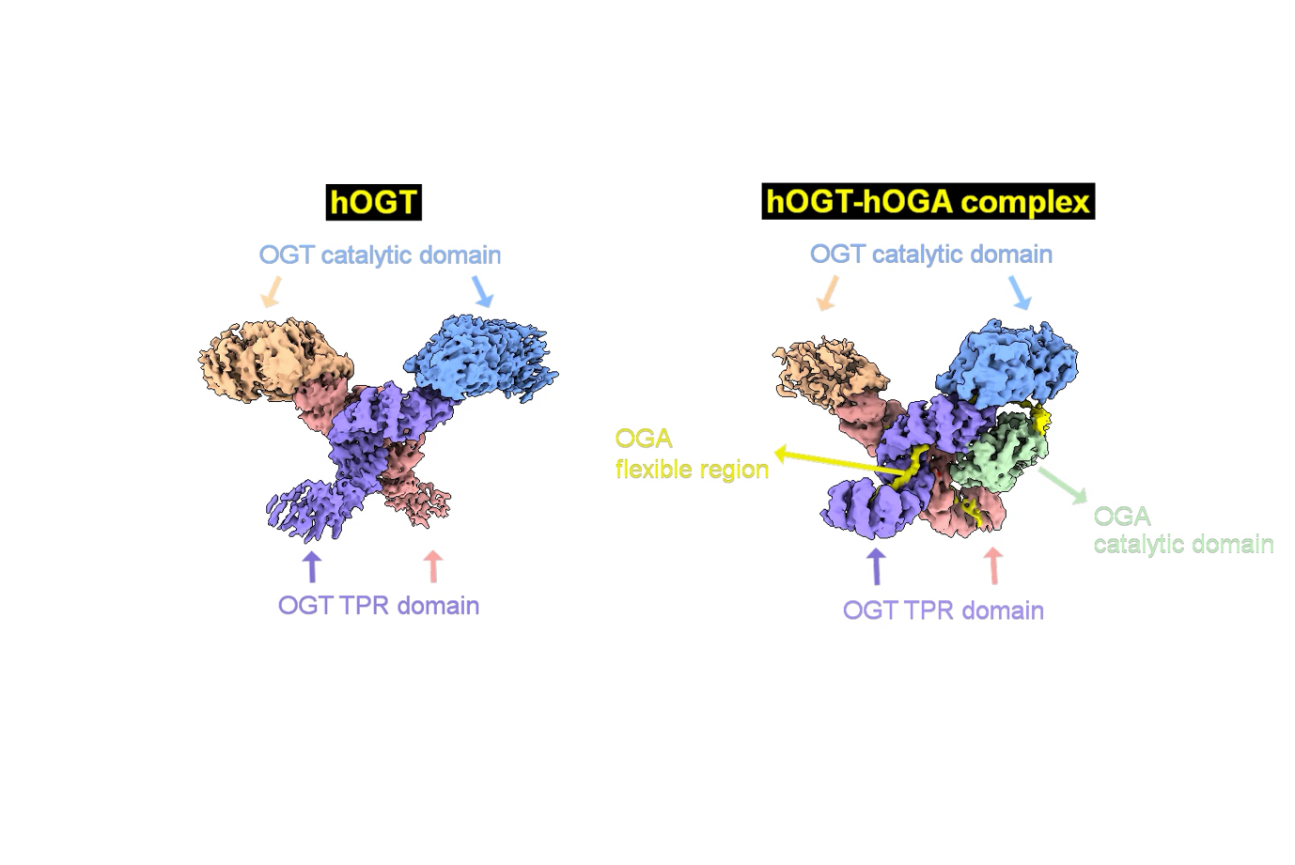
Supplementary Video 1 Cryo-EM maps and structures of human OGT homodimer and OGT-OGA complex

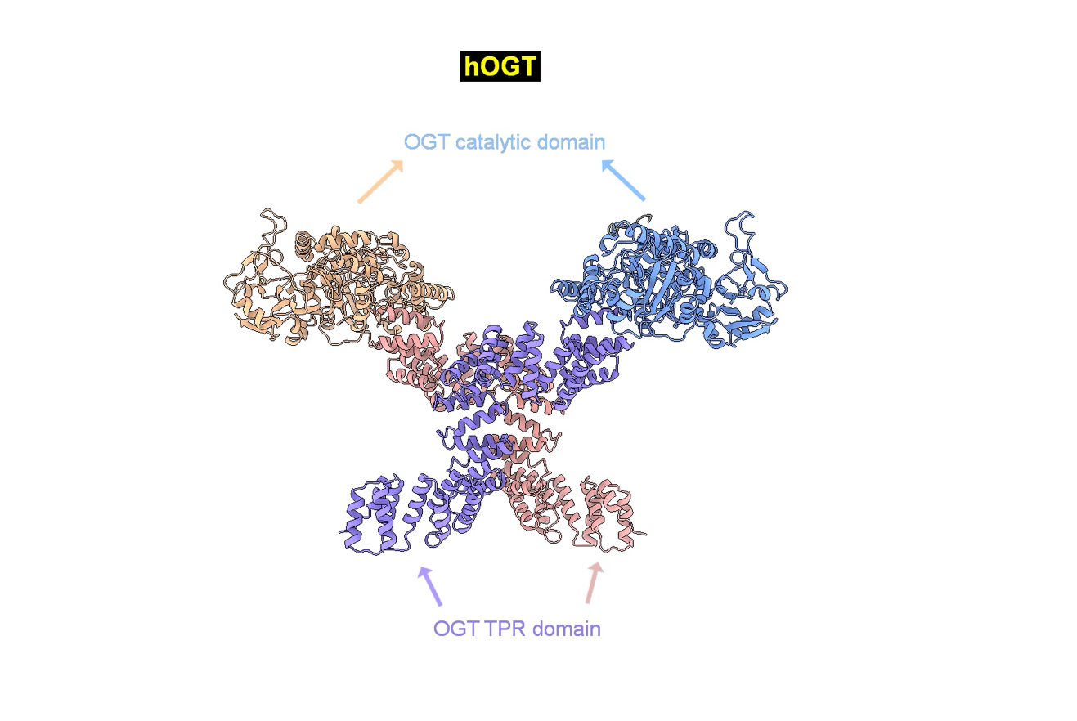

Supplementary Video 2 The conformational changes of OGT upon OGA binding

