Extended Data Table 1 | Compilation of the Greater India reconstruction and the size of Greater Indian Continent (GIC) ª
Num | Size | Reference | Num | Size | Reference | Num | Size | Reference
1 | >1400km | Argand, 1924^{b} | 16 | ~100km (smallest) | Gnos et al., 1997^{b} | 31 | Values not stated | Replumaz et al., 2004^{b}
2 | >1400km | Holmes, 1965^{b} | 17 | ~2000km | Matte et al., 1997^{b};  Mattauer et al., 1999^{b} | 32 | ~870km | Zhou & Murphy, 2005 ^{b}
3 | Values not stated | Veevers et al.,1971,1975^{b} | 18 | Values not stated | Scotese et al., 1999^{b} | 33 | ~550km | Kosarev et al., 1999^{b}
4 | Values not stated | Powell & Conaghan., 1975^{b} | 19 | ~1700km | Lee & Lawver., 1999^{b} | 34 | ~800km | Tilmann & Ni, 2003^{b}
5 | Values not stated | Powell, 1979^{b} | 20 | Values not stated | Kobben & de Wit, 2000^{b} | 35 | ~950km in the center,  ~500km in the east,  ~600km in the west | ⁴⁵Ali & Aitchison, 2005
6 | Values not stated | Crawford, 1974^{b} | 21 | >2800km | Rotstein et al., 2001^{b} | 36 | ~1500±480km | ⁴⁶Yi et al., 2011
7 | Values not stated | Molnar & Tapponnier, 1975,1977^{b} | 22 | 0-400km | Kent et al., 2002^{b};  Gaina et al., 2003^{b} | 37 | ~1350km in the west;  ~2050km in the center;  ~2550km in the east | ⁴⁷van Hinsbergen et al., 2011
8 | Values not stated | Barazangi & Ni, 1982^{b} | 23 | ~2000km | O’Neill et al., 2003^{b};  Heine et al., 2004^{b} | 38 | ~1000km | ⁹Gibbons et al., 2012
9 | ~500km | Besse & Courtillot, 1988^{b} | 24 | ~1450km in center;  ~1000km in west | Hall, 2002^{b} | 39 | Great Indian Basin,  (2675±699km N-S) | ²van Hinsbergen et al., 2012
10 | ~1700km | Powell et al., 1988^{b} | 25 | ~1800km | Lawver & Gahagan, 2003^{b} | 40 | ~1000km | ⁷Yakovlev & Clark, 2014
11 | ~110km in the west;  ~550km in the center and east | Dewey et al., 1989^{b} | 26 | ~600km | Replumaz & Tapponnier, 2003^{b} | 41 | ~1800km | ⁴⁸Scotese, 2016
12 | 800-900km | Treloar & Coward, 1991^{b} | 27 | ~700-800km | Stampfli & Borel, 2003^{b} | 42 | 2400km | ¹Ingalls et al., 2016
13 | ~1000km in the center;  ~670km in the east and west | Le Pichon et al., 1992^{b} | 28 | Values not stated | Meert, 2003^{b} | 43 | 2675±720km in the west,  1950±970km in the east | ⁸Meng et al., 2019
14 | ~1300km in the east;  >1100km in the west | Klootwijk et al., 1992^{b} | 29 | 500-700km | Ali & Aitchison, 2004^{b} | 44 | ~2400km | ⁴⁹Wang et al., 2020
15 | ~800km in the west;  ~1200km in the east | Patzelt et al., 1996^{b} | 30 | Values not stated | Van der Voo et al., 1999^{b}
- This compilation of the size of GIC is modified after the review paper of Ali & Aitchison (2005)⁴⁵.
- These references with superscript ^{b} in the table can be found in Ali & Aitchison (2005)⁴⁴, and are not listed in this paper.

Extended Data Table 2 | Compilation and calculation of felsic crust mass deficit of Greater Indian Continent (GIC).
Reference | Extension of GIC | Area of GIC | Volume of UCC and MCC in GICª | Area of HI ^{b} | Thickness of UCC/MCC in HI ^{c} | Volume of UCC/MCC in HI | Volume of erosional UCC/MCC in HI^{d} | Missing UCC and MCC | percent
⁷Yakovlev & Clark (2014)  ⁹Gibbon et al. (2012) | ~1100km | 4.2±0.4×10⁶km² | 9.66±0.92×10⁷km³ | 0.83km² | 57km | 4.73×10⁷km³ | 10.38×10⁶km³ | 3.892±0.92×10⁷  km³ | 40.29%
⁶Replumaz et al. (2010) | ~1000km | 3.1×10⁶km² | 7.13×10⁷km³ | 0.83km² | 57km | 4.73×10⁷km³ | 10.38×10⁶km³ | 1.362×10⁷km³ | 19.10%
¹Ingalls et al. (2016) | ~2400km | 4.2×10⁶km² | 9.66×10⁷km³ | 0.83km² | 57km | 4.73×10⁷km³ | 10.38×10⁶km³ | 4.8875×10⁷km³ | 40.29%
⁸Meng et al. (2019) | 2675±720in west  1950±970in east | >4.7×10⁶km² | 10.81×10⁷km³ | 0.83km² | 57km | 4.73×10⁷km³ | 10.38×10⁶km³ | 6.0375×10⁷km³ | 46.64%
- The pre-collisional thickness of upper and middle crust of GIC is approximated as 23km. UCC: upper continental crust; MCC: middle continental crust.
- The area of modern Himalaya (HI) is derived from Replumaz et al. (2010)⁶.
- In this calculation, an extreme assumption is applied that all 57km of modern Himalayan crust⁶ are felsic. Therefore, our estimate of the missing upper and middle crust of GIC is in the lower limit.
- The erosion rate in Himalaya is derived from Richter et al. (1992)¹³. Our estimate of the crustal erosion in Himalaya is comparable with Replumaz et al. (2010) ⁶ (i.e. 10.4×10⁶km³).

Extended Data Table 3 | Compositions of upper continental crust (UCC), middle continental crust (MCC), lower continental crust (LCC), bulk oceanic crust (BOC), pyrolite and reduced compositions of the slab components used in phase equilibrium modelling.
wt % | SiO₂ | TiO₂ | Al₂O₃ | FeO_{T} | MnO | MgO | CaO | Na₂O | K₂O | P₂O₅
UCC¹⁰ | 66.62 | 0.64 | 15.40 | 5.04 | 0.10 | 2.48 | 3.59 | 3.27 | 2.80 | 0.15
MCC¹⁰ | 63.5 | 0.69 | 15.0 | 6.02 | 0.10 | 3.59 | 5.25 | 3.39 | 2.30 | 0.15
LCC¹⁰ | 52.0 | 1.13 | 17.0 | 9.08 | 0.15 | 7.21 | 10.28 | 2.61 | 0.54 | 0.13
BOC⁵⁰ | 49.94 | 0.67 | 17.01 | 7.61 | 0.159 | 9.78 | 12.96 | 1.75 | 0.037 | 0.086
Pyrolite⁵¹ | 45.0 | 0.201 | 4.45 | 8.05 | 0.135 | 37.8 | 3.55 | 0.36 | 0.029 | 0.021
Reduced compositions used in phase equilibrium modelling
UCC⁷ | 67.16 |  | 15.52 | 5.08 |  | 2.50 | 3.62 | 3.30 | 2.82
MCC⁷ | 64.11 |  | 15.15 | 6.08 |  | 3.62 | 5.30 | 3.42 | 2.32
LCC⁷ | 52.68 |  | 17.22 | 9.20 |  | 7.30 | 10.41 | 2.64 | 0.55
BOC⁵⁰ | 50.42 |  | 17.17 | 7.68 |  | 9.87 | 14.39 | 1.77
Pyrolite⁵¹ | 45.36 |  | 4.49 | 8.11 |  | 38.10 | 3.58 | 0.36
References: 10-Rudnick & Gao (2014); 50-Melson et al. (2002); 51-McDonough & Sun (1995).

Extended Data Table 4 | Compilation of different Compositions of upper continental crust and the upper and lower limits of Si content, X_{Mg}, X_{Al}, X_{Ca} (where X_{Mg} =[MgO/(MgO+FeO)], X_{Al} [Al₂O₃/(Al₂O₃+MgO+FeO)], X_{Ca} =[CaO/(CaO+MgO+FeO+Na₂O)])
Reference |  | SiO₂ | TiO₂ | Al₂O₃ | FeO | MnO | MgO | CaO | Na₂O | K₂O | P₂O₅ | Total | Si | X_{Mg} | X_{Al} | X_{Ca}
¹⁰Rudnick and Gao, 2014 | wt% | 66.62 | 0.64 | 15.40 | 5.04 | 0.10 | 2.48 | 3.59 | 3.27 | 2.80 | 0.15 | 100.09
¹⁰Rudnick and Gao, 2014 | mol% | 72.09 | / | 9.82 | 4.56 | / | 4.00 | 4.16 | 3.43 | 1.93 | / | 100.00 | 72.09 | 0.47 | 0.53 | 0.26
⁵²Clarke, 1889 | wt% | 60.20 | 0.57 | 15.27 | 7.26 | 0.10 | 4.59 | 5.45 | 3.29 | 2.99 | 0.23 | 99.95
⁵²Clarke, 1889 | mol% | 64.70 | / | 9.67 | 6.52 | / | 7.35 | 6.28 | 3.43 | 2.05 | / | 100.00 | 64.70 | 0.53 | 0.41 | 0.27
⁵³Clarke and Washington, 1924 | wt% | 60.30 | 1.07 | 15.65 | 6.70 | 0.12 | 3.56 | 5.18 | 3.92 | 3.19 | 0.31 | 100.00
⁵³Clarke and Washington, 1924 | mol% | 65.68 | / | 10.04 | 6.10 | / | 5.78 | 6.04 | 4.14 | 2.22 | / | 100.00 | 65.68 | 0.49 | 0.46 | 0.27
⁵⁴Goldschmidt, 1933 | wt% | 62.22 | 0.83 | 16.63 | 6.99 | 0.12 | 3.47 | 3.23 | 2.15 | 4.13 | 0.23 | 100.00
⁵⁴Goldschmidt, 1933 | mol% | 68.21 | / | 10.74 | 6.41 | / | 5.67 | 3.79 | 2.28 | 2.89 | / | 100.00 | 68.21 | 0.47 | 0.47 | 0.21
⁵⁵Shaw et al., 1967 | wt% | 66.80 | 0.54 | 15.05 | 4.09 | 0.07 | 2.30 | 4.24 | 3.56 | 3.19 | 0.15 | 99.99
⁵⁵Shaw et al., 1967 | mol% | 72.18 | / | 9.58 | 3.70 | / | 3.71 | 4.91 | 3.73 | 2.20 | / | 100.00 | 72.18 | 0.50 | 0.56 | 0.31
⁵⁶Fahrig and Eade, 1968 | wt% | 66.20 | 0.54 | 16.10 | 4.40 | 0.08 | 2.20 | 3.40 | 3.90 | 2.91 | 0.16 | 99.89
⁵⁶Fahrig and Eade, 1968 | mol% | 72.02 | / | 10.32 | 4.00 | / | 3.57 | 3.96 | 4.11 | 2.02 | / | 100.00 | 72.02 | 0.47 | 0.58 | 0.25
⁵⁷Ronov and Yaroshevskiy, 1976 | wt% | 64.80 | 0.55 | 15.84 | 5.78 | 0.10 | 3.01 | 3.91 | 2.81 | 3.01 | 0.16 | 99.97
⁵⁷Ronov and Yaroshevskiy, 1976 | mol% | 70.22 | / | 10.11 | 5.24 | / | 4.86 | 4.54 | 2.95 | 2.08 | / | 100.00 | 70.22 | 0.48 | 0.50 | 0.26
⁵⁸Condie, 1993 | wt% | 67.00 | 0.56 | 15.14 | 4.76 | 0.00 | 2.45 | 3.64 | 3.55 | 2.76 | 0.12 | 99.98
⁵⁸Condie, 1993 | mol% | 72.31 | / | 9.63 | 4.30 | / | 3.94 | 4.21 | 3.71 | 1.90 | / | 100.00 | 72.31 | 0.48 | 0.54 | 0.26
⁵⁹Gao et al., 1998 | wt% | 67.97 | 0.67 | 14.17 | 5.33 | 0.10 | 2.62 | 3.44 | 2.86 | 2.68 | 0.16 | 100.00
⁵⁹Gao et al., 1998 | mol% | 73.20 | / | 8.99 | 4.80 | / | 4.21 | 3.97 | 2.99 | 1.84 | / | 100.00 | 73.20 | 0.47 | 0.50 | 0.25
⁶⁰Borodin, 1998 | wt% | 67.12 | 0.60 | 15.53 | 4.94 | 0.00 | 2.10 | 3.51 | 3.21 | 3.01 | 0.00 | 100.02
⁶⁰Borodin, 1998 | mol% | 72.70 | / | 9.91 | 4.47 | / | 3.39 | 4.07 | 3.37 | 2.08 | / | 100.00 | 72.70 | 0.43 | 0.56 | 0.27
⁶¹Taylor and McLennan, 1985 | wt% | 65.89 | 0.50 | 15.17 | 4.49 | 0.07 | 2.20 | 4.19 | 3.89 | 3.39 | 0.20 | 99.99
⁶¹Taylor and McLennan, 1985 | mol% | 71.40 | / | 9.69 | 4.07 | / | 3.55 | 4.86 | 4.09 | 2.34 | / | 100.00 | 71.40 | 0.47 | 0.56 | 0.29
⁶²Wedepohl, 1995 | wt% | 66.80 | 0.54 | 15.05 | 4.09 | 0.07 | 2.30 | 4.24 | 3.56 | 3.19 | 0.15 | 99.99
⁶²Wedepohl, 1995 | mol% | 72.18 | / | 9.58 | 3.70 | / | 3.71 | 4.91 | 3.73 | 2.20 | / | 100.00 | 72.18 | 0.50 | 0.56 | 0.31
Upper limit |  |  |  |  |  |  |  |  |  |  |  |  | 64.70 | 0.43 | 0.41 | 0.21
Lower limit |  |  |  |  |  |  |  |  |  |  |  |  | 73.20 | 0.53 | 0.58 | 0.31
Extended Data Table 5 | Viscous flow laws used in the numerical experiments ^{a)}
Symbol | Flow Law | E (kJ·mol⁻¹) | V (J·MPa⁻¹·mol⁻¹) | n | A_{D}(MPa^{-n}·s⁻¹) | η₀(Pa^{n}·s)ª
RA | Wet quartzite | 154 | 8 | 2.3 | 3.2×10⁻⁴ | 1.97×10¹⁷
RB | Plagioclase An₇₅ | 238 | 8 | 3.2 | 3.3×10⁻⁴ | 4.80×10²²
RC | Dry olivine | 532 | 8 | 3.5 | 2.5×10⁴ | 3.98×10¹⁶
RD | Wet olivine | 470 | 8 | 4.0 | 2.0×10³ | 5.01×10²⁰
^{a)} η₀ is the reference viscosity, which is calculated by η₀ = (1/A_{D}) ×10^{(6n)}. References are from Kirby (1983)³⁹, Kirby and Kronenberg (1987)⁴⁰, Ranalli and Murphy (1987)⁴¹, Ji and Zhao (1993)⁴², and Ranalli (1995)⁴³.

Extended Data Table 6 | Material properties used in the numerical experiments.
Material (state) | ρ₀  (kg·m⁻³) | C_{p}  (J·kg⁻¹·K⁻¹) | k ª  (W·m⁻¹·K⁻¹) | Q_{L}  (kJ·kg⁻¹) | H_{r}  (μW·m⁻³) | α  (K⁻¹) | β  (MPa⁻¹) | Viscous ^{b}  Flow law | Plastic ^{c}  C₀ (MPa) | Plastic ^{c}  sin(φ_{eff})
Stick air | 1 | 3.3x10⁶ | 200 | - | 0 | 0 | 0 | 10¹⁸Pa·s | - | -
Water | 1000 | 3.3x10³ | 200 | - | 0 | 0 | 0 | 10¹⁸Pa·s | - | -
Sediment | 2600 | 1000 | K₁ | 300 | 2.0 | 3×10⁻⁵ | 1×10⁻⁵ | RA | 10 | 0.15
Continental upper crust | 2700 | 1000 | K₁ | 300 | 1.0 | 3×10⁻⁵ | 1×10⁻⁵ | RA | 10 | 0.15
Continental middle crust | 2700 | 1000 | K₁ | 300 | 1.0 | 3×10⁻⁵ | 1×10⁻⁵ | RA | 10 | 0.15
Continental lower crust | 3000 | 1000 | K₁ | 380 | 1.0 | 3×10⁻⁵ | 1×10⁻⁵ | RB | 10 | 0.15
Oceanic upper crust | 3000 | 1000 | K₂ | 380 | 0.25 | 3×10⁻⁵ | 1×10⁻⁵ | RA | 10 | 0.15
Oceanic lower crust | 3000 | 1000 | K₂ | 380 | 0.25 | 3×10⁻⁵ | 1×10⁻⁵ | RB | 10 | 0.15
Mantle | 3300 | 1000 | K₃ | 400 | 0.022 | 3×10⁻⁵ | 1×10⁻⁵ | RC | 10 | 0.60
Mantle (weak zone) | 3300 | 1000 | K₃ | 400 | 0.022 | 3×10⁻⁵ | 1×10⁻⁵ | RD | 10 | 0.06
References ^{d} | 19,64 | 19,64 | 65 | 19,65 | 19 | - | - | 39-43 | 66 | 66
ª K₁=[0.64+807/(T_{K}+77)]·exp(0.00004P_{MPa}); K₂=[1.18+474/(T_{K}+77)]·exp(0.00004P_{MPa}); K₃=[0.73+1293/(T_{K}+77)]·exp(0.00004P_{MPa}).
^{b} Parameters of viscous flow laws are shown in Extended Data Table 5.
^{c} Strain weakening effect is included in the plastic rheology, in which both cohesion C₀ and effective friction coefficient sin(φ_{eff}) decrease with larger strain. The cut-off values are corresponding to the strain ‘0~1’.
^{d} References: 19-Turcotte & Schubert (2002); 64-Bittner & Schmeling (1995); 65-Clauser & Huenges (1995); 39-Kirby (1983); 40-Kirby and Kronenberg (1987); 41-Ranalli and Murphy (1987); 42-Ji and Zhao (1993); 43-Ranalli (1995); 66-Vogt et al. (2012).

Extended Data Table 7 | Compilation of the major mineralogical evidences and the peak metamorphic pressures of continental deep subduction worldwide.
UHP index minerals | Locality | Lithology | Peak pressure  (GPa) | References
1. Stishovite (pseudomorphism) | Altyn Tagh | pelitic gneiss | > 12GPa  (>350km) | ⁶⁷Liu et al., 2007
1. Stishovite (pseudomorphism) | Altyn Tagh | eclogite | >8–9 GPa | ⁶⁸Liu et al., 2018
2. Pyroxene±rutile±apatite exsolutions in garnet | Western Gneiss Region | garnet peridotite | >11.5GPa  (≥350km) | ⁶⁹Spengler et al., 2006
2. Pyroxene±rutile±apatite exsolutions in garnet | Western Gneiss Region | garnet peridotite | >8GPa  (>246km) | ⁷⁰van Roermund et al., 2001
2. Pyroxene±rutile±apatite exsolutions in garnet | Western Gneiss Region | garnet peridotite | 6-6.5GPa  (>185km) | ⁷¹van Roermund & Drury, 1998
2. Pyroxene±rutile±apatite exsolutions in garnet | Sulu | eclogite | >7GPa  (>200km) | ⁷²Ye et al., 2000
2. Pyroxene±rutile±apatite exsolutions in garnet | North Qaidam | garnet peridotite | >7GPa  (>200km) | ⁷³Song et al., 2004
2. Pyroxene±rutile±apatite exsolutions in garnet | Altyn Tagh | garnet pyroxenite | >7GPa  (>200km) | ⁷⁴Liu et al., 2005
3. Sodic amphibole exsolution in garnet | North Qaidam | garnet peridotite | >7GPa  (>200km) | ⁷⁵Song et al., 2005
4. Aragonite and magnesite inclusions | Kokchetav | gt–cpx dolomitic marbles | ~6-9GPa  (~190-280km) | ⁷⁶Dobrzhinetskaya et al., 2006
5. Coesite exsolution lamellae in titanite | Kokchetav | an impure calcite marble | >6GPa  (>190km) | ⁷⁷Ogasawara et al., 2002
6. FeTiO₃ and chromite exsolution in olivine | Alpe Arami | garnet peridotite | 10-15GPa  (~300-400km) | ⁷⁸Dobrzhinetskaya et al., 1996
7. C2/c clinoenstatite exsolution in clinopyroxene | Alpe Arami | garnet peridotite | >8GPa  (>250km) | ⁷⁹Bozhilov et al., 1999
7. C2/c clinoenstatite exsolution in clinopyroxene | Dabie | garnet peridotite | >9.5GPa  (>300km) | ⁸⁰Liu et al.,2007
8. Ilmenite exsolution in olivine | Alpe Arami | garnet peridotite | 9-12GPa  (280-350Gpa) | ⁸¹Bozhilov et al., 2003
10. Quartz + rutile+ apatite exsolution in garnet | Greek Rhodope | metapelites | >7GPa  (~220km) | ⁸²Mposkos et al., 2001
11. Phlogopite and coesite exsolution from super-silicic clinopyroxene | Kokchetav | dolomite marble | >8GPa  (>250km) | ⁸³Zhu & Ogasawara, 2002
12. Majorite inclusion | Trans–North China Orogen | eclogite | 13Gpa  (~380km) | ⁸⁴Xu et al., 2017

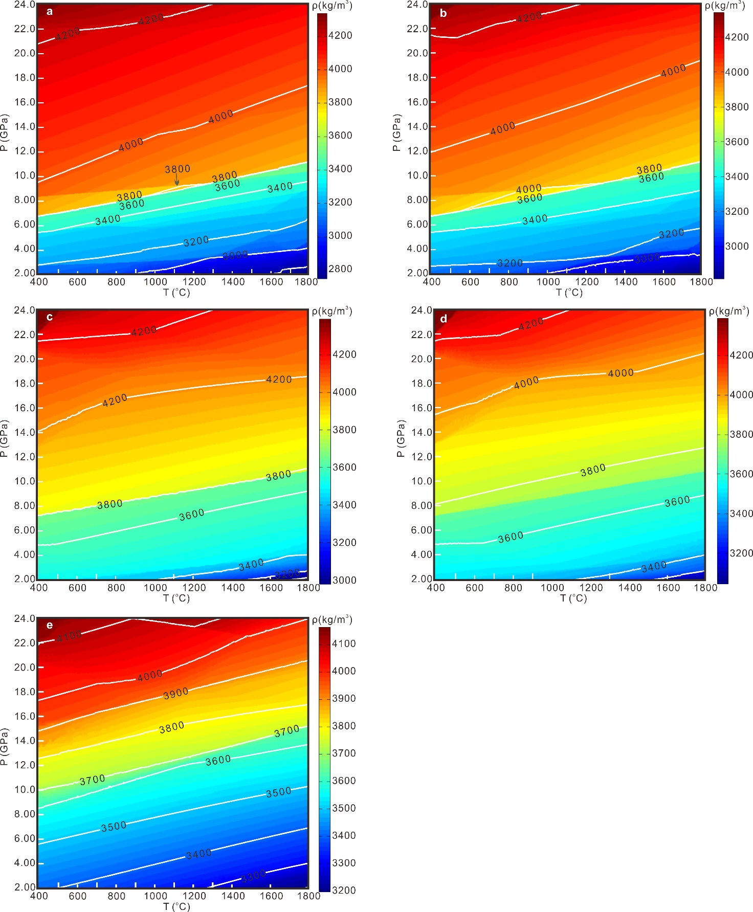
Extended Data Fig. 1 | Density evolutions for the chosen compositions of UCC (a), MCC (b), LCC (c), BOC (d) and pyrolite (e).

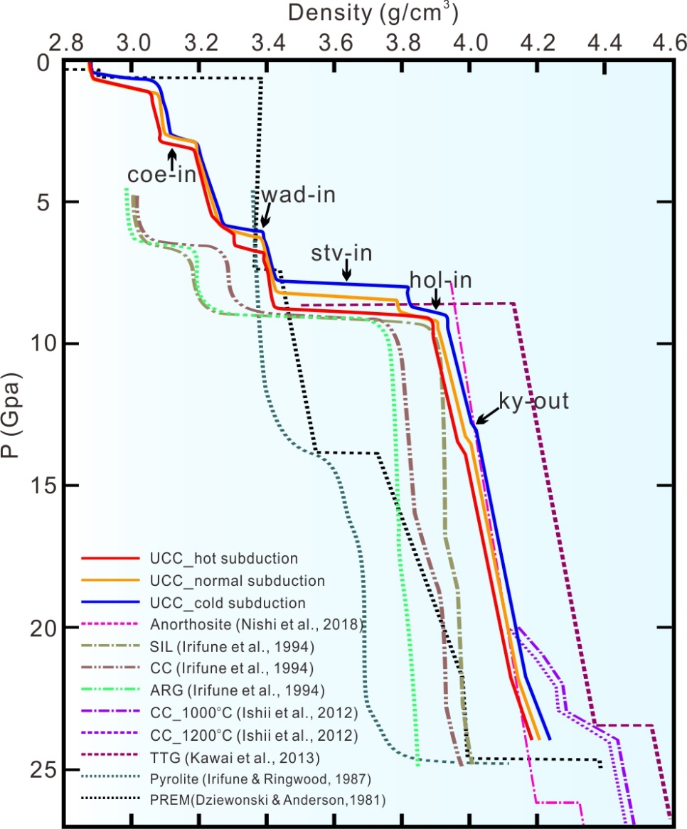
Extended Data Fig. 2 | Comparison of calculated density evolutions of UCC with respect to the density profiles derived from experimental petrology^{15,16,17,85,86} and PREM model⁴⁴. Calculated density profiles are carried out along three geotherms which are typical for cold, normal and hot subduction. SIL: siliceous facies; CC: continental crust; ARG: argillaceous facies; TTG: tonalite-trondhjemite-granodiorite.

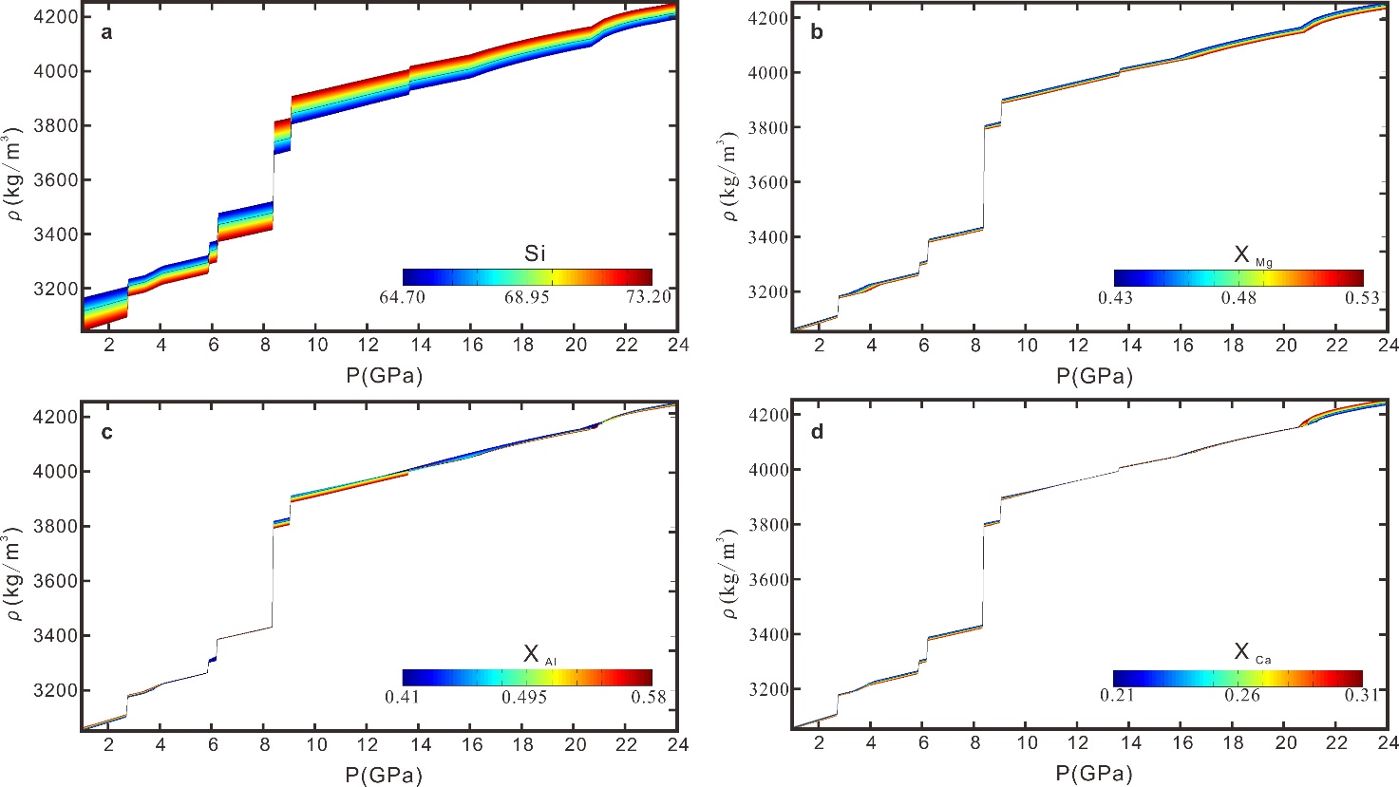
Extended Data Fig. 3 | The density profiles of UCC along average subduction P-T path with variable bulk-rock compositions (Extended Data Table 4). a, Si content (ranging from 64.70 to 73.20). b, X_{Mg} (ranging from 0.43 to 0.53). c, X_{Al} (ranging from 0.41 to 0.58). d. X_{Ca} (ranging from 0.21 to 0.31).

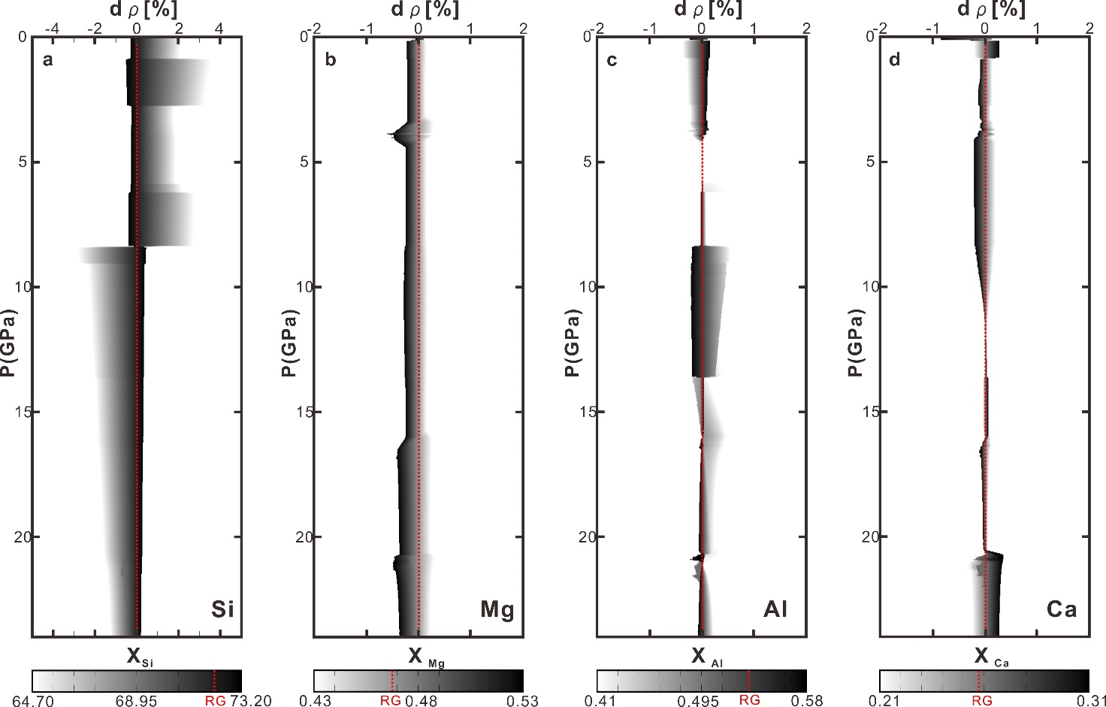
Extended Data Fig. 4 | The UCC density variations ($dρ=\frac{ρ-ρ_{RG}}{ρ_{RG}}$) due to different bulk-rock compositions along an average subduction P-T path. a, Si content. b, X_{Mg}. c, X_{Al}. d, X_{Ca}. RG and the dashed red lines represent the reference composition of UCC in Rudnick and Gao (2014)¹⁰. ρ_{RG} is the reference density of UCC.

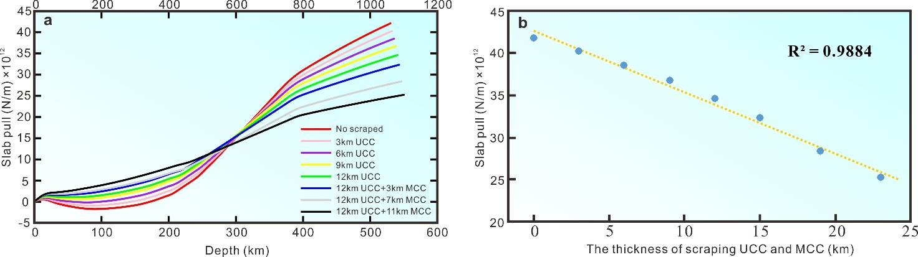
Extended Data Fig. 5 | (a) The depth-dependent slab pull evolution of subducted continental crust (CC) with scraping off a certain thickness of UCC/MCC, assuming a typical P-T path in the subduction channel. The colors of lines represent different experiments with contrasting amounts/thicknesses of scraped UCC/MCC. (b) The correlation between the entire slab pull of subducted CC above the depth of 660 km and the thickness of scraped UCC/MCC.

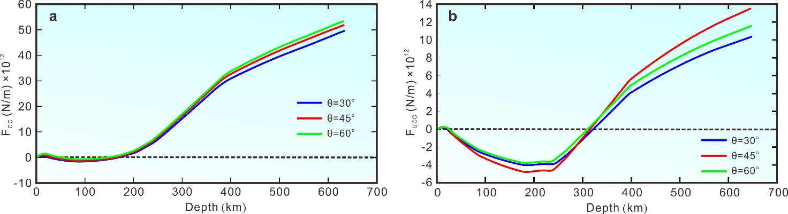
Extended Data Fig. 6 | (a) The slab pull evolutions of subducted continental crust (CC) with variable slab dip angles of θ=30º, 45º, 60º, respectively, assuming that no crustal layer is scraped off during subduction. (b) The slab pull evolutions of subducted upper continental crust (UCC) with variable slab dip angles of θ=30º, 45º, 60º, respectively, assuming again that no crustal layer is scraped off during subduction.

Extended Data Fig. 7 | Compilation of the major mineralogical evidences and the peak metamorphic pressures of continental deep subduction worldwide (Extended Data Table 7). The dashed blue line represents the depth at which the body force of the entire subducted continental crust (CC) is zero; the dashed red line represents the depth where the body force of subducted upper continental crust (UCC) is zero.

REFERENCES CITED
- Ali, J. R. & Aitchison, J. C. Greater India. Earth-Sci. Rev. 72, 169-188 (2005).
- Yi, Z., Huang, B., Chen, J., Chen, L. & Wang, H. Paleomagnetism of early Paleogene marine sediments in southern Tibet, China: Implications to onset of the India–Asia collision and size of Greater India. Earth Planet. Sci. Lett. 309(1-2), 524-541 (2011).
- van Hinsbergen, D. J. J. et al. Restoration of Cenozoic deformation in Asia and the size of Greater India. Tectonics 30, TC5003 (2011).
- Scotese. Paleomap PaleoAtlas for GPlates and the PaleoData plotter program. (2016). DOI: 10.13140/RG.2.2.34367.00166
- Wang et al. The latest Jurassic protoliths of the Sangsang mafic schists in southern Tibet: Implications for the spatial extent of Greater India. Gondwana Res. 79, 248–262 (2020)
- Melson, W. G., O'Hearn, T. & Jarosewich, E. A data brief on the Smithsonian abyssal volcanic glass data file. Geochem. Geophys. Geosyst. 3(4), 1023 (2002).
- Mcdonough, W. F. & Sun, S. S. The composition of the Earth. Chem. Geol. 120(3–4), 223-253 (1995).
- Clarke, F. W. The relative abundance of the chemical elements. Philosophical Society of Washington Bulletin XI, 131–142 (1889).
- Clarke, F. W. & Washington, H. S. The composition of the Earth’s crust. US Geological Survey Professional Paper 127 (1924).
- Goldschmidt, V. M. Grundlagen der quantitativen Geochemie. Fortschritte der Mineralogie, Kristallographie und Petrographie 17, 112 (1933).
- Shaw, D. M., Reilly, G. A., Muysson, J. R., Pattenden, G. E. & Campbell, F. E. An estimate of the chemical composition of the Canadian Precambrian shield. Can. J. Earth Sci. 4, 829–853 (1967).
- Fahrig, W. F. & Eade, K. E. The chemical evolution of the Canadian Shield. Geochim. Cosmochim. Acta 5, 1247–1252 (1968).
- Ronov, A. B. & Yaroshevsky, A. A. A new model for the chemical structure of the Earth’s crust. Geokhimiya 12, 1761–1795 (1976).
- Condie, K. C. Chemical composition and evolution of the upper continental crust: Contrasting results from surface samples and shales. Chem. Geol. 104, 1-37 (1993).
- Gao S. et al. Chemical composition of the continental crust as revealed by studies in east China. Geochim. Cosmochim. Acta 62, 1959–1975 (1998)
- Borodin, L. S. Estimated chemical composition and petrochemical evolution of the upper continental crust. Geochem. Int. 37(8), 723–734 (1998).
- Taylor, S. R. & McLennan, S. M. The geochemical evolution of the continental crust. Rev. Geophys 33, 241–265 (1995).
- Wedepohl, H. The composition of the continental crust. Geochim. Cosmochim. Acta 59, 1217–1239 (1995).
- Kirby, S.H. & Kronenberg, A.K. Rheology of the lithosphere: selected topics. Rev. Geophys. 25, 1219–1244 (1987).
- Bittner, D. & Schmeling, H. Numerical modelling of melting processes and induced diapirism in the lower crust. Geophys. J. Int. 123(1), 59–70 (1995).
- Clauser, C. & Huenges, E. Thermal Conductivity of Rocks and Minerals. Rock Physics & Phase Relations 105–126 (1995).
- Vogt, K., Gerya, T. & Castro, A. Crustal growth at active continental margins: Numerical modeling, Phys. Earth Planet. Inter. 192–193, 1–20 (2012).
- Liu, L., Zhang, J., Ii, H. W. G., Jin, Z. & Bozhilov, K. N. Evidence of former stishovite in metamorphosed sediments, implying subduction to > 350km. Earth Planet. Sci. Lett. 263(3), 180-191 (2007).
- Liu et al. Evidence of former stishovite in UHP eclogite from the south Altyn Tagh, western China. Earth Planet. Sci. Lett. 484, 353-362 (2018).
- Spengler, D., van Roermund, H. L., Drury, M. R., Ottolini, L., Mason, P. R. & Davies, G. R. Deep origin and hot melting of an Archaean orogenic peridotite massif in Norway. Nature 440(7086), 913-7 (2006).
- van Roermund, H. L. M., Drury, M. R., Barnhoorn, A. & De Ronde, A. Relict majoritic garnet microstructures from ultra-deep orogenic peridotites in western Norway. J. Petrol. 42(1), 117-130 (2001).
- van Roermund, H. L. M. & Drury, M. R. Ultra‐high pressure (P >6 GPa) garnet peridotites in western Norway: Exhumation of mantle rocks from >185 km depth. Terr. Nova 10, 295-301(1998).
- Ye, K., Cong, B. & Ye, D. The possible subduction of continental material to depths greater than 200 km. Nature 407(6805), 734-736 (2000).
- Song, S., Zhang, L., Chen, J., Liou J.G., & Niu, Y. Sodic amphibole exsolutions in garnet from garnet-peridotite, North Qaidam UHPM belt, NW China: Implications for ultradeep-origin and hydroxyl defects in mantle garnets. Am. Miner. 90(5-6), 814-820 (2005).
- Liu, L., Chen, D.L., Zhang, A.D., Sun, Y., Wang, Y., Yang, J.X. & Luo, J.H. Ultrahigh pressure (>7 GPa) gneissic K-feldspar (-bearing) garnet clinopyroxenite in the Altyn Tagh, NW China: evidence from clinopyroxene exsolution in garnet. Sci. China, Ser. D 48, 1000–1010 (2005).
- Song, S., Zhang, L., Chen, J., Liou J.G., & Niu, Y. Sodic amphibole exsolutions in garnet from garnet-peridotite, North Qaidam UHPM belt, NW China: Implications for ultradeep-origin and hydroxyl defects in mantle garnets. Am. Miner. 90(5-6), 814-820 (2005).
- Dobrzhinetskaya, L. F., Wirth, R. & Ii, H. W. G. Nanometric inclusions of carbonates in Kokchetav diamonds from Kazakhstan: a new constraint for the depth of metamorphic diamond crystallization. Earth Planet. Sci. Lett. 243(1), 85-93 (2006).
- Ogasawara, Y., Fukasawa, K. & Maruyama, S. Coesite exsolution from supersilicic titanite in UHP marble from the Kokchetav massif, Northern Kazakhstan. Am. Miner. 87(4), 454-461 (2002).
- Dobrzhinetskaya, L., Green, H. W. & Wang, S. Alpe Arami: a peridotite massif from depths of more than 300 kilometers. Science 271(5257), 1841-1845 (1996).
- Bozhilov, K. N., Nd, G. H. & Dobrzhinetskaya, L. Clinoenstatite in Alpe Arami peridotite: additional evidence of very high pressure. Science 284(5411), 128-132 (1999).
- Liu, X. W., Jin, Z. M. & Green, H. W. Clinoenstatite exsolution in diopsidic augite of Dabieshan: garnet peridotite from depth of 300 km. Am. Miner. 92(4), 546-552 (2007).
- Bozhilov, K. N., Green, H. W. & Dobrzhinetskaya, L. F. Quantitative 3D measurement of ilmenite abundance in Alpe Arami olivine by confocal microscopy: Confirmation of high-pressure origin. Am. Miner. 88(4), 596-603 (2003).
- Mposkos, E. D. & Kostopoulos, D. K. Diamond, former coesite and supersilicic garnet in metasedimentary rocks from the Greek Rhodope: A new ultrahigh-pressure metamorphic province established. Earth Planet. Sci. Lett. 192(4), 497-506 (2003).
- Zhu, Y.F. & Ogasawara, Y. Phlogopite and coesite exsolution from super-silicic clinopyroxene. Int. Geol. Rev. 44(9), 831-836 (2002).
- Xu, C et al. Recovery of an oxidized majorite inclusion from earth’s deep asthenosphere. Sci. Adv. 3(4), e1601589 (2017).
- Kawai, K., Yamamoto, S., Tsuchiya, T. & Maruyama, S. The second continent: existence of granitic continental materials around the bottom of the mantle transition zone. Geosci. Front. 4, 1-6 (2013).
- Irifune, T. & Ringwood, A.E. Phase transformations in a harzburgite composition to 26 GPa: implications for dynamical behaviour of the subducting slab. Earth Planet. Sci. Lett. 86, 365e376. (1987).

