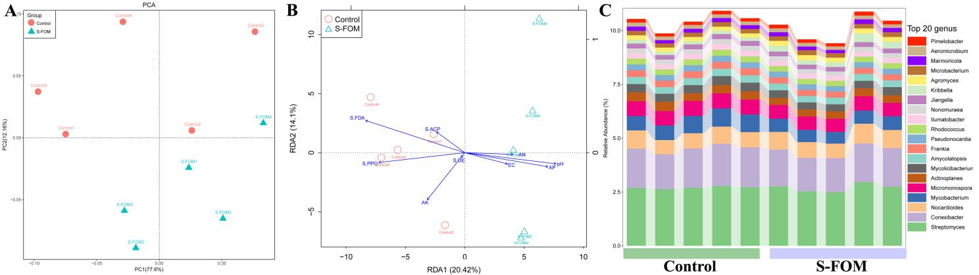
Fig S1 Principal component analysis of soil microbial community structure (A), RDA analysis (B) and Actinomycetes community composition (C).

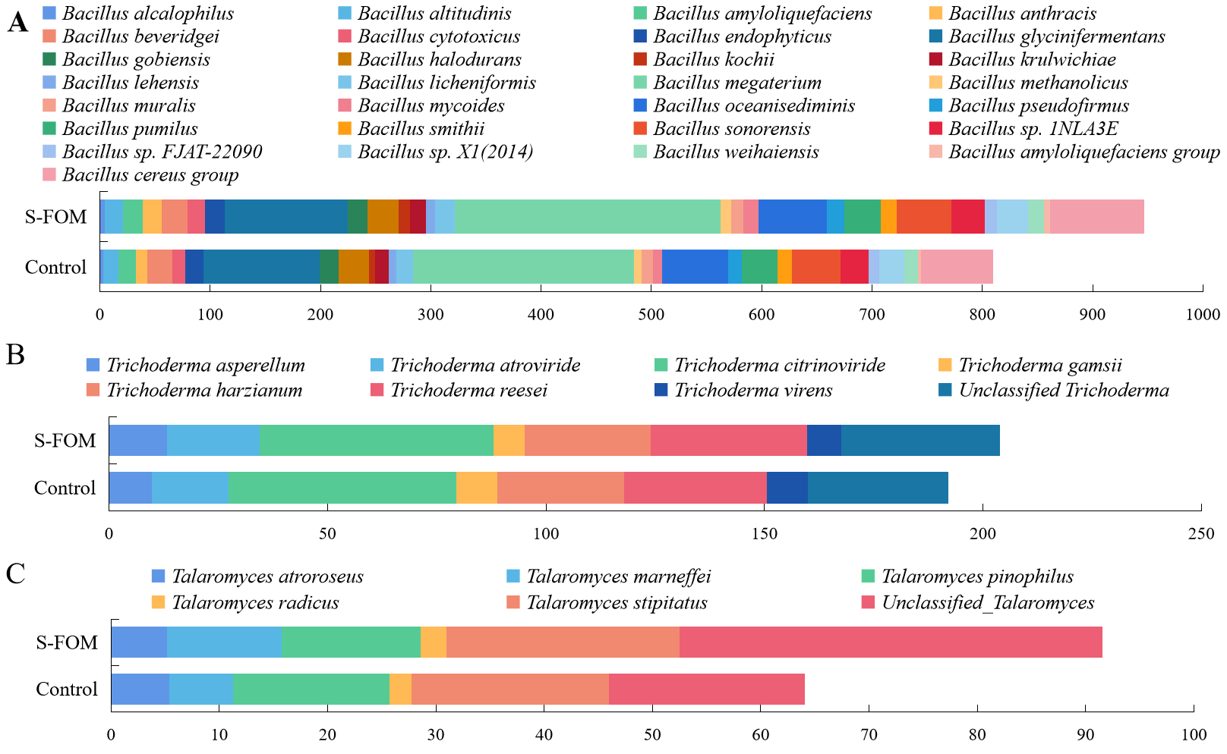
Fig S2 The species diversity and composition of Bacillus sp., Trichoderma sp., and Talaromyces sp.

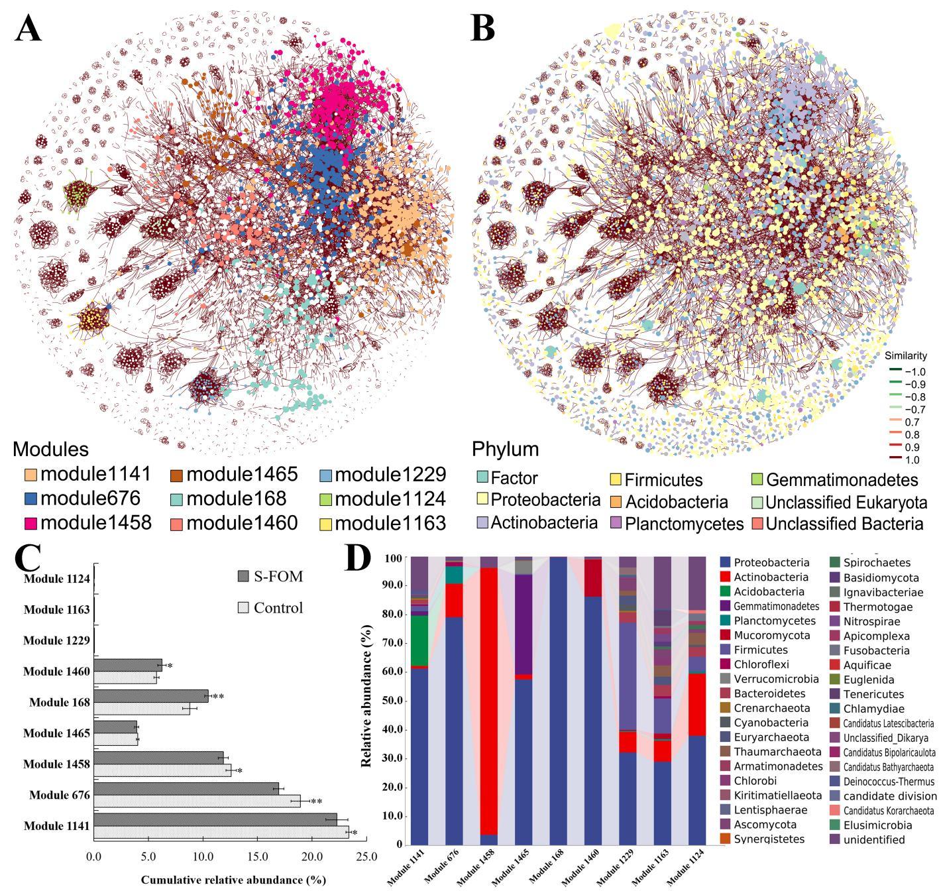
Fig. S3 Co-occurrence networks of soil communities constructed from Control and S-FOM based on correlation analysis
A: Networks analysis revealing the modular associations of soil microbes; B: Phylum-level composition of the network; C: Cumulative relative abundance of all bacteria and fungi of the main modules in co-occurrence networks; D: the microbial composition of the modules at phylum level. A connection stands for a strong (Spearman's ρ>0.6) and significant (P-value <0.05) correlation. The size of each node is proportional to the number of connections (degree). Fom: F. oxysporum. The same below.

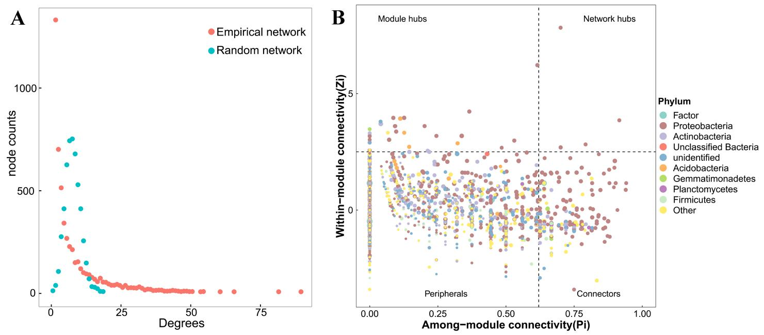
Fig. S4 The distributions of degree (A) and Zi-Pi plot (B) of nodes in the Co-occurrence network

Fig.S5 The influence of different nutritions and culture conditions on the colonies growth of strain Q2
Glu: Glucose; Sta: Starch; Lac: Lactose; Mal: Maltose; Suc: Sucrose; D-Fur: D-Furctose; CK: control; BE: Beef Extract; Urea: Carbamide; Pep: Peptone; AC: Ammonium chloride; AS: Ammonium sulfate; AN: Ammonium nitrate.Different letters in the same column indicate significant difference at P<0.05 level by Student's t-test.

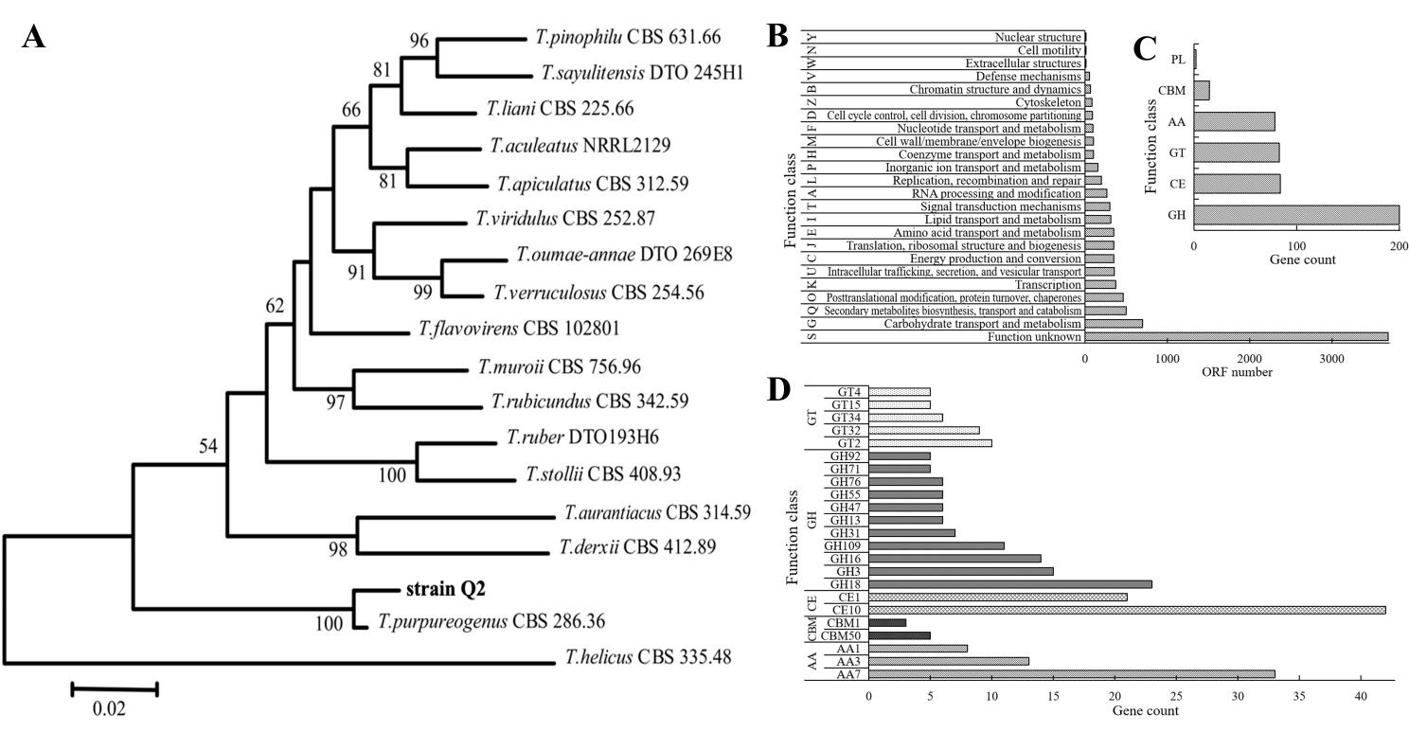
Fig. S6 The phylogenetic tree and gene function of beneficial microorganisms strain Q2
A: Best-scoring Maximum Likelihood tree calculated using MEGA7.0, based on combined data set of partial ITS, BenA, CaM sequences showing the relationships of Q2 among members of Talaromyces spp.; The bootstrap support percentages of the maximum likelihood (ML) analysis are presented at the nodes; Bootstrap support values less than 50 % are not shown. B: the function classification of the genes of strain Q2 based on eggNOG (evolutionary genealogy of genes: Non-supervised Orthologous Groups). C: the types of CAZyme of strain Q2, Glycoside Hydrolases (GH), Carbohydrate Esterases (CE), Glycosyl Transferases (GT), Auxiliary Activities (AA), Carbohydrate-Binding Modules (CBM), Polysaccharide Lyases (PL). D: the abundant enzymes in the CAZyme.
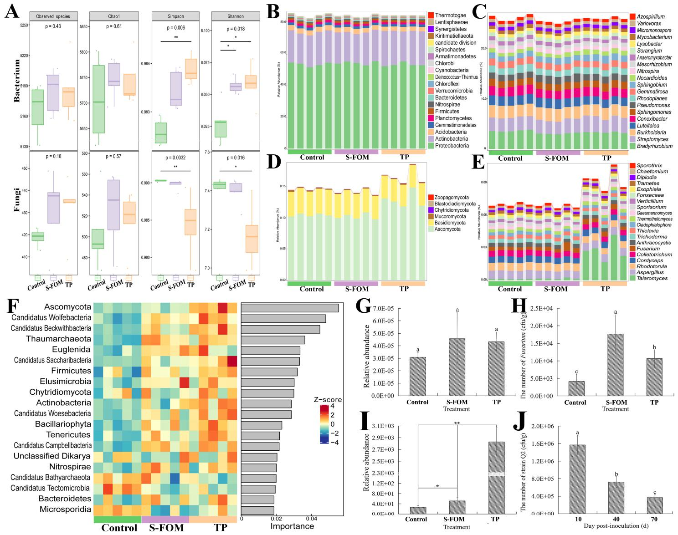
Fig. S7 The influence of strain Q2 on microbial alpha diversity index and community composition based on metagenomics
A: Microbial alpha diversity index. B: Relative abundance of bacterial taxa at the phylum level. C: Relative abundance of bacterial taxa at the genus level genus. D: Relative abundance of fungal taxa at the phylum level. E: Relative abundance of fungal taxa at the genus level. F: The random forest mean predictor importance of microbial phylum as drivers of the variation of soil microbiota. G: the relative abundance of Fusarium. H: the number of Fusrium based on Komada’s medium (a Fusarium selective medium). I: the relative abundance of strain Q2 (the result was obtained by comparing the genome of the strain Q2 to the metagenomic sequencing data). J: the ability of strains Q2 colonize in soil was compared at 30-day intervals up to 70 days.
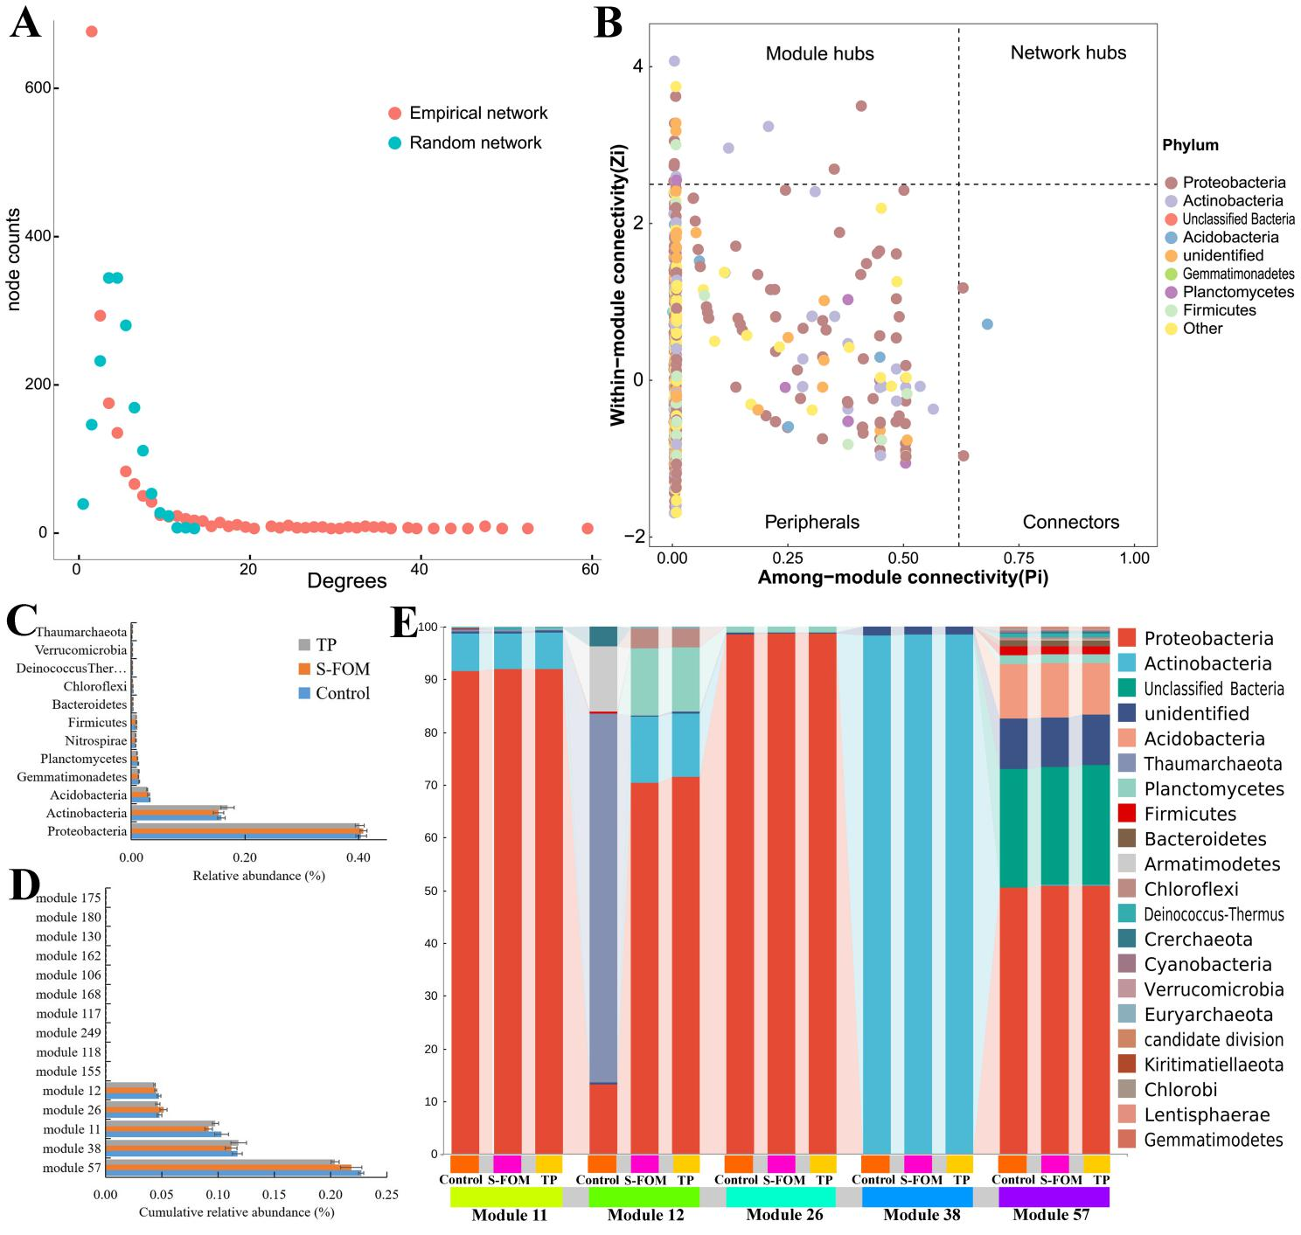
Fig. S8 The network-level microbial features of co-occurrence network
A: The distributions of degree. B: Zi-Pi plot of nodes. C: The relative abundance of the main microbial phylum in co-occurrence networks. D: Cumulative relative abundance of all bacteria and fungi of the main modules in co-occurrence networks; E: The microbial composition of the modules at phylum level.

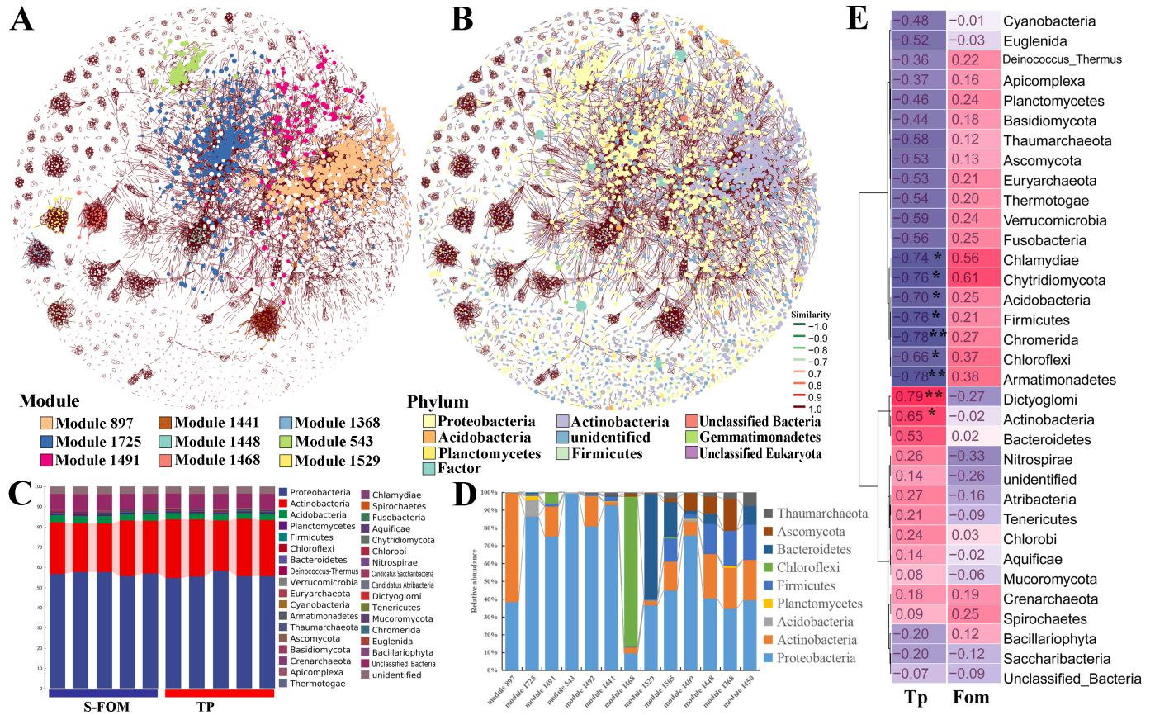
Fig. S9 Co-occurrence networks of soil communities constructed from S-FOM and TP based on correlation analysis
A: Networks analysis revealing the modular associations of soil microbes; B: Phylum-level composition of the network; C: The microbial composition of the 13 larger modules at phylum level; D: The key microbes in the modules; E: Spearman’s correlation analysis to explain the variation of key microbes caused by F. oxysporum f. sp. momordicae (Fom) and T. purpureogenus (Tp).

Fig.S10 Single-culture and co-culture of T. purpureogenus Q2 and/ or FOM.
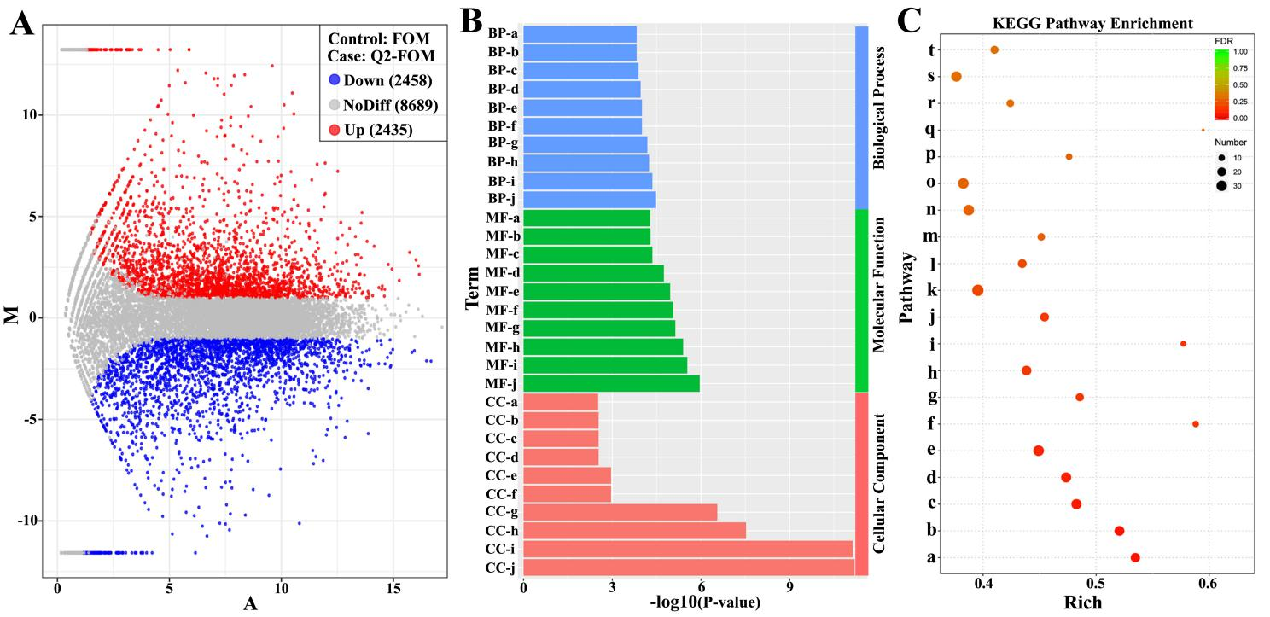

Fig.S11 MA map analysis (A), Gene Ontology analysis (B) and KEGG enrichment analysis (C) of differentially expressed genes (DEGs) in the comparison of FOM and Q2-FOM.
BP-a: carboxylic acid transport(GO:0046942), BP-b: organic acid transport (GO:0015849), BP-c: ion transport (GO:0006811), BP-d: oxidation−reduction process (GO:0055114), BP-e: carboxylic acid transmembrane transport (GO:1905039), BP-f: organic acid transmembrane transport (GO:1903825), BP-g: anion transport (GO:0006820), BP-h: amino acid transmembrane transport (GO:0003333), BP-i: anion transmembrane transport (GO:0098656), BP-j: transmembrane transport (GO:0055085), CC-a: eukaryotic 43S preinitiation complex (GO:0016282), CC-b: translation preinitiation complex (GO:0070993), CC-c: eukaryotic 48S preinitiation complex (GO:0033290), CC-d: eukaryotic translation initiation factor 3 complex (GO:0005852), CC-e: intrinsic component of plasma membrane (GO:0031226), CC-f: integral component of plasma membrane (GO:0005887), CC-g: membrane (GO:0016020), CC-h: membrane part (GO:0044425), CC-i: integral component of membrane (GO:0016021), CC-j: intrinsic component of membrane (GO:0031224), MF-a: oxidoreductase activity, acting on a sulfur group (GO:0016667), MF-b: substrate−specific transporter activity (GO:0022892), MF-c: disulfide oxidoreductase activity (GO:0015036), MF-d: RNA polymerase II transcription factor activity, s (GO:0000981), MF-e: anion transmembrane transporter activity (GO:0008509), MF-f: transporter activity (GO:0005215), MF-g: ion transmembrane transporter activity (GO:0015075), MF-h: substrate−specific transmembrane transporter activ (GO:0022891), MF-i: transmembrane transporter activity (GO:0022857), MF-j: oxidoreductase activity (GO:0016491), a: Glyoxylate and dicarboxylate metabolism, b: Glutathione metabolism, c: Valine, leucine and isoleucine degradation, d: Glycerophospholipid metabolism, e: Phenylalanine metabolism, f: Nitrogen metabolism, g: Propanoate metabolism, h: Pyruvate metabolism, i: ABC transporters, j: Galactose metabolism, k: Tyrosine metabolism, l: Glycerolipid metabolism, m: Butanoate metabolism, n: Arginine and proline metabolism, o: Starch and sucrose metabolism, p: Nicotinate and nicotinamide metabolism, q: Arachidonic acid metabolism, r: Methane metabolism, s: Amino sugar and nucleotide sugar metabolism, t: Pentose phosphate pathway.

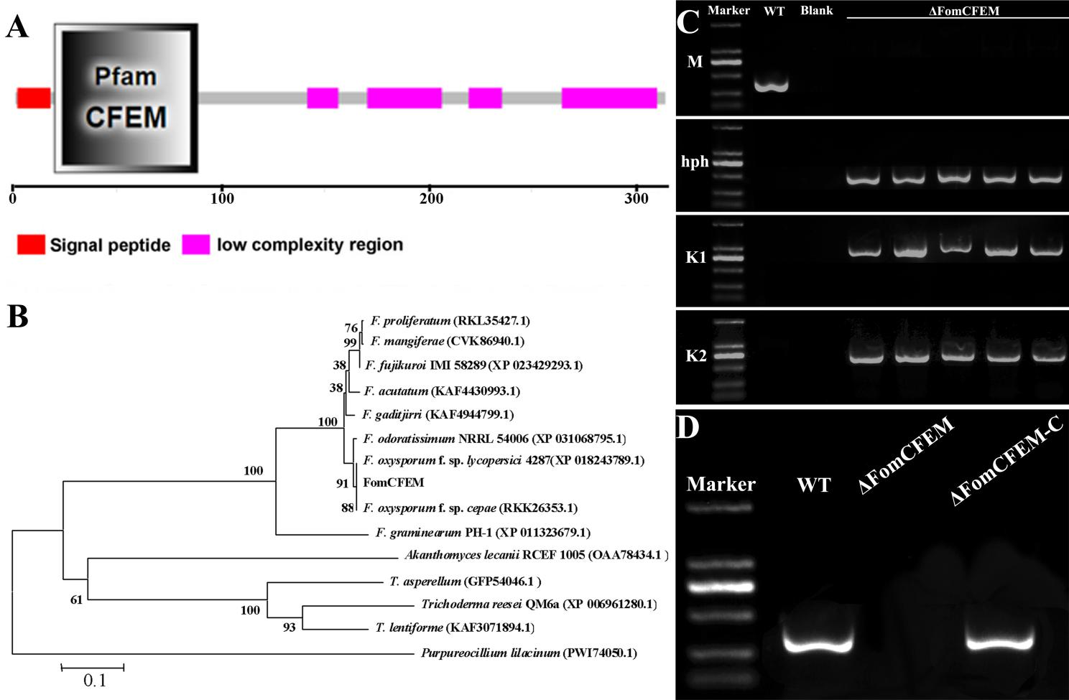
Fig.S12 The domain, phylogenetic tree and deletion construct of FomCFEM in Fusarium oxysporum f.sp. momordicae.
A: Schematic illustrations of FomCFEM. The domain of FomCFEM was predicted by SMART web site; B: Phylogenetic analysis of FomCFEM and CFEM proteins from other fungi; C:The deletion construct used to transform the wild type strain containing the hygromycin resistance (hph) cassette flanked by an upstream and downstream sequence of FomCFEM gene; D: PCR amplifications carried out to check the FomCFEM deletion mutants and FomCFEM-C
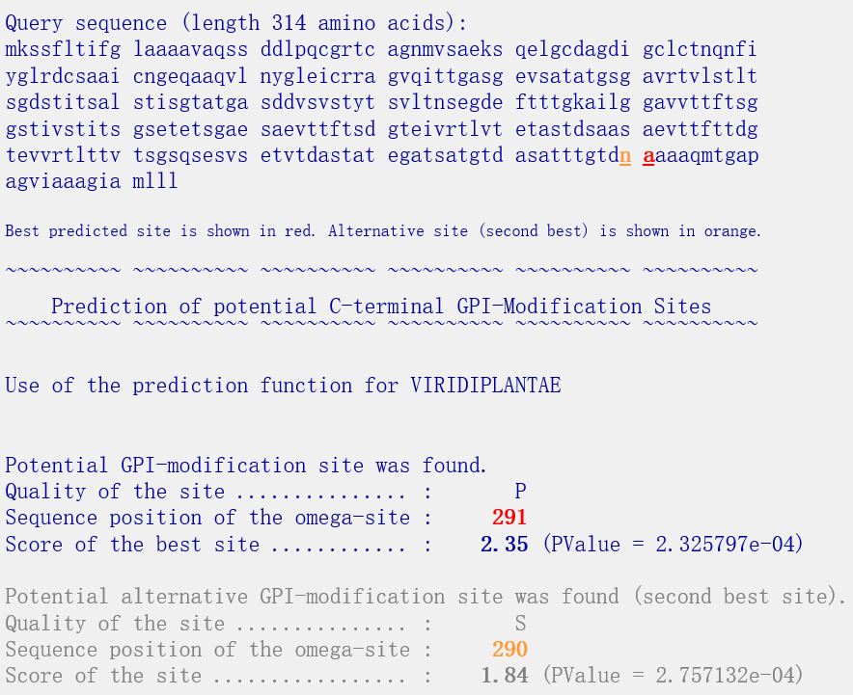
Fig.S13 GPI site prediction of FomCFEM
The site (http://mendel.imp.ac.at/gpi/plant_server.html) was used to analyze potential GPI modification site of FomCFEM.

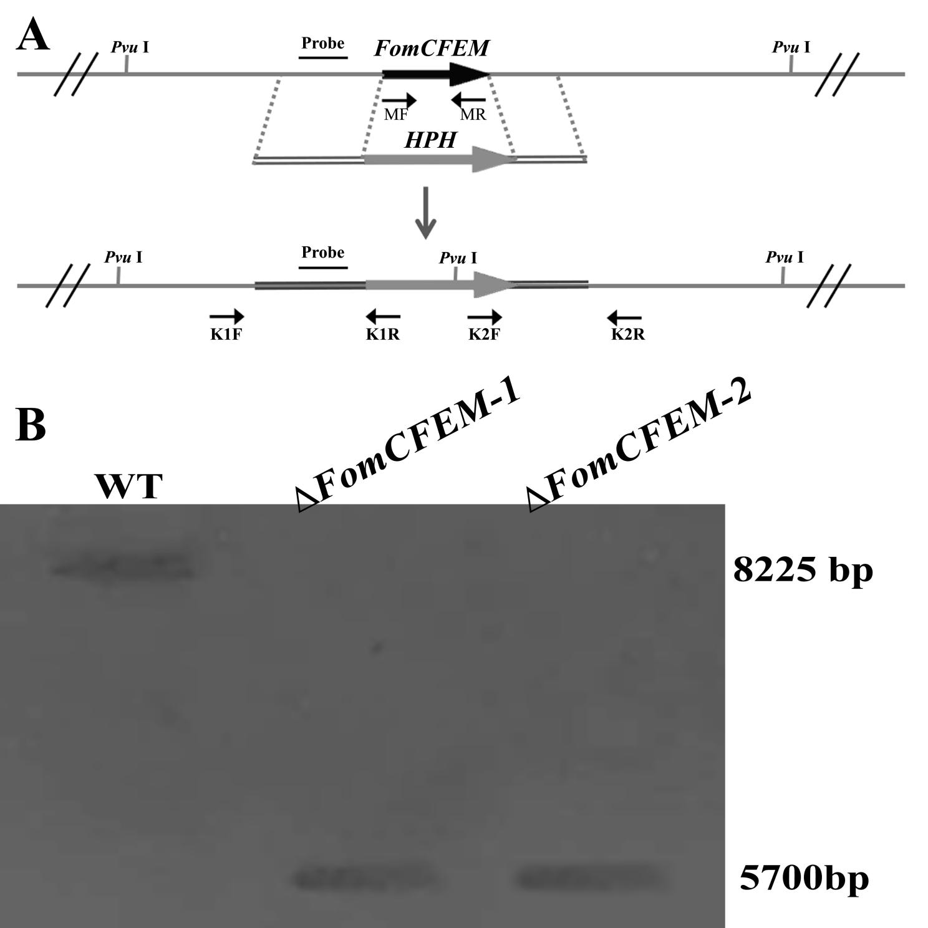
Fig.S14 Schematic diagram and identification of FomCEFM deletion mutant
A: Deletion strategy used for FomCEFM. B: Southern blot analysis of two candidate FomCEFM deletion transformants

