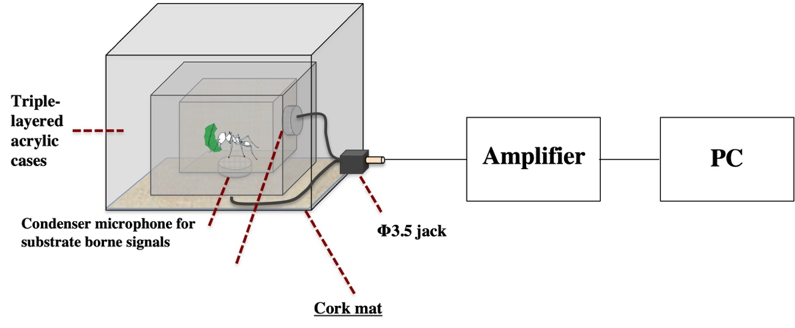
Cork mat

Supplementary data 4. Schematic figure of our originally developed high-resolution recording device.

