Supplementary Figures and Figure Legends
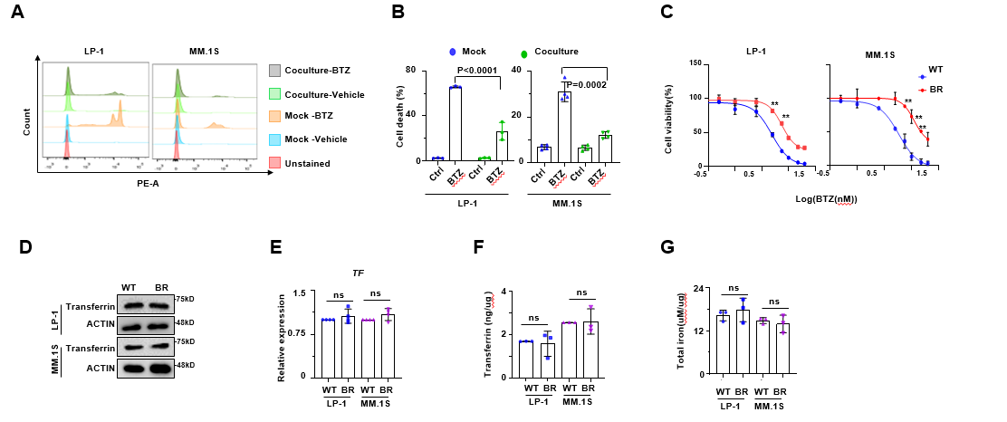
S Figure 1. Co-cultured MM cells are more resistant to BTZ treatment.
(A) Representative flow cytometry assay showing dead cells determined by PI in mock and co-cultured MM cells induced by BTZ for 48 hours, and (B)shown the statistical analysis of flow cytometry (n=3). Mock, MM.1S cells only; Co-culture, MM.1S+BMSCs. (C) The alternation of IC50 to BTZ in WT and BR cells (n=3). (D) Representative western blotting showing transferrin level in WT and BR MM cells (n=3). (E) Real-time PCR results showing mRNA expression of TF in WT and BR MM cells (n=3). (F) Elisa analysis of transferrin level in WT and BR MM cells (n=3). (G) Total iron level in WT and BR MM cells (n=3). **, P<0.01. P values are determined by unpaired two‐sided t‐tests with Welch's correction.
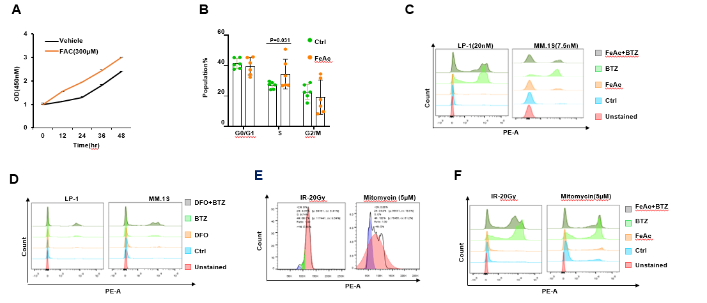
S Figure 2. Iron promotes MM cells more resistant to BTZ.
(A) Cell viability assay showing proliferation speed of MM cells treated with FeAc (n=3). (B) Cell cycle analysis of Vehicle and FeAc treated MM cells (n=6). (C) Representative flow cytometry assay showing dead cells determined by PI in MM cells induced by BTZ (7.5nM) and FeAc (300μM) for 48 hours (n=3). (D) Representative flow cytometry assay showing dead cells determined by PI in cells induced by BTZ (7.5nM) and DFO (100μM) for 48 hours (n=3). (E) Representative flow cytometry assay showing cell cycle of MM cells in the presence of mitoMYCin (5μM) or IR(20Gy) for 48 hours (n=5). (F) Representative flow cytometry assay showing dead cells determined by PI in MM cells induced by BTZ (7.5nM) and FeAc (300μM) in the presence of mitoMYCin (5μM) or IR(20Gy) for 48 hours (n=5). P values are determined by unpaired two‐sided t‐tests with Welch's correction.
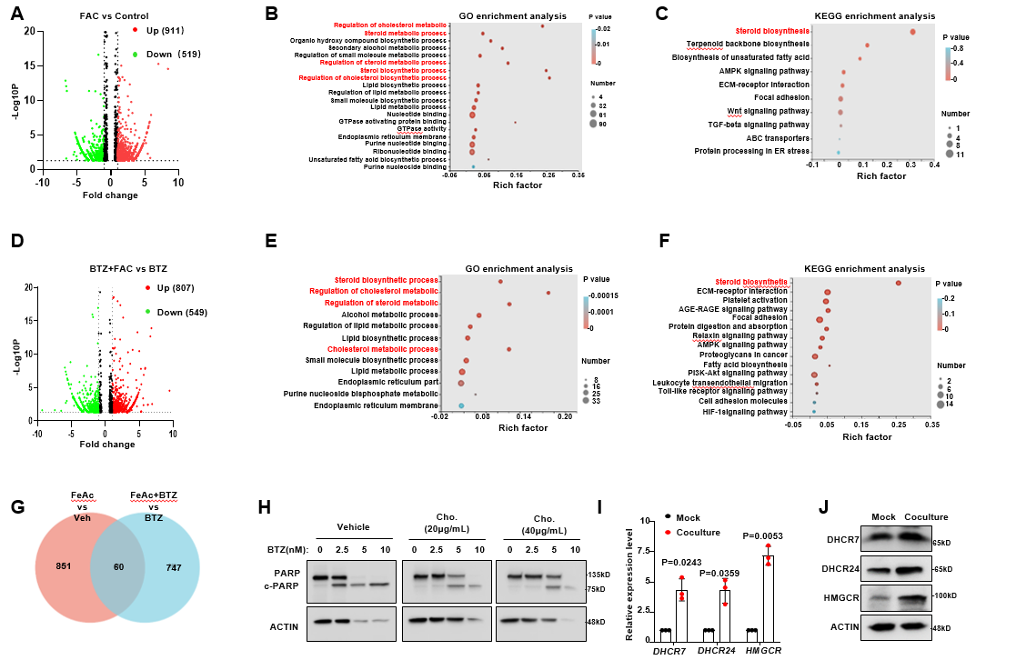
S Figure 3. RNA sequencing reveals that iron promotes production of cholesterol.
(A) Volcano plot showing differentially expressed genes in FeAc treated MM.1S cells in the absence of BTZ. Number of genes downregulated or upregulated in MM.1S cells is shown on the top (fold change > 1.5; adjusted p-value < 0.05). (B) Gene Ontology (GO) analysis showing top 20 biological processes in FeAc treated MM.1S cells in the absence of BTZ. (C) KEGG analysis showing top 10 pathways in FeAc treated MM.1S cells in the absence of BTZ. (D) Volcano plot showing differentially expressed genes in FeAc treated MM.1S cells in the presence of BTZ. Number of genes downregulated or upregulated in MM.1S cells is shown on the top (fold change > 1.5; adjusted p-value < 0.05). (E) Gene Ontology (GO) analysis showing top 20 biological processes in FeAc treated MM.1S cells the presence of BTZ. (F) KEGG analysis showing top 10 pathways in FeAc treated MM.1S cells the presence of BTZ. (G) Venn diagrams showing the overlap of significantly differentially upregulated genes in the FeAc treated MM.1S cells in the absence or presence of BTZ. (H) Representative western blotting showing PARP and c-PARP level in cholesterol supplemented MM cells (n=3). (I) Real-time PCR results showing mRNA expression of DHCR7, DHCR24 and HMGCR in mock and co-cultured MM cells. Mock, MM.1S cells only; Co-culture, MM.1S+BMSCs. (J) Representative western blotting showing level of DHCR7, DHCR24 and HMGCR in mock and co-cultured MM cells (n=3). Mock, MM.1S cells only; Co-culture, MM.1S+BMSCs. P values are determined by unpaired two‐sided t‐tests with Welch's correction.
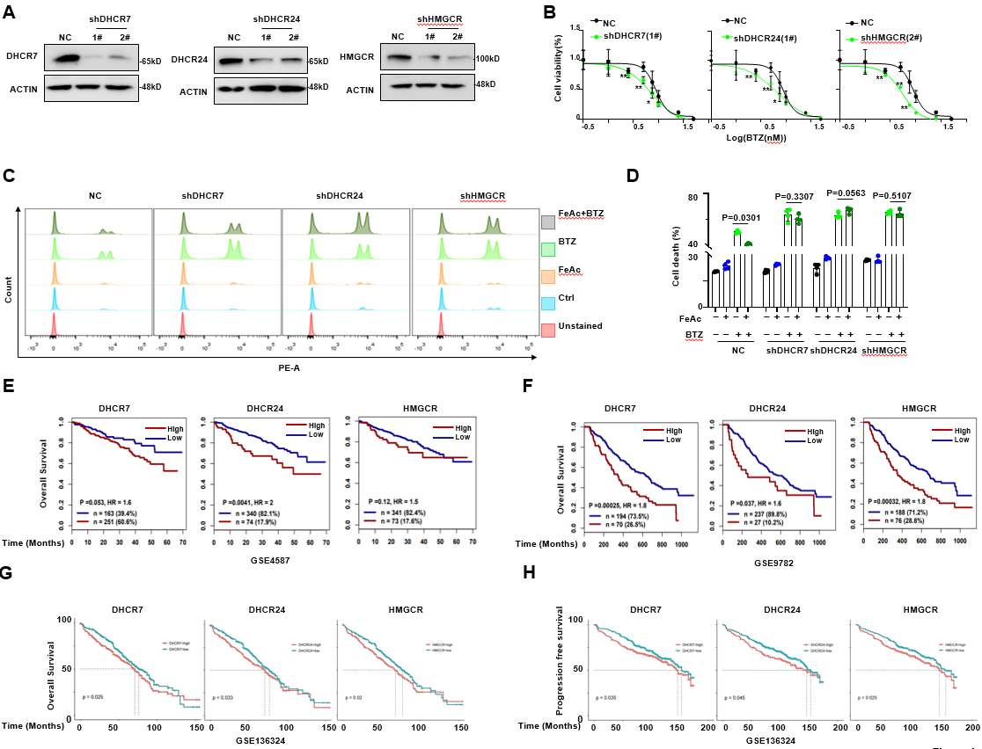
S Figure 4. Cholesterol promotes BR of MM.
(A) Representative western blotting showing knockdown effect of DHCR7, DHCR24 and HMGCR in MM.1S cells (n=3). (B) Alternation of IC50 to BTZ in DHCR7, DHCR24 and HMGCR knocking down MM.1S cells, respectively (n=3). (C) Representative flow cytometry assay showing death cells determined by PI, and statistical analysis (D) in DHCR7, DHCR24 and HMGCR knocking down MM.1S cells, respectively, in the absence or presence of FeAc for 48 hours (n=3). (E) The prognostic value of DHCR7, DHCR24 and HMGCR in database GSE4587. (F) The prognostic value of DHCR7, DHCR24 and HMGCR in database GSE9782. (G-H) The prognostic value of DHCR7, DHCR24 and HMGCR in database GSE136324. *, P<0.05; **, P<0.01. P values are determined by unpaired two‐sided t‐tests with Welch's correction.
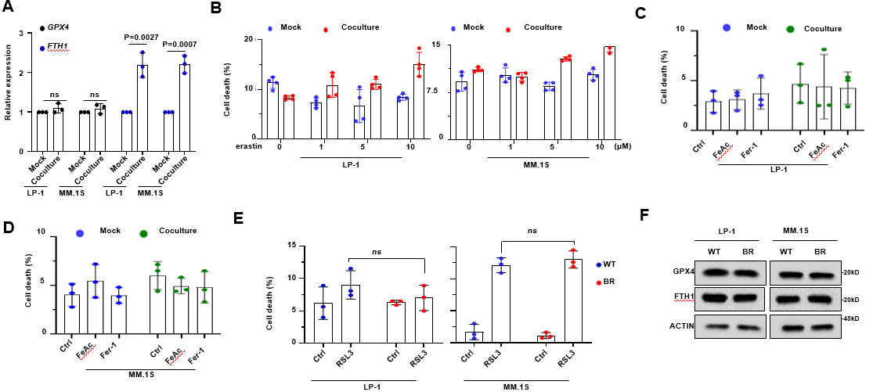
S Figure 5. Co-culture treatment with BMSC cells augments sensitivity of MM cells to GPX4 inhibitor.
(A) Real-time PCR results showing mRNA expression of FTH1 and GPX4 in mock and co-cultured MM cells. (n=3). Mock, MM.1S cells only; Co-culture, MM.1S+BMSCs. (B) Statistical analysis of flow cytometry assay showing cell death determined by PI in mock and co-cultured MM cells induced by System xc⁻ inhibitor (n=4). Mock, MM.1S cells only; Co-culture, MM.1S+BMSCs. (C-D) Statistical analysis of flow cytometry assay showing cell death determined by PI in mock and co-cultured MM cells induced by FeAc and Fer-1 (n=3). Mock, MM.1S cells only; Co-culture, MM.1S+BMSCs. (E) Statistical analysis of flow cytometry assay identified cell death determined by PI in WT and BR MM cells induced by GPX4 inhibitor. (F) Representative western blotting showing GPX4 level in WT and BR MM cells. P values are determined by unpaired two‐sided t‐tests with Welch's correction.
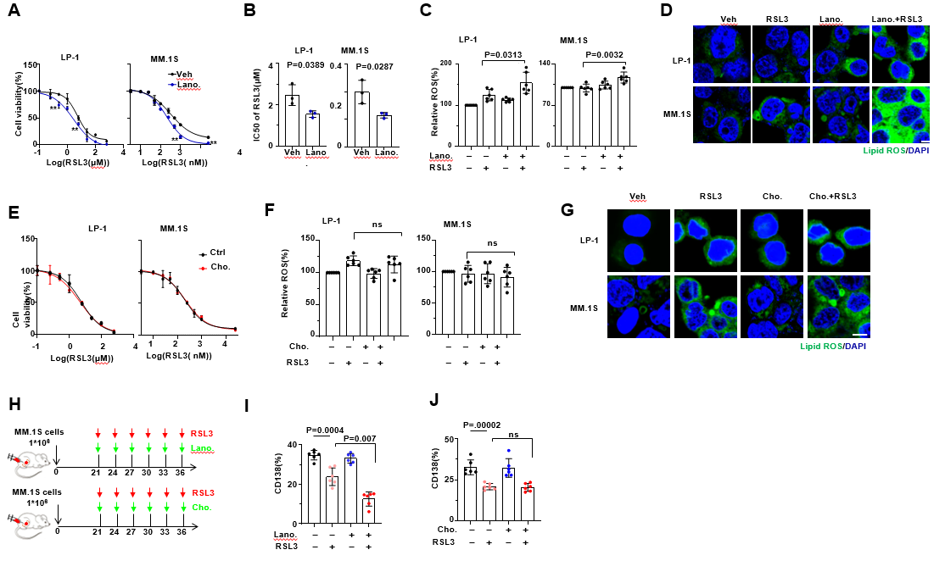
S Figure 6. Lanosterol accumulation in co-cultured MM cells generates ferroptosis induced by RSL3.
(A) The alternation of IC50 to RSL3 in MM cells in the absence or presence of lanosterol supplementation, and (B) statistical analysis of IC50 (n=3). (C) Lipid ROS level of RSL3 treated MM cells in the absence or presence of lanosterol supplementation (n=6). (D) Representative confocal images of MM cells loaded by oxidized formed C11-BODIPY (n=3). (E) The alternation of IC50 to RSL3 in MM cells in the absence or presence of cholesterol supplementation (n=3). (F) Lipid ROS level of RSL3 treated MM cells with or without cholesterol supplementation (n=6). (G) Representative confocal images of MM cells loaded by oxidized formed C11-BODIPY (n=3). (H) Zebra plot showing CD138⁺ cells infiltration in bone marrow of NSG mouse derived intra-bone model with or without lanosterol supplementation identified by flow cytometry (n=6). **, P<0.01. P values are determined by unpaired two‐sided t‐tests with Welch's correction.
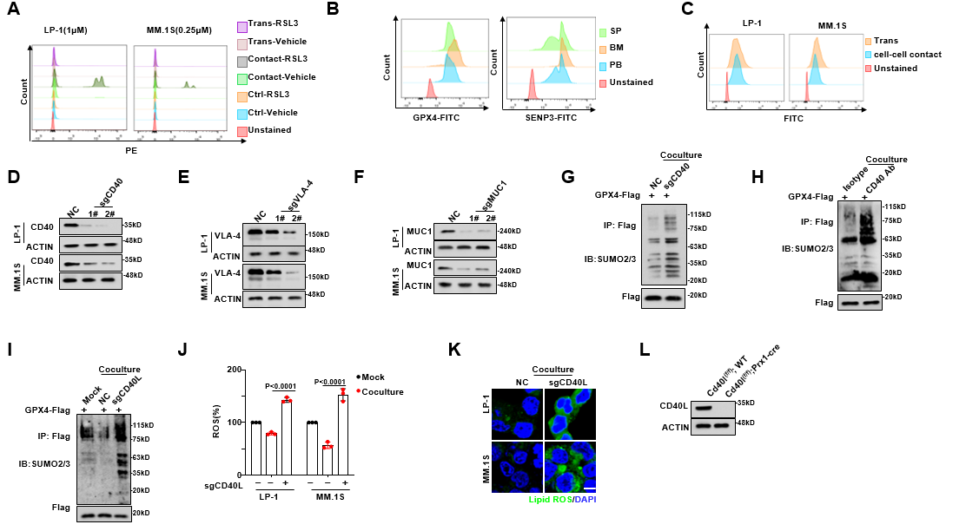
S Figure7. SENP3 stabilizes GPX4 through de-SUMOylation of GPX4 by CD40-CD40L bridging BMSCs and MM cells.
(A) Representative flow cytometry assay showing dead cells determined by PI in MM cells interacted with BMSC cells by cell-cell contact or transwell model (n=3). (B) Representative flow cytometry assay showing GPX4 level and SENP3 level of CD138⁺ B220⁻ cells separated from peripheral blood, bone marrow and spleen of Vk*MYC mouse model (n=6). (C) Representative flow cytometry assay showing fluorescent integrated density of oxidized BODIPY in MM cells interacted with BMSCs by transwell model (n=3). (D-F) Representative western blotting qualifying the knocked out effect of CD40, VLA-4 and MUC1 in MM cells (n=3). (G) Representative western blotting showing SUMOylation level of GPX4 modified by SUMO2 in CD40 knocked out MM cells when they were directly interacted with BMSC cells (n=3). (H) Representative western blotting showing SUMOylation level of GPX4 modified by SUMO2 in MM cells when they were directly interacted with BMSC cells with or without CD40 neutralize antibody treatment (n=3). (I) Representative western blotting showing SUMOylation level of GPX4 modified by SUMO2 in MM cells when they were directly interacted with CD40L knocked out BMSCs (n=3). Mock, MM.1S cells only; Co-culture, MM.1S+BMSCs. (J) Representative confocal images of MM cells loaded by oxidized formed C11-BODIPY (n=3). Mock, MM.1S cells only; Co-culture, MM.1S+BMSCs. (L) Representative western blotting qualifying knockout of CD40L in BMSC cells derived from Cd40l^{(f/f)}; WT and Cd40l^{(f/f)};Prx^{cre/+} mouse (n=3).

