Construction of ZnIn₂S₄/MOF-525 heterojunction system to enhance photocatalytic degradation of tetracycline
Xiansheng Zhang ª, Zhifeng Liu ^{a,} *, Binbin Shao ª, Ting Wu ª, Yuan Pan ª, Songhao Luo ª, Miao He ª, Lin Ge ª, Jingwen Sun ª, Chunyun Cheng ª, Jian Huang ^{b}
ª College of Environmental Science and Engineering, Hunan University and Key Laboratory of Environmental Biology and Pollution Control (Hunan University), Ministry of Education, Changsha 410082, P.R. China
^{b} Faculty of Environmental Science and Engineering, Kunming University of Science and Technology, Kunming, Yunnan Province 650500, China

* Corresponding authors at: College of Environmental Science and Engineering, Hunan University and Key Laboratory of Environmental Biology and Pollution Control (Hunan University), Ministry of Education, Changsha 410082, P.R. China
E-mail: zhifengliu@hnu.edu.cn (Z. Liu)

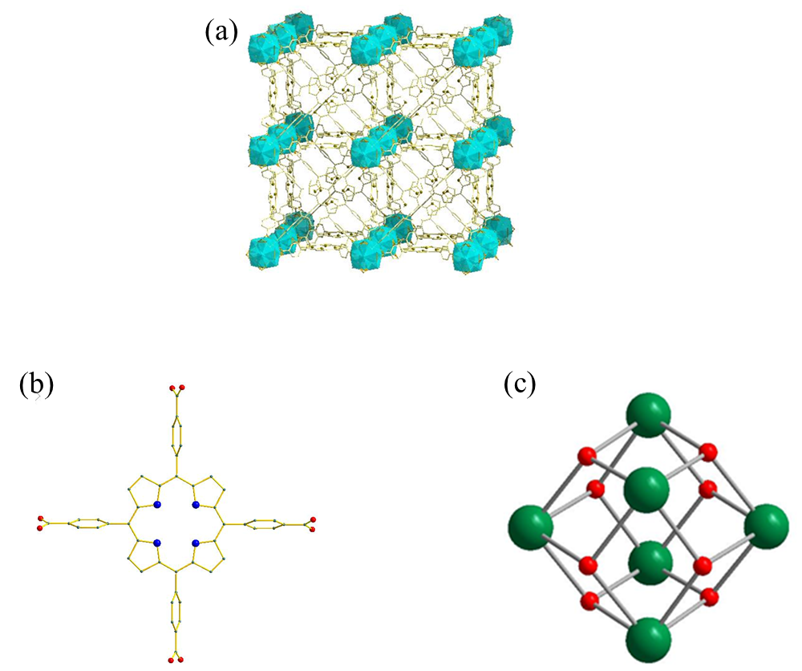
Fig. S1 (a) Spatial structure of MOF-525; (b) Structure of TCPP ligand in MOF-525; (B)Zr₆O₈ metal cluster in MOF-525. Color code: C: green, O: red, N: blue.
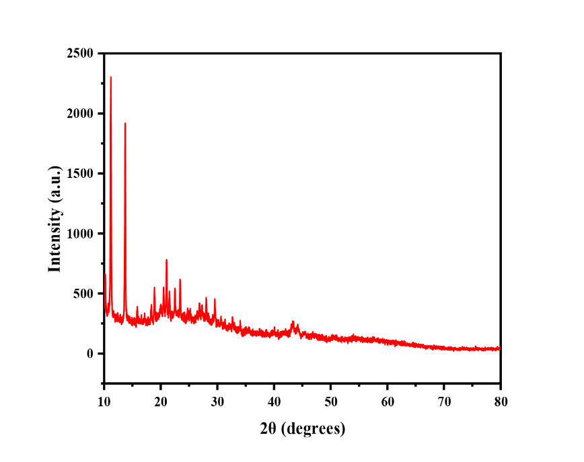
Fig. S2 XRD spectrum of MOF-525 at 10°-80°.

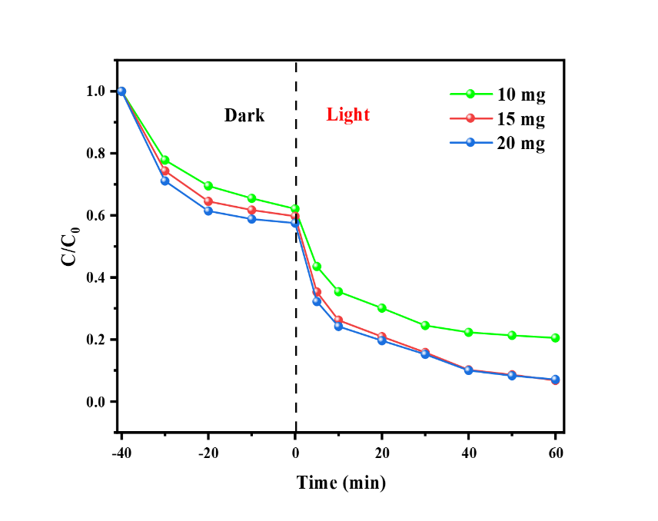
Fig. S3 Effect of catalyst amount on photodegradation of TC.

