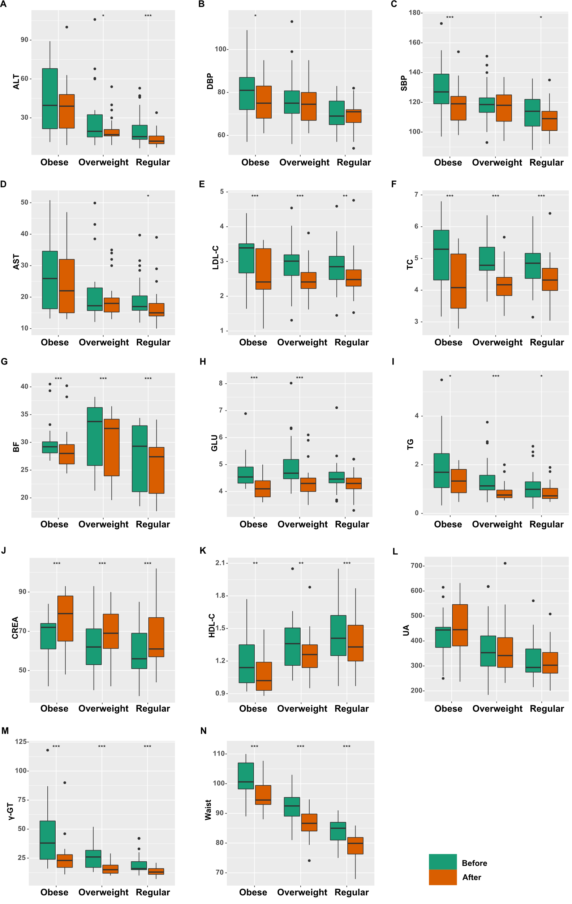

Figure S1. Changes in clinical parameters after the three-weeks IF intervention. Most of the parameters showed significant improvement (*** represents adjusted p < 0.001, ** represents adjusted p < 0.01, * represents adjusted p < 0.05, respectively, paired Wilcoxon test) after the intervention. The improvements were mostly uniform among different levels of obesity. Plots of BMI, weight, and AI are presented in the main Figure 1B and therefore omitted here.

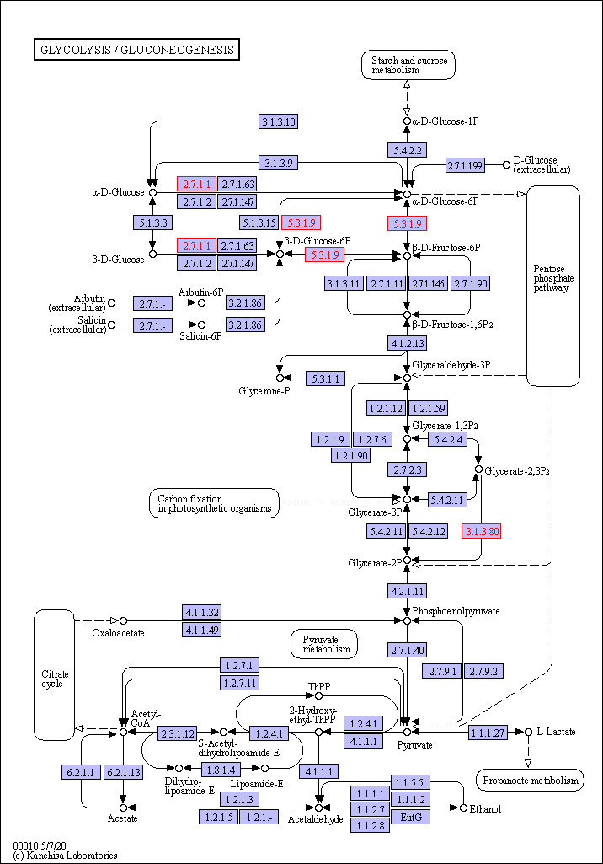

Figure S2. Diagram of the carbon metabolism pathway (KEGG map01200). K00844, K06859, and K15037 were enriched after the IF intervention and labelled in red.

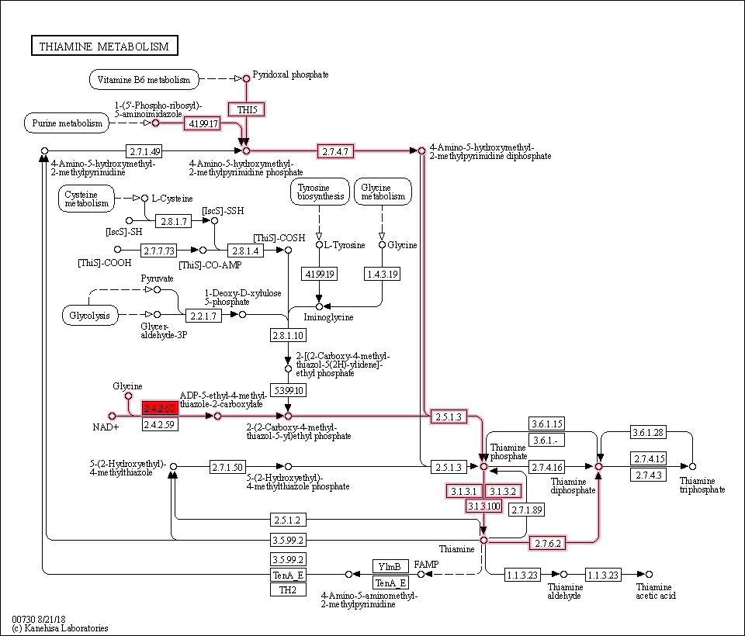

Figure S3. Diagram of the thiamine metabolism pathway (KEGG map00730). K03146 was enriched after the IF intervention and labelled in red. The reactions relevant to thiamine synthesis which will be affected by K03146 are also highlighted.

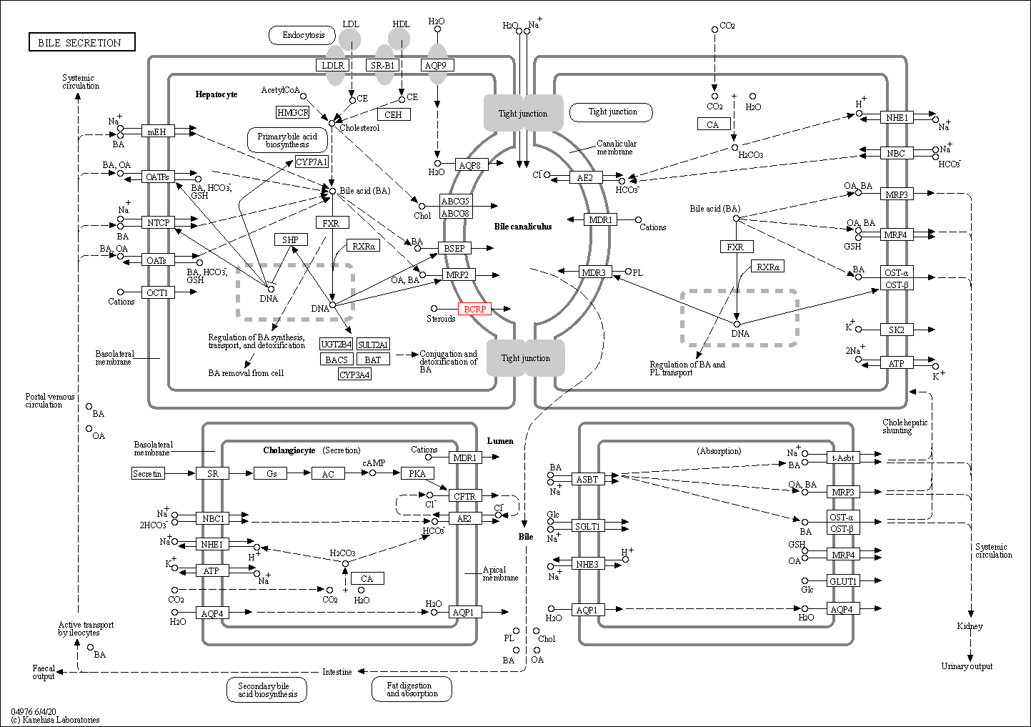

Figure S4. Diagram of the bile secretion (KEGG map04976). K05681 was enriched after the IF intervention and labelled as red.

