Identifying demographic, social, and clinical predictors of interleukin inhibitor biologic therapy effects using the real-world clinical data
Shasha Han, PhD^{1,2 *}, Peng Wu, PhD^{3,4*}, Zhihui Yang, MD^{5,6,7*}, Ruoyu Li, MD^{5,6,7}, Hang Li, MD^{5,6,7†} , Xiao-Hua Zhou, PhD^{1,8,9†}
- Beijing International Center for Mathematical Research, Peking University, Beijing, China
- School of Population Medicine and Public Health, Chinese Academy of Medical Sciences & Peking Union Medical College, Beijing, China
- School of Mathematics and Statistics, Beijing Technology and Business University, Beijing, China
- Research Center for Consumption Big Data and Intelligent Decision-Making, Beijing Technology and Business University, Beijing, China
- Department of Dermatology and Venerology, Peking University First Hospital, Beijing, China
- Beijing Key Laboratory of Molecular Diagnosis of Dermatoses, NMPA Key Laboratory for Quality Control and Evaluation of Cosmetics, Peking University First Hospital, Beijing, China
- National Clinical Research Center for Skin and Immune Diseases, Beijing, China
- Department of Biostatistics, School of Public Health, Peking University, Beijing, China
- National Engineering Laboratory of Big Data Analysis and Applied Technology, Peking University, Beijing, China
*These authors contributed equally.
†To whom correspondence should be addressed to:
Hang Li (drlihang@126.com) and Xiao-Hua Zhou (azhou@math.pku.edu.cn).

Supplementary figures 1− 2.

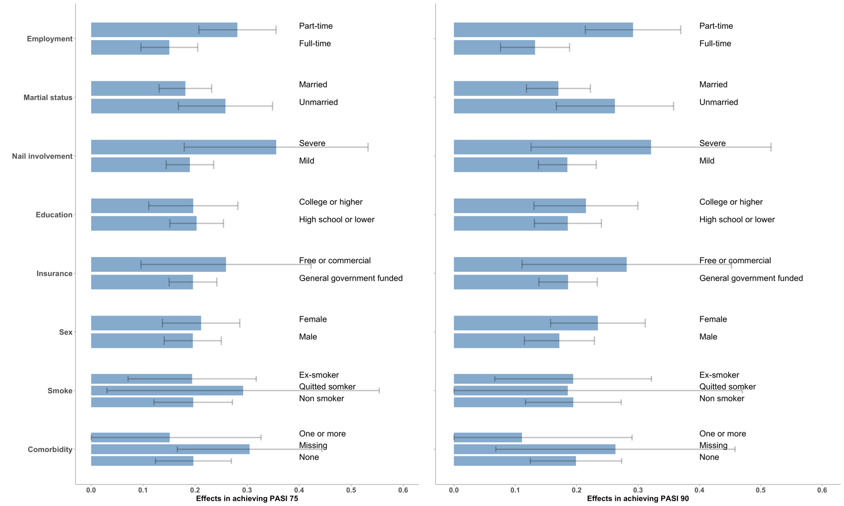
eFigure 1 Estimated conditional treatment effects of IL inhibitor biologics versus the conventional therapies in weeks 5–46, on candidate predictors with categorical values. Whiskeys represent 95CI. Lower 95CI below 0 are not shown.
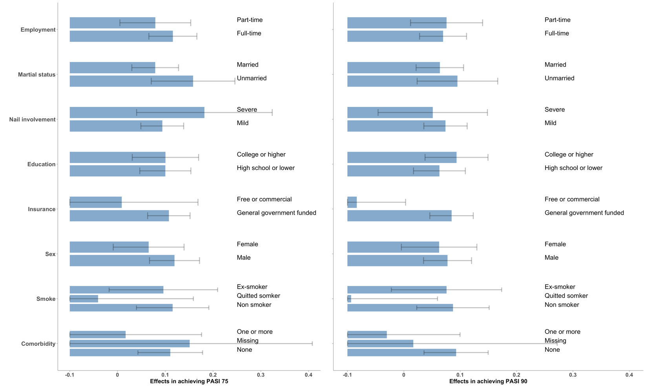
eFigure 2 Estimated conditional treatment effects of IL inhibitor biologics versus the conventional therapies in weeks 1–4, on candidate predictors with categorical values. Whiskeys represent 95CI. Lower 95CI below -0.1 are not shown.

