Table 1 Basic information about Qin Terra-Cotta Warriors painted films in Pit 2.
No. of samples | excavation location | sample picture | sample description
a | T21G20:1 | 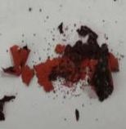 | The film is brown, thin, fragile, curling, cracked and covered with red paint.
b | K5:142 | 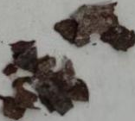 | The film is brown, thin, fragile, curling, cracked and covered with white paint.
C | K5:133 | 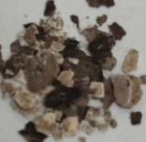 | The film is brown, thin, fragile, curling, cracked and covered with white paint.
d | K5:103 | 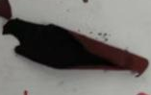 | The film is brown, thin, fragile, curling, cracked and covered with red paint.
e | T21G20:2 | 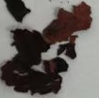 | The film is brown, thin, fragile, curling, cracked and covered with red paint.
f | K5:67 | 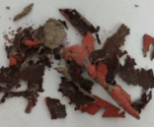 | The film is brown, thin, fragile, curling, cracked and covered with red paint.

Table 2 The surface of the painted films observed under the ultra-depth-of-field microscope
No. of samples | the surface of the films | the surface of the pigments
a | 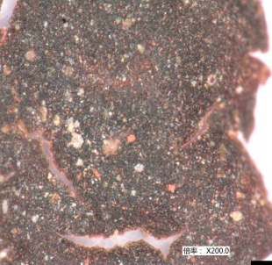 | 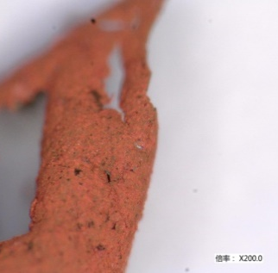
b | 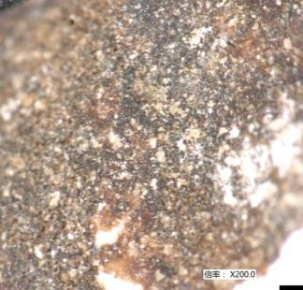 | 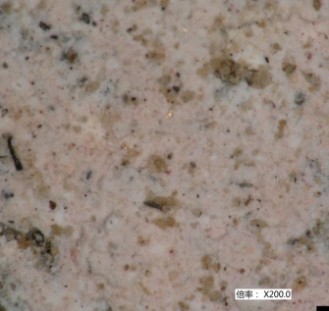
C | 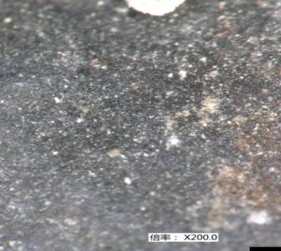 | 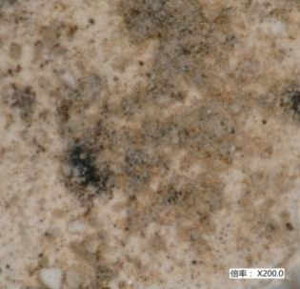
d | 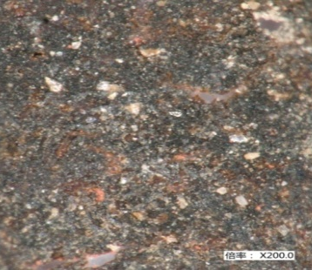 | 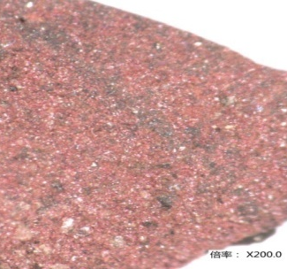
e | 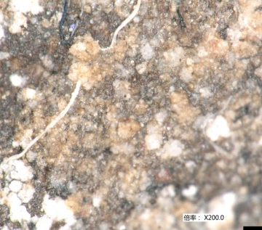 | 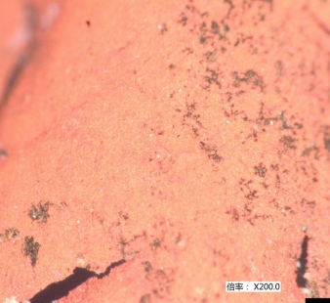
f | 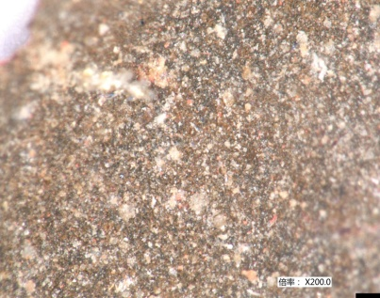 | 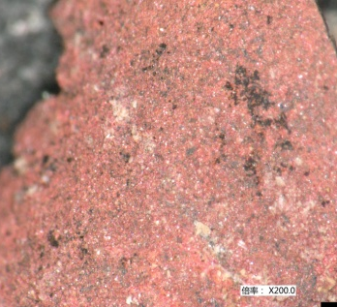

Table 3 Thickness and layers of the painted films
No. of samples | Analytical results
a | Two layers. The red layer is 10.1um thick on average. The black layer is 20.6um thick on average.
b | Two layers. The white layer is 10.5um thick on average. The Black layer is 19.4um thick on average.
c | Two layers. The white layer is 10.3um thick on average. The black layer is 20.3um thick on average.
d | Two layers. The red layer is 9.6um thick on average. The black layer is 21.5um thick on average.
e | Two layers. The red layer is 9.9um thick on average. The black layer is 18.5um thick on average.
f | Two layers. The red layer is 10.0um thick on average. The black layer is 22.5um thick on average.

Table 4 Main infrared absorption bands of painted films unearthed in Pit No. 2
Wavenumber（cm⁻¹） | Assignment | Wavenumber（cm⁻¹） | Assignment
3442 | v(O-H) | 1250 | vas（Ar-O-R）,  v（Ar-OH）
2929,2851 | vas(CH₂),v（CH₂） | 1037 | vas（Si-O-Si）
1635 | v(C=C）,δ( O-H ) | 790, | γH （Ar1,2,4）, v（Si-O-Si）
1556,1400 | vas(COO),v（COO） | 779 | γH（Ar1,2,3）, v（Si-O-Si）

Table 5 Table 5 Main infrared absorption bands of films in raw lacquer
Wavenumber（cm⁻¹） | Assignment | Wavenumber（cm⁻¹） | Assignment
3460 | v(O-H) | 1500~1100 | δ（O-H）,β（O-H）,  V（ C-O）
3017 | v（C=H） | 994 | γ(RHC=CH₂）
2927，2853 | vas(CH₂)，v（CH₂） | 778、734 | γH（Ar1,2,3）
1610~1370 | v（C=C）of benzene ring | 803 | γH（ Ar 1,2,4）
1475 | δCH₂ | 863,831,734 | γH（Ar1,3,5）

